Local AI Studio — Film Recipe
How to make a narrated short film, start to finish, on one GPU · works for any subject · state as of 6 October 2026

1. What this recipe makes
A finished, narrated film of anything from two to fifteen minutes: picture, ambient sound, voice-over, score, titles and captions, made entirely in the studio and edited together at the end. Every step below is a tab you already have, and every render goes through the one job queue, so a night's worth of shots can be lined up and left to run.
Step | Tab | What it gives you
Script, shot plan, prompts | 🧠 Language (or Claude Code) | The words and the timed plan
Narration | 🔊 Text → Speech / 🗣️ Voice Studio | Kokoro for fast clean narration, Chatterbox or a cloned voice for character
Keyframes | 🎨 Image — Generate / ✂️ Edit | One still per shot that fixes composition, light and characters
Picture + ambient sound | 🎬 Video (MiniMax H3) | Each shot as a clip with its own sound, from one pass
Score | 🎵 Music Generation / 📊 Composer | A music bed per section, or one continuous cue
Sound effects | 🔊 Sound Effects | Impacts, foley and room tone for the gaps
Caption timing | 🎙️ Speech → Text | Word timings from the finished narration
Edit, titles, mix | Your editor of choice | DaVinci Resolve, ffmpeg, or HyperFrames driven by Claude Code

2. The one rule: plan before you render
A video clip costs minutes of GPU time; a line in a plan costs seconds. Every expensive mistake in AI film-making is a decision that was made during rendering instead of before it. So the order is fixed: brief → script → timed plan → approval → only then the first render. If the film is for someone else, the plan is what they approve, not the footage.

3. Step 1 — The brief (one page)
Write these down before anything else. Each one prevents a whole class of rework.
Heading | What to decide
Message | The one sentence the viewer should leave with.
Runtime | A target length, agreed now. It sets the word count and the shot count.
Audience and platform | Who it's for and where it will be watched (phone, TV, YouTube). It sets pacing, caption size and loudness.
Must-haves | Factual limits (e.g. only real physics), tone, how sensitive subjects are handled, anything that must or must not appear.
Look | Photoreal or stylised, decided once. A palette and light for each location, so places read at a glance.
Cutting | Hard cuts, or transitions? Decide the house style now. Hard cuts are the safe default.
Delivery and licences | Where it will be published, and whether every model you plan to use allows that (see section 14).

4. Step 2 — The script
- Write the narration as it will be spoken. Draft it in the Language tab or with Claude Code, then read it aloud: anything you stumble on, the voice will too.
- Measure the voice before you trust the maths. Voice one paragraph with the engine you'll use and time it. Speaking rates vary by engine and voice, and the whole plan hangs off this number.
- Leave room. Narration should cover roughly three-quarters of the runtime; the rest is pictures and score breathing on their own, plus titles and credits.
- Write for the picture. Every sentence should be showable. If a line has no image, cut the line or find one.

5. Step 3 — The timed plan
Break the film into chapters, chapters into scenes, and scenes into shots, each with a start, end and length. Mark where the voice starts and stops inside each scene, and where title cards sit. This document is the film; everything after it is execution.
# | Start | End | Len | Shot | Sound
1 | 0:00.0 | 0:04.0 | 4s | Wide: a harbour at first light, fishing boats leaving, camera slowly rising | Gulls, engines, water
2 | 0:04.0 | 0:09.0 | 5s | Medium: an old woman mending a net on the quay, hands in focus | Rope creak, distant radio
3 | 0:09.0 | 0:13.0 | 4s | Close: her face as she looks up at the sea | Wind, a single bell
An illustrative scene. Voice 0:01.5–0:12.0; hard cuts.
- Shots of 3–8 seconds. The Video tab renders up to 15 s, but long clips drift; 4–6 s is the sweet spot.
- One action per shot. A clip asked to do two things usually does one of them badly. Longer actions become a chain of shots (section 9).
- Budget the render before approving the plan. Once one clip has run, the queue shows a measured time per clip; multiply by the shot count, add keyframes and rerolls, and decide whether the plan fits the time you have.
- Get the plan approved — by yourself, or by whoever the film is for — before any render starts.

6. Step 4 — Voice first
Render the narration before any picture. Its real durations will differ from the estimate by a few percent; re-time the plan to the real voice now, while that costs nothing. Picture is then cut to the voice, never the voice squeezed to fit the picture.
- Kokoro is fast and clean for documentary narration; Chatterbox or a Voice Studio clone gives a specific character. Clean up a cloning reference clip with the one-click cleanup first.
- Voice line by line or paragraph by paragraph, so a single bad line can be re-voiced without touching the rest.
- Normalise every narration file to the same loudness (section 11) so lines from different takes match.

7. Step 5 — The look bible
A short reference document, plus a few images, that every prompt draws from. It is what makes shot 80 look like it belongs in the same film as shot 3.
- Per location: palette, light, time of day, weather, lens feel. Write it once and paste it into every prompt for that place.
- Recurring characters: generate one clear reference image of each (face, hair, clothes) in the Image tab, and re-use it — as the source for Image Edit keyframes, or as a reference image in the Video tab's References mode.
- Describe what you want, never what you don't. Image models don't read negation: writing "no cars" or "no flags" tends to add cars and flags. Describe the empty street instead.
- Use concrete geometry, not adjectives. "Camera at knee height, looking up, subject filling the left third" beats "dramatic angle". Abstract wording gets ignored or averaged away.

8. Step 6 — Keyframes
Make one still per shot in the Image tab at 16:9, then animate from it. A keyframe pins down composition, light and who is in frame, so the video model only has to supply motion — and a reroll at this stage costs seconds rather than minutes.
- Choose the model by where the film is going: Base 4B is Apache-licensed and commercial-safe; Miraclein 9B is for personal art.
- Use Image Edit with a character reference when the same person appears across shots.
- Check every keyframe at full size before it goes to video: hands, limbs, faces of foreground people, readable text, details that belong to the era and place. A flaw here is copied into every frame of the clip.

9. Step 7 — Clips in the Video tab
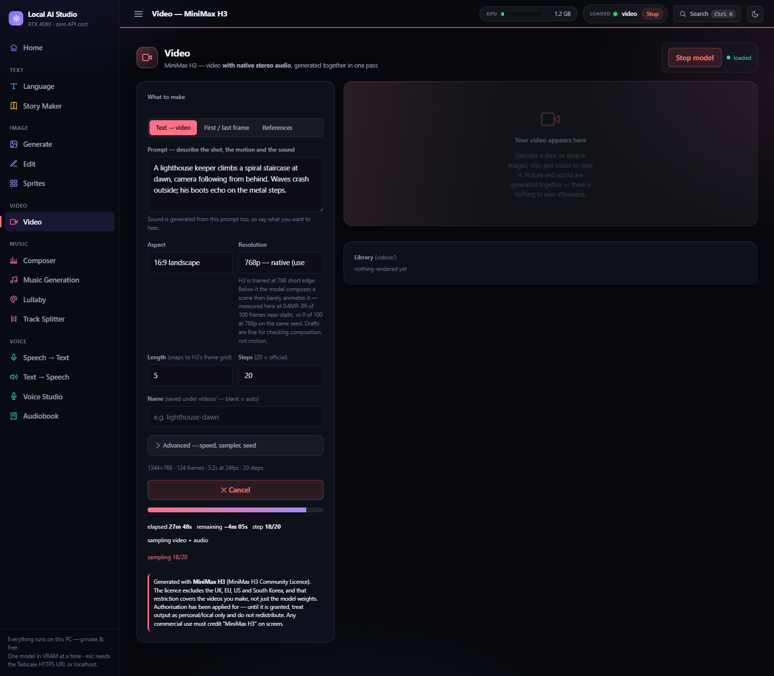
The Video tab: text → video, first/last frame, or references, with sound from the same pass.
Mode | Use it for
First frame (image → video) | The default for a planned film. Your keyframe fixes the composition; the prompt supplies motion and sound.
First + last frame | Controlled moves and transitions: H3 travels between two keyframes you made.
Text → video | Shots where exact composition doesn't matter — skies, crowds, establishing views.
References | Keeping a person, prop or style consistent: up to 9 images, plus reference video for motion and reference audio for voice or ambience.

Settings that matter
- Always 768p (native). Below it, H3 composes the scene and then barely moves it — use lower resolutions only to check composition, never motion.
- 20 steps is the official setting. Leave EasyCache off when the clip's sound will be used: it speeds things up but measurably thins the audio.
- Render each clip half a second longer than its slot, so the edit has handles to trim.
- Write the prompt in three parts: the shot (framing, subject, place), the motion (what moves and how the camera moves), and the sound (what you'd hear standing there).

Movement and transitions
- One action per clip. For a longer action, take the last frame of one clip as the first frame of the next and continue.
- Make transitions physical, not optical. A camera that really travels — through a doorway, over a ridge, following someone walking — reads as filmed. Dissolves, flares and morphs read as generated.
- Let people carry a transition: a subject walks from one place into the next and the camera stays with them. Camera moves through empty spaces feel like a screensaver.
- Give a travelling move time: about 4.5–5 seconds. Faster, and the model blurs the space between.

Checking clips
Look at the first, middle and last frame of every clip at full size, not just the thumbnail: limbs that appear, merge or bend wrongly, hands, faces, and anything that drifts away from the keyframe. Reroll with a new seed rather than patching.

10. Step 8 — Work in batches

Queue a batch of shots from any tab and walk away; the drawer shows each job's measured time.
Don't render the whole film and then watch it. Produce it in batches of about thirty seconds of finished film — graded, mixed and captioned, at final quality — and review each batch before starting the next. A problem with the look, the voice or the pacing shows up in batch one, when fixing it is cheap, instead of in batch twenty.
- Keep a running fix list per batch: which shot, what is wrong, what will change. Re-render only what failed.
- Line up the whole batch in the queue — keyframes, clips, music, effects — and leave it. Same-model jobs are grouped automatically to save model loads.
- Keep other GPU-heavy programs off while a batch runs. Even a headless browser render can roughly double generation time.

11. Step 9 — Sound
Four layers, each normalised on its own before mixing. Integrated loudness (LUFS) is what matters; peak level alone doesn't make two clips sound equally loud.
Layer | Source | Level | Notes
Narration | Text → Speech | −17 LUFS | Every line normalised to the same level.
Ambience | Each clip's own H3 audio | −24 LUFS | Normalise every clip before cutting: H3 picks its own level per render, and clips can differ by 25 dB.
Score | Music / Composer | −22 LUFS | Fade in and out; one continuous cue across scenes sounds more like a film than a cue per shot.
Effects | Sound Effects | By ear | Hits, foley, room tone to cover gaps between clips.
- Duck the score about 7 dB and the ambience about 9 dB under the narration, with a soft attack (~0.35 s) and release (~0.8 s), so the voice sits on top without the bed pumping.
- Bring the final mix to −16 LUFS integrated with a limiter for web and phone playback. A browser or phone can't boost a quiet video past full volume, so a mix that's too quiet stays too quiet.

12. Step 10 — Assembly
Once every batch is approved, rebuild the film as one piece: one picture timeline and one continuous audio mix. Don't just join the batch files — the score and narration need to run across scene and chapter boundaries, and joined batches leave seams at every join.
- Upscale H3's 1344×768 to 1920×1080 with a good scaler (Lanczos) and a light sharpen; keep 24 fps throughout.
- Titles and captions: small, consistent, and clear of the corners platforms draw over (YouTube's duration stamp sits bottom-right).
- Caption timing: run the finished narration through Speech → Text for word timings, then correct the words against the script.
- Any editor works. DaVinci Resolve (free) for a manual cut; ffmpeg for a scripted one; HyperFrames through Claude Code to build the whole edit — titles, captions, timing — as code.

13. Step 11 — Final checks
- Watch the whole film, start to finish, with sound, on the device your audience will use.
- People: hands, limbs and faces in the foreground of every shot.
- Continuity: characters, clothes, light and places stay the same where they should.
- Sound: no level jumps at cuts, narration always intelligible, no clipped peaks.
- Text: captions match the words, titles are spelled right, credits and disclosures are present.

14. Step 12 — Delivery and licences
- Keep two files: a high-bitrate master for uploading and archiving, and a small copy (about 8 Mbit/s) for sharing and messaging apps.
- Platforms re-encode everything; upload the master, not the small copy.
- Disclose AI-generated content wherever the platform asks (YouTube's altered-content setting) — realistic generated people and places require it.
- Check every model's licence against where the film is going. MiniMax H3 output is territory-restricted and requires disclosure (see the Install guide, §5); Base 4B images are commercial-safe, Miraclein 9B is for personal use; music and voice models each have their own terms.
- Make thumbnails from real frames of the finished film, so the thumbnail promises what the video delivers.

15. Optional — Claude Code as director
Everything above can be driven by Claude Code: it can write the script, build the timed plan, write every keyframe and clip prompt from the look bible, submit the jobs to the studio's queue (POST /api/queue/add), check frames, mix the sound and assemble the edit. Keep the human gates where they are — approving the plan, and reviewing every batch — and it stays your film.

16. When something goes wrong
Symptom | Likely cause | Fix
Clip barely moves | Rendered below 768p | Re-render at 768p native.
An edited keyframe keeps the reference image's pose | Abstract pose wording | Describe the pose as concrete geometry (where each arm, leg and the head are), and state the camera view twice.
An unwanted object keeps appearing | The prompt names it, even as "no …" | Remove the word; describe what should be there instead.
A character changes between shots | No shared reference | Generate a reference image; use Image Edit or Video References.
Volume jumps at every cut | Clip audio not normalised | Normalise each clip's audio before cutting (section 11).
Thin, quiet clip audio | EasyCache was on | Re-render with EasyCache off.
Renders suddenly take twice as long | Another program is using the GPU | Close it, or wait until the batch finishes.
A transition looks fake | Optical effect (dissolve, flare, morph) | Replace it with real camera travel or a subject walking through.

