Vinny Diehl
Chapter 3 Homework

Multiple Choice

- A
- A
- D
- C
- B
- B
- A
- D
- C
- B
- A
- C
- D

True and False

- True
- True
- False
- True
- True
- False

Find the Error

- Corrections highlighted.
public int total(int value1, int value2, int value3)
{
return value1 + value2 + value3;
}

Algorithm Workbench

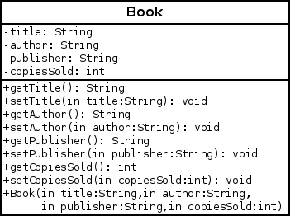
- Book Class c.
  - public Book(String title, String author,
String publisher, int copiesSold)
{
this.title = title;
this.author = author;
this.publisher = publisher;
this.copiesSold = copiesSold;
}
  - public String getTitle() { return title; }
public void setTitle(String title) { this.title = title; }
public String getAuthor() { return author; }
public void setAuthor(String author) { this.author = author; }
public String getPublisher() { return publisher; }
public void setPublisher(String publisher) { this.publisher = publisher; }
public int getCopiesSold() { return copiesSold; }
public void setCopiesSold(int copiesSold) { this.copiesSold = copiesSold; }

Short Answer

- A class is the blueprint from which an instance is created.
- A class is the blueprint, an object is the house.
- An accessor reads the class's private member variables. A mutator writes to them.
- Hiding the internal workings of a class allows one to change the implementation while maintaining backwards compatibility.
- Only methods of the class have access.
- new creates an instance of a class.

