1. Which requirements you implemented (5 pts)
   1. single mesh rendering mode (Flat Shading)

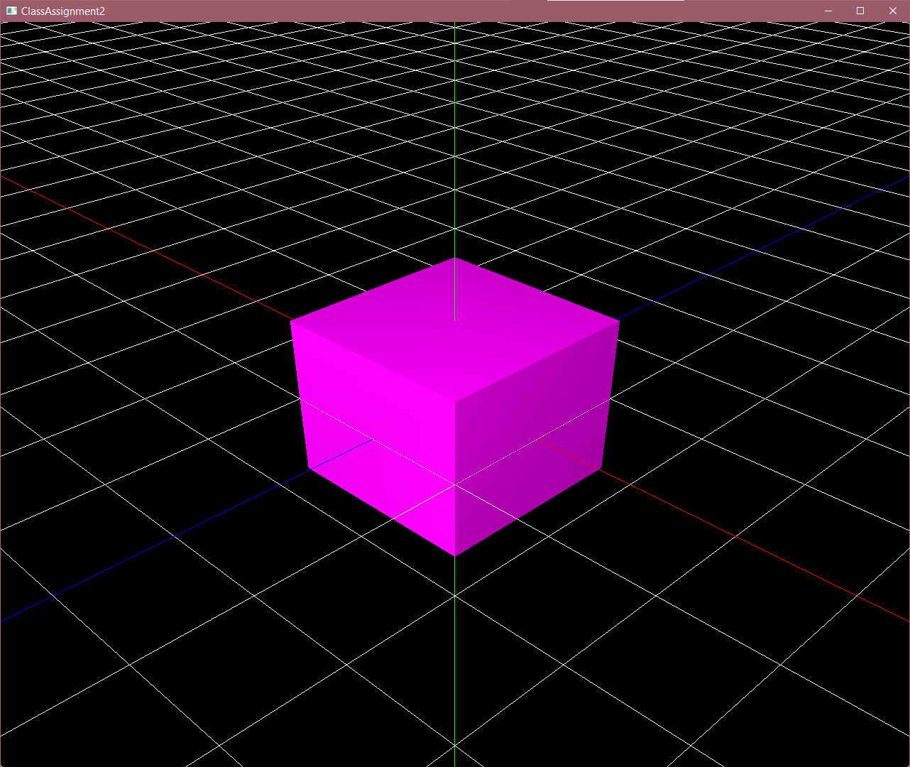 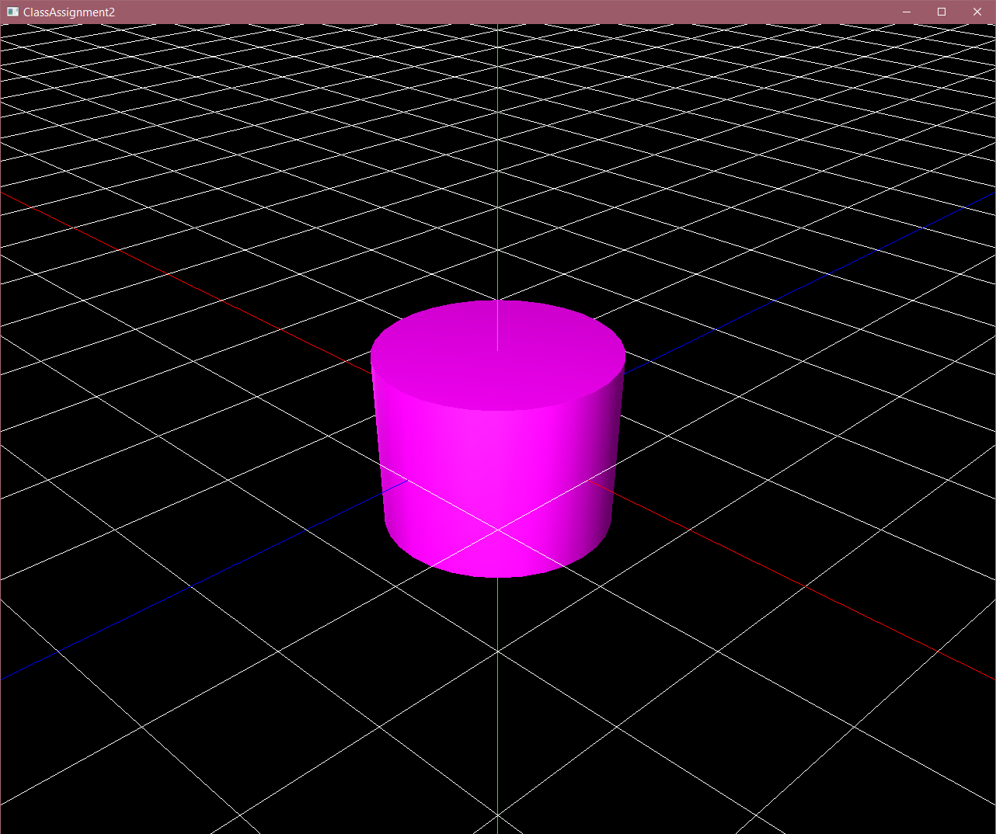 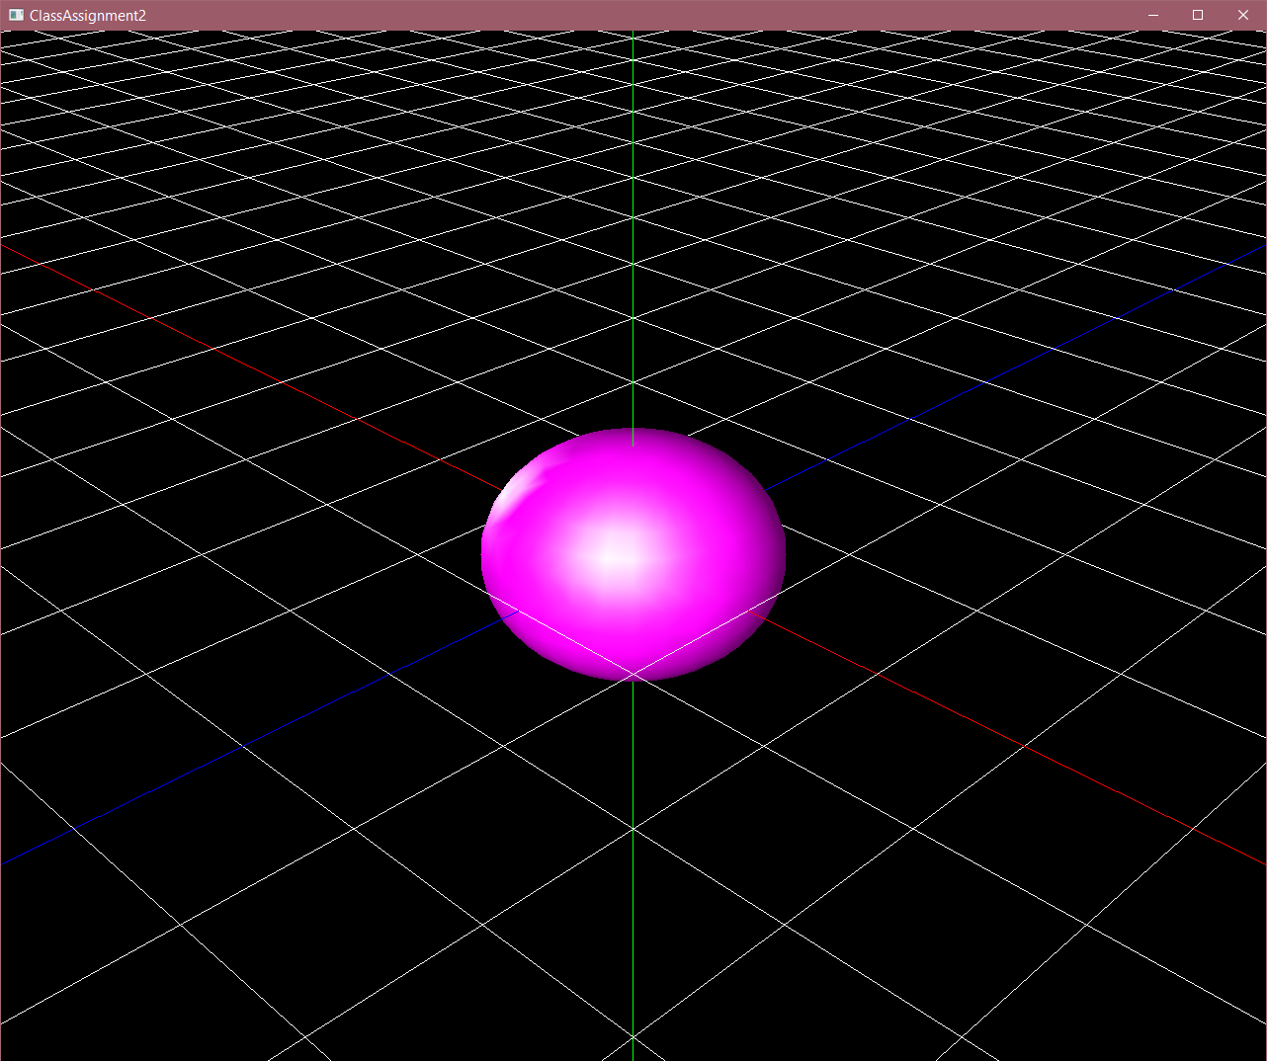

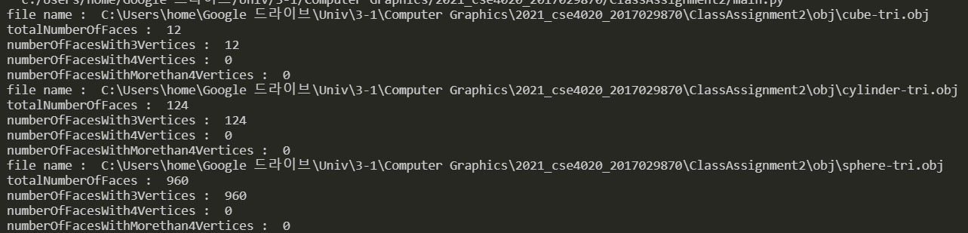

* 1. Animating hierarchical model rendering mode (50 pts)
     1. 아래 유투브 링크 참고
     2. 달 모양이 폴리곤이 많아서 로딩하는 데에 시간이 걸릴 수 있음
        1. 본인 컴퓨터에서 약 5초
     3. 지구, 달, 돌 obj파일을 연결시킴

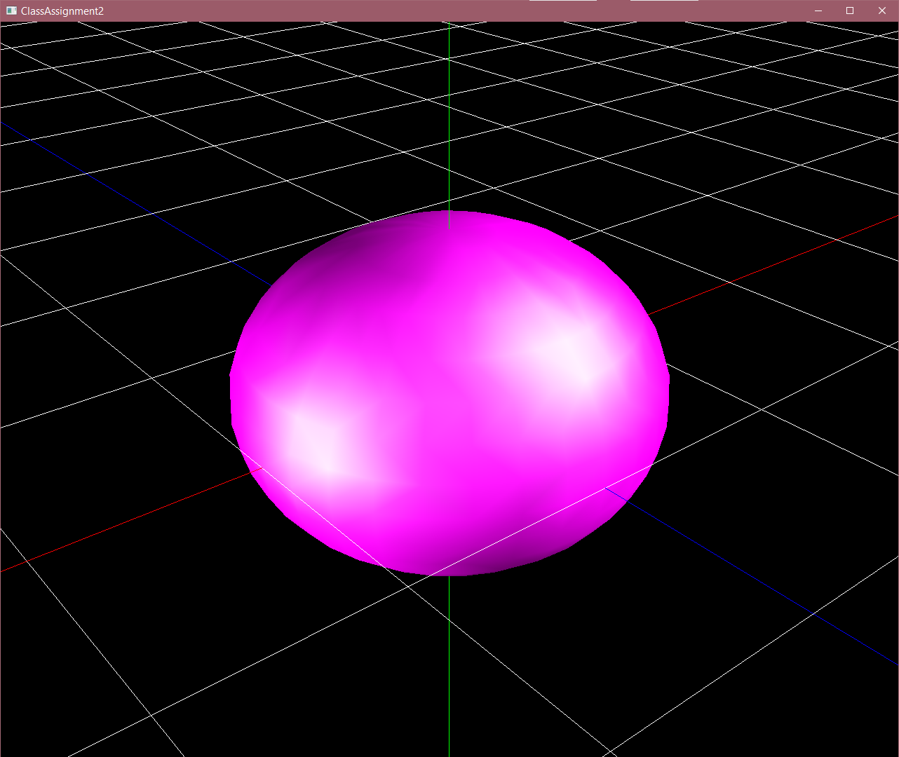 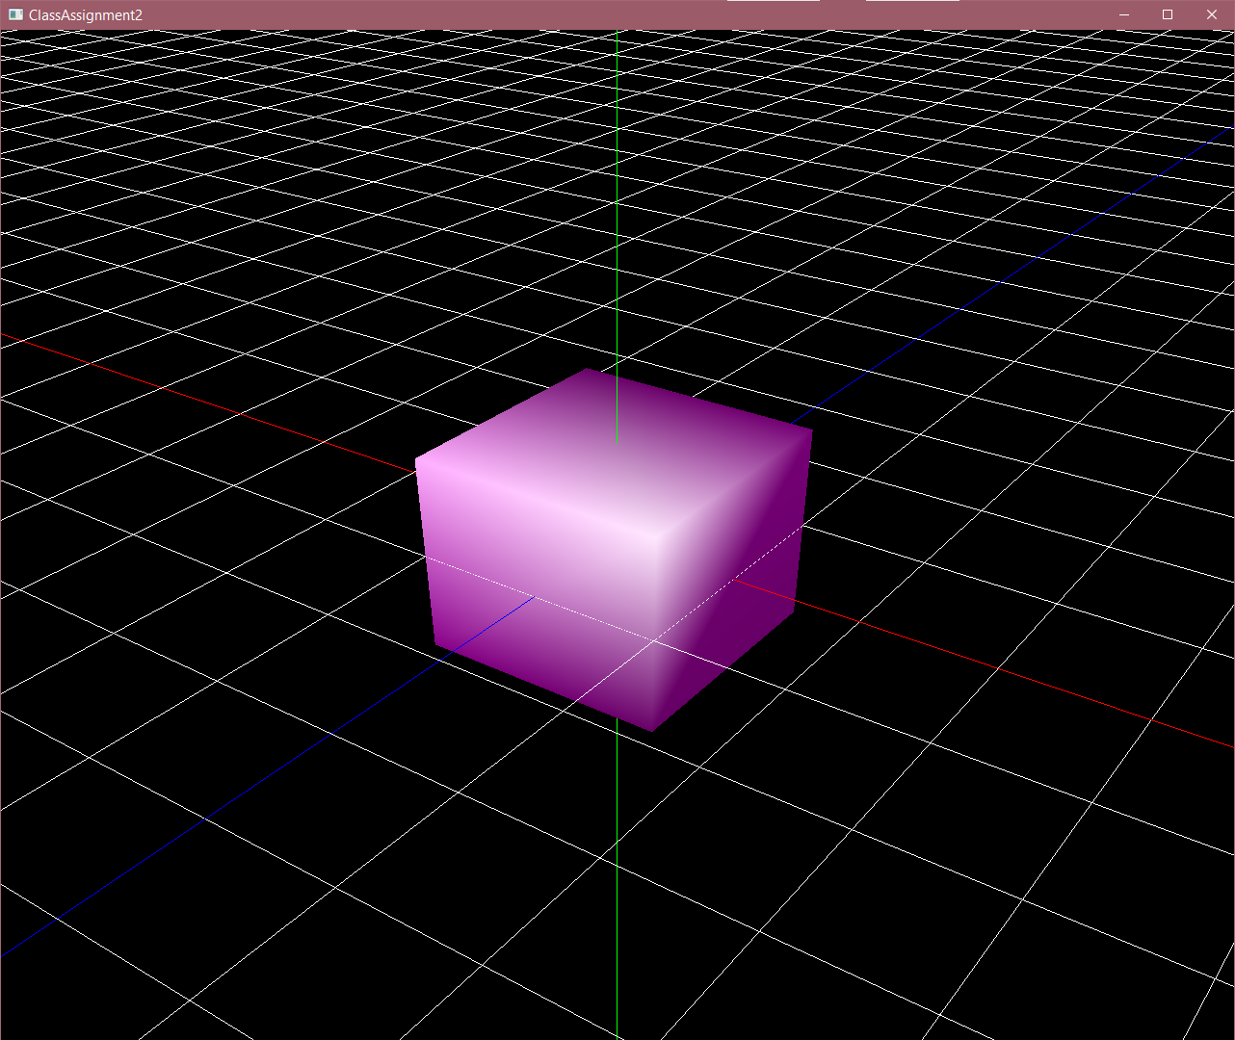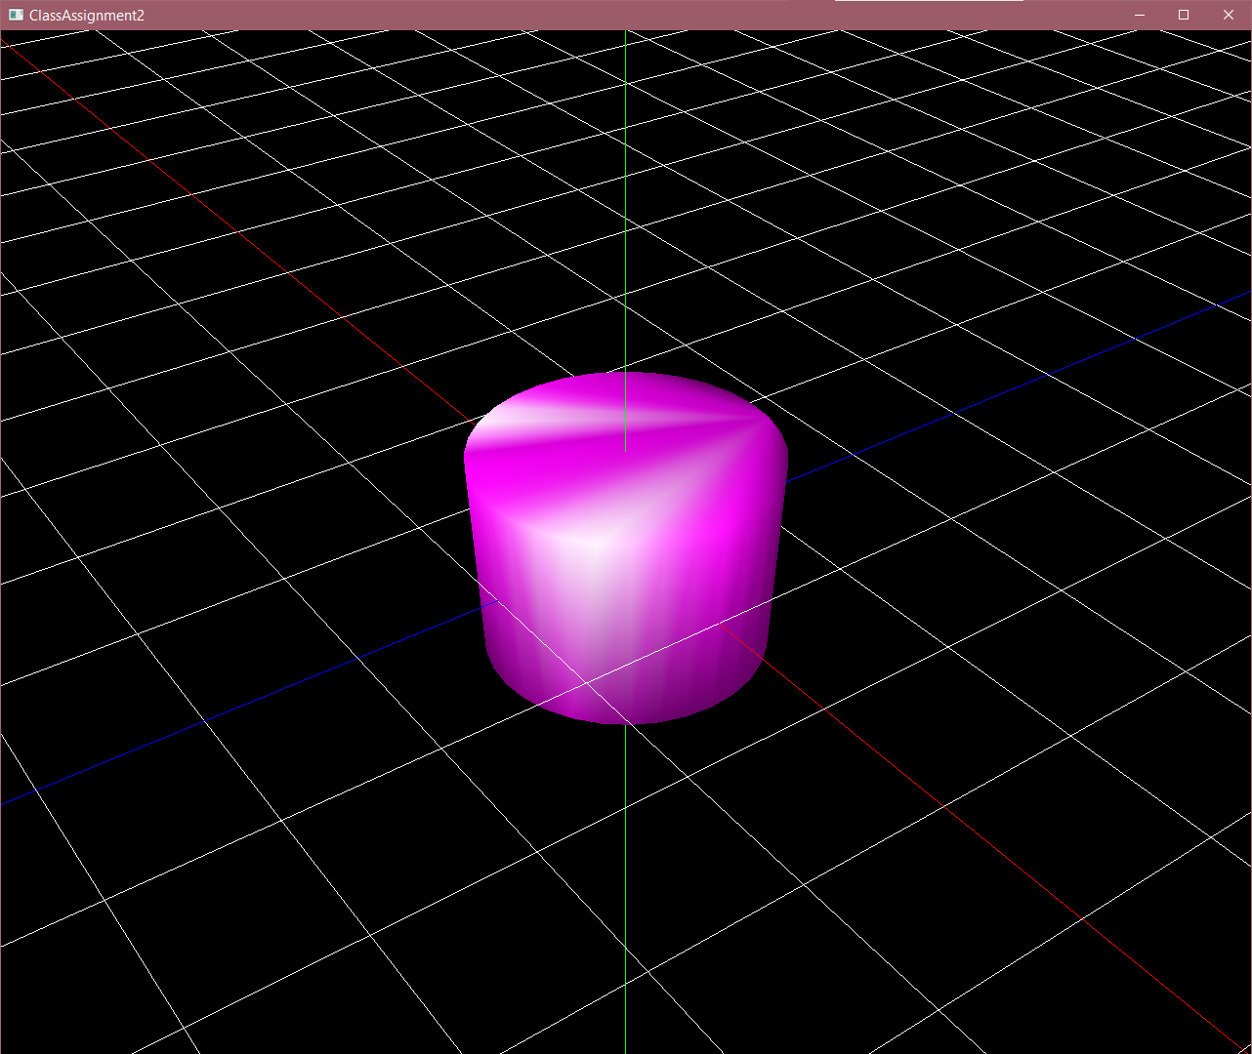

* 1. Use multiple light sources (not a single light) to better visualize the meshes (10 pts). & Toggle [shading using normal data in obj file] / [forced smooth shading] by pressing ‘s’ key (+10 pts)
     1. 위 사진들은 서로 다른 광원 2개에서 smooth shading을 하는 모습
  2. Toggle wireframe / solid mode by pressing ‘z’ key (similar to pressing ‘z’ key in Blender) (10 pts).

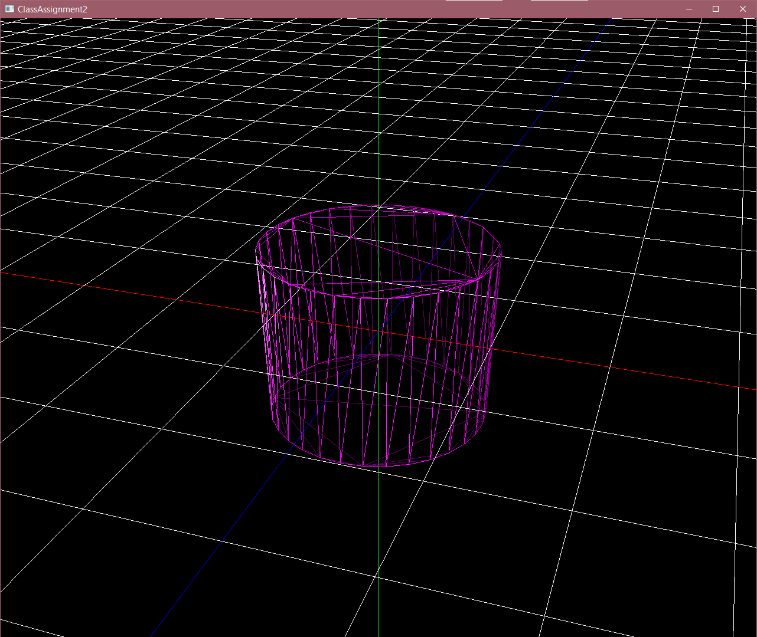 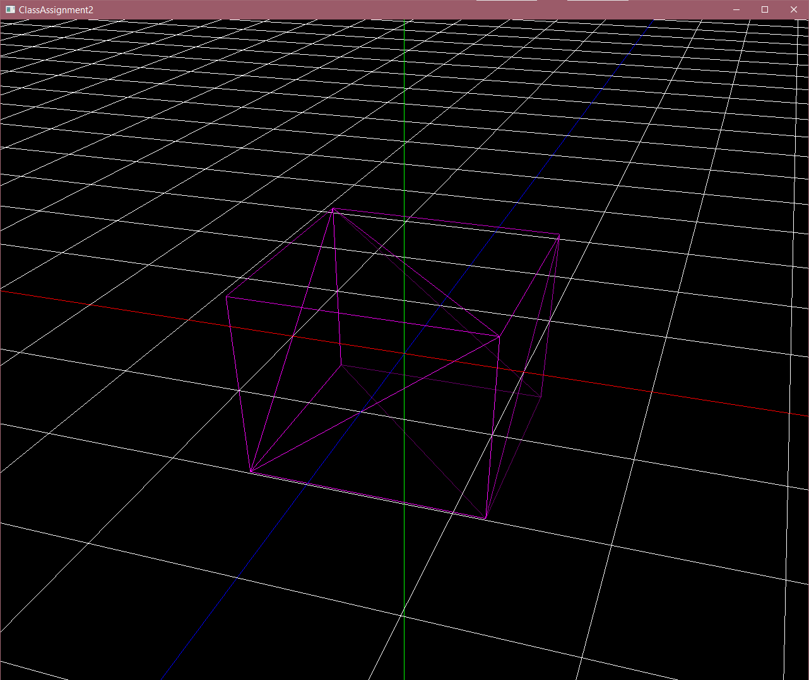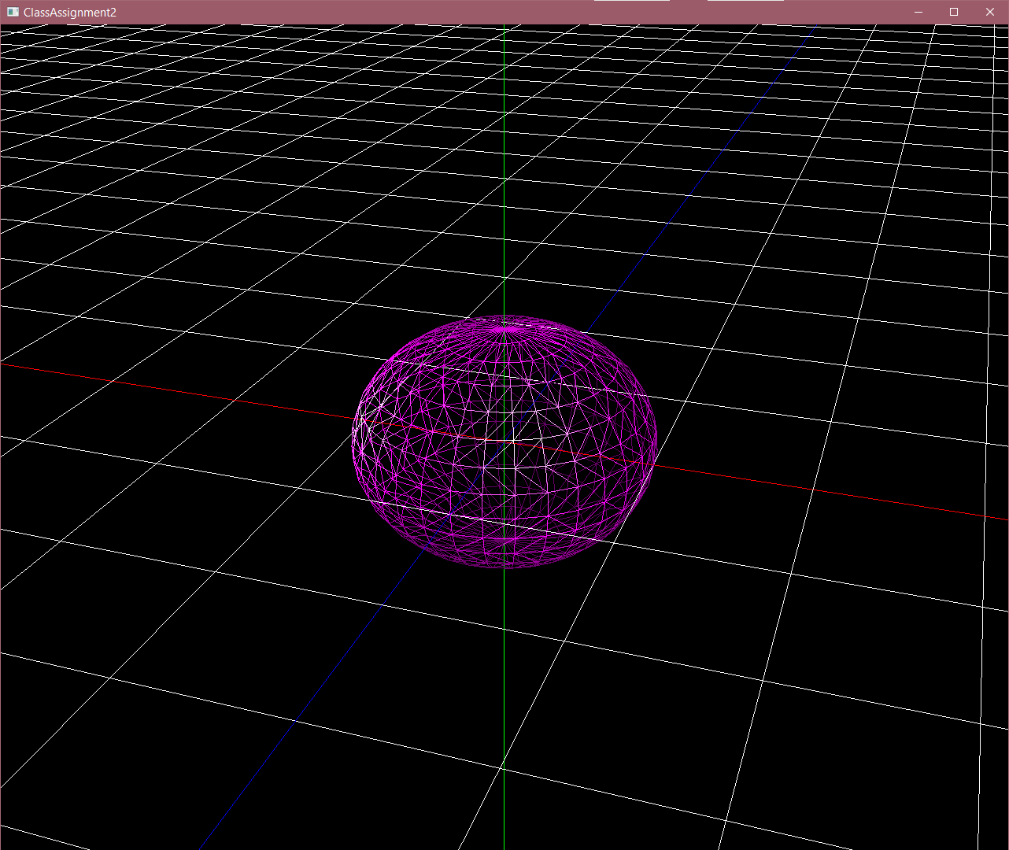

* 1. Load & render a mesh that does not have the same number of vertices of all polygons using glDrawArrays() or glDrawElements() (+10 pts)

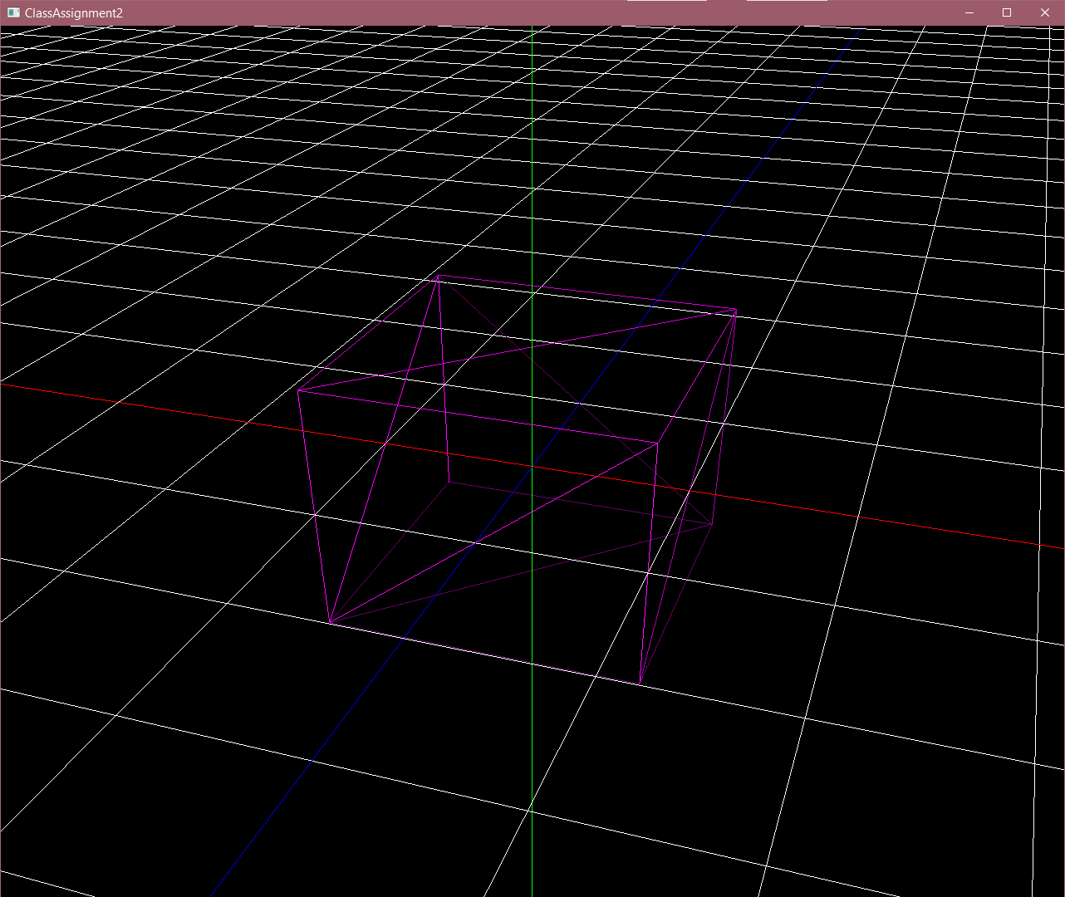 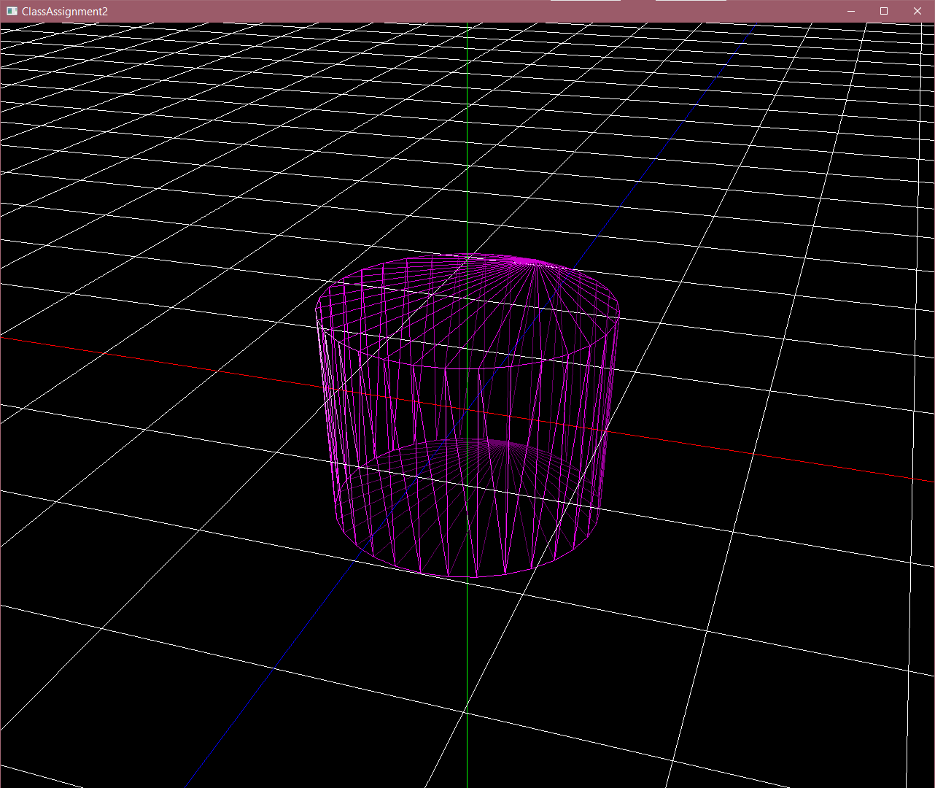 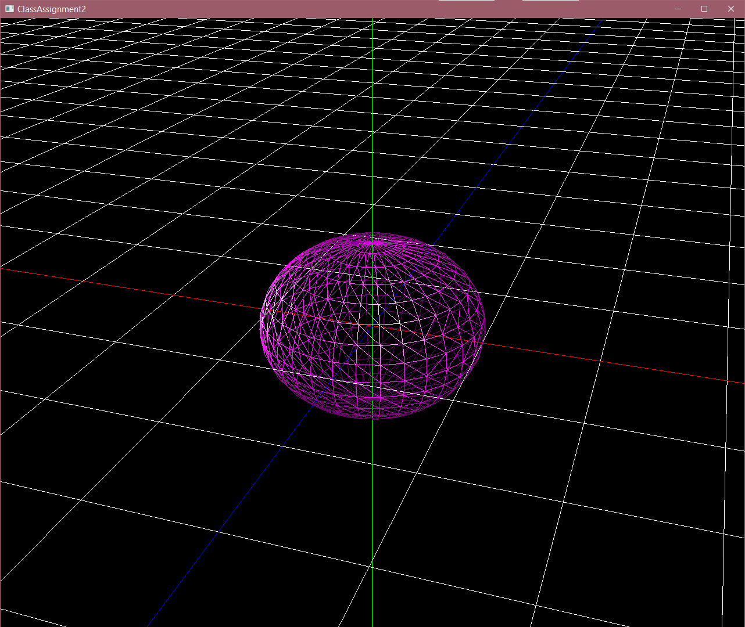

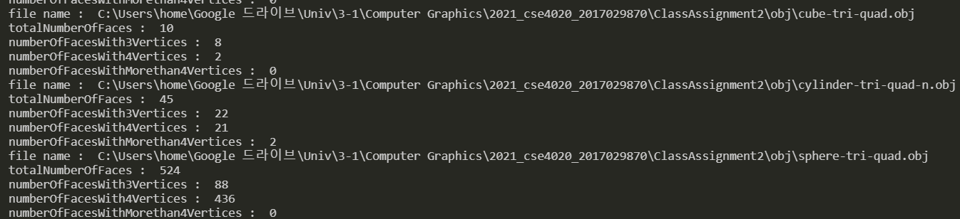차례로 cube-tri-quad, cylinder-tri-quad-n, sphere-tri-quad

1. A hyperlink to the video uploaded to Internet video streaming services (such as YouTube and Vimeo) by capturing the animating hierarchical model as a video (10 pts).
   1. <https://www.youtube.com/watch?v=3YkkPQo_g7U>
2. Lighting configuration (5 pts):
   1. How many light sources?
      1. 2 light sources
   2. Where do you put the light sources?
      1. lightPos = (3., 4., 5. ,1.)
      2. lightPos2 = (-3., 0., 0. ,1.)
   3. What is the type of each light source (point light or directional light)?
      1. LightPos = directional light
      2. LightPos2 = directional light