1. Which requirements you implemented
   1. Manipulate the camera in the same way as in ClassAssignment1 using your ClassAssignment1 code (10 pts).
      * + - Implemented
   2. Load a bvh file and render it (80 pts)
      1. Open a bvh file by drag-and-drop to your bvh viewer window (10 pts)
         * + Implemented
      2. 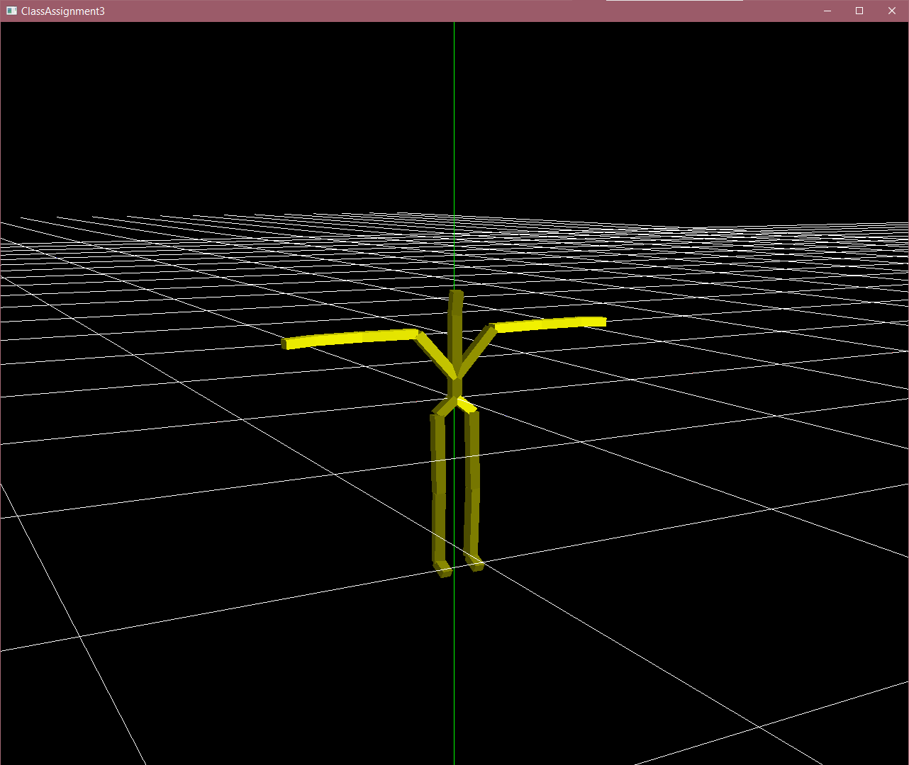Read the bvh file and render the “skeleton” (t-pose) of the motion when you load the file by drag-and-drop (30 pts).
      3. Animate the loaded motion if you press the <spacebar> key (30 pts).
         1. 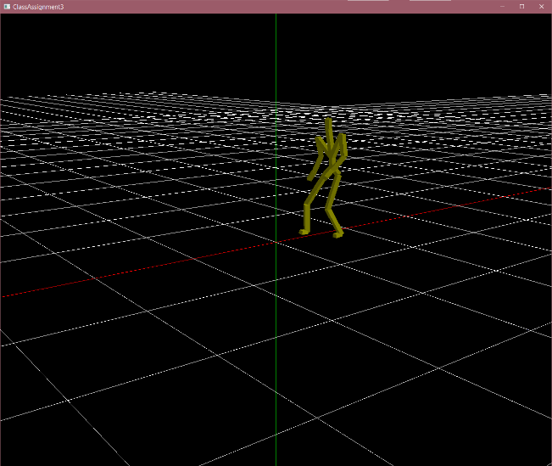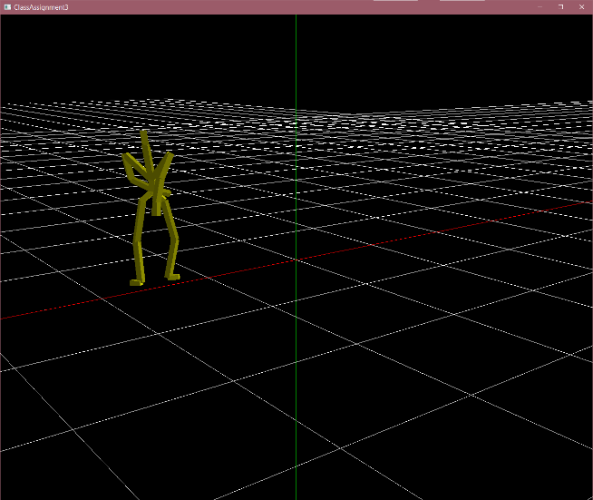spin
         2. 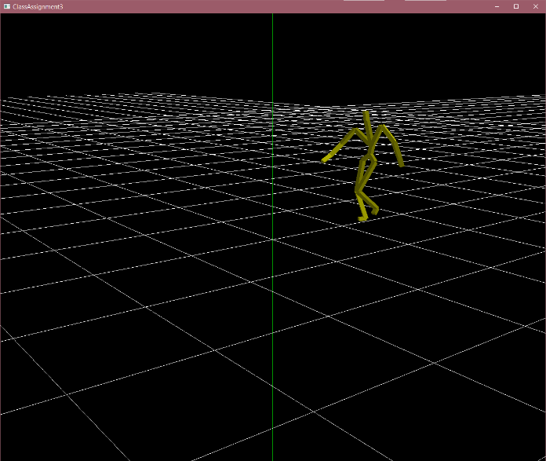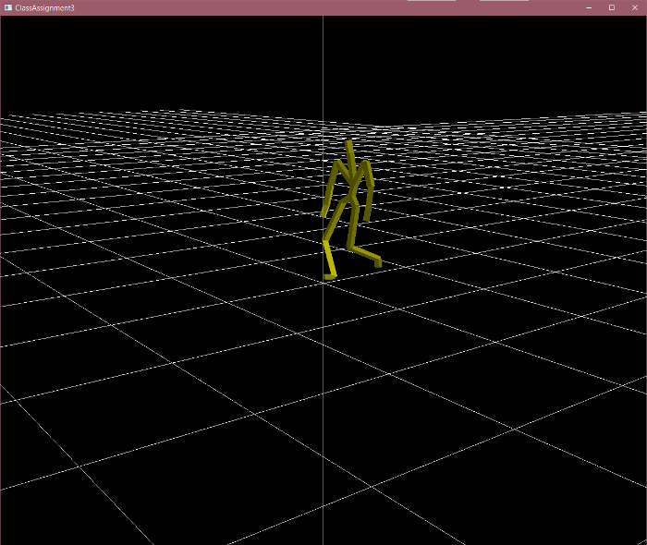Walk
      4. 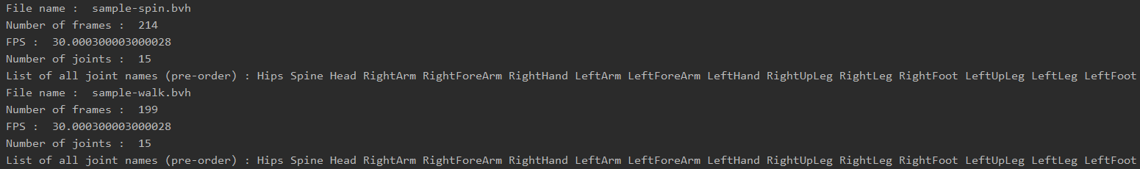When open a bvh file, print out the following information of the bvh file to stdout (console) (10 pts)
   3. Extra credits
      1. Use a box to draw each body part instead of a line segment (+10 pts).
         1. 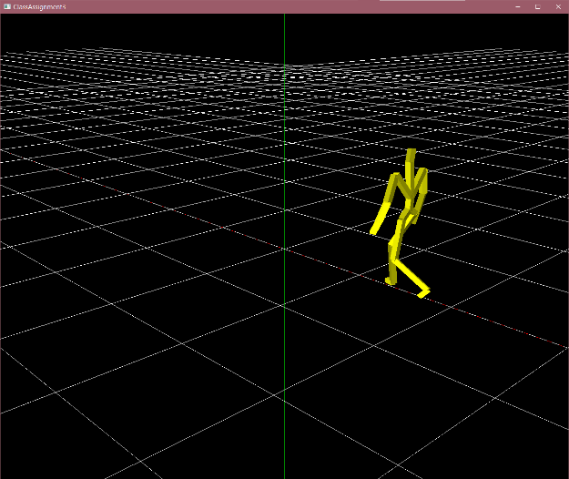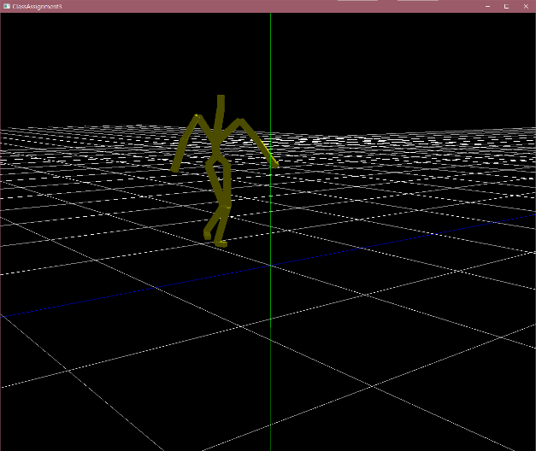Flat shading을 활용하였음
2. A hyperlink to the video uploaded to Internet video streaming services (such as YouTube and Vimeo) by capturing the animating hierarchical model as a video (10 pts).
   1. <https://youtu.be/hqVs3eyeYjg>