# Declaration

This is to certify that the work being presented in the project entitled “FARMBASE” submitted by undersigned students of Third Year B.Sc. in COMPUTER SCIENCE in partial fulfillment for the award of degree in Bachelor of Science {Computer Science} is a record of our own work carried out by us under guidance and supervision of Mr. Biomdo of the Department of Statistics and Computer Science and that this work has not been submitted anywhere else for the award of any other degree.

**Name of student: ____________________________________________**

**: ____________________________________________**

**: ____________________________________________**

**: ____________________________________________**

**: ____________________________________________**

**Registration Number: ____________________________ Sign: ……………**

**: ____________________________ Sign: ……………**

**: ____________________________ Sign: ……………**

**: ____________________________ Sign: ……………**

**: ____________________________ Sign: ……………**

# APPROVAL

This project was done and presented by us before the panel concerned on the 1st June 2017 at Moi University with our approval and that of our supervisor Mr. Biomdo.

**Name of student: ____________________________________________**

**: ____________________________________________**

**: ____________________________________________**

**: ____________________________________________**

**: ____________________________________________**

**Registration Number: ____________________________ Sign: ……………**

**: ____________________________ Sign: ……………**

**: ____________________________ Sign: ……………**

**: ____________________________ Sign: ……………**

**: ____________________________ Sign: ……………**

Name Supervisor: **Mr. Biomdo**

Signature: ____________________

# DEDICATION

All the work done in coming up with this system is dedicated to my group members for being a part of the whole process.

# ACKNOWLEDGEMENT

The satisfaction that accompanies that the successful completion of any task would be incomplete without the mention of people whose ceaseless cooperation made it possible, whose constant guidance and encouragement crown all efforts with success.

I am very grateful to my project supervisor Mr. Biomdo for the guidance, inspiration and constructive suggestions that helped us in the preparation of this project.

**CLARIFICATION OF TERMS**

Throughout the documentation the words Farmer,Seller and Buyer will be used to describe the general user of the application, whereas the words Admin, Administrator will describe the application user with administrative priviledges, the words consultant or agricultural extension officer will describe the user of application whose job is to give the general users advice on matters pertaining to farming through the application.

1. **Introduction and Background**

**1.1 Statement of Problem Area**

In our current society the farming sector has always endured tough times with improving technology and the ever infringing middlemen. The agricultural extension officer has always had to travel to the customer’s locality to give agricultural advice. The consumers too have always been affected by the middlemen since they usually don’t have an easier way to buy products directly from the farmers.

**1.2 Background**

**FARMBASE** was created because;

There has been a problem with access of information by farmers, farmers tend to plant their crops and keep their livestock without any advice from the agricultural extension officers and thus brings about low yields. The application solves this by allowing a farmer to send questions to the Agricultural extension officer asking for advice.

**1.3 Brief Project description**

Our project aims at benefiting the farmer and the consumer. The farmer can ask for agricultural advice from the agricultural officer and can also post his products for consumers and middlemen to buy and know their availability. The consumer, farmer and the agricultural extension officer create accounts in our online application.

**1.4 Objectives of Project**

The objectives of this project are;

1. Help farmers advertise their products.
2. Help farmers get help on nurturing their products from Agricultural officers.
3. Consumers get products they need easily.
4. Business men can buy goods from farmers in bulk.

**2. Literature Review**

**2.1 Previous and Current Work, Methods and Procedures**

In the past, the communication channels between the farmers, agricultural extension officers and the consumers has always been a hard task to accomplish. This has often given way to the rise of many middlemen whose aim is usually to “help” the three bodies in providing for their needs while enriching themselves. This has led to the falling economy in the country since its structure is based on the survival for the fittest. Farmers too have always had problems in reaching out to the Agricultural extension officers to help them with advising on the growth patterns and fertilizer usage on the different types of soil in a locality.

This involved too many procedures thus bringing a setback in delivering goods and services to the consumers and increase in prices in the process. It’s not every day that one can order farm products from his/her phone or their computers and also not every day does a farmer get to be answered when he or she has a question and is logged on.

Most researchers have conducted researches involving the introduction of technology in the farming sector. It’s about time we brought farming at per with technology and in so doing we`ll be improving the business of farming and as an economy too.

According to the Food and Agriculture Organization of the United Nations, the world population will reach 9.1 billion by 2050, and to feed that number of people, global food production will need to grow by 70%. For Kenya, which is projected to be home to about 55 million people by then, farm productivity must accelerate at a faster rate than the global average to avoid continued mass hunger. This can be achieved by educating farmers to grow crops that are suitable for their environment and use suitable manure. This can be easily done using our online application through Agricultural extension officers.

In an attempt to build any software system that follows the required standards by the client, it’s necessary to follow certain software development rules. Thus software development process models which we used in our project will be discussed here.

All models follow the basic foundation as follows:

*Planning*: This is the initial evaluation of the software to be developed or in most cases; it is an attempt to upgrade an existing system.  
*Requirement Analysis and Specification:* In this stage, the problem the new system is identified; its operational capabilities are defined and the resources needed for the system and maintenance goals are set. (M.Ridley, Requirement analysis and specification, 2006)  
*Functional Specification or Prototyping*: The computational aspect, relation and attributes of the software system are identified. Also, the operations that will transform these objects along with the constraints of the system behaviors are considered at this point. (Archer, P. Personalized Access to Cultural Heritage Space. Project, 2009)  
*Architectural Design and Configuration Specification*: The interconnection between all the component and modules of the system are defined in such a way that they meet the detailed design. (Bersoff, E. H. (1984).)  
*Detailed Component Design Specification*: This is the stage in which the modules of the defined component are transformed from required inputs into provided outputs. (Spriestersbach, A. Resource development and Management, 2011) 5  
*Component Implementation and Debugging*: codifies the preceding specifications into Operational source code implementations and validates their basic operation. (P. Graham, B. Nelson, and B. Hutchings, 2001)  
*Software Integration and Testing*: This is the stage where integrity of the software system configuration is tested and verified for consistency and completeness. All developed modules, interfaces and resources are verified against their specification. (Goa, J. San Jose state University, 2002)  
*Documentation Revision and System Delivery*: At this stage, the technical know-how of the developed soft-ware system is documented as user’s guides. (Goa, J. San Jose state University, 2002)  
*Deployment and Installation*: Installation of the software system into local computing environment, operating systems configuration and diagnostic test cases to ensure the workability of the system is done at this stage. (Goa, J. San Jose state University, 2002)  
*Training and Us*e: Providing training support for the users of the software system is as important as the development of the software system itself, since the user of the system needs to have a good under-standing of the system itself. (Goa, J. San Jose state University, 2002)  
*Software Maintenance*: Maintaining the system in the environment in which it is created for is also an important aspect that must be taken into consideration. (Goa, J. San Jose state University, 2002)

For us we used the iterative software development process.

This model is developed in response to the shortcoming of waterfall model. It does not start with full specification requirement of a project, rather specify and implement some part of the software one at a time in other to review it at every step along the line to identify any further requirement. These processes have to be done again and again to produce a new requirement 8 version for the software and as shown in the figure below, the process starts with the initial planning, and then moves further to the real planning stage before the requirement stage. (Larman, C. & Basili, V (Dr). History of Iterative and Incremental Model 1980).Iterative development divides the deliverables into different stages. Within each stage, functionality is implemented using the cross-discipline work, which actually starts with the identification of the model to execution. (Larman, C. & Basili, V (Dr). History of Iterative and Incremental Model 1980).

**Iterations models follows the phases listed below:**  
**Inception**: In this phase, the scope of the project, requirements for functional and nonfunctional parts included.  
**Elaboration**: Complete detailed assessment of the project which includes risk assessment  
**Construction**: This phase is the most important and delicate part of the project because at this stage, the architectural part with the already written code from the analysis, designs, implementation and testing are incrementally inscribed into the project.  
**Transition**: The last phase of the project is the point where the system is facilitated with the operation environment each of the aforementioned phases can be illustrated in single or multi-face iterations. These iterations are mainly time-bound instead focused on features. The role of the experts is clearly allocated and distributed, that is architects and analysts assess and write out the iteration leaving the work-product backlogs to developers and testers.

**4 System Performance Requirements**

**4.1 Efficiency**

**On a Pentium 4 dual core processor computer with 1 Giga Byte of RAM:**

* The application’s heaviest page takes 14.9 seconds to load 5.3 Mega Bytes of data, and make 29 HTTP requests to the server on a good 3G network.
* DOM content is loaded in 2.6 seconds

**On a core i5 dual core processor computer with 4 Giga Bytes of RAM and two virtual cores:**

* The application’s heaviest page takes 6.2 seconds to load 5.3 Mega Bytes of data and make 29 HTTP requests to the server on a good 3G network.
* DOM content is loaded in 0.8 seconds

Using this data we found out that our application is slightly below Google’s performance metrics for web applications

<https://developers.google.com/web/fundamentals/performance/rail>. This difference is mostly caused by the delicate balance between optimization of user uploaded images and keeping their quality.

**4.2 Reliability**

The web application is reliable, that is it can be online for a long time without needing maintenance. However the site’s maintenance needs to be done manually, when this occurs user will be notified in advance just in case the site needs to be down for a period of time.

**Accuracy and Precision**

The web application is accurate in terms of associating users with their posts or availing to users data on the selected posts.The software solves user problems precisely and accurately. This is based on user feedback from 7 randomly selected users from the university.

**Consistency**

The web application has consistency in the user interface, feedback messages and also error handling.

This consistency ensures users develop quick familiarity with the application so as to solve their problems more efficiently.

**Reproducibility**

The web application is consistent hence actions will almost always have the same result over and over again and exceptions are handled in the same way throughout the application that is by showing error messages on the user interface.

**Acceptable Failure Rate**

The acceptable failure rate is about 30%. This is due to the fact that there’s limited hardware resources for hosting the web application and our lack of asynchronous running of tasks which might lead to failure of the system given a high enough traffic to our servers

**4.3 Security**

**Hardware security**

The hardware security is ensured by the hosting company. The user however will have to secure their own hardware while using the software.

**Software security**

The biggest threat to this application system is attacks against its software component . The software is protected against:

1. Cross Site Request Forgery (CSRF) attacks by embedding a CSRF token along each HTTP request, therefore making it harder for attackers to perform successful attacks.
2. SQL injection by using the version 5.9.* of PHP which protects the application against such an attack.

**Data Security**

The data we collect from users will not be disclosed to third parties unless the law of the country compels us to do so.

The users passwords are hashed which makes their accounts more secure.

**Execution Security**

Users have to be authenticated and verified before using the software system

**4.4 Maintainability**

The system is maintainable because it is modularized and the module interfaces are well defined. The source code has a consistent coding style that would be easy to read and in turn debug or update.

**4.5 Modifiability**

The system’s code base can be easily modified without breaking any of the core functionalities this because of the use of object oriented programming techniques.

The user interface styling is modular therefore components can be swapped without much overhead.

**4.6 Portability**

The system can run on any operating system since it is a web based application. It can run on most modern browsers. Older browsers are supported through fall back code.

**5. System Design Overview**

The system has been designed to be easy to use hence the most important functions can generally be categorized into read function, create functions, delete functions and delete functions.

**5.1 System Data Flow Diagrams**

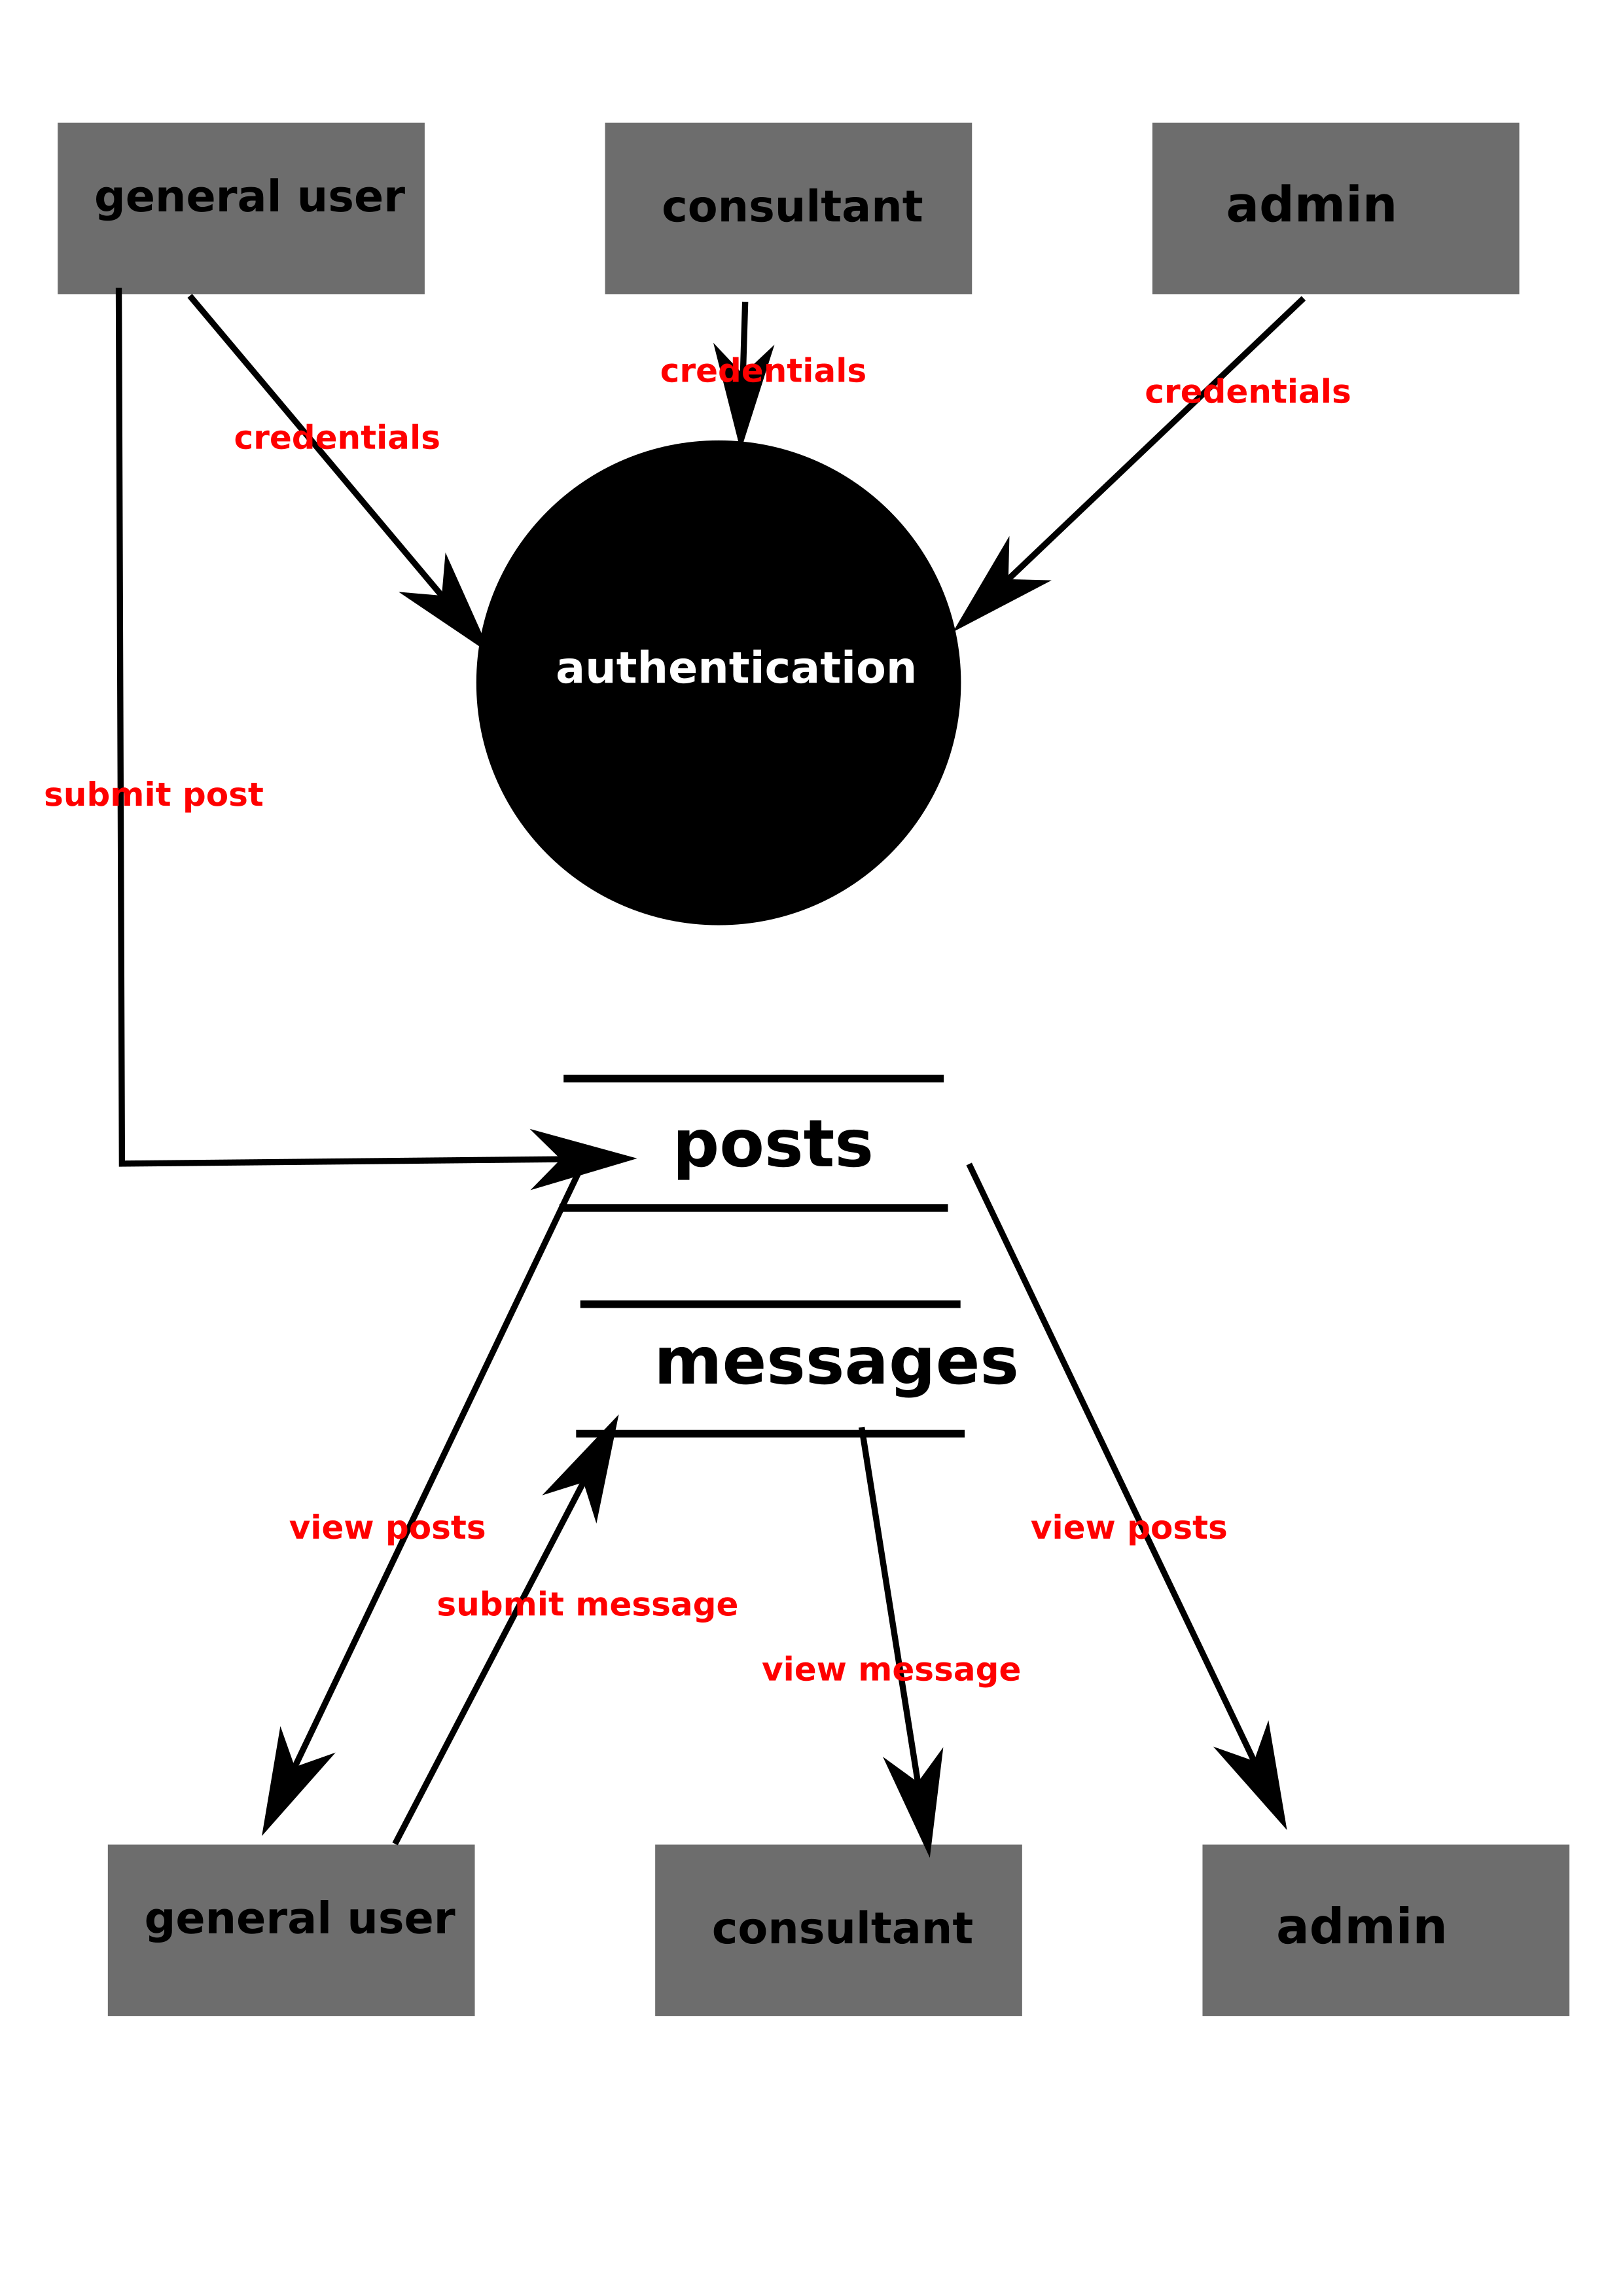*posts data diagram*

**5.2 System Architecture and Structure**

The software system is designed around simplicity. The system core functions are to read, update, delete and create records. The system also has a front end that serves to present organized data to users such as the farmer, consultants and the administrator.

The structure of the application system is such that it include:

* Authentication subsystem
* Messaging subsystem
* Post listing subsystem
* Post favorite subsystem
* Administrator panel subsystem

**5.3 System Data Dictionary**

|  |  |  |  |
| --- | --- | --- | --- |
| **ATTRIBUTE NAME** | **REQUIRED** | **ATTRIBUTE TYPE** | **ADDITIONAL DESCRIPTION** |
| Name | YES | String/VARCHAR | User name |
| Email | YES | VARCHAR | User email |
| Phone | YES | VARCHAR | User phone number |
| Location | YES | VARCHAR/String | User location |
| Post title | YES | String/VARCHAR | Describes product |
| Post description | YES | String/Long Text | Describes product |
| Post image | NO | Media | Post image |
| Post ID | YES | Integer/Look up | Relates post with other entities |
| Read status | YES | Boolean | Marks a message/notification as read |
| Message | YES | String/VARCHAR/Long text | Makes up the body of a notification message |
| Password | YES | VARCHAR | User password |
| Product Category | YES | String | Used to categorize user posts |
| Time stamp | YES | Timestamp | Used to record time |
| Favorite | NO | Boolean | Used to mark a post as favorite |

**5.4 Description of System Operation (high level)**

* The application run on a browser platform. The browser is the interface between the application and the operating system.
* The application enables one to place an advertisement online. To be able to associate the advertisements with users an authentication subsystem is in place to make sure that a user has the right permissions to advertisement posts.
* The application includes a database. This database stores entities such as user posts, user details, consultant details, user messages and notification.
* The application has a post listing module which is used to gather relevant posts and display them to the user.
* The administrator oversees most of the activities in the system operation.

**5.5 Equipment Configuration (diagram and description)**

The system has to access the Internet for it to work as intended

**5.6 Implementation Languages**

1. PHP, it is a server side language that is supported by most web hosting companies it is also easy to learn and implement.
2. MySQL, it allows combination, extraction, manipulation and organization of data in the voters’ database. It is platform independent and therefore can be implemented and used across several such as Windows, Linux server and is compatible with various hardware mainframes. It is fast in performance, stable and provides business value at a low cost since it is open source.
3. SQL, it is a database querying language that has been used to record, read, update and delete records from the database.
4. J Query, it is a JavaScript library that makes DOM manipulation easier and convenient. It aim at reducing the code written to perform common tasks. This reduced our front end development time considerably.
5. HTML, This is currently the core of the web world, it is a language used to makeup web page. It is the glue that holds everything together. Although HTML was used for the implementation of the software, it is highly compatible with extensible HTML (XHTML) which is designed to be a replacement of HTML made to handle data and is also portable between different browsers and platforms with little or no alterations in code
6. CSS3, the user interface for the software has been styled using CSS. CSS3 is used because it is supported by most browsers.

**5.7 Required Support Software.**

1. Apache, it is a server software without which the back-end of the software system will not work.
2. Browsers, it is the platform upon which the web application will run.

**6. System data structure specification**

**6.1 User Input Specification**

**6.1.1 Identification of input data**

User Input includes the following data types:

* Personal Details
* Advertisement Post details
* User location details
* User contact details

**6.1.2 Source of Input data**

Sources of input data include:

* Administrator
* Client input
* Google location data

**6.1.3 Input Medium**

Input medium for the application will be personal computers’ and mobile devices’ keyboards, mice and screens.

Input medium for Google location data will be Google location API.

**6.1.4 Data format**

Different data types will have different formats

* Personal Details

Email: emails have to match against a regular expression for email to be valid.

Name: name will be a string and it will be required for account creation

Phone Number: phone number has to be an integer to be valid

* Location Details

Location: location will be a string and will use Google maps API format will be in JSON

* Advertisement Post details

User ID: this is an integer foreign key that associates a user with the advertisement they have posted

Title: it is a requirement for creation of the advertisement it has to be a string

Description: it is a requirement for creation of the advertisement it has to be a string

Image: it might be either png or jpeg format

* Authentication Details

Password: they are required for authentication they might be either integer or string format; dependent on user preference.

* AJAX requests data

AJAX requests will use JSON to pass data to the back-end PHP code.

**6.2 User output specification**

**6.2.1 Identification of output data**

Output data will include:

* database query results
* Personal Details
* Advertisement Post details
* User location details
* User contact details

**6.2.2 Output devices**

Output devices include:

* personal computer and mobile devices screens and monitors

**6.2.3 Output format**

Output will include:

* collection of arrays from database querying results
* collection of JSON format data for the AJAX request responses
* collection of image files

**6.2.4 Output interpretation**

* Collection of arrays from database querying results will be parsed into the front-end HTML this will be interpreted as user posts, application user lists, location data.
* Collection of JSON format data will be parsed by the JavaScript front-end libraries. This will interpreted as user posts, application user lists, location data.
* Collection of image files will be interpreted as user posts images, user profile images and GUI styling images.

**6.3 System Data Base/File Structure Specification**

**6.3.1 Identification of Data Base/Files**

The database contains 10 tables as shown below.

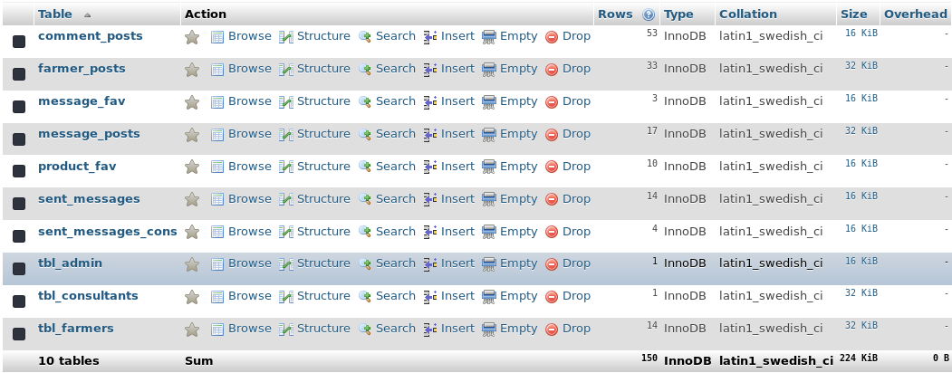

|  |  |
| --- | --- |
| **TABLE** | **FUNCTION** |
| comment_posts | It stores the comments associated with blog posts |
| farmer_posts | It stores the user advertisement posts |
| message_fav | It associates the blog posts with the user favorite mark |
| message_posts | It stores user notification messages and associates the message with the sender, recipient and the advertisement post |
| product_fav | It associates the product posts with the user favorite mark |
| sent_messages | It stores and associates user notification messages with the sender and recipient |
| sent_messages_cons |  |
| tbl_admin | It stores application administrator details |
| tbl_consultants | It stores consultant details |
| tbl_farmers | It stores the general user’s details |

**6.3.2 (Sub)systems Accessing the Data Base (creating, updating, deleting and reading frequency)**

The subsystem accessing the database include:

* Authentication Subsystem

This subsystem creates records and reads the database it however does not update nor delete records from the database. The frequency of the subsystem’s interaction is at most twice per session.

* User Account Configuration Subsystem

This subsystem reads and updates the database the frequency of access is user dependent therefore hard to measure

* Post Display Subsystem

This subsystem only reads from the database. The frequency of access for this will depend on number of users currently logged on to the application.

* Administrator Panel Subsystem

this subsystem can read,write,update and delete from the database. The frequency of access to database is very high considering it takes data from other subsystem.

* Favorite subsystem

It can read , create and update the records in database. Frequency of access is dependent on the users’ preferences and it is high.

**6.3.3 Logical File Structure (record formats, file organization, access methods, rationale)**

The database is organized as shown below:

|  |  |  |
| --- | --- | --- |
| **TABLE** | **RELATIONSHIP** | **TABLES RELATED** |
| comment_posts | One to Many | farmer_posts |
| message_fav | Many to Many | tbl_farmers, message_posts |
| message_posts | One to Many | tbl_consultants |
| product_fav | Many to Many | farmer_posts, tbl_farmers |
| sent_messages | One to Many | tbl_farmers |
| sent_messages_cons | One to Many | tbl_consultants |
| tbl_consultants | One to Many | message_posts |
| tbl_farmers | One to Many | farmer_posts,sent_messages |

Record formats include:

VARCHAR – variable characters

INT – integers

BOOLEAN – true or false value

LONGTEXT -for long posts

TIMESTAMP -for recording unique time

The application logic is modularized into classes while the user interface has been categorized under views for easier debugging and readability.

**6.3.4 Physical File Structure**

The database is stored in remote server provided by a web hosting service provider. The application logic is under the sub-domain Farmbase in the domain [venturezhub.com](http://www.venturezhub.com/).

**6.3.5 Data Base Management Subsystems Used (internal or external)**

The application uses MySql as its database management system, it also has a separate database configuration PHP file for handling database authentication. Database queries are employed as needed throughout the application.

The phpmyadmin application is the GUI for our database management system.

7.1 **Notification**

**7.1.1 Module functional specification**

**Functioned performed**

This module displays farm products posted by seller to the interested consumer.

It also displays information or comments posted by Agricultural Exxtension Officer about advices on the good farm produce.

**Module interface specification**

The input/output and arguments used are:

1. Name of product- in this text field you instert the name of the product you want to post as a string
2. Description of the product-the seller describes the produce he/she wants to post.
3. Category of the product-the seller choses in which category does the farm produce fall in.this can be
4. Feeds Supplements and seeds.
5. Farm Machinery And tools.
6. Livestock Poultry And Fish
7. Farm Produce
8. Location-in the text field you indicate the greographical place that you are in so as the buyers can know.

Product image-the seller uploads the image so as it can appear at the home page for it to be viewed.

**Module limitation.**

1. You cant see the notifications unless you have registered and logged in into the correct account
2. Notifications only appears into users account.

**7.1.2 Module Operation Specification.**

**Locally Declared Data Specification**

The local data variables that have been declared in here is the category section and they include.

1. Feeds Supplements and seeds.
2. Farm Machinery And tools.
3. Livestock Poultry And Fish
4. Farm Produce

**Algorithm Specification**

1.Start

2.Seller/officer post data

3a.Post rejected and redirected

Stop

4.Post notification output

**Description of module operation.**

Use case1: Seller /Agricultural Extension Officer post data to be viewed.

Mainflow(seller/ Agricultural Extension Officer)

1. The user starts the web application
2. User input data and hits submit button.
3. System sends data to Admin panel to be filtetred .
4. Admin verifies post
5. System sends verified post to the notification
6. stop
7. Alternative 3a:

* System notifies user post is rejected and redirects user to main flow 2

**7.2 Messaging.**

**7.2.1 Module Functional Specification**

**Function performed**

This module notifies the seller that there is an unread message for him in form of a notification

The module displays the information in form of a text.

**Module Interface Specification**

The input/output and arguments used are:

* Full names: In here you provide your full names as you want them to appear on the recipient end.
* Email address:you provide your email address incase of further contact with the seller
* Phone no:the buyer inputs his phone number incase the seller wants to call him personally in regards to the product

Message:the buyer inputs his information which is to be sent to the buyer about the product that has been posted.

**Module limitation.**

1. Buyer cant send a message unless you have registered and logged in into the correct account
2. Onces the message has been send cant be stopped in transition.

**7.22 Module Operation Specification**

**Locally Declared Data Specification**

There is no any locally declared data in this module

**Algorithm Specification**

start

Consumer writes message to notify seller

Seller hits the send button

4 system sends message to the person

stop

**Description of module operation.**

Use Case2: Consumer sends messageto the seller who posted the produce ad.

Mainflow: (seller/buyer)

* User starts the web application.
* User writes the message on the text area.
* User hits the send button
* System sends the message to the desired person
* stop

**7.3 Search**

**7.3.1 Module Function Specification**

**Function performed**

This module allows user to have easy time since the buyer can search the product by using the first name from the glyphicon search

**Module Interface Specification**

The input/output and arguments used are:

Glyphicon _search-the user is able to input his/her name product and can easily access the product since the system produce a variety of product which have the same letter as used in search button.

**Module limitation**

* The search button only accommodates the products in the web application.
* The farm product can be so many hence finding the algorithm to suit all product can be difficult to implement

**7.3.2. Module operation specification**

**Locally declared data specification.**

There is no any locally declared data in this module

Algorithm specification

1.Start

2 buyer inputs the name of the product

3. buyers input are filtered by the system

4. buyers search is output

3a. buyers input is rejected and redirected.

4.Stop

**Description of module operation.**

Case 3: Buyer searching for products on the web page.

Main Flow(buyer)

* Buyer starts the application
* Buyer inputs name on the search button
* Buyers search is filtered by the system
* Buyers search is displayed
* stop

Alternative 3a:

* System displays nothing on the search button
* System redirects buyer to main flow

**7.4 Register**

**7.4.1 Module Function Specification**

**Function Performed**

The user is able to create an account so as he can access the services of the web application like posting,receiving notification etc.

**Module Interface Specification**

The input/output and arguments used are:

* Full names (var-char)-user inputs his/her full names that would aappear in his account.
* Email(var-char)-user inputs his/her email in the coreect format
* Phone number(int)-user input his/her phone number so as to be contacted whenever he/she post product on the application
* password(var-char)- user inputs his/her secret password that he will use whwnwver he is accessing his account.
* Confirm password(var-char)-user repeats the password for security measures

**Limitation**

* One must fill all fields before signing up.
* Agree to terms –user must check the check box before sign up.

**7.4.2Module operation specification**

**Locally declared data specification.**

There is no any locally declared data in this module

Algorithm Specification

1.Start

2 user inputs his/her credentials

3a credentials are rejected and redirected

3.users credentials are filtered by the system

4.user is directed to his home page

4.Stop

**Description of module operation.**

Case 4: user registry on the web page.

Main flow(buyer,seller and agricultural extension officer)

* User starts the web application.
* User registers to the application.
* Users credientials are filtered by the system for security
* User is directed to his home page.
* Stop

Alternative 3a:

1. Users credientials are rejected and redicted

**7.5 login**

**7.5.1 Module Function Specification**

**Function Performed**

Allows user to have access into his own account so as to view the cutrent products in the market,post his/her products and also receive notification.

**Module Interface Specification**

The input/output and arguments used are:

1. Email (var-char)-user inputs his/her email in the correct format in the text field provided.
2. Password(var-char)-user inputs his/her password that he used during registering so as to be redirected to his own home page.

**Limitation**

1. User cant login with another email address or password that he/she didn’t use during registering.
2. User cant login with any other details he?she is limited to email and password

**7.5.2** **Module operation specification**

**Locally declared data specification.**

There is no any locally declared data in this module

**Algorithm Specification**

1.Start

2 user inputs his/her login credentials

3.users login credentials are filtered by the system

4.user is **directed** to his home page

4.Stop

3a. system rejects credentials and user is directed to his home page

Case 5: user login

Main flow(buyer,seller,agricultural extension officer)

1. User launches the web application
2. User inputs his login credentials
3. System filters the credentials entered by the user
4. User is directed to his home page
5. stop

Alternative 3a:

1. System rejects credentials and redirects to step 2.

**7.6 logout**

**Module Function Specification**

**Function performed**

User is able to leave his own web page without leaving the page online and hence somebody else accessing the page.

**Module Interface Specification**

The input/output and arguments used are:

On the users navigation bar there is a dropdown where when clicked user just signs out with a lot of ease.

**Limitation**

1. Once signed out you cant access the apge until you login again with the correct credentials.

**7.6.2 Module Operation Specification**

**Locally declared data specification**

There is no any locally declared data in this module

**Algorithm specification**

1.Start

2 .user click on on the dropdown on the nav bar

3user is logged out

4.system directs user to a default home page

4.Stop

Case 7: user log out

Main flow(buyer,seller and agricultural extension officer)

1. Users launches the web application
2. User clicks on the dropdown menu to on navbar to acces the logout button
3. User clicks the logout button
4. System directs user to a default home page
5. Stop

**7.7 Favourite**

**Module Function Specification**

**Function performed**

This module helps user to favourite am post ad that has been posted by the seller.It helps the seller to know how many people really have interested in their products.

**Module Interface Specification**

# 8 Testing

Software testing is done to verify that the completed software package functions according to the expectation defined by the specifications. The core purpose for testing is to detect the software failures so that they are corrected and perfected . It also helps to identify any situations that can impact negatively the user under specific conditions. The scope of software testing involves the examination of code during execution and what sort of errors it displays.

This is a software development process in which the smallest modules parts are individually and independently tested to check wheather they are properly working.

## 8.1 Unit Testing

|  |  |  |  |  |
| --- | --- | --- | --- | --- |
| Test type | **Name of module** | **objective** | **result** | **Percentage success rate** |
|  | Notification module | This module displays farm products posted by seller to the interested consumer | Enhance easy communication between the buyer and the seller | 95% |
| Messaging module | This module notifies the the seller that there is unread message for him inform of a notification | Helps the seller to know how his/her products are fairing on on the web application | 93.3% |
| Search module | This module displays all products available when searched | Makes it easy for buyer to look for products as quick as possible | 92.9% |
|  | Register module | User is able to create his personal account in the web application | User can access services of the web application like posting products,buying products and receiving notification | 94% |
|  | Login module | Allows user to have access into own account | User is able to view the current product in the market,post his/her products and receive notification | 92.8% |
|  | Logout module | User is able to leave the page without any difficulty |  | 91.4% |

**8.2 8.3User acceptance testing:**

**8.4 Local farmer selling platform**

The sample size that the researcher had conducted were 100 people out of the targeted population of 120 all being local farmers and agricultural extension officer. The number of those who responded over the user acceptance test were 100 translating to 83.3% who fill the questionnaire and the other 26.7% did not responded to the questionnaire. This made us through the acceptance test to know how to gauge the application

This was investigated by asking the local farmer whether the online portal in theapplication module has meet its objectives,core functionality and its efficiency in monitoring of the local farm produce and enhancingselling of the same. The response from the local farmer were presented in a graph as shown below

The analysis of figure shows that 83.3% of the respondent said that the online module portal is good, 33.3% said the online module portal is average of the module while 8.3% of the respondent said the online module portal is bad.

**Overall user interface on the online portal**

The local farmer and the agricultural extension officer were then requested to comment on the entire system interface by filling in the questionnaire posted to them. The results were recorded by our developers and presented in a graph as shown below.

From the figure below, the results show that 94.4% of the local farmer and agriculture extension officer are satisfied with the user interface and feel that overall design of the system, is good 38.8% of the local farmer and agriculture extension said the online portal isaverage of the entire system interface design and5.5% of the local farmer and agriculture extension said the online portal is bad of the entire system design interfaces.