TE/IT/A-1
1114003 Abhilasha S. Lahigude.
1114018 Charmi A. Patel .
Exp. 1: PROBLEM DEFINITION
PROPERTY MANAGEMENT SYSTEM
This is a basic system that will keep record of housing properties available on rent or for sale, and will work as connecting bridge between customer and property sellers.
Due to this system there is no need to visit various places in search of desired property. The information of various properties in various locations can be accessible at one place.
This system will provide a platform to home line property sellers and buyers. This will keep record of land, houses or flats available for sale or on rent with their rates and make this available to customers. Also will keep record of contact information of customer and will send necessary notices and/or reminders to customer.
Exp. 2: REQUIREMENTS ANALYSIS
FUNCTIONAL REQUIREMENTS:
- Register.
- Validation.
- Keep clients record.
- Add property details.
- Provide the list of properties with necessary information.
- Loan options.
- Payment options.
- Special offers.
- Book appointment.
- Accept suggestions.
NON-FUNCTIONAL REQUIREMENTS:
- Improve the search facility and all users of property management system should get all the information in a second.
- The application should support the capability to use multi usre environment.
- Display search result in one second.
- Update the list every hour.
- System should be available 24*7.

Exp. 3: USE CASE DIAGRAM

Exp.4: STRUCTURAL DIAGRAM
CLASS DIAGRAM:
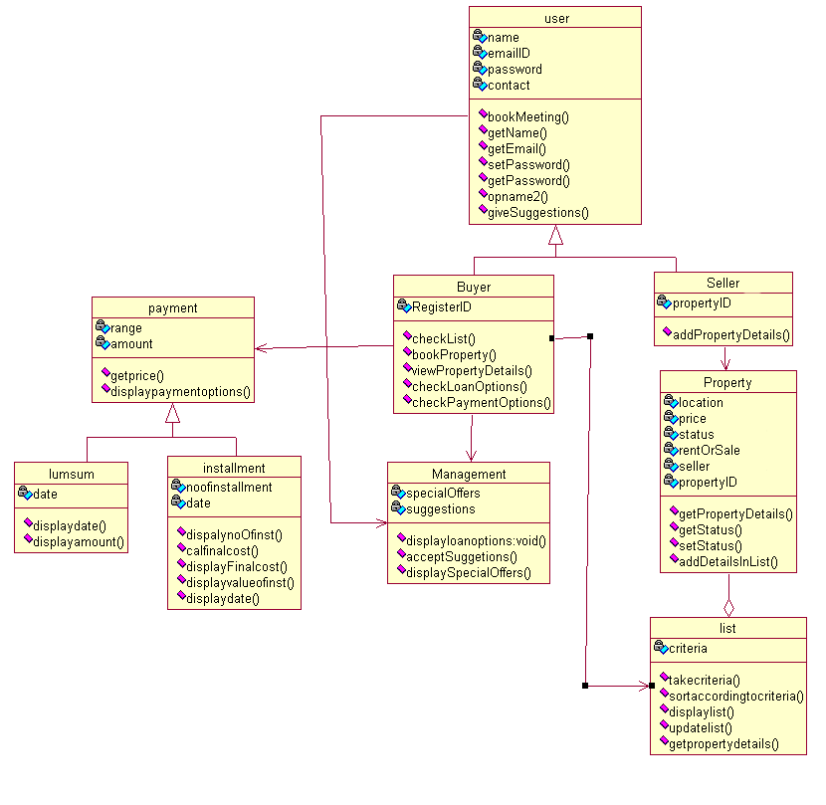

OBJECT DIAGRAM:

Exp.5: INTERACTION DIAGRAM
SEQUENCE DIAGRAM:
COLLABORATION DIAGRAM:
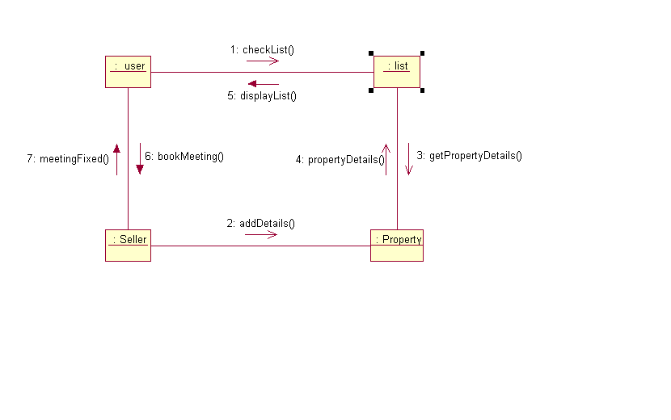

Exp.6: BEHAVIORAL DIAGRAM
STATE DIAGRAM:
ACTIVITY DIAGRAM:
Exp.7: ARCHITECTURAL DIAGRAM
COMPONENT DIAGRAM:
DEPLOYMENT DIAGRAM:
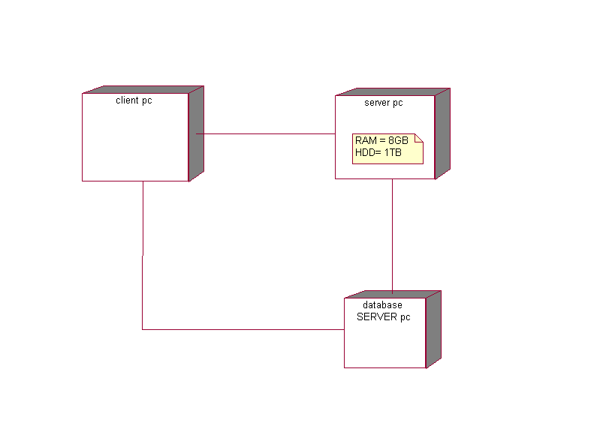
Exp.8: OBJECT MODEL TO DATABASE SCHEMA
INHERITANCE
Property
NAME | location | ID | TYPE | STATUS | OWENER | PRICE
AJAY | ANDHERI | D123 | RENT | AVAILABLE | ABHILASHA | 40,000
ASHOK | MULUND | D456 | SALE | SOLD | CHARMI | 50LAKHS
NOTE: ID is the primary key

MANY TO MANY RELATIONSHIP
CUSTOMER
NAME | EMAIL | CUSTOMER ID
PINKY | PINKY@GMAIL.COM | V85
MINKY | MINKY@HOTMAIL.COM | V86
NOTE: CUSTOMER ID is the primary key
SELLER
NAME | EMAIL | SELLER ID | PROPERTY
DR.PATEL | PATEL@YAHOO.COM | D78 | PARADISE
DR.SMITA | SMITA@GMAIL.COM | D83 | TAPASYA
NOTE: SELLER ID is the primary key
LINK TABLE
CUSTOMER ID | SELLER ID
D78 | V85
D83 | V86

Exp.9: USER INTERFACE DESIGNE
PRINCIPLES APPLIED IN USER INTERFACE:
- Do not rely on usability guidelines – always test with users.
- Base UI design on user task.
- Ensure that the sequence of action to achieve a task are as simple as possible.
- Ensure that user always knows what he or she can and should do next.
- Provide good feedback encoding techniques.
- User understandable encoding techniques.
- Consider the needs of different groups of user.
- Be consistent.

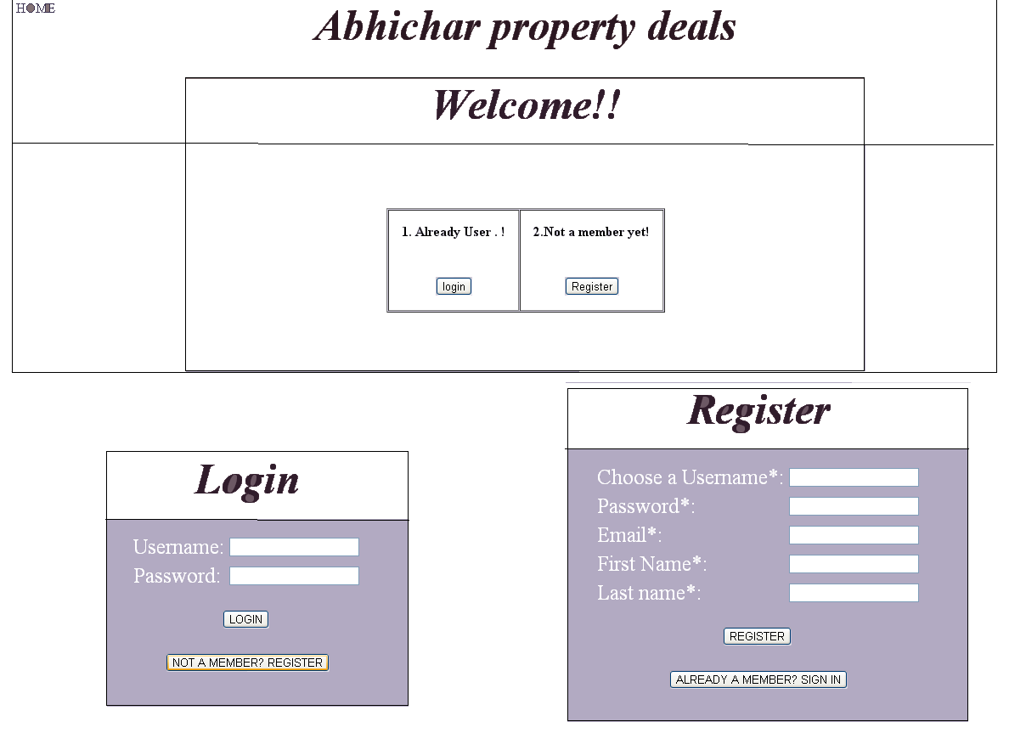
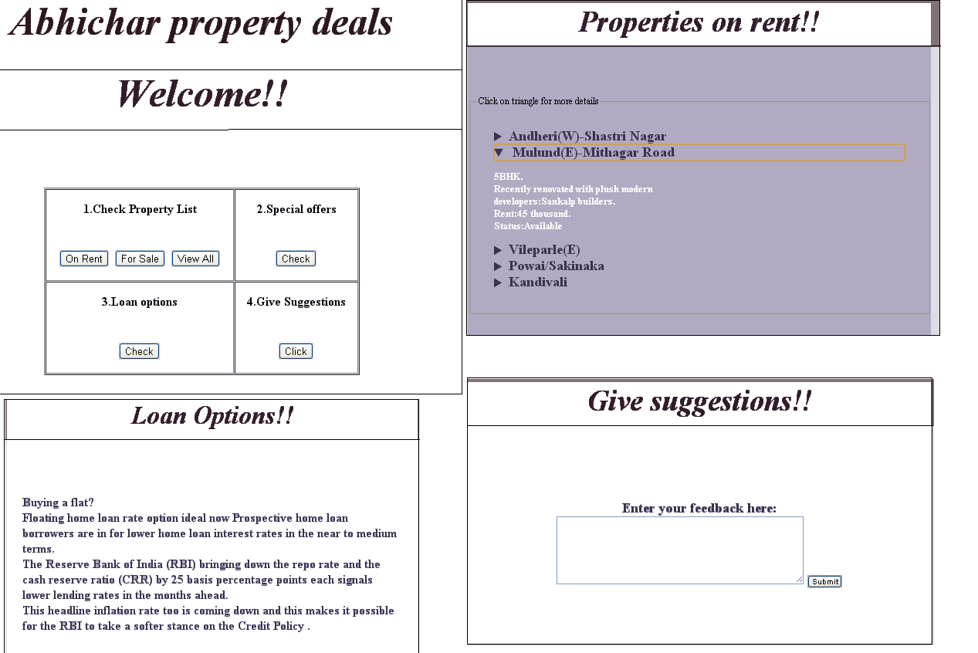

Exp.10: DEVELOPE THE TEST CASES FOR THE SYSTEM

TEST CASE ID | DESCRIPTION | INPUT | EXPECTED OUTPUT | ACTUAL OUTPUT | STATUS
Case 1.1:  Case 1.2: | User login | 1: Username  2:Password | Appropriate message for invalid user  Valid user should be directed to intended page after logging | Message genearted for invalid user  Directed to  intended page after logging | Unsuccessful  Successful
Case2: | User Home page | Select the option to proceed | Test case would open the appropriate page as per option selected by user | Displays desired page | Successful
Case 3.1  Case 3.2 | Check list  Display lists | Select criteria | Will display criteria.  Lists should be displayed according to criteria | Options for criteria displayed.  Lists should be displayed according to criteria | Successful  Successful
Case 4 | Special offers |  | Special offers should be displayed | Special offers data displayed. | Successful
Case 5 | Loan options |  | Loan options details to be displayed | Loan options information displayed. | Successful

Case 6.1  Case 6.2 | Suggestion | Enter suggestions text area  click on submit. | Suggestions should be taken.  Suggestions should be sent to server | Suggestions entered and submitted.  Not sent to the server | Successful  Unsuccessful

JAVA IMPLEMENTATION
import java.util.*;  class Customer  {  static String name, email, password, userID;  public Customer() //constructor  {}  public static void login()  {  Scanner sc=new Scanner(System.in);  System.out.println("Enter  else  System.out.println("incorrect ID or password! please retry. \n new member? register !");  if(pass.equals(password))  {System.out.println("Registration complete");  System.out.println();  System.out.println();}  else  {System.out.println("ReEnter password correctly!:");  pass=sc.next();}  }  public static void giveSuggestion() //Ready  {  Management mgmt=new Management();  Scanner sc=new Scanner(System.in);  System.out.println("Enter your Suggestion:");  String sugg=sc.next();  mgmt.acceptSuggestions(sugg);  }  }  class Buyer  {  int registerID;  public Buyer() //constructor  {}  public static void checkList() //Ready  {  List li=new List();  li.displayList();  }  public static void checkLoanOptions()  public static void acceptSuggestions(String sugg) //Ready  {  String s=sugg;  System.out.println("Suggestion noted, Thank you for your feedback!");  }  }  class List  {  String criteria;  public List() //constructor  {}  public static int selectCriteria()  {  Scanner sc=new Scanner(System.in);  int cr=3;  System.out.println("Select criteria:");  System.out.println("1. To buy. \n 2. For rent. \n 3. All.");  int chcr=sc.nextInt();  switch(chcr)  {  case 1:  {cr=1;  break;}  case 2:  {cr=2;  break;}  case 3:  {cr=3;  break;}  }  return cr;  }  System.out.println("* Dadar(E)...3BHK on rent for more detail enter 25.");  int propID=sc.nextInt();  prop.getPropertyDetails(propID);  }  else if(cr==3)  {  System.out.println("* Andheri(W)-Shastri Nagar...4BHK for more detail enter 11.");  System.out.println("* Mulund(E)-Mithagar Road... Recently renovated with plush modern for more detail enter 12.");  System.out.println("* Vileparle(E) ...5BHK for more detail enter 13.");  System.out.println("* Powai/Sakinaka...4BHK for mor detail enter 14.");  System.out.println("* Kandivali...Good location for more detail enter 15.");  System.out.println("* Vasai Road...3BHK on rent for more detail enter 21.");  System.out.println("* Mulund(E)-V.P.Road... 2BHK on rent for more detail enter 22.");  System.out.println("* Thane(E) ...1BHK on rent for more detail enter 23.");  System.out.println("* Bhandup(w)...2BHK on rent for more detail enter 24.");  System.out.println("* Dadar(E)...3BHK on rent for more detail enter 25.");  int propID=sc.nextInt();  prop.getPropertyDetails(propID);  Property prop=new Property();  Management mgmt=new Management();  List li=new List();  int ch;  Scanner sc=new Scanner(System.in);  System.out.println("Welocome to ABHICHAR Property deals!!");  do{  System.out.println("Menu:");  System.out.println("1.Login");  System.out.println("2.Not a Member!.. Register");  System.out.println("3.Propery List");  System.out.println("4.Check Loan Options");  System.out.println("5.Give suggestions");  System.out.println("6.Exit");  ch=sc.nextInt(); | }  public static void register()  {  Scanner sc=new Scanner(System.in);  System.out.println("Enter the emailed:");  email=sc.next();  System.out.println("Select the UserID:");  userID=sc.next();  System.out.println("Enter the password:");  password=sc.next();  System.out.println("ReEnter the password:");  String pass=sc.next();  //ready  {  Management mgmt=new Management();  mgmt.displayLoanOptions();  }  }  class Management  {  int loanOptions;  String specialOffers, suggestions;  public Management() //constructor  {}  public static void displayLoanOptions()  {System.out.println();  System.out.println("Loan options");  System.out.println("Buying a flat? Floating home loan rate option ideal now \n Prospective home loan borrowers are in for lower home loan interest rates \n in the near to medium terms. \n The Reserve Bank of India (RBI) bringing down the repo rate \n and the cash reserve ratio (CRR) by 25 basis percentage points each signals\n lower lending rates in the months ahead. \n This headline inflation rate too is coming down and this makes it possible\n for the RBI to take a softer stance on the Credit Policy .");  System.out.println();  System.out.println();  System.out.println();  }  public static void displayList()  {  Property prop=new Property();  Scanner sc=new Scanner(System.in);  int cr=selectCriteria();  if(cr==1)  {  System.out.println("* Andheri(W)-Shastri Nagar...4BHK for more detail enter 11.");  System.out.println("* Mulund(E)-Mithagar Road... Recently renovated with plush modern for more detail enter 12.");  System.out.println("* Vileparle(E) ...5BHK for more detail enter 13.");  System.out.println("* Powai/Sakinaka...4BHK for more detail enter 14.");  System.out.println("* Kandivali...Good location for more detail enter 15.");  int propID=sc.nextInt();  prop.getPropertyDetails(propID);  }  else if(cr==2)  {  System.out.println("* Vasai Road...3BHK on rent for more detail enter 21.");  System.out.println("* Mulund(E)-V.P.Road... 2BHK on rent for more detail enter 22.");  System.out.println("* Thane(E) ...1BHK on rent for more detail enter 23.");  System.out.println("* Bhandup(w)...2BHK on rent for more detail enter 24.");  }  }  }  class Property  {  String name, location, ownerName, status, type;  int price, propertyID;  public Property()  {}  public static void getPropertyDetails(int propID)  {  int id=propID;  System.out.println();  System.out.println("Details not available for property with ID "+id);  System.out.println();  System.out.println();  }  }  class PropertyMgmtSyst  {  public static void main(String args[])  {  Customer cust=new Customer();  Buyer buy=new Buyer();  switch(ch)  {  case 1:  {cust.login();  break;}  case 2:  {cust.register();  break;}  case 3:  {buy.checkList();  break;}  case 4:  {buy.checkLoanOptions();  break;}  case 5:  {cust.giveSuggestion();  break;}  case 6:  break;  }  }while(ch!=6);  }  }

