1. Ability to create tables with seats. One seat = One customer. Each table  
be given a unique number which will be Alphanumeric and will be given by the admin.  
  
2. Each table is assigned a Server. Any server can take the order by the  
order will be assigned to the server who is assigned to that table. There  
will be two people associated with an order i.e. Server Name and Order taken  
by.   
  
3. Each server will login to the system with user name. The presumption is  
that each server will be assigned a tablet / mobile phone. Once logged in,  
the specific device would store the name of the server.  
  
4. Before picking the order, the server would 1st select the table number.  
This will show the following information:  
a. Number of clients / seats  
b. Assigned server  
c. Date & Time  
After this, the server would start taking the order. This will be a typical  
order screen of POS.  
  
5. The products are defined in special ways as follows:  
a. Meal: The food item will consist of a set of items e.g. Kiddy Meal  
includes: Chicken Nuggets (6 PCS) + 1 Mini Fries + 1 Soda (Any).  
As the server types Kiddy Meal in the order screen, the system prompts for  
Soda name, since this is a choice item. These kind of items need to be  
stored as "Choice Items". Whenever the server selects such items, the system  
should prompt for "Choice". These choice consists of items of choice.  
  
b. Accompaniments: These items are those which are supplied with meals e.g.  
When burger is bought, Tomato ketchup sachet are provided. When Soda is  
served, Straw is served, When dish is served, Napkins & Fork, knives etc are  
served so on.  
  
6. As the order is placed, the same shows up at the Kitchen as well as  
billing till.  
  
7. When the kitchen staff prepares the food and clicks on kitchen terminal,  
the system will remove those inventory items from system.  
  
8. When the server clicks on Checkout on a table order, the bill is  
finalized at the cashier till. This order can't be changed at this point  
onwards.

Clarification:

* Kitchen Meal Processing: How is queues handled by kitchen personnel?

[first come first serve basis. In the same context also note that a kitchen order may come as new customer order or from a customer who has already placed an order. E.g. some customer would like to order more food. But irrespective of who places the order, the kitchen queue would be on first come first serve basis]

* Servers normally work in shifts, will that be captured by the system?

[For now it does not matter. We will handle this in next version]

* Can a Server be assigned more than one table?

[Yes. In fact it is like that in all of the cases]

* More information on the kitchen Staff , their role, and whether they should be logged in.

1. A kitchen staff is like any other staff except the department is Kitchen.
2. In current version, their role is to keep clicking the kitchen order records and mark them as done.
3. In case they do not have enough stocks to prepare a dish then they can mark those dishes as out of stock. This will update the food entry in the menu screen which is visible to server.

* The possibility of more than billing point.

1. Yes, it is possible, each point will be registered as a Till in POS. Current version has the option of multiple tills. Ask David on that.

* The user in charge of table management (supervisor for the servers), their role in the system.

Following are the additional details of users:

Supervisor:

1. Allows the cashier to void an order. Sometimes, the cashier enters an incorrect entry in the bill and would like to change it. Then supervisor logs in on the same screen as cashier and edits the order i.e. Edit / Delete.
2. Allow a staff to change the password, in case they forget. The supervisor can open the change password screen and ask the staff to enter the new password. The passwords are masked so supervisor cant see.
3. Give discounts
4. Exchange the dish. Sometimes the dish is spoilt or there is some error in the order or some other reason. So the customer demands for a change of dish or the restaurant decides to do a free replacement. In this case the supervisor can mark that dish or even order as complementary. A complementary order or dish is any normal order but zero amount payable. When the supervisor marks an order as complementary then a reason is required and such entries need to be flagged.

Cashier

1. A cashier enters the orders into the system.
2. There are three types of orders that cashier selects while entering the order.
   1. Eat here: The customer eats at the restaurant
   2. Take away: The customer take the order with them
   3. Delivery: The order is delivered at the customer’s location
3. When the customer is done eating the cashier finalizes the order and prints a bill that customer settles. This is normal POS function

Server:

1. Takes the order from customers.
2. At present the orders will be taken manually and then order slip will be handed over to the cashier to be entered in an order form. Later this will be automated.
3. The server functions will be manual in this version.

Algorithm – Restaurant POS System

1. Customer walks in to eat at a restaurant.
2. Server greets them and show them to the table.
3. Server hands over menu card and awaits for the order
4. Server, writes the order on Order Slip
5. Order slip is handed over to the cashier
6. Cashier enters the order in the screen with Table number.
7. This attaches the server to the order.
8. If this is some other server then the cashier changes the server name on that order. But the assigned server name is still attached to the order.
9. Cashier processes the order.
10. This shows the order on Kitchen Terminal. Following is a sample.

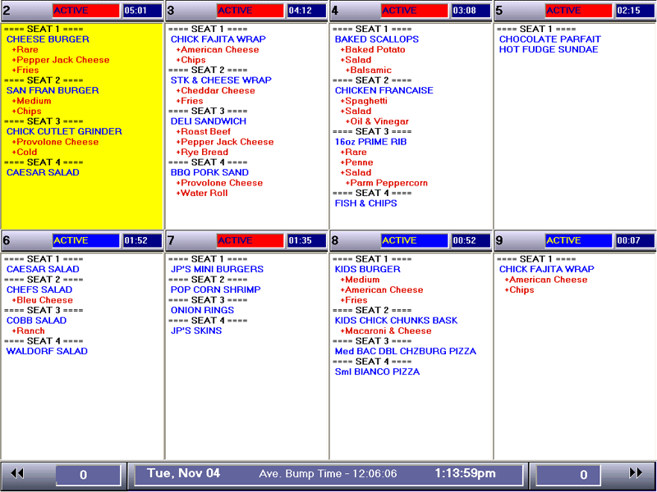

1. The Cooks prepare the dish as per their own plan. i.e. some dishes could be prepared sooner than others so as they complete the orders, they click on respective order and mark it has done.
2. There is a screen placed outside the kitchen that is referred by the servers. This screen shows the list of orders that are completed by the Cooks. As an order is marked complete by the Cook, it shows up on this screen. The respective server collects the order and serves to the table.
3. If there is a dish that needs to be returned, then the server is informed. The server informs the Cashier who marks that dish in the order as returned. This will be done as follows:
   1. Open the order. There are following buttons available namely “Replace Dish”, “Exchange Dish” & “Cancel Order”
      1. Replace Dish: when one or more dish in an order needs to be exchanged with same dish with a change in preparation e.g. less spicy or less salt etc
      2. Exchange Dish: When one or more dish need to be exchanged with another dish. E.g. Non-Veg food served to Vegan customers etc
      3. Cancel Order: When the customer decides to cancel the order
   2. Click on the button “Replace Dish”. This will ask for supervisor permission (unless the cashier has been given this permission from user rights)
   3. Supervisor enter password on the pop-up frame
   4. The cashier selects the dish(es) that needs to be replaced, enters a reason for replacement (e.g. too much salt etc) and clicks on “Process” button
   5. This shows a fresh Kitchen order with dishes to be made. This order has special marker that shows this is a replacement order and shows the instructions (e.g. Too much salt)
   6. Since this is a replacement order, the POS adds these dishes to same order to the list but with zero amount.
4. When the customer is done with the order, the server informs the cashier who will click on Check-out and tender the transaction.