IR Project Document
Task 2 – Text Classification Battle

Name: Vino Bala V
Reg No: RA2411026050054
Class: CSE AIML A
Year: 3rd Year
GitHub Repository
https://github.com/vino7075/vino7075-IR_Text_Classification_Vino
Project Overview
This project performs sentiment classification on real customer tweets about six US airlines, from the Twitter US Airline Sentiment dataset. Each tweet is labelled negative, neutral or positive. After removing duplicate and empty tweets, 14,382 tweets were used. The classes are imbalanced: about 63% of the tweets are negative. Each tweet is cleaned by removing @mentions, links and HTML codes, then preprocessed by lowercasing, tokenization, stop word removal and stemming as in Task 1, but with negation words such as 'not' and 'no' kept because they carry sentiment. The text is converted into TF-IDF features (unigrams and bigrams). Decision Tree, KNN, SVM and Naive Bayes are trained on the same stratified 80/20 split and compared using Accuracy, macro Precision, Recall, F1-score and confusion matrices. As a what-if experiment, the standard stop-word list, which removes negation words, was compared with the negation-preserving list.
Code and Execution Screenshots
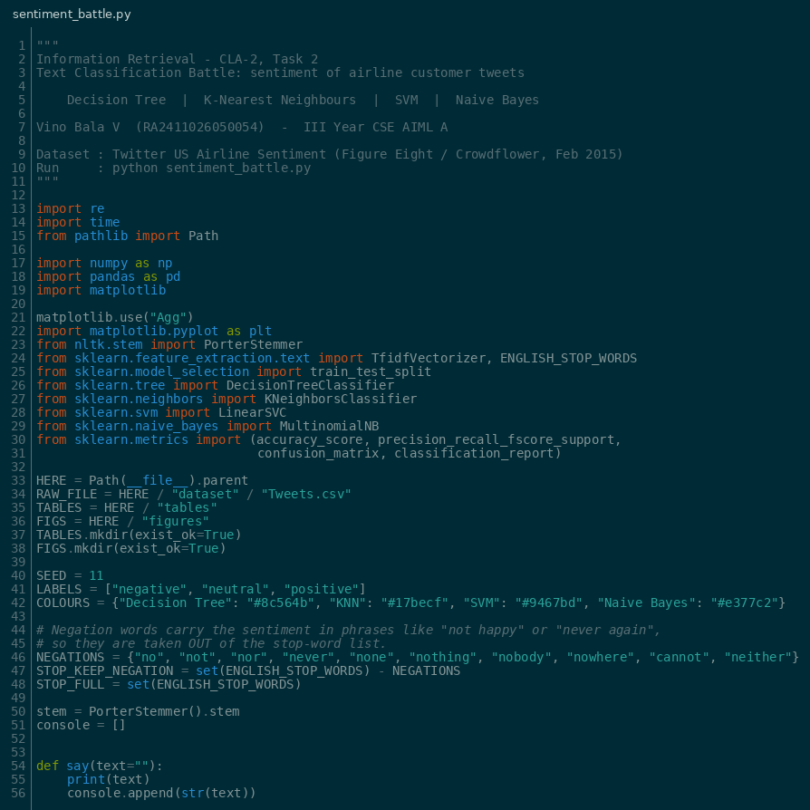
Figure 1: Imports, configuration and negation-aware stop-word list
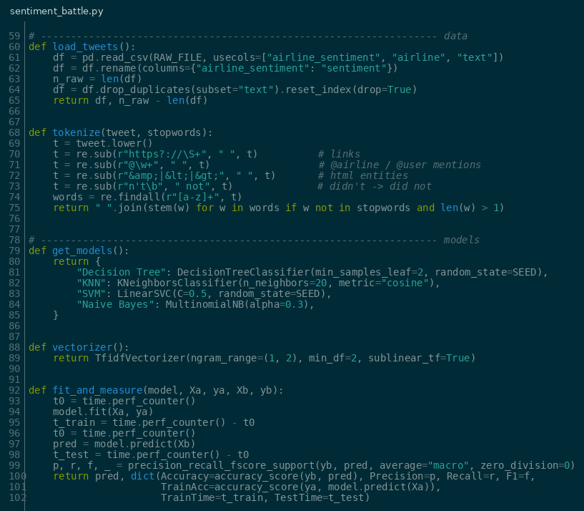
Figure 2: Loading data, tweet preprocessing and the four classifiers
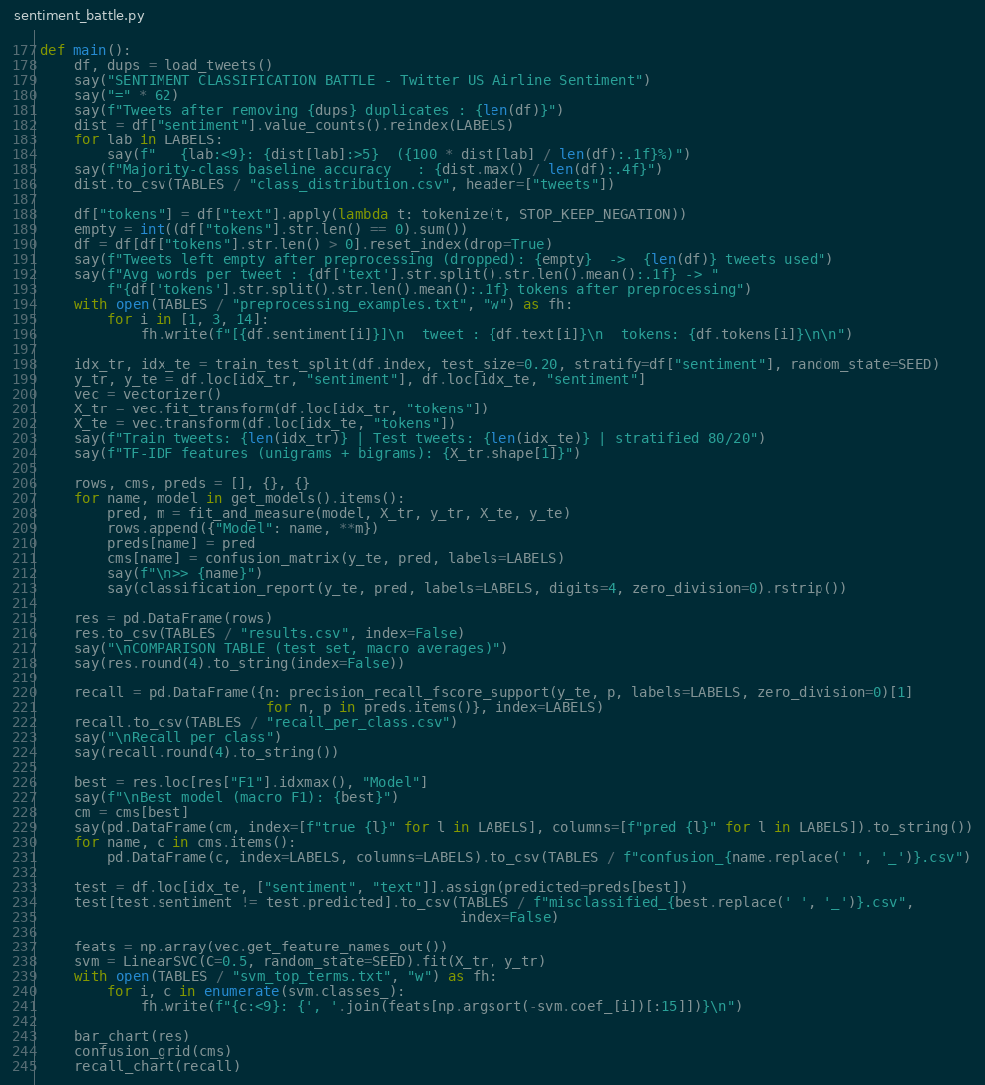
Figure 3: Main experiment – split, TF-IDF, training, evaluation and confusion analysis
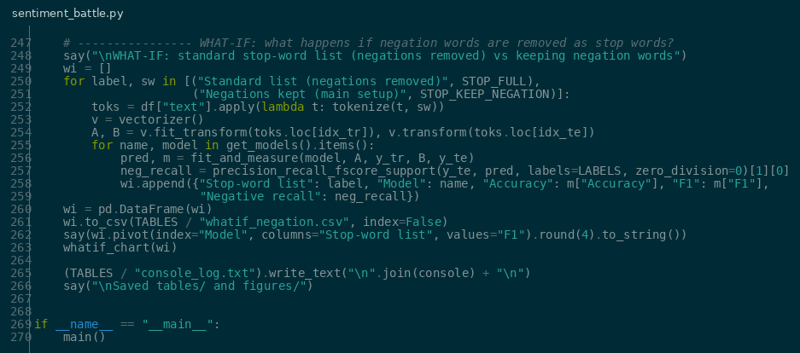
Figure 4: What-if experiment code
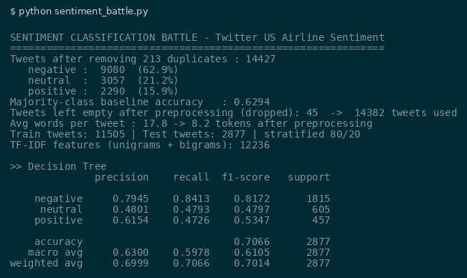
Figure 5: Execution output – dataset details and Decision Tree report
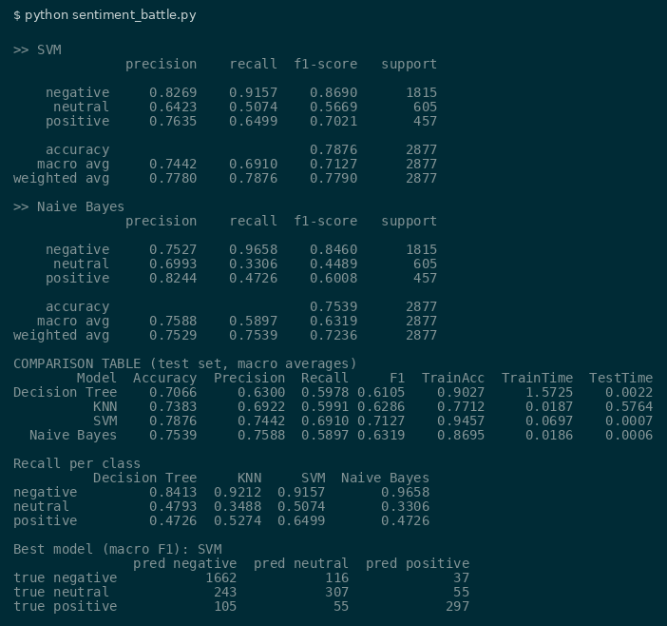
Figure 6: Execution output – comparison table, recall per class and best model
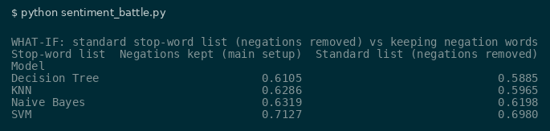
Figure 7: Execution output – what-if experiment result
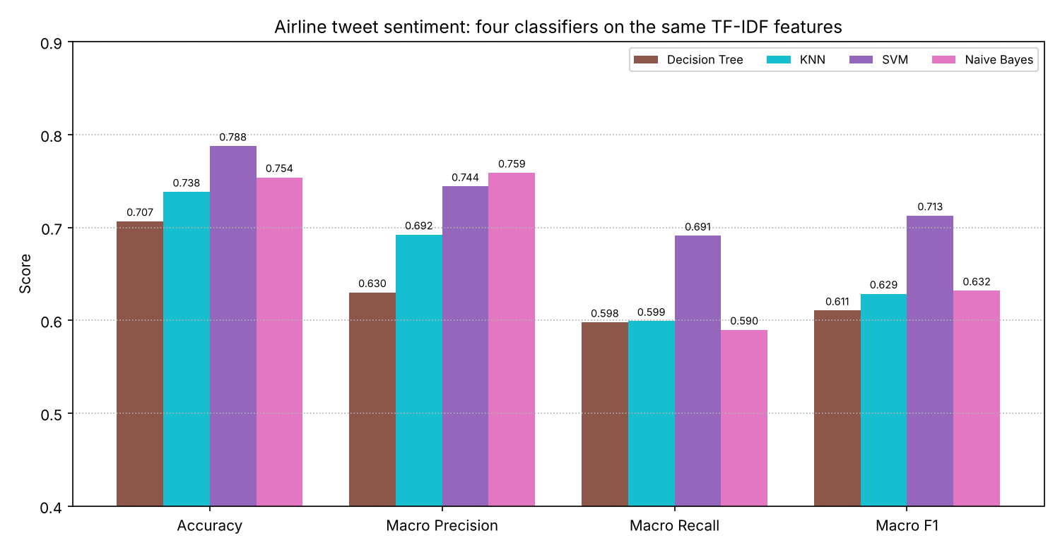
Figure 8: Comparison of the four classifiers
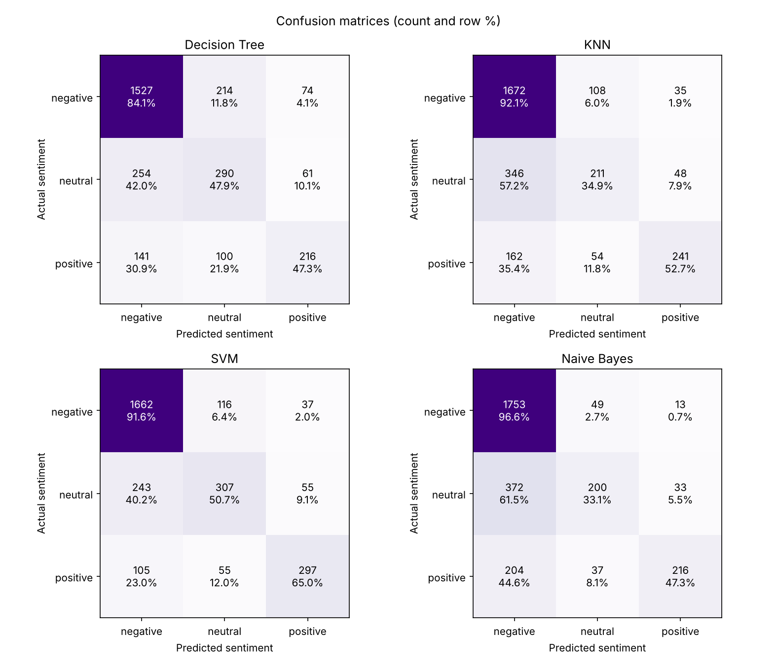
Figure 9: Confusion matrices of the four classifiers
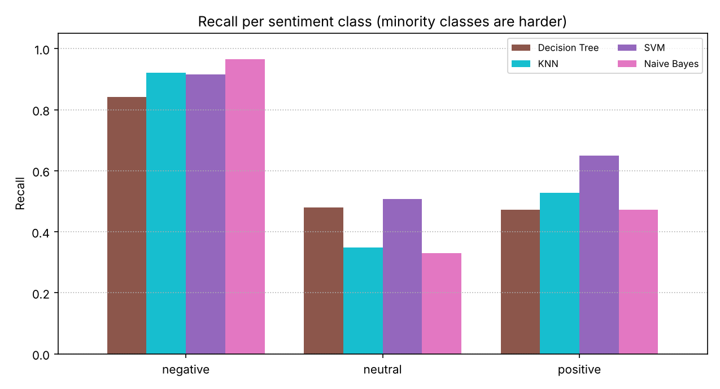
Figure 10: Recall for each sentiment class
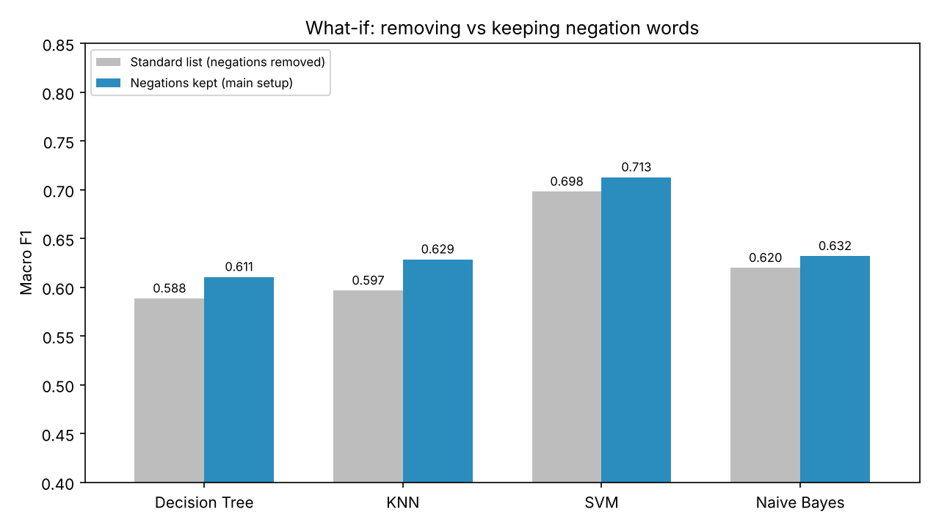
Figure 11: What-if – effect of keeping negation words
Project Result
The program processed 14,382 tweets, built 12,236 TF-IDF features and evaluated all four classifiers on 2,877 test tweets. SVM performed best, with an accuracy of 0.7876 and a macro F1-score of 0.7127. It was followed by Naive Bayes (0.6319), KNN (0.6286) and Decision Tree (0.6105). Because most tweets are negative, every model found the negative class easy (84–97% recall) but struggled with neutral and positive tweets. Naive Bayes predicted 'negative' for 61.5% of neutral tweets. SVM handled the minority classes best, with 65% recall on positive tweets, which is why it has the highest macro F1-score even though its accuracy is not far above the 62.9% majority baseline. In the what-if experiment, removing negation words lowered the macro F1-score of all four models: KNN dropped from 0.6286 to 0.5965 and SVM from 0.7127 to 0.6980. This shows that words like 'not' are important for sentiment. SVM with negation-aware TF-IDF features is therefore recommended for this task.

