UML Diagrams

- Use Case Diagram
- Class Diagram
- Sequence Diagram
  - Registration Sequence Diagram
  - Login Sequence Diagram
  - Admin Sequence Diagram
  - Admin Sequence Diagram II
  - Manage Posts Sequence Diagram
  - Manage Private Message Sequence Diagram
  - Search Posts Sequence Diagram
  - View Members List Sequence Diagram
  - View Profile Sequence Diagram
  - Guest Sequence Diagram
- Collaboration Diagram
  - Registration Collaboration Diagram
  - Login Collaboration Diagram
  - Admin Collaboration Diagram
  - Admin Collaboration Diagram II
  - Manage Posts Collaboration Diagram
  - Manage Private Message Collaboration Diagram
  - Search Posts Collaboration Diagram
  - View Members List Collaboration Diagram
  - View Profile Collaboration Diagram
  - Guest Collaboration Diagram
- Activity Diagram
- Deployment Diagram

1.Use Case Diagram

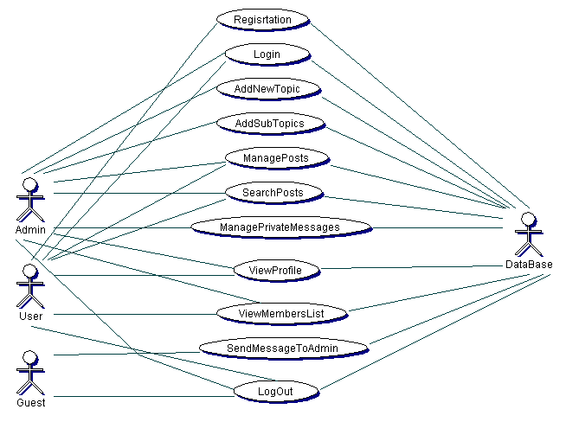

2.Class Diagram

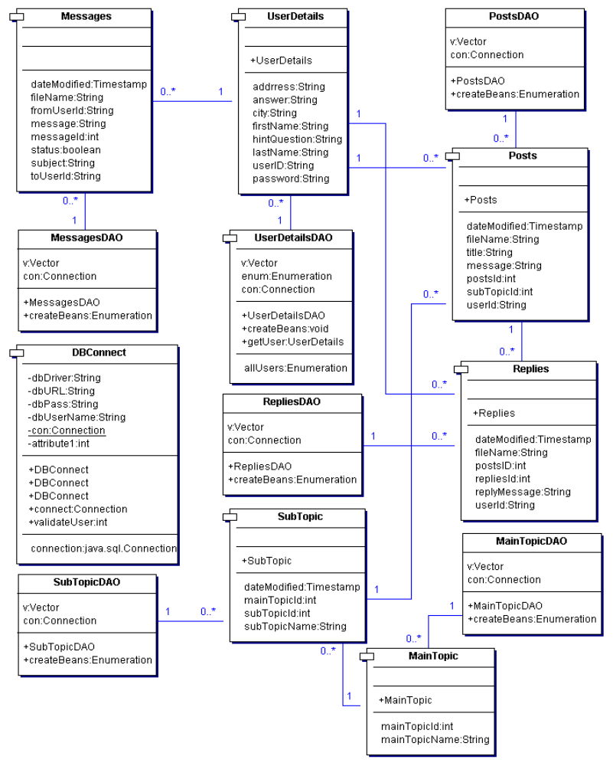

3.Sequence Diagram

1.Registration Sequence Diagram

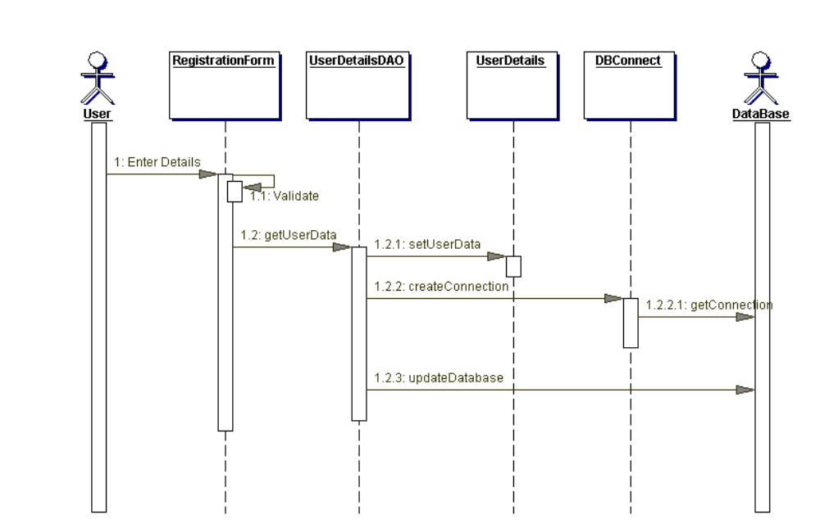

Sequence Diagram

2.Login Sequence Diagram

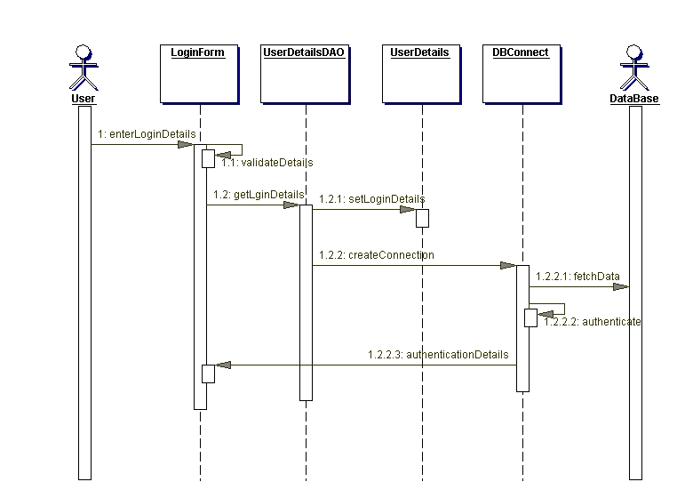

Sequence Diagram

3.Admin Sequence Diagram

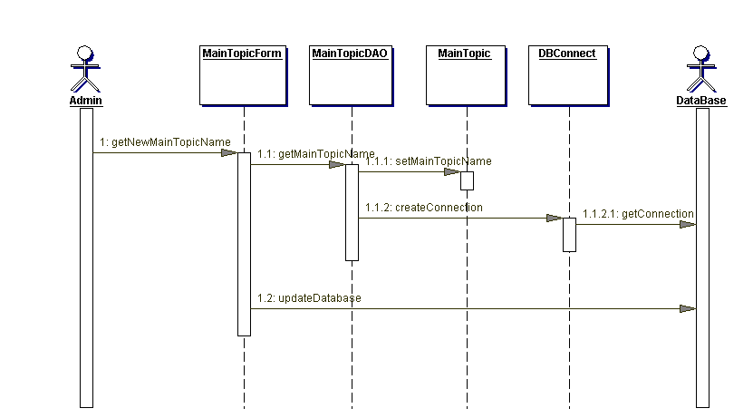

Sequence Diagram

4.Admin Sequence Diagram

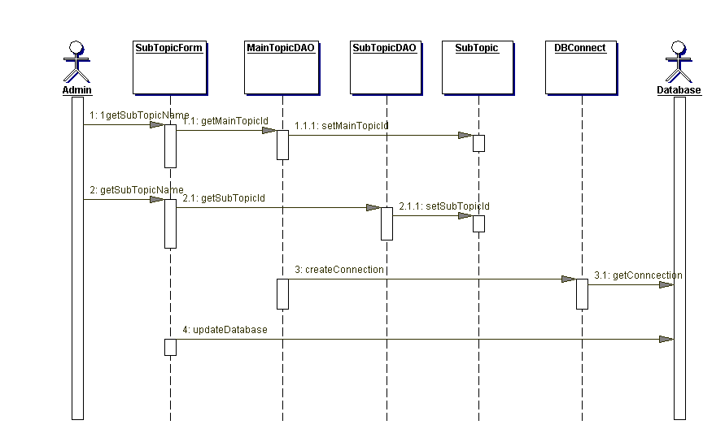

Sequence Diagram

5.Manage Posts Sequence Diagram

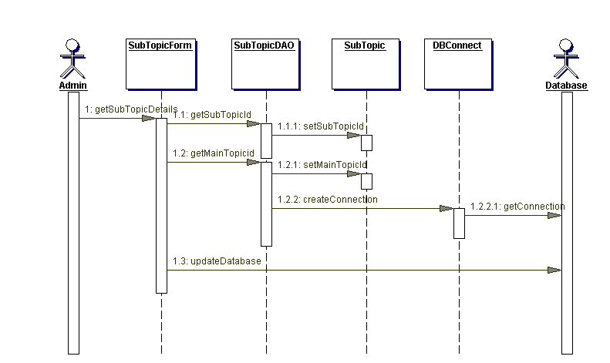

Sequence Diagram

6.Manage Private Messages Sequence Diagram

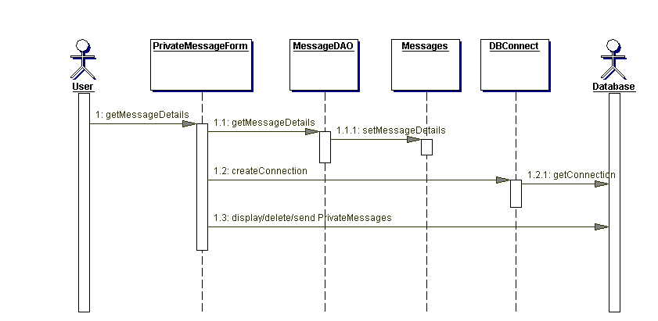

Sequence Diagram

7. Search Posts Sequence Diagram

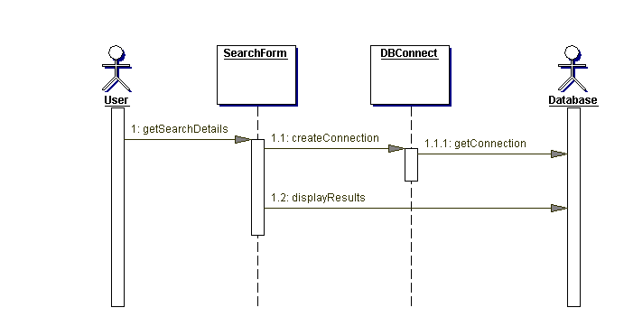

Sequence Diagram

8.View Members List Sequence Diagram

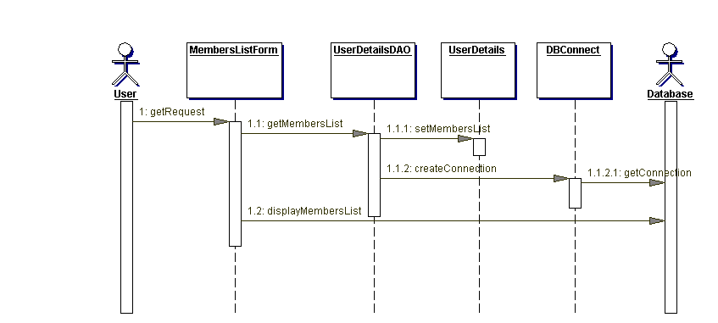

Sequence Diagram

9.View Profile Sequence Diagram

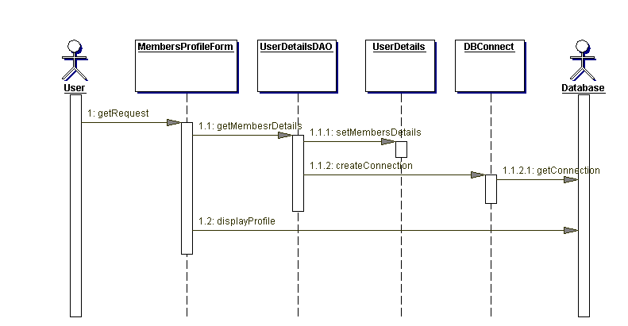

Sequence Diagram

10.Guest Sequence Diagram

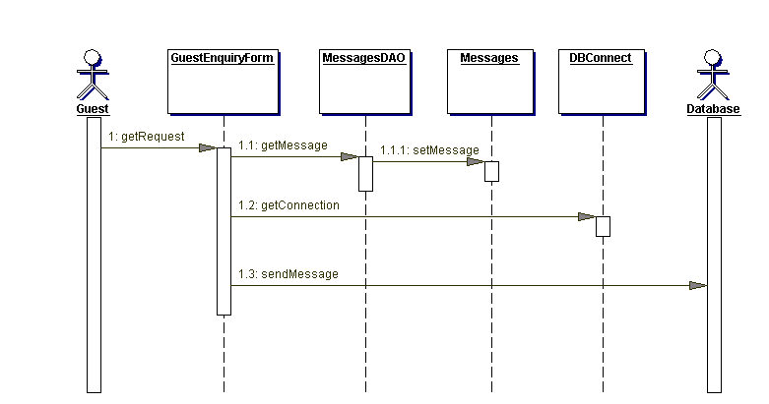

4.Collaboration Diagrams

1.Registration Collaboration Diagram

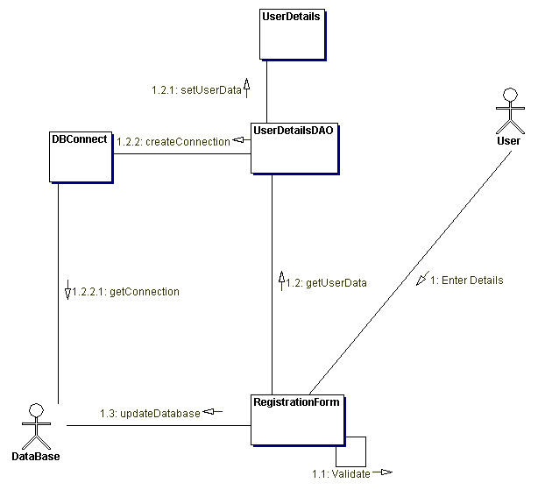

Collaboration Diagrams

2.Login Collaboration Diagram

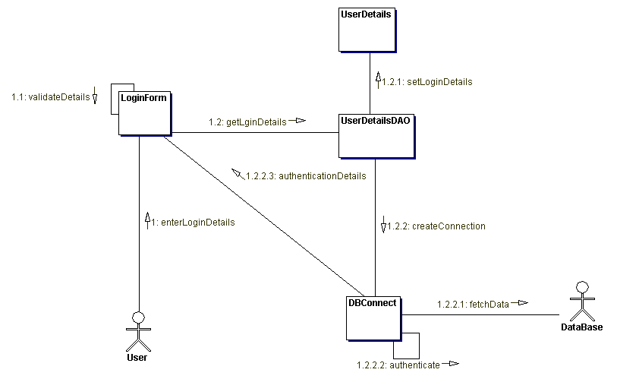

Collaboration Diagrams

3.Admin Collaboration Diagram

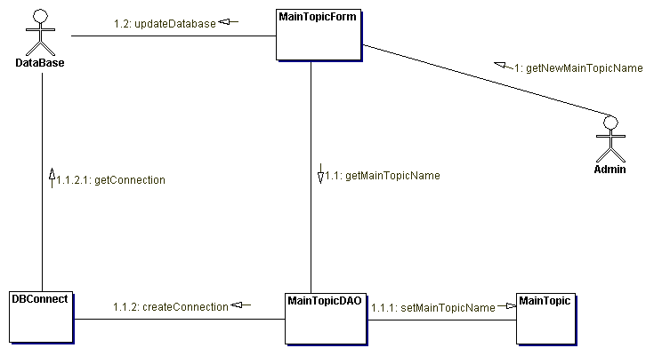

Collaboration Diagrams

4.Admin Collaboration Diagram

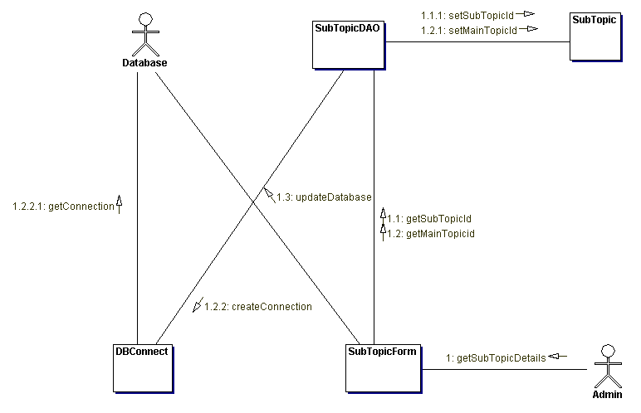

Collaboration Diagrams

5.Manage Posts Collaboration Diagram

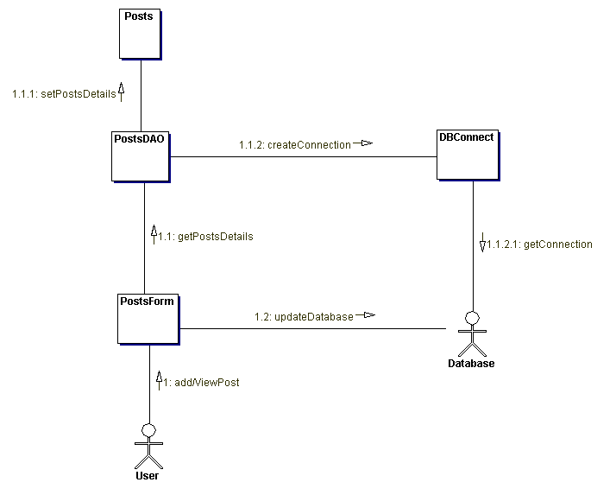

Collaboration Diagrams

6.Manage Private Message Collaboration Diagram

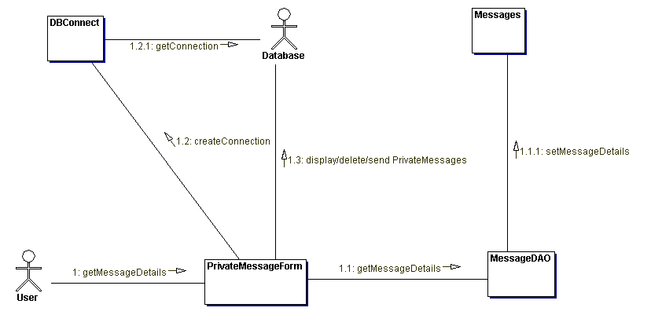

Collaboration Diagrams

7.Search Posts Collaboration Diagram

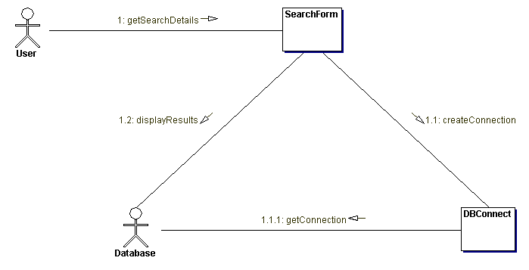

Collaboration Diagrams

8.View Members List Collaboration Diagram

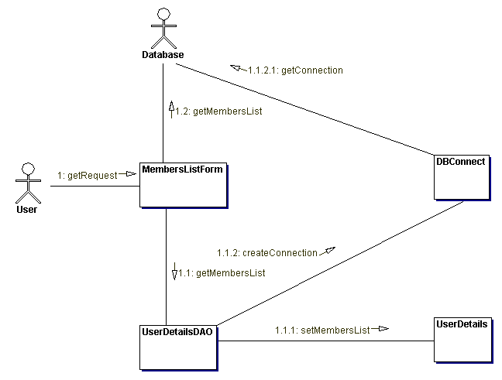

Collaboration Diagrams

9.View Profile Collaboration Diagram

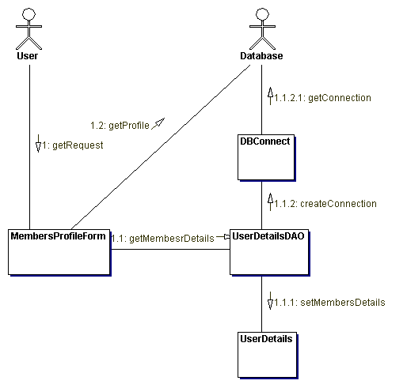

Collaboration Diagrams

10.Guest Collaboration Diagram

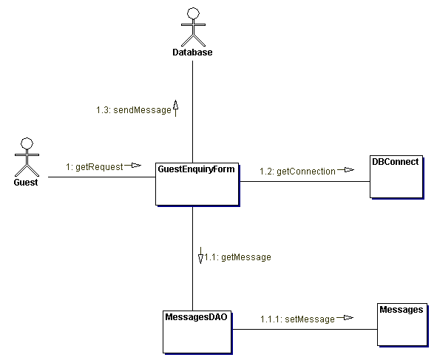

5.Activity Diagram

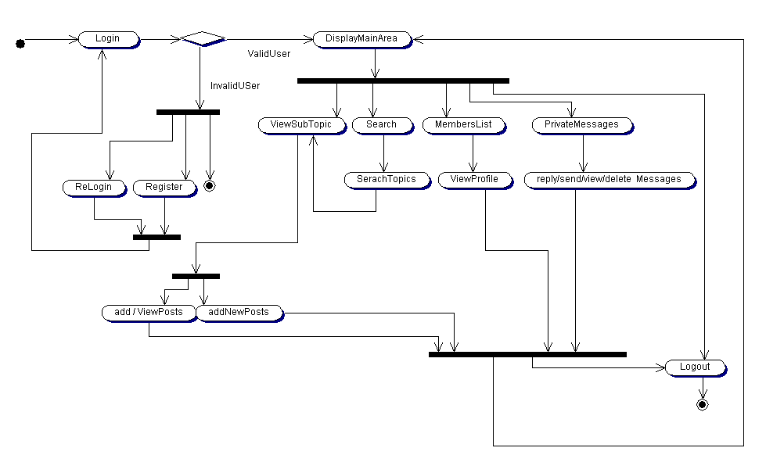

6.Deployment Diagram

