**Query to find 10th highest salary of an employee?**

**Write a query to calculate N-N’?**N={1,1,2,3,2,1,2,3}  
N’={1,2,3}

**Write a output for inner, left, right and full outer join?**

**A B**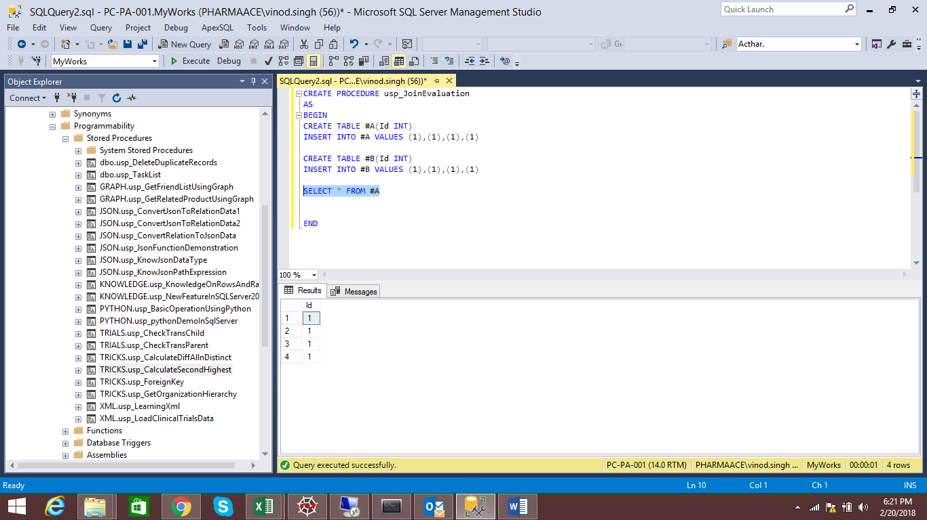 

**What will be output for below query?**select case when null is null then 'Yup'   
 else 'Nope'   
 end as Result;

**What will be the output for below query:**  
 Runners Races

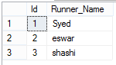 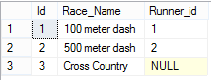

select * FROM RUNNERS WHERE Id NOT IN (SELECT Runner_id from RACES).

**Given a table TBL with a field “Nmbr” that has rows with the following values:**

1, 0, 0, 1, 1, 1, 1, 0, 0, 1, 0, 1, 0, 1, 0, 1

Write a query to add 2 where “Nmbr” is 0 and add 3 where “Nmbr” is 1.

**Write a query on table below:**

Customer

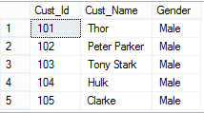

Product  
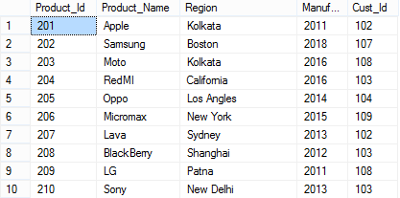

1.Get number of products manufactured in each year?  
2.Name of the Customer used the product manufactured in between year '2011' and '2015'?  
3.Fetch the customer name who used more than one product?  
4.Get the Customer details who purchased?