PayBooks:CTC Structure Previous Updated

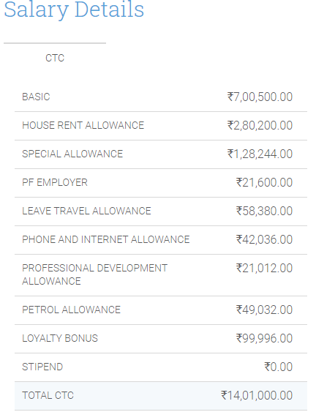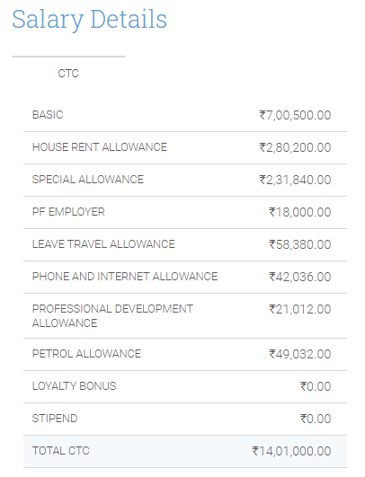

**October Increment Letter**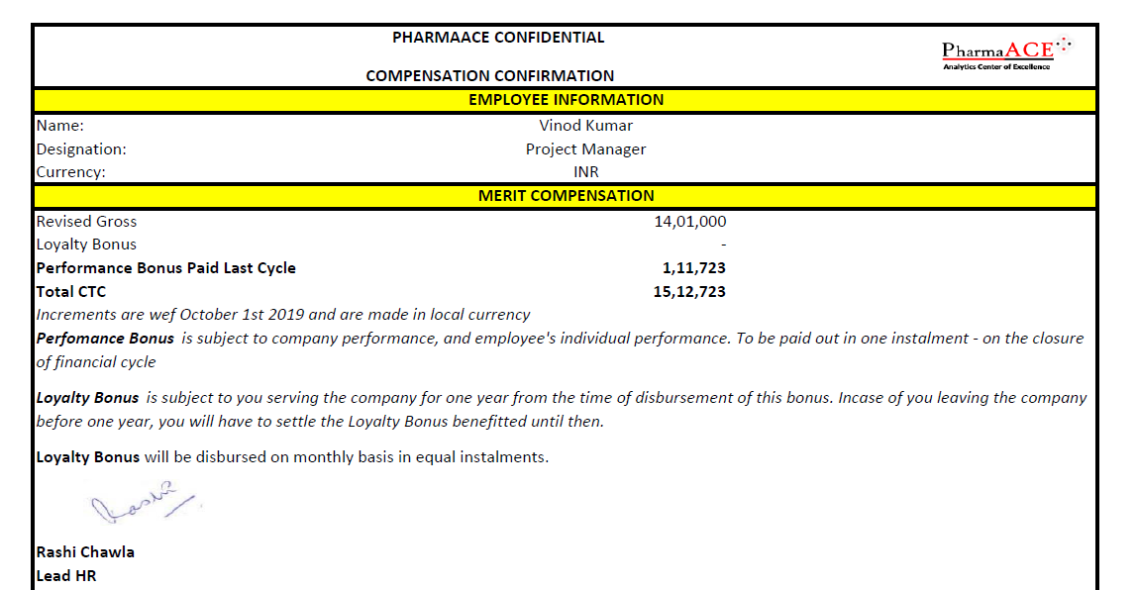

**April 2020 Salary Slip:**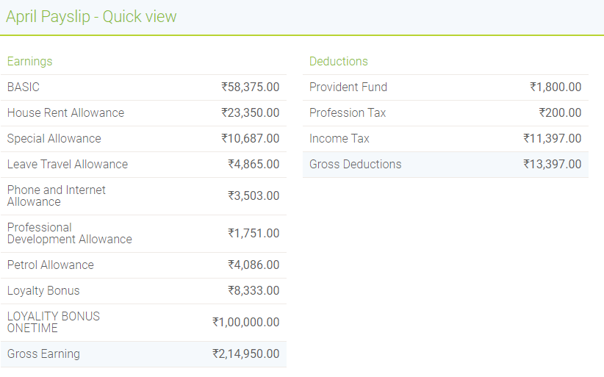

**March 2020 Salary Slip:**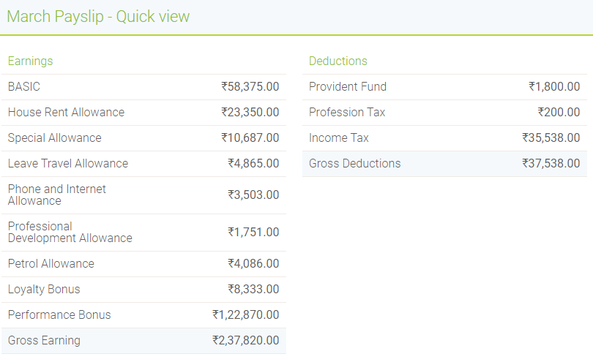

**July 2018 Salary slip: (from paybooks starting date to till date 8333 Loyalty component)**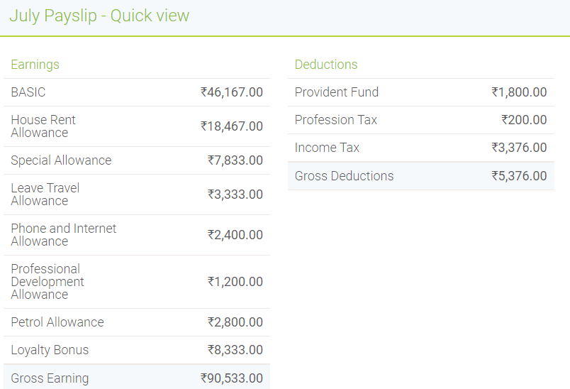

**Offer Letter 2016**

