Docker :
Yum install docker
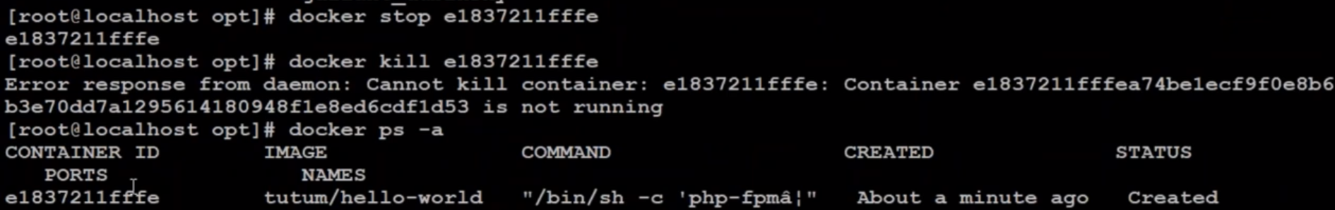
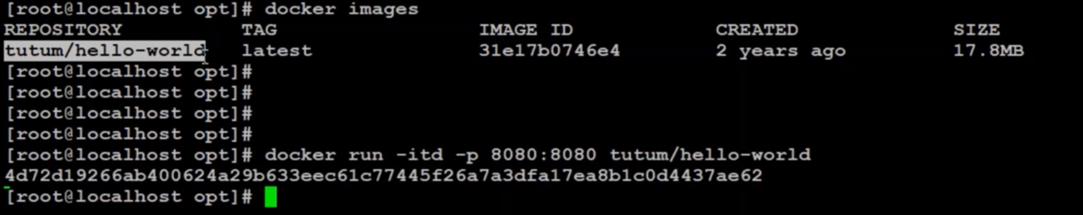

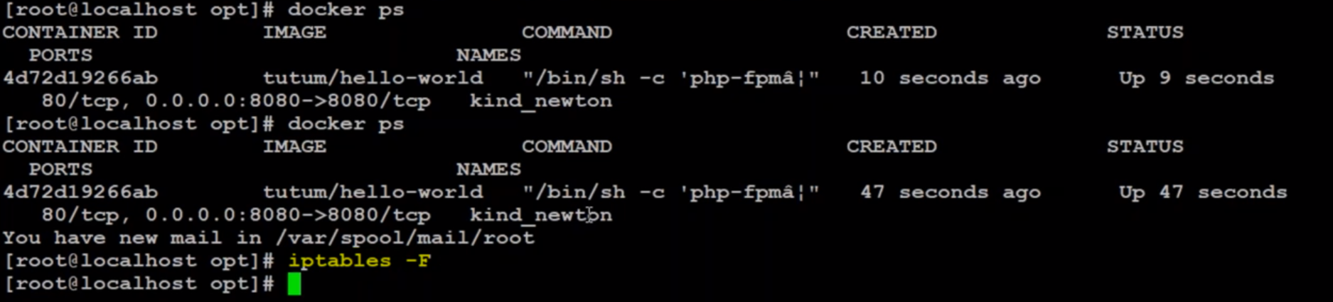

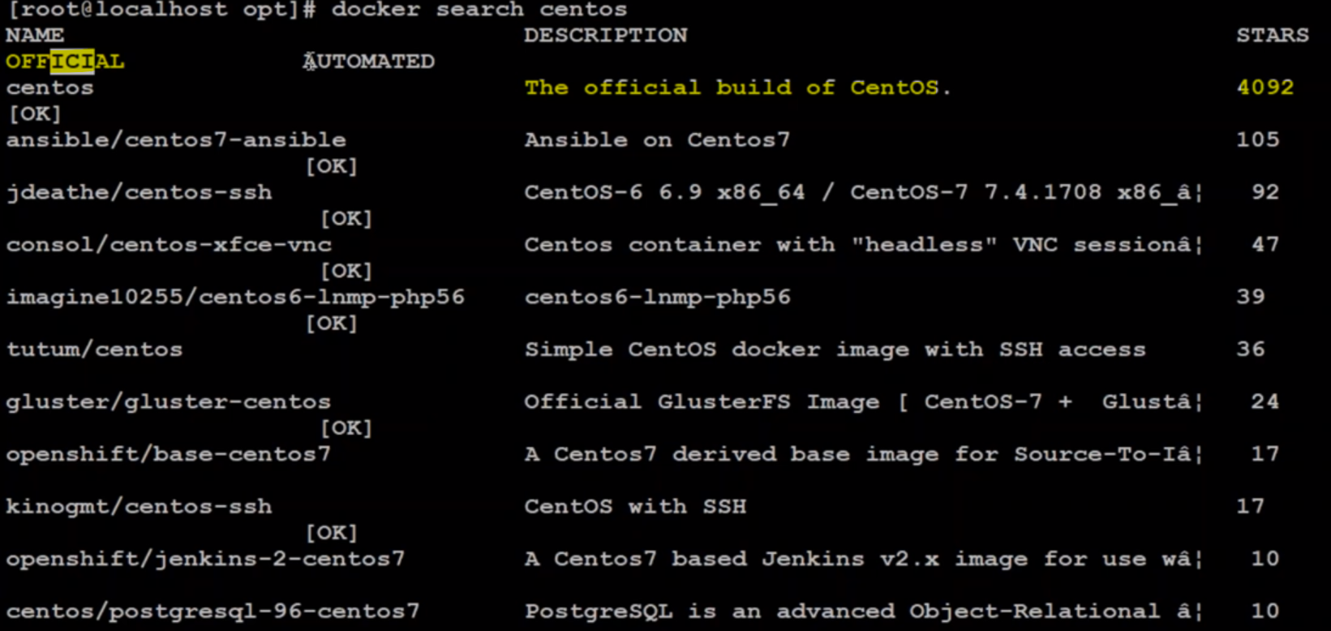
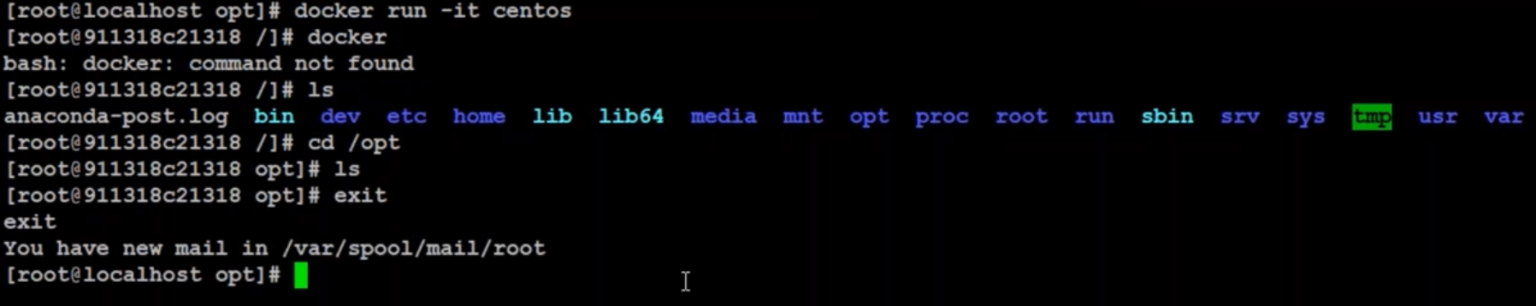

Create image from container
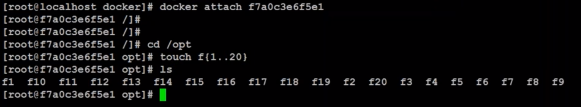

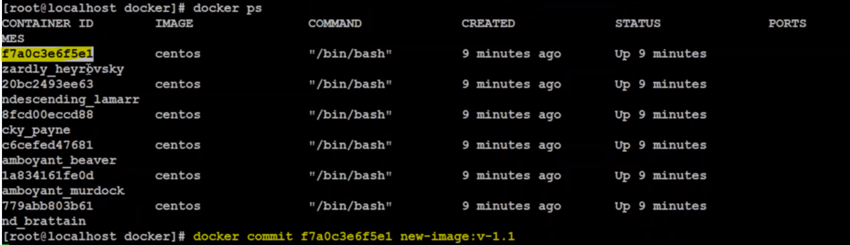
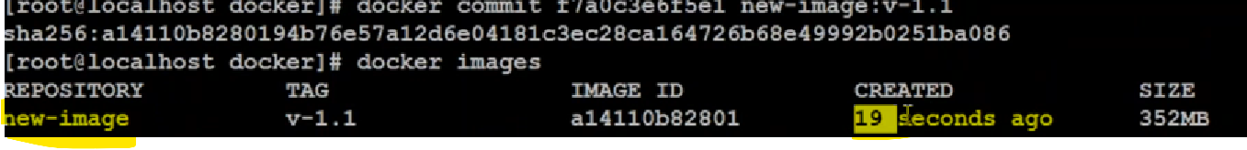

Docker Swarm and Docker compose:

What is Docker Swarm?
What is the use of Docker Swarm?

To list the Docker details:
$docker info
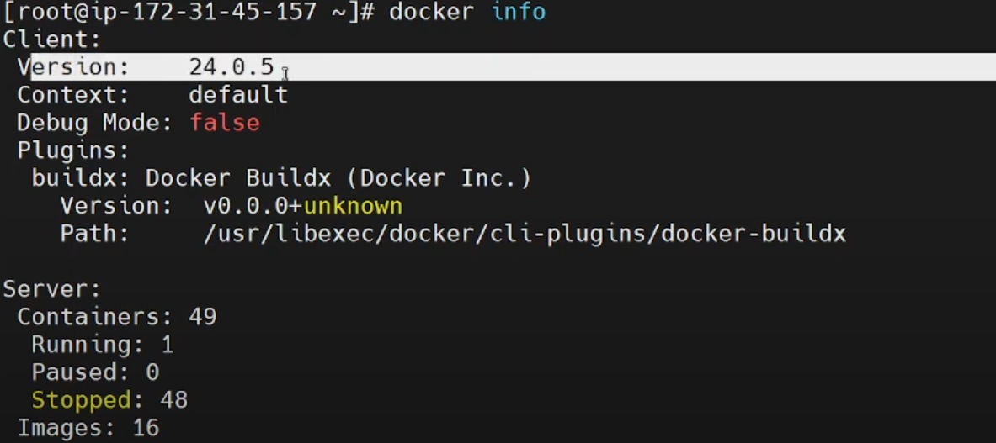

Install docker swarm
$docker swarm init - -advertiseddr 172.31.45.157

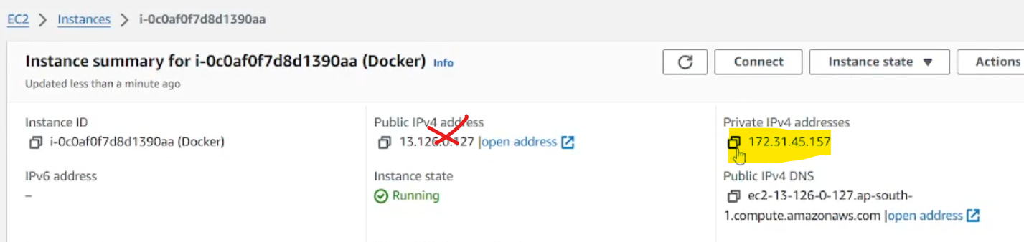

Then it will initialize and generate token

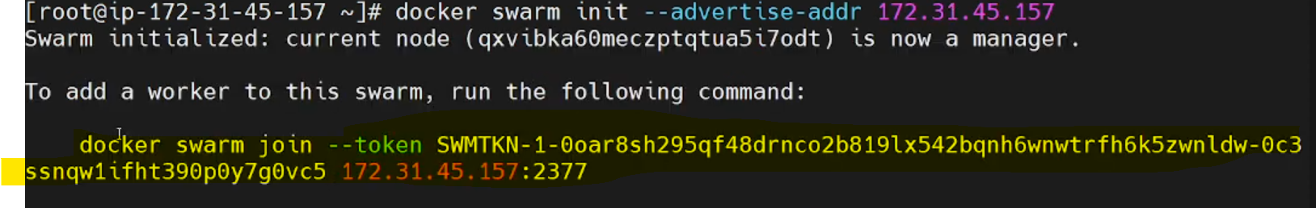

Swarm port is 2377 so before using command in node server enable this port in all servers

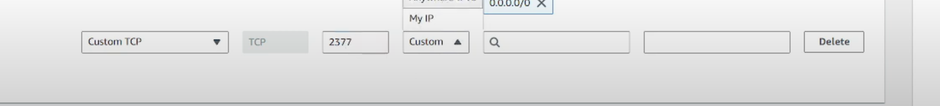
Execute the token in node server to join the server under this docker as a worker nodes

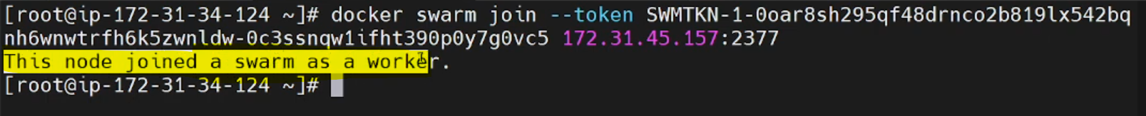

List the nodes once you added

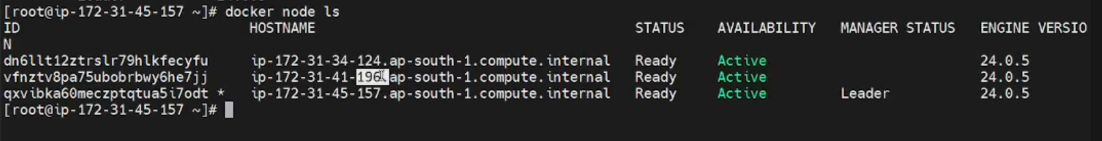

To promote node to reachable state then use below command and add node it

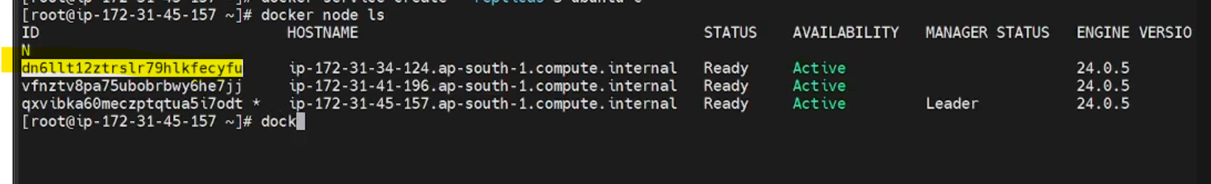

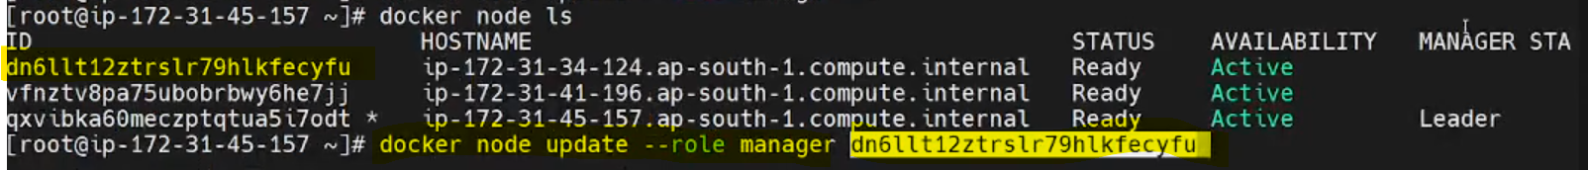
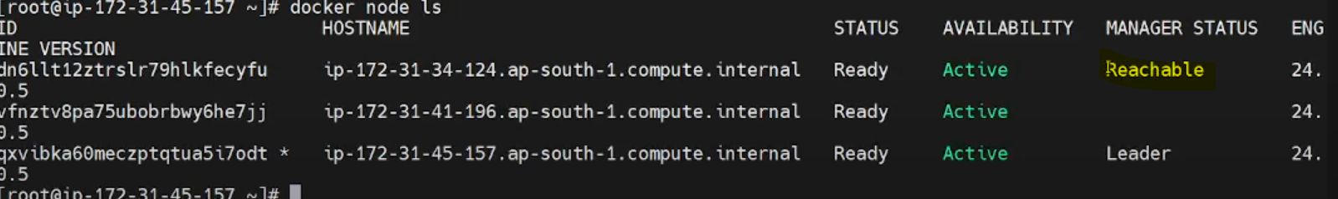
Toc heck basic image run below command

If we remove container in node server again it will create a new container automatically

If you want to scaleup more container

Use below command and container id and ghow many replicas you need

To leave the node from the manger

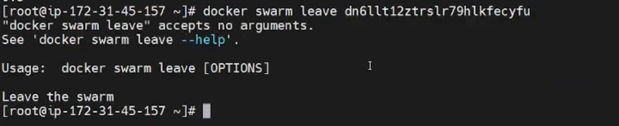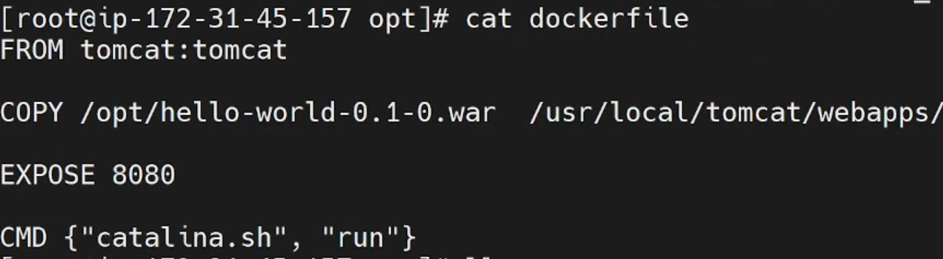

Create a yml file

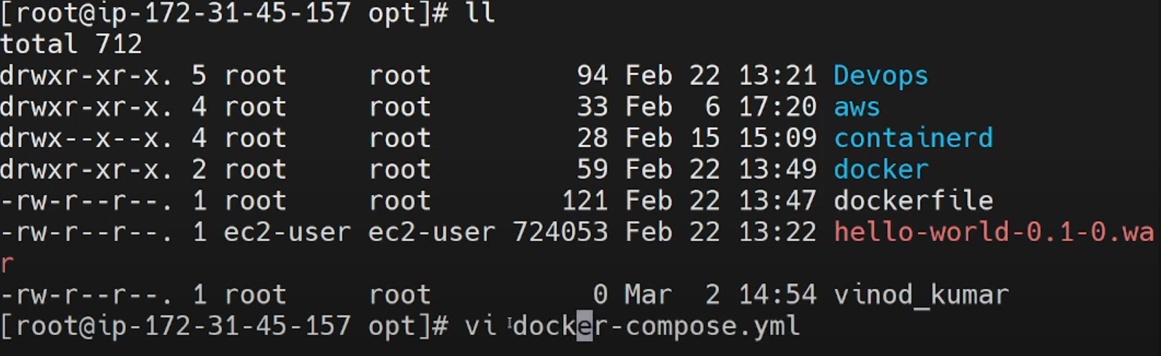

Writea service inside docker file

