**STUDENT CAMPUS DRIVE TRACKING PORTAL**

A project report submitted in partial fulfillment of the

Requirements for the award of degree of

**Bachelor of Technology**

In

**Computer Science and Engineering**

By

**CH.V.V. SATYA NARAYANA(N160096)**

**P. VINOD KUMAR(N160406)**

**M.RAMA KOTESWARA RAO(N160051)**

**P. CHANDRA MOHAN(N160144)**

Under the Supervision of

Mrs. PADMA BHAI



**Department of Computer Science and Engineering**

**Rajiv Gandhi University of Knowledge Technologies –Nuzvid, Eluru district – 521202**

April 2022

**RAJIV GANDHI UNIVERSITY OF KNOWLEDGE TECHNOLOGIES**

**(A.P. Government Act 18 of 2008)**

**RGUKT-NUZVID, Eluru Dist - 521202**

**Tele Fax: 08656 – 235557/235150**

--------------------------------------------------------------------------------------------------------------------------------------------------------

## CERTIFICATE OF PROJECT COMPLETION

This is to certify that the work entitled, “**STUDENT CAMPUS DRIVE TRACKING PORTAL”** is the bonafied work of  **CH.V.V. Satya Narayana** with ID No: **N160096** and P**. Vinod Kumar** with ID No: **N160406** and **M. Rama Koteswara Rao** with ID No: **N160051** and **P. Chandra Mohan** with ID No: **N160144** carried out under my guidance and supervision for the partial fulfillment of the requirement for the award of the degree of Bachelor of Technology in the department of Computer Science and Engineering in RGUKT Nuzvid. This work is done during the academic session December 2021 – April 2022, under my guidance.

**DATE:**

**PLACE:**

|  |  |  |
| --- | --- | --- |
| ---------------------------- |  | --------------------------- |
| Mrs. Padma Bhai |  | Mr. S. Chiranjeevi |
| Project Supervisor |  | Head of CSE Department |
| Faculty, Dept. of CSE |  | Assistant Professor, Dept. of CSE |
| RGUKT, Nuzvid |  | RGUKT, Nuzvid |

 **RAJIV GANDHI UNIVERSITY OF KNOWLEDGE TECHNOLOGIES**

**(A.P. Government Act 18 of 2008)**

**RGUKT-NUZVID, Eluru Dist - 521202**

**Tele Fax: 08656 – 235557/235150**

--------------------------------------------------------------------------------------------------------------------------------------------------------

**CERTIFICATE OF EXAMINATION**

This is to certify that the work entitled, **“STUDENT CAMPUS DRIVE TRACKING PORTAL” ”** is the bonafied work of  **CH.V.V.Satyanarayana** with ID No: **N160096** and **P.Vinod Kumar** with ID No: **N160406** and  **M.Rama Koteswara Rao** with ID No: **N160051** and **P.Chandra Mohan** with ID No: **N160144** here by accord our approval of it as a study carried out and presented in a manner required for its acceptance in the partial fulfillment of the requirement for the award of the degree of Bachelor of Technology for which it has been submitted. This approval does not necessarily endorse or accept every statement made, opinion expressed or conclusion drawn, as a recorded in this thesis. It only signifies the acceptance of this thesis for the purpose for which it has been submitted.

---------------------------- --------------------------

Mrs. Padma Bhai Examiner

Project SupervisorProject Examiner

Faculty Dept. of CSE Faculty Dept. of CSE

RGUKT, Nuzvid RGUKT, Nuzvid

 **RAJIV GANDHI UNIVERSITY OF KNOWLEDGE TECHNOLOGIES**

**(A.P. Government Act 18 of 2008)**

**RGUKT-NUZVID, Eluru Dist - 521202**

**Tele Fax: 08656 – 235557/235150**

--------------------------------------------------------------------------------------------------------------------------------------------------------

**DECLARATION**

We,  **CH.V.V.Satya Narayana** with ID No: **N160096** and **P.Vinod Kumar** with ID No: **N160406** and **M.Rama Koteswara Rao** with ID No: **N160051** and **P.Chandra Mohan** with ID No: **N160144** hereby declare that the project report entitle **“STUDENT CAMPUS DRIVE TRACKING PORTAL”** done by us under the guidance of **Mrs. Padma Bhai** is submitted for the partial fulfillment of the requirement for the award of the degree of Bachelor of Technology in Computer Science and Engineering in the academic session **December 2021 – April 2022** at RGUKT – Nuzvid. We also declare that this project is a result of our own effort and has not been copied or imitated from any source. Citations from any websites are mentioned in the references. The results embodied in this project report have not been submitted to any other university or institute for the award of any degree or diploma.

Date: CH.V.V. Satya Narayana(N160096)

Place: Nuzvid P. Vinod Kumar(N160406)

M.Rama Koteswara Rao(N160051)

P. Chandra Mohan (N160144)

**ACKNOWLEDGEMENT**

We would like to expose our profound gratitude and deep regards to my guide

Mrs. Padma Bhai for his exemplary guidance, monitoring and constant encouragement throughout the course of this thesis.

We are extremely grateful for the confidence bestowed in us and entrusting our project entitled **“STUDENT CAMPUS DRIVE TRACKING PORTAL”.**

At this juncture we feel deeply honored in expressing our sincere thanks to him for making the resources available at right time and providing valuable insights leading to the successful completion of our project.

We would like to thank RGUKT Nuzvid Director, faculty and staff for their valuable suggestions and discussions.

Last but not least I thank almighty, and I place a deep sense of gratitude to my family members and my friends who have been constant source of information during the preparation of this project work.

CH.V.V. Satyanarayana(N160096)

P. Vinod Kumar(N160406)

M.Rama Koteswara Rao(N160051)

P. Chandra Mohan(N160144)

Table of contents page no.

**1. Abstract**

1.1 Abstract ------------------------------------------------------------------------------------------------------------------- 8

**2. Introduction**

2.1 Motivation for work ------------------------------------------------------------------------------------------------ 9

2.2 Real-world applications -------------------------------------------------------------------------------------------9

**3. Related works or Existing works**

3.1 Few related works and their limitations -------------------------------------------------------------------10

**4. Proposed Method**

4.1 Flowcharts of proposed system ------------------------------------------------------------------------------- 11

4.2 Explanation of each component ------------------------------------------------------------------------------ 14

**5. Experimental Results**

5.1 Technologies or Libraries used ------------------------------------------------------------------------------18

5.2 Datasets ------------------------------------------------------------------------------------------------------------- 21

5.3 System Hardware -------------------------------------------------------------------------------------------------- 21

5.4 Results ------------------------------------------------------------------------------------------------------------------- 22

**6. Conclusion** --------------------------------------------------------------------------------------------------------- 29

**7. Future scope** ------------------------------------------------------------------------------------------------------- 30

**8. References** ----------------------------------------------------------------------------------------------------------- 31

Abstract

Our “*Student Campus Drive Tracking Portal*” is a web application where the student can manage his/her company drive processes and will know about the currently applied drive statuses. They will be notified about important or key information regarding the drives, through notifications in website, registered mail and mobile number. This application also includes the features like dynamically updating the student’s semester wise marks data, validating students to apply drive based on the information gathered from semester wise results (remedial count, CGPA), profile fields update, reset password, resume update section, update password and interactive user interface (with user understandable text responses), updating final year batches information in database to proceed the campus drives for students on every academic year.

Introduction

**2.1 Motivation for work**

Our project idea is extracted from the thought of having a system where we can specifically apply and track the company drives which are added by the administration. This thought is originated from the keen observation on our university’s career development placement cell shortly “CDPC”. By observing the workflow and basic management of this system, we came to the idea of designing our project.

**2.2 Real world applications**

Our project is a user-friendly application from both administration side as well as from student side. Application interface is easy to understand and work with. As company drives are important to the students to start their career, it is necessary to have system where it specifically organizes the drives and passes the related information to the students according to the planned format. And for the administration it reduces the burden and makes it easy for adding, managing drives and broadcasting information to the students through this application.

Related works or Existing works

**3.1 Few related works and their limitations**

We have a sort of pre-existing system but which is static and has to do lot of manual work like gathering student’s information and passing it to the companies and updating companies drive statuses through the messaging platforms like whatsapp. Student does not have any specific platform like an integrated website to do check about their applied drives. All the information flow is happening in private messaging platforms. Which we find it as somewhat inefficient and need a better improvement. This kind of manual work also increases the work load on the administration and creates the clumsiness in working process. Here the source of information about the drive is maintained by an employee in administration, so for every needed information the students have to contact that particular employee, which makes the communication inefficient and lagging.

Proposed Method

**4.1 Flowchart of proposed system**

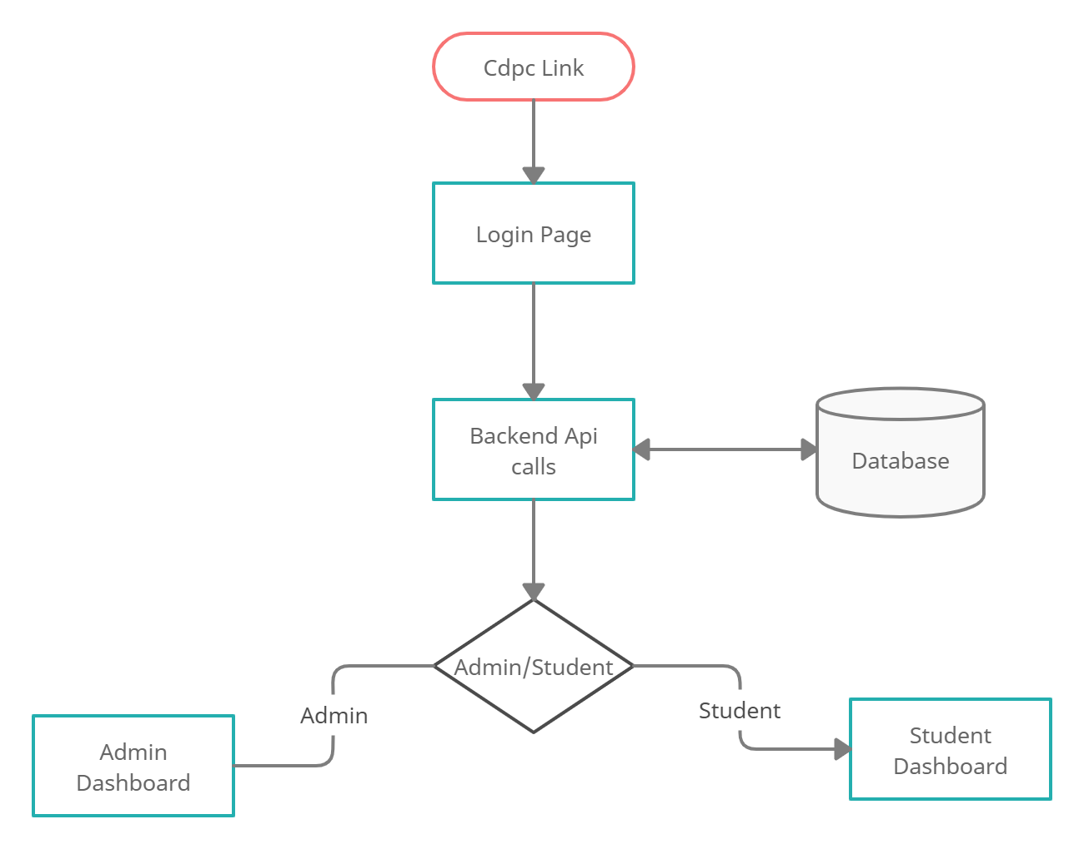

Fig 1.1

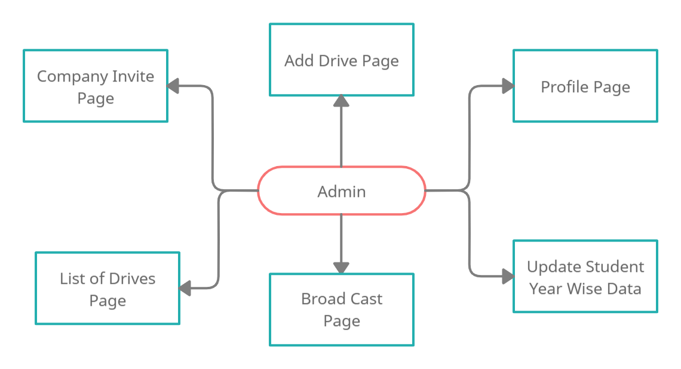

Fig 1.2

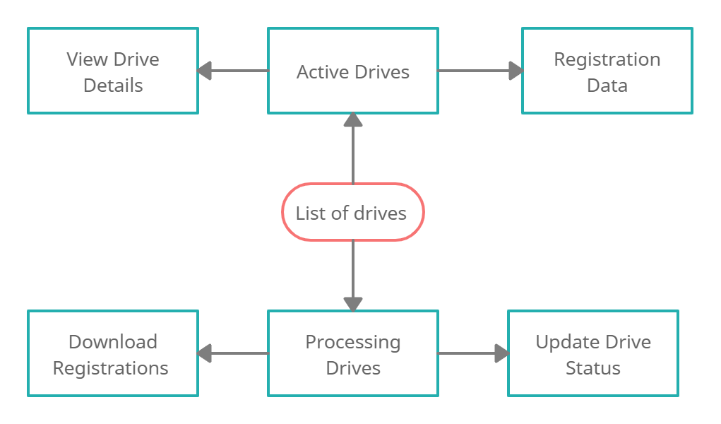

Fig 1.3

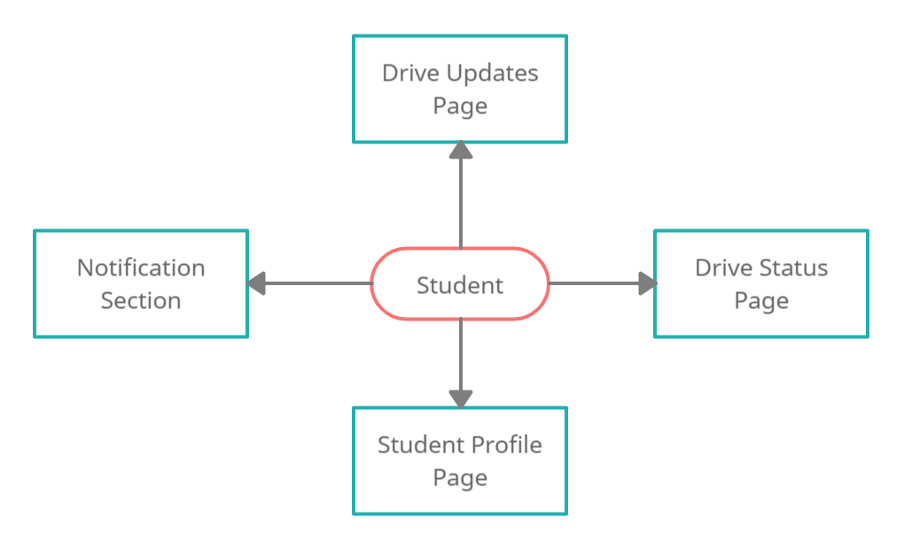

Fig 1.4

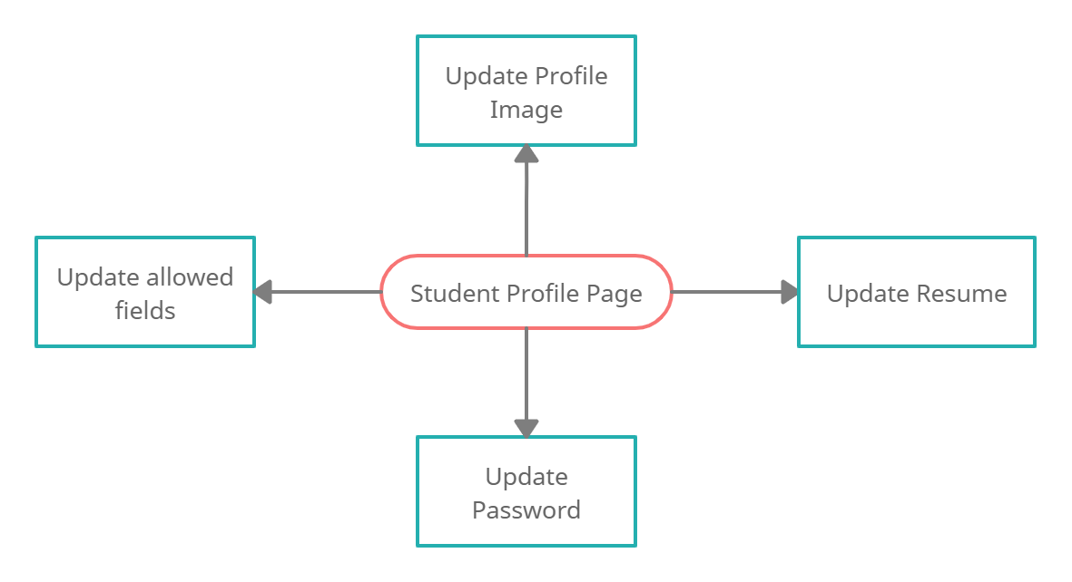

Fig 1.5

**4.2 Explanation of each component**

Fig 1.1

**Backend API Calls:**

In login page Student/Admin provides the credentials both username and password, after providing the credentials, UI requests the spring boot login API. Login API will validate the credentials. If it is valid 200 response will send along with token, roles, username and expiry time. If it is not, bad credentials response will be sent.

**Admin/Student Page:**

From login response, application will identify the role of the user is i.e., Admin/Student, according to the role of the user, it redirects to the user interface (UI) of the Admin/Student Page.

Fig 1.2

**Add Drive Page:**

In add drive page admin has access to add new drive and it will be displayed to all students in the website. In add drive form, it will take the company details, eligibility requirements of the students, mode of the drive process, included steps in drive process and description about the job nature, role, location, stipend and bond details etc.

**Add Profile Page:**

In Admin profile page user can only update the password. User need to provide both old password and new password.

**Company Invite Page:**

In this page, admin invite the company to add new drive in the website. It requires email address to send drive form to the email to the company mail. Here we providing a temporary access to add drive page to the company. For example, we are sending invite link with one/two days validity of the add drive page. The link expires after the validity date.

**Broadcast Page:**

In this page admin can send notifications to all students. Using broadcast page admin can easily establish communication with students and forwarded company updates with this page.

**Update Student Year Wise Data:**

In this page admin have access to add new batch of students who has qualified to apply drives. The format of student data is JSON file. Admin provides JSON file with student’s data, in backend it will take all the student data and save it in database with role STUDENT.

Fig 1.3

**Active Drives:**

In Active Drives page, it shows all drives which are in active state and it will show the registered students details for the particular drive with count of applied students. Admin can view the drives details and can download it after the registration link expired.

**Processing Drives:**

In processing drives page, all the drives which are expired to apply will be present to proceed the further steps. It will change the status to starting round of the drive. Admin can download all the registered data and data will be sent to company. Using the registered student’s data admin starts the drive process with company. In this page admin can update the qualified students to next round.

Fig 1.4

**Drive Updates Page:**

In drive processing page it will show all the list of drives that are currently active. Student can view the details of the drive and can apply if he/she interested in the drive and if he/she meet the eligibility criteria.

**Drive Status Page:**

In drive status page it will show all the list of all the drives that the student applied and shows the status of the student in each drive, like at which round student is present or qualified.

**Student Profile Page:**

In this page the student personal details are displayed and the student will able to update few allowed details.

**Notifications Section:**

The notices that are sent regarding the drives or any other information will be displayed here.

Fig 1.5

**Update Profile Image:**

Here students are allowed to change the current profile image.

**Update Student Resume:**

Here students can update the his/her current resume with the updated one.

**Update Student Details:**

Here students allowed to modify the some of the fields in their personal information.

Experimental Results

**5.1 Technologies or Libraries used**

**Technologies:**

For Front-end development:

* + NPM (Node Package Manager)
  + ReactJs Library from JavaScript
  + Visual Studio Code (software)

For Back-end development:

* + - Amazon web services EC2 and S3 bucket
    - SpringBoot framework from Java
    - MySQL & mongo DB databases
    - Eclipse Editor

**Libraries:**

For Front-end development:

**HTTP Request module**:

React component exposes network request functionality. Useful component to perform a network request and parse the response using fetch request module.

**Bootstrap v.5:**

 React-Bootstrap is a component-based library that provides native Bootstrap components as pure React components. Instead of utilizing JavaScript source and plugins from the CDN, it converts all JavaScript to React and bundles all components together.

**React Router v.6:**

React Router – like the name implies – helps you route to/navigate to and render your new component in the index. html file. So as a single page application, when you navigate to a new component using React Router, the index.

For Back-end development:

**Amazon Web Services:**

AWS (Amazon Web Services) is a comprehensive, evolving [cloud computing](https://www.techtarget.com/searchcloudcomputing/definition/cloud-computing) platform provided by Amazon that includes a mixture of infrastructure as a service ([IaaS](https://www.techtarget.com/searchcloudcomputing/definition/Infrastructure-as-a-Service-IaaS)), platform as a service ([PaaS](https://www.techtarget.com/searchcloudcomputing/definition/Platform-as-a-Service-PaaS)) and packaged software as a service ([SaaS](https://www.techtarget.com/searchcloudcomputing/definition/Software-as-a-Service)) offerings. AWS services can offer an organization tool such as compute power, database storage and content delivery services.

API (Application Programming Interface):

API is the acronym for Application Programming Interface, which is a software intermediary that allows two applications to talk to each other. Each time you use an app like Facebook, send an instant message, or check the weather on your phone, you’re using an API

Making data available via API can support faster and easier data migration and improved data quality review and cleanup. APIs can provide greater flexibility in delivering services; for example, using a service that accesses a backend system to power a new product

A language and message format used by an application program to communicate with the operating system or some other control program such as a database management system (DBMS) or communications protocol

**Spring Boot:**

Spring Boot makes it easy to create stand-alone, production-grade Spring based Applications that you can just run. We take an opinionated view of the Spring platform and third-party libraries so you can get started with minimum fuss. Most Spring Boot applications need minimal Spring configuration. It has features Create stand-alone Spring applications, Embed Tomcat, Jetty or Undertow directly (no need to deploy WAR files), Provide opinionated 'starter' dependencies to simplify your build configuration, automatically configure Spring and 3rd party libraries whenever possible, Provide production-ready features such as metrics, health checks, and externalized configuration, absolutely no code generation and no requirement for XML configuration

**5.2 Datasets**

* Student’s information from SMS (Student Management System)
* Student’s examination results from Examination cell (website)
* Companies temporarily created database from MongoDB

**5.3 System Hardware**

* + Windows 10/11 with 64-bit operating system (or) Other supported operating systems
  + HardDisk with available space up to 50GB
  + RAM with minimum of 8GB

**5.4 Results**

Back - end code Samples:

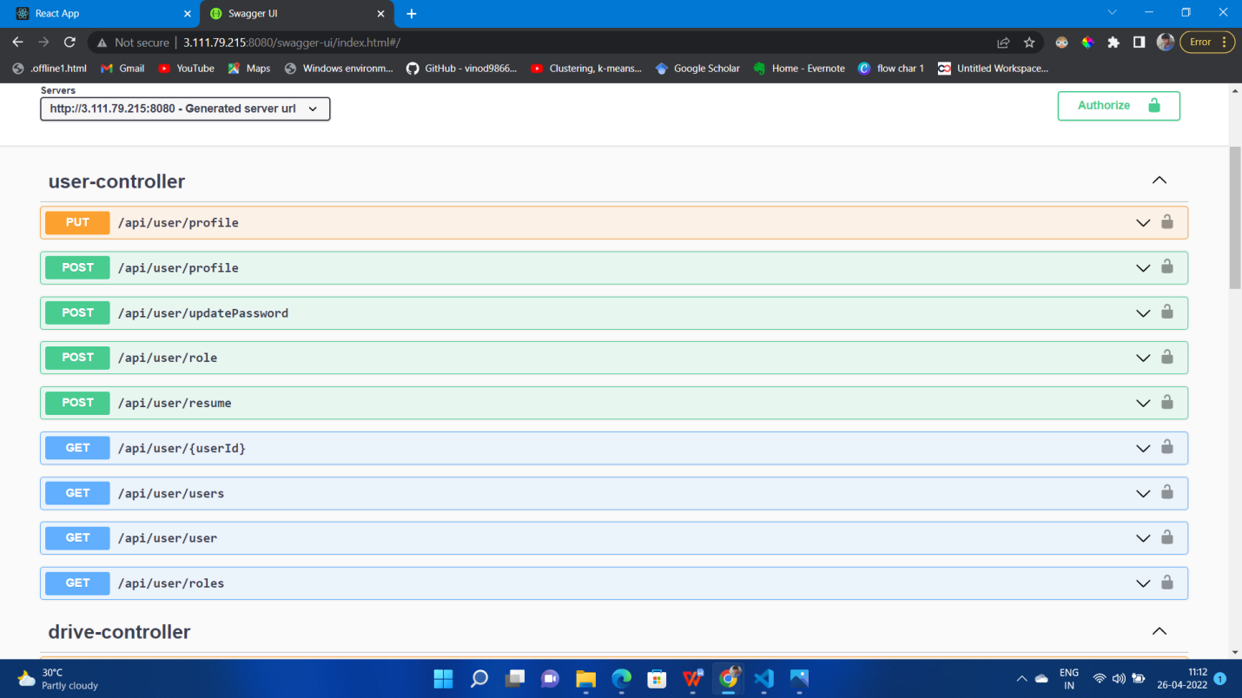

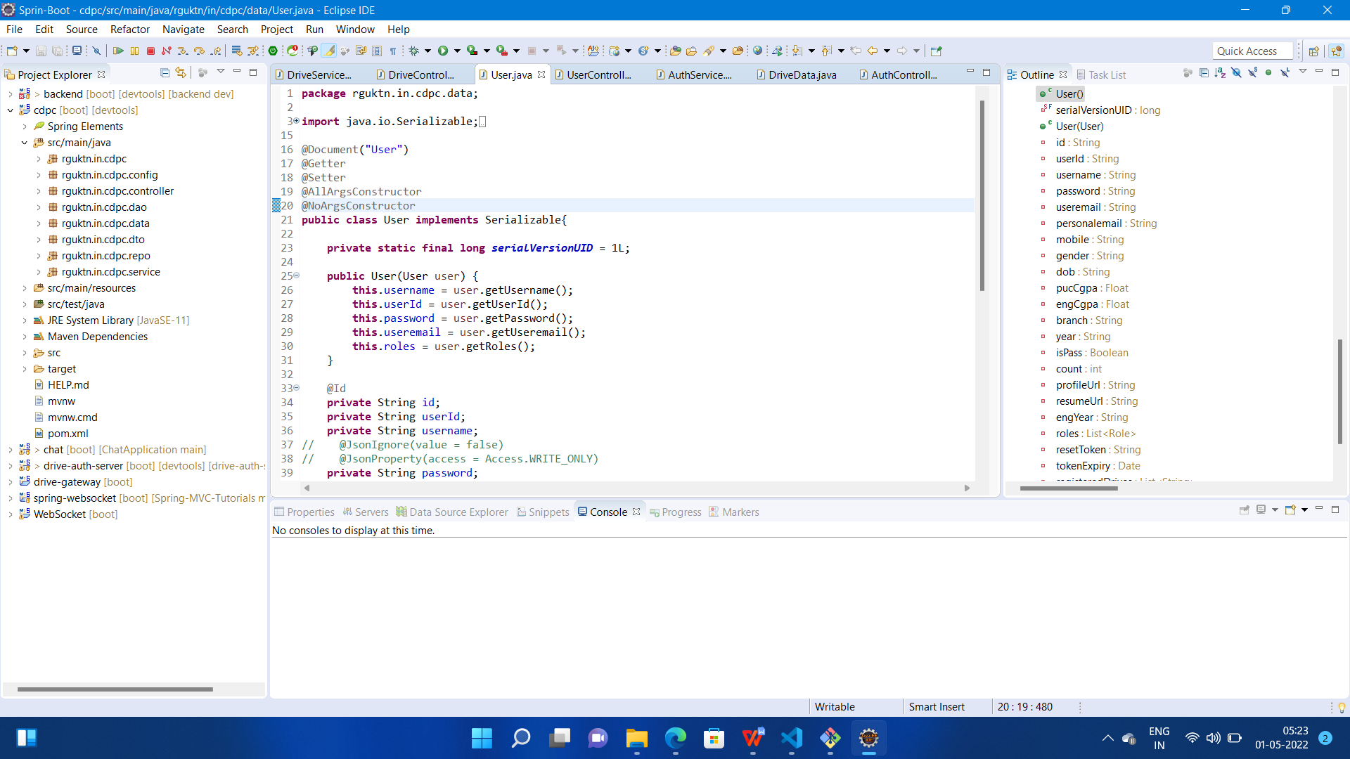

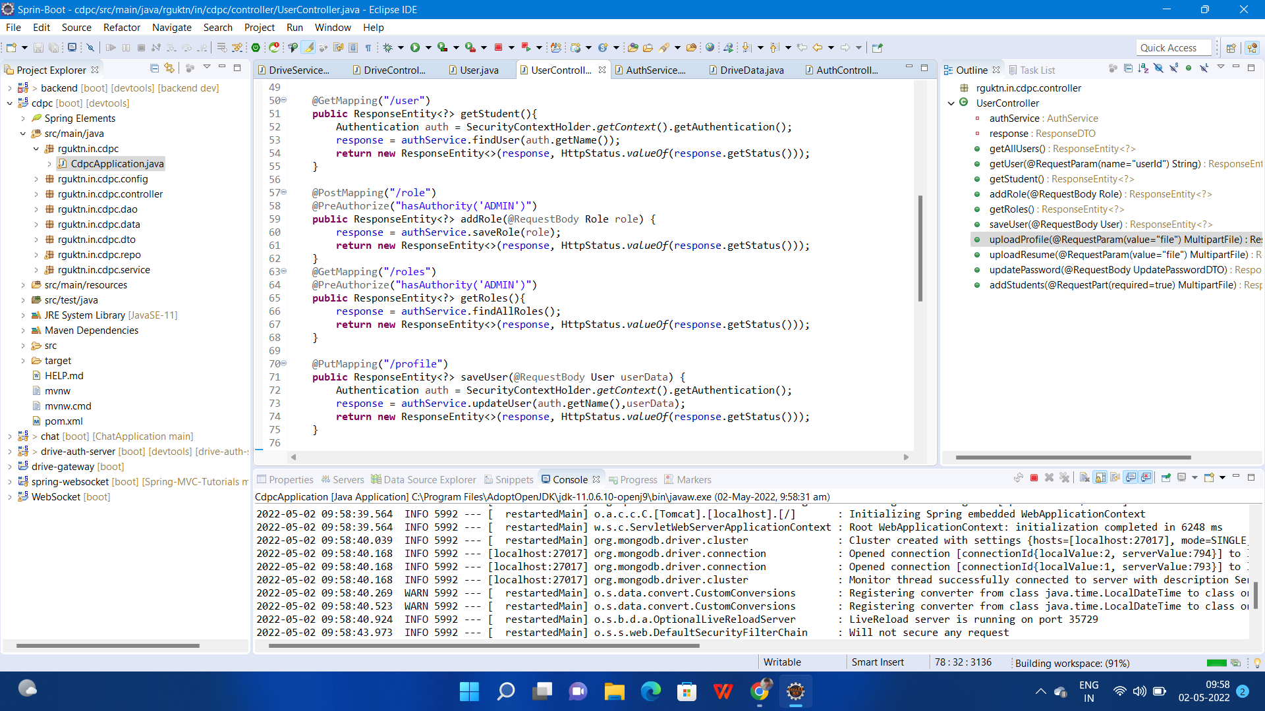

Front-end Results :

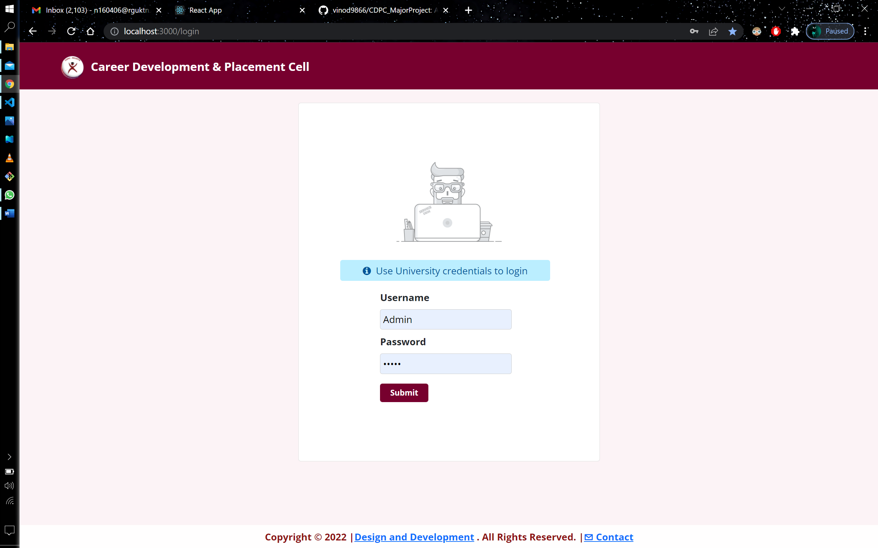

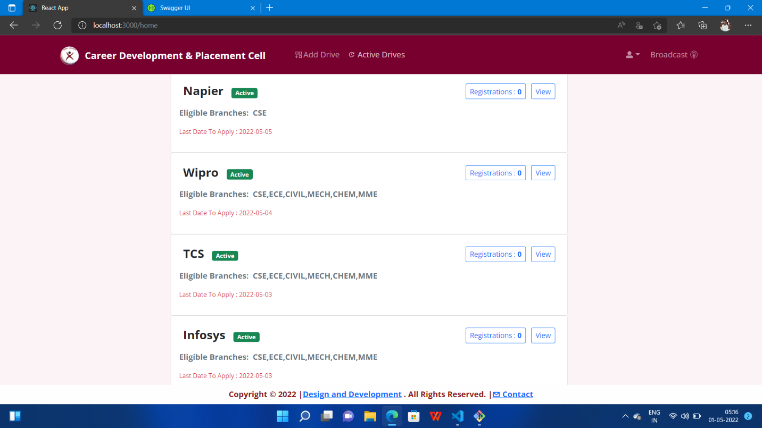

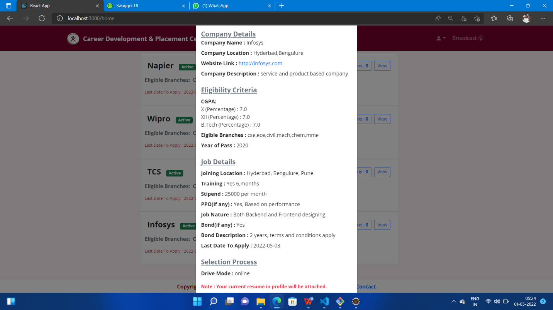

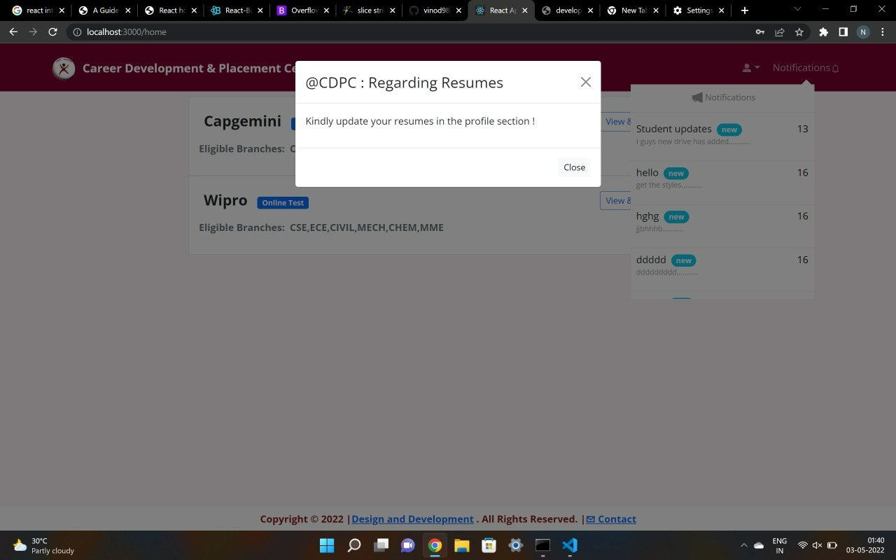

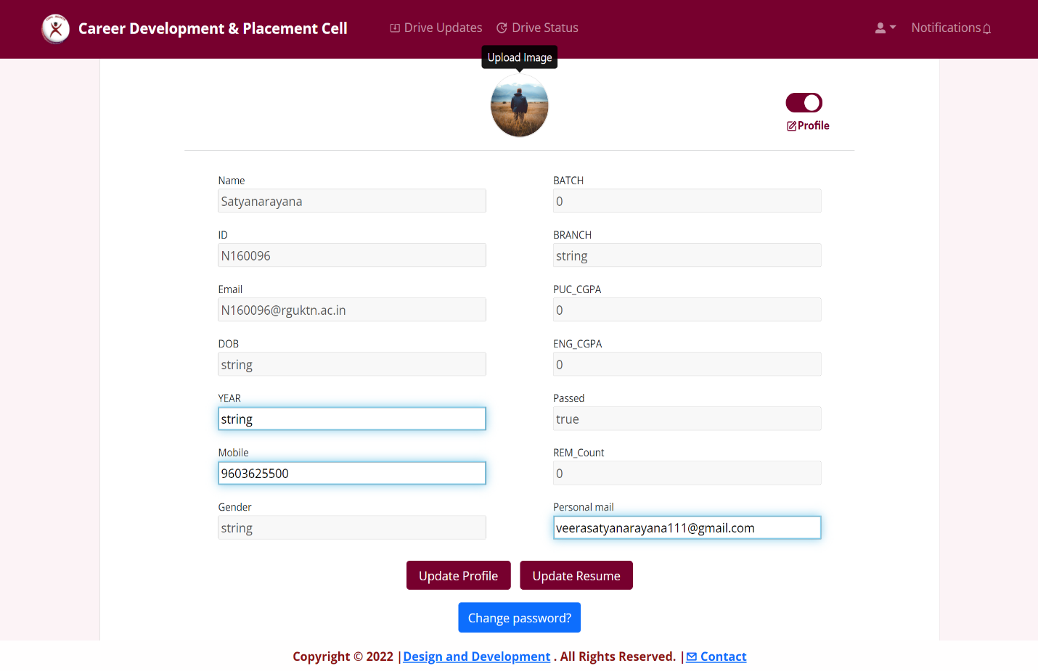

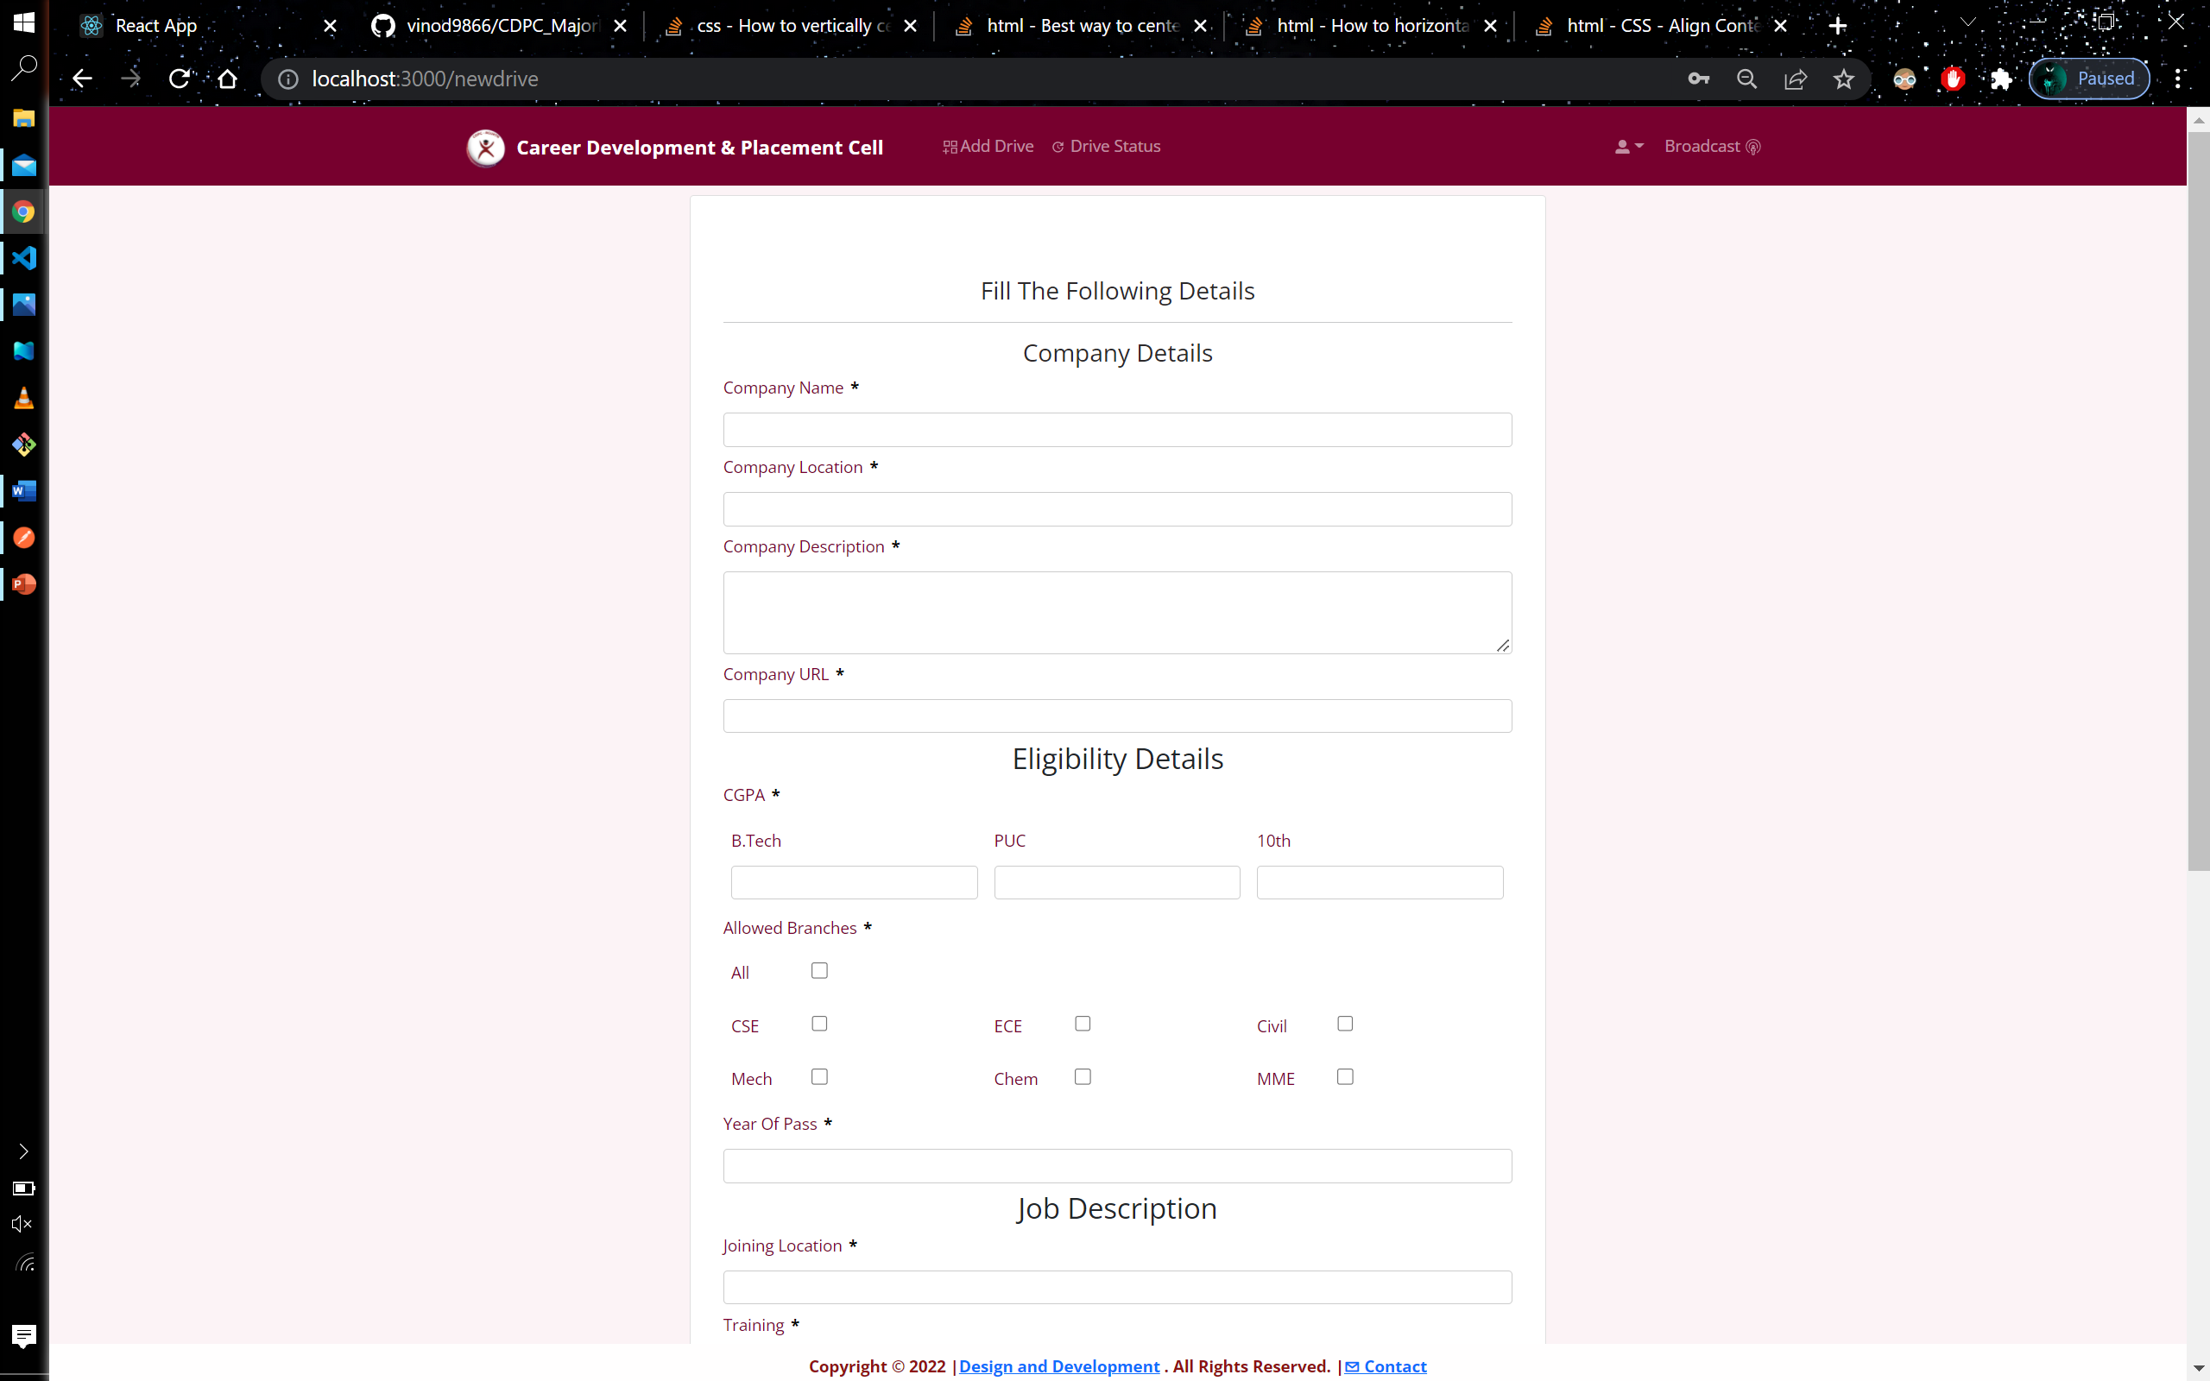

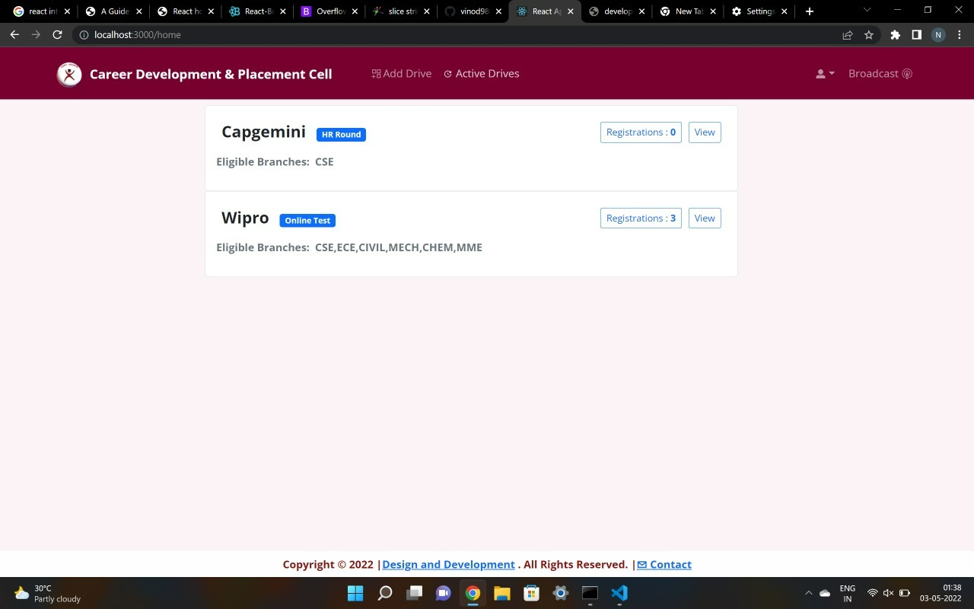

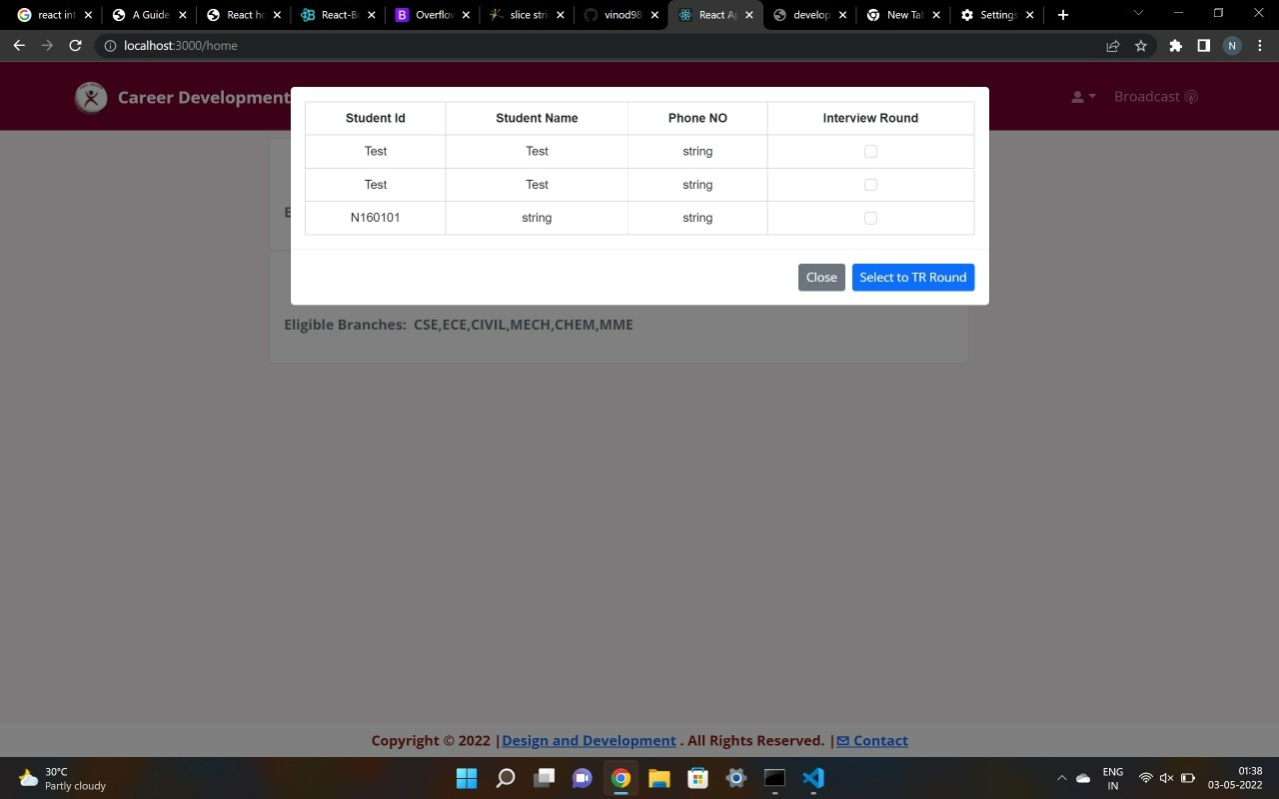

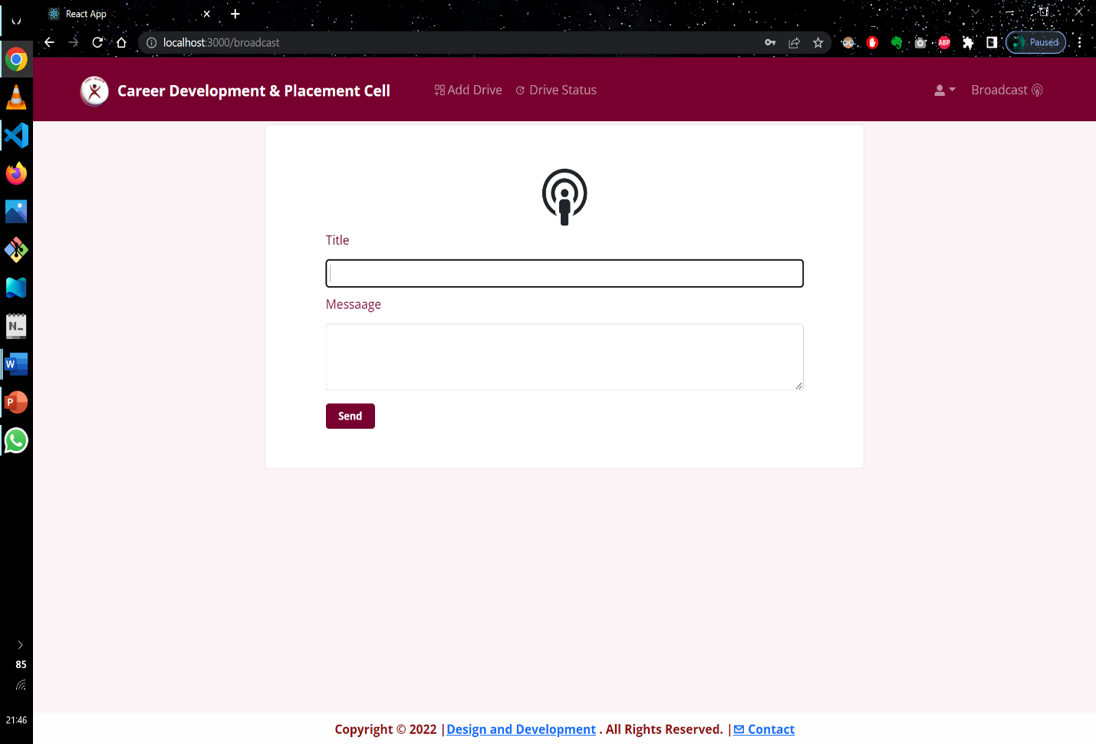

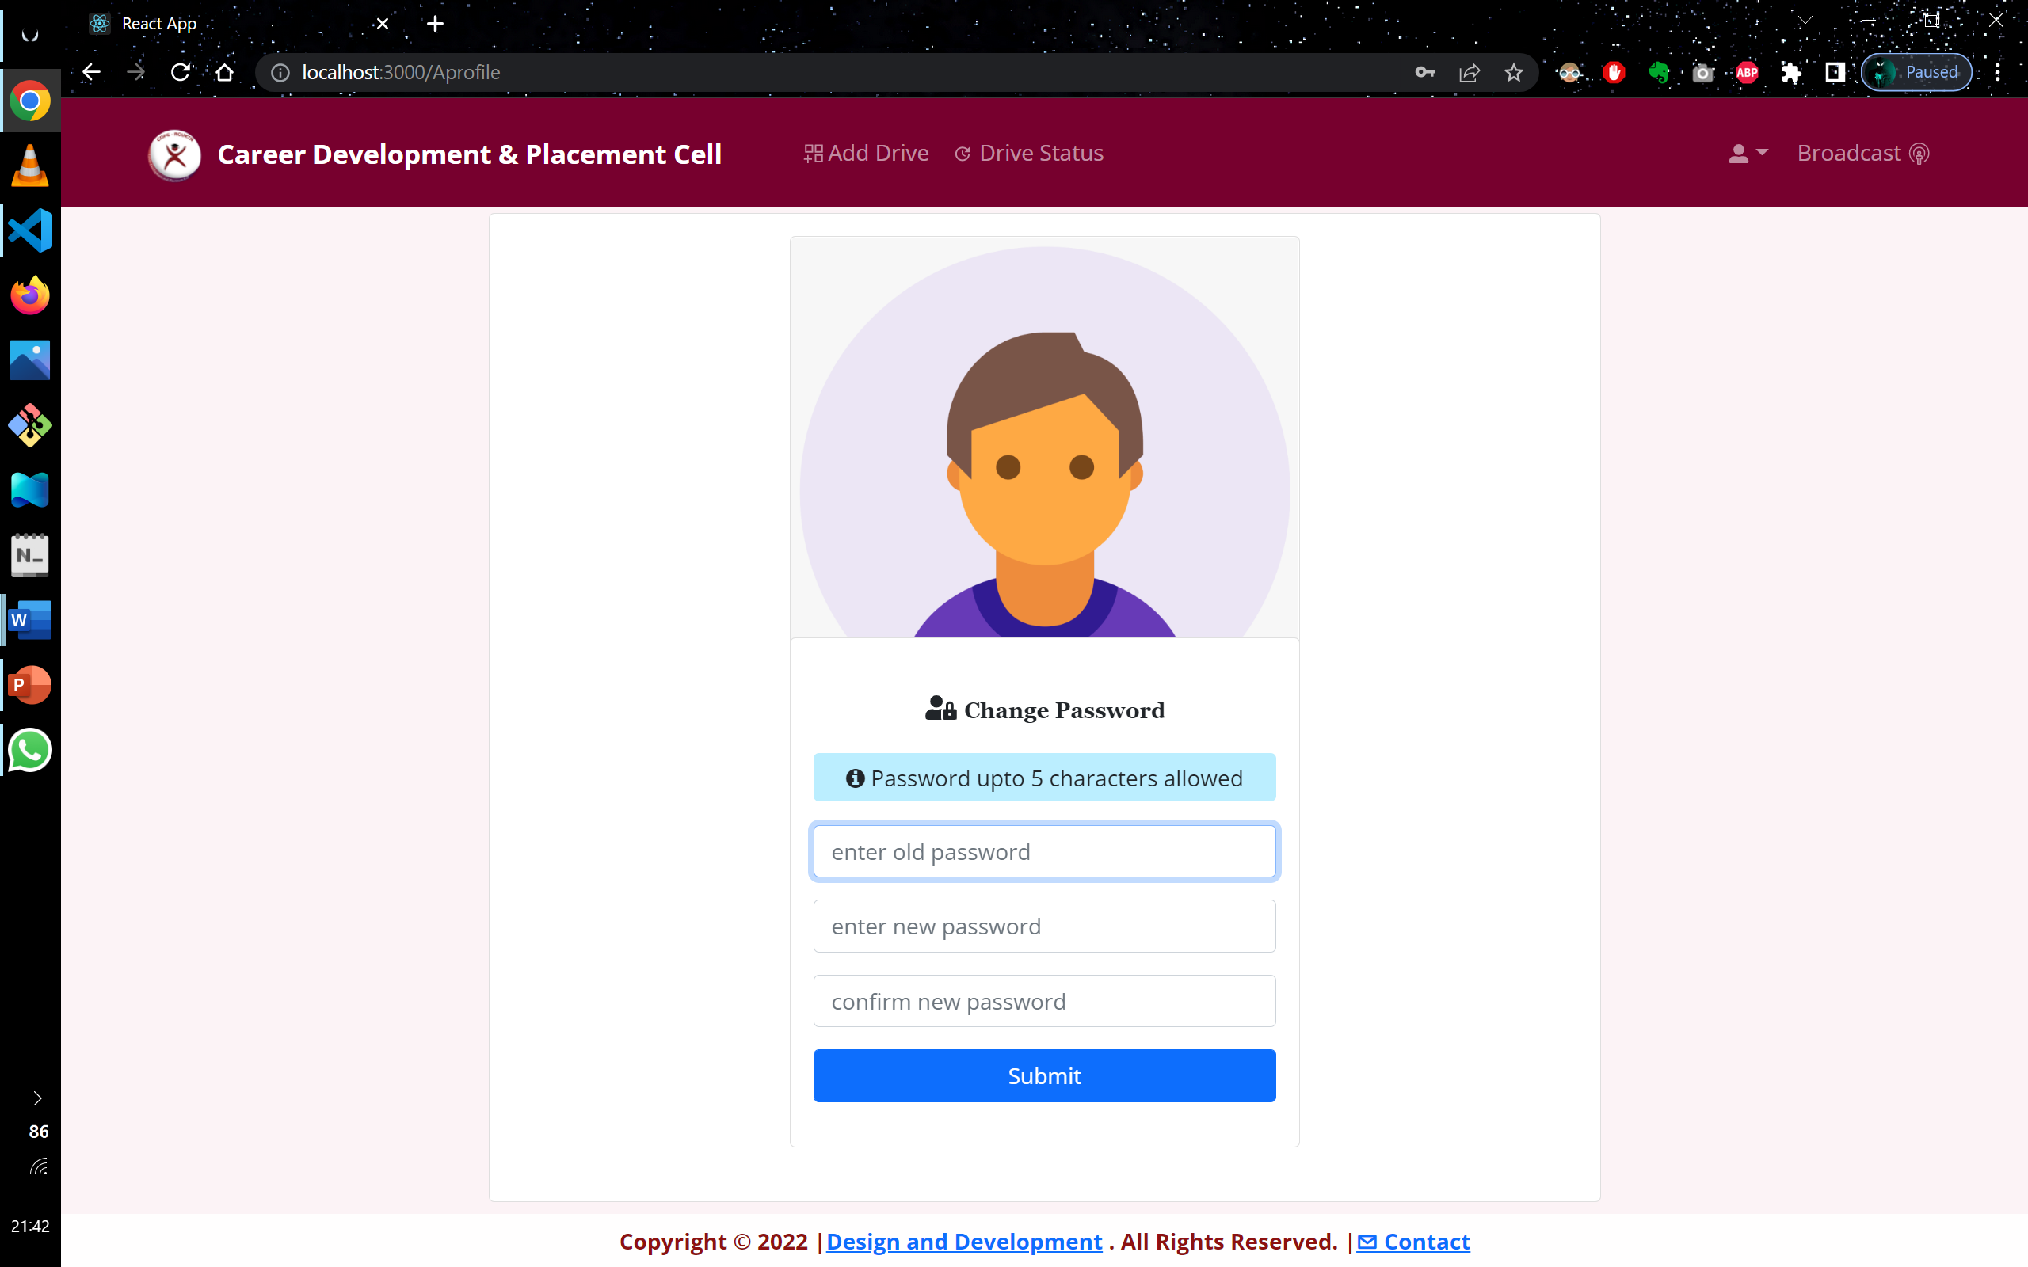

Conclusion

“Student campus drive tracking portal” is a web application used by students and managed by administration for applying company drives and keep tracking of the applied drives. Admin has right to add drives and update drive processes and can broadcast information to all the students. Student can able to perceive the information about the newly added drives and can trace about his status on applied drives by receiving notifications thorough website, registered email and mobile number.

Future Scope

* Achieving the improvement of the styles and responsiveness in application on particular sections
* Provide admin, the authority to cancel a particular drive directly
* Adding additional features like direct text for registered mobile number, when the student is qualified to the next round. It is beneficial for the student, who doesn’t use neither social media application nor gmail.
* Provide concerned company, more options and flexible accessibility to handle their drives individually with the co-ordination of administration.

References

**https://spring.io/projects/spring-boot**

**https://reactjs.org/**

**https://aws.amazon.com/**

**https://oauth.net/articles/authentication/**