# Project 1

# Dashboard Screen of My Project

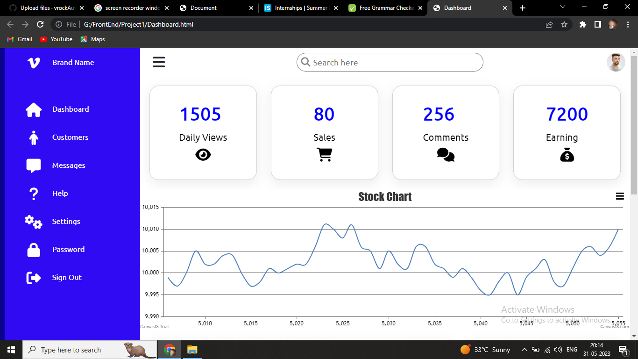

# 2) Highlight the all navigation bar

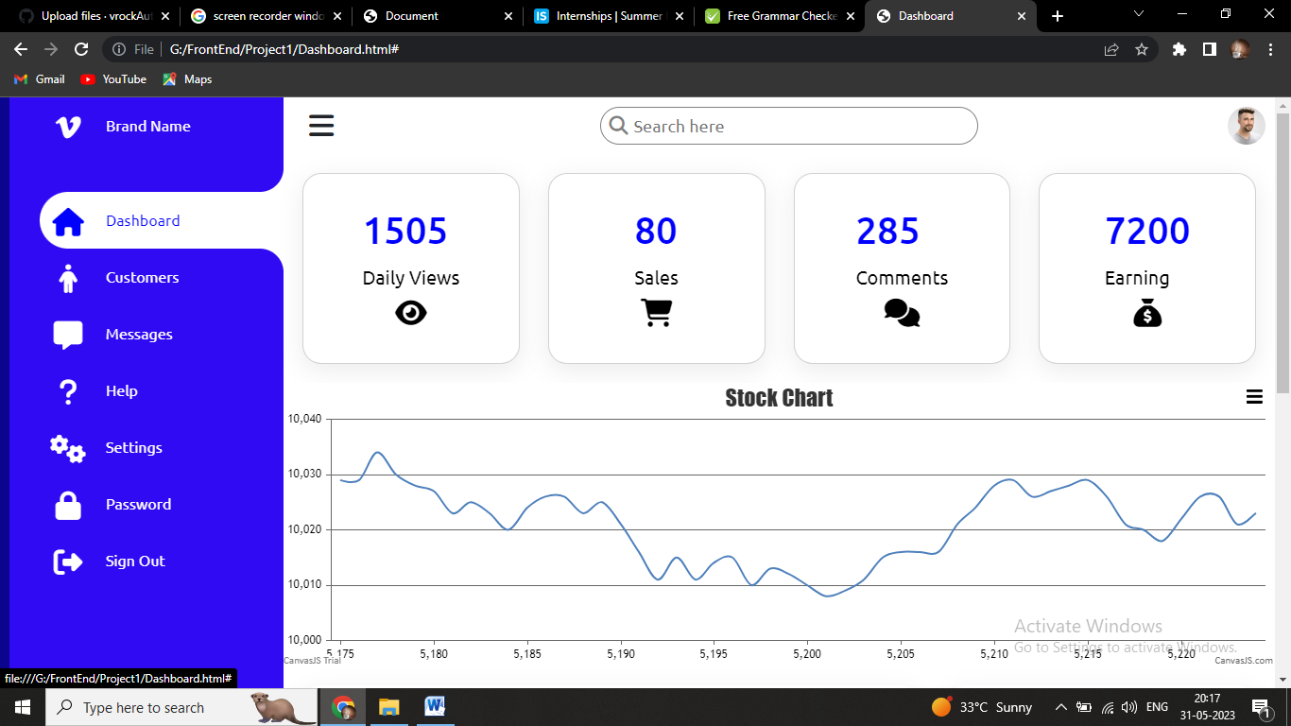

# Dynamic Chart of company’s Stock

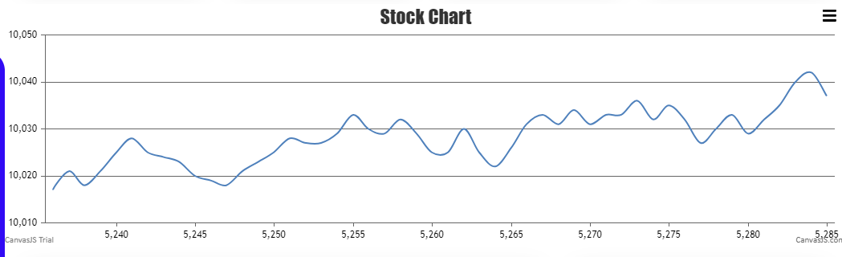

­

# Daily Viewers, Sales, Comments and Earing etc.

­­­­­­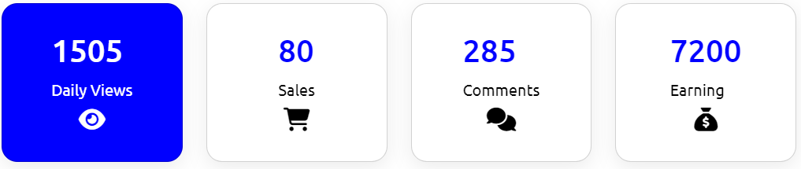

# Recent Orders

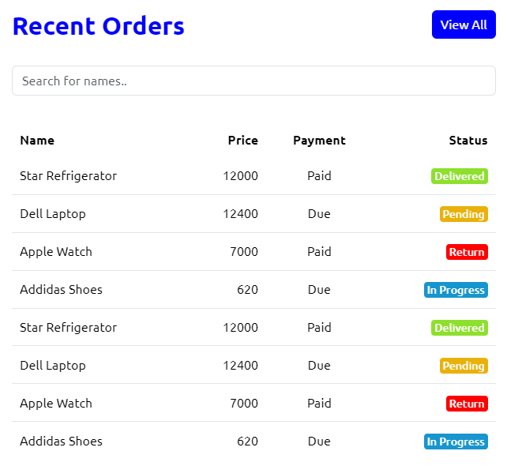

# Recent Customer

