1. **VS Code pusing the changes “Added Execute Image” in the repository.**

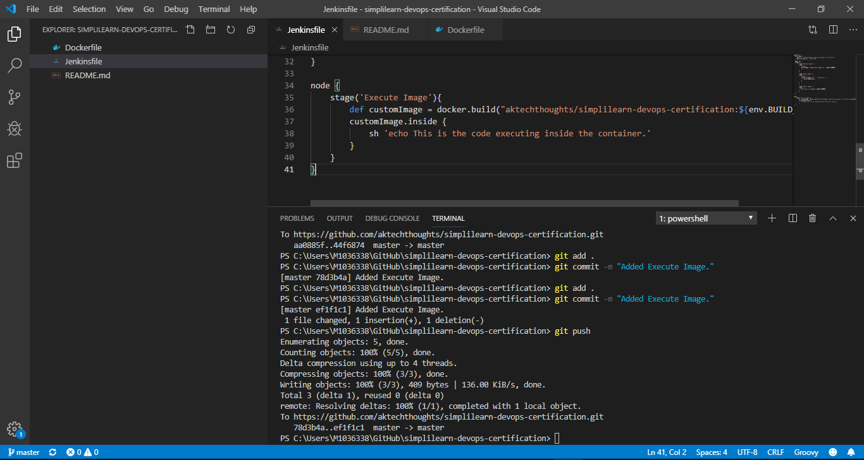

1. **Jenkin CI pipeline for building and pushing the image to docker hub.**

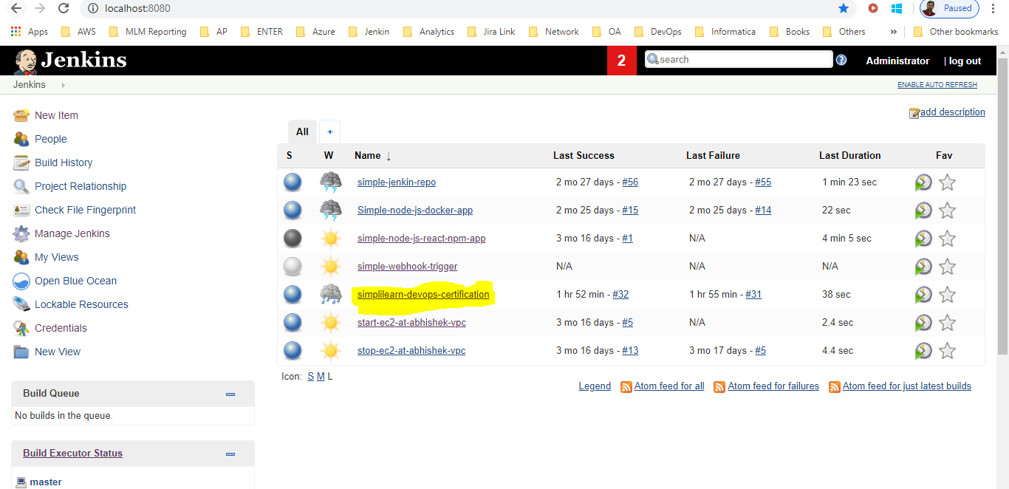

1. **CI pipeline at the time of execution.**

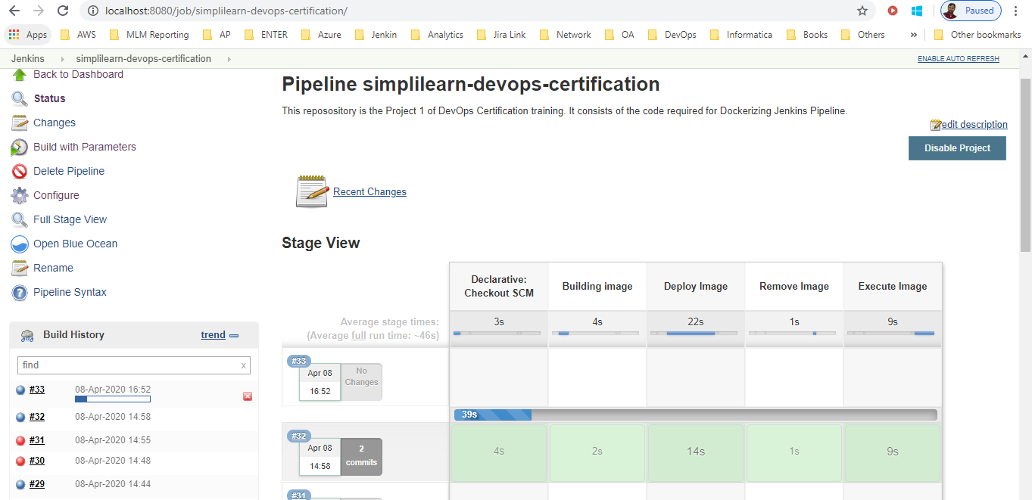

1. **CI pipeline executing the command “echo This is the code executing inside the container.” Inside the container.**

