How to run the .ipynb file in Kaggle portal

- Since this project requires a massive 45 GB data, we need GPU enabled platform for training and testing, hence local machine and Google Colab will encounter multiple issues and consumes lot of time. Hence run the code in the Kaggle environment.
- Launch https://www.kaggle.com/ portal
- Register with email ID and log in to the portal
- Complete the verification using mobile number and it’s a mandate
- Click New File notebook
- Navigate to File Import Notebook
- Once the NIH_ChestXray_DiseaseDetection_Final_V1.ipynb file is loaded, you will be able to view all the cells
- Navigate to the below path as specified and ensure the GPU T4 is enabled and internet if OFF.

- 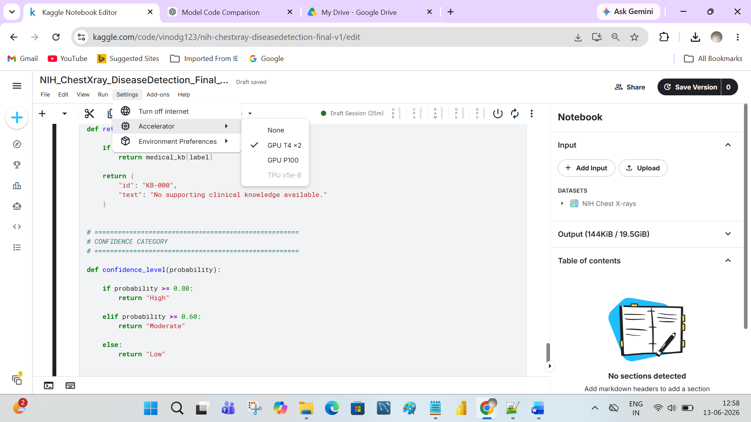

- Click on Add Input and Enter the path - https://www.kaggle.com/datasets/nih-chest-xrays/data/data
- And click on + button to upload the dataset
- Click on Save Session and enable the below details.

- 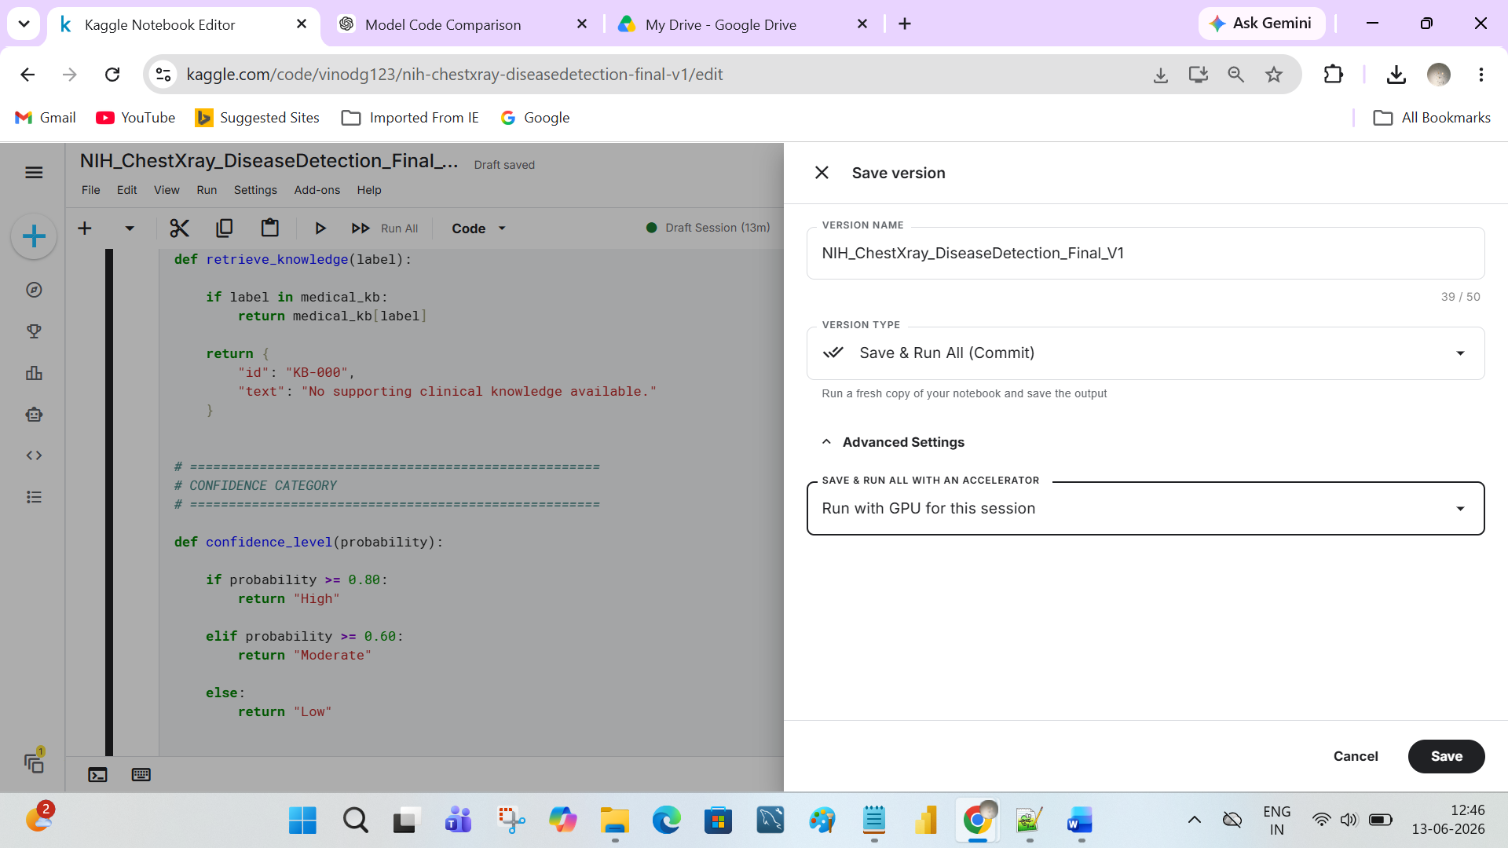

- Hit Save and waiting for the test to run.
- One more way to run the test, no need to perform Save Version and run each cell through option.
- Save Version enable you to trigger the run and continue with some other some activity.

