Streamlit Dashboard Validation Report
AI-Assisted Performance Testing & Quality Engineering
This report documents a visual review of the Streamlit performance-testing dashboard. The screenshots show the upload workflow, summary metrics, charts, baseline analysis, investigation section, current-run data, and report export controls.

1. Scope and observed workflow
- Upload baseline and current-run JMeter CSV files separately.
- Display summary metrics including average response time, throughput estimate, error rate, and maximum concurrent users.
- Visualize response time by transaction and transaction throughput contribution.
- Display baseline regression analysis and quality-gate status.
- Provide investigation sections and current-run transaction data.
- Offer Excel and PowerPoint report download controls.

2. Observed dashboard metrics
Metric | Displayed value | Interpretation / caveat
Average response time | 94.0 ms (approximately) | Displayed summary value; verify against raw CSV calculations.
Overall throughput | 10.60 req/s | Timestamp-derived estimate; may differ from JMeter's official run duration.
Observed error rate | 0.00% | No failures shown in the displayed run; validate with a failed-request test.
Maximum concurrent users | 1 | Displayed run appears to have used one concurrent user.
Values are transcribed from the screenshots, not independently recalculated from the CSV files. Treat throughput as an estimate unless exact test start and end times are available.

3. Validation checklist
Test case | Expected result | Evidence in screenshots | Status
Upload baseline and current CSV | Both files accepted and comparison shown | Upload controls and success message visible | Observed
Display summary metrics | Summary metrics visible | Response time, throughput, error rate and users displayed | Observed
Render performance charts | Transaction charts render | Response-time and throughput charts visible | Observed
Show regression analysis | Comparison and quality gate appear | Analysis table and PASS message visible | Observed visually; calculations not independently verified
Show investigation and current data | Investigation sections and table appear | Both sections visible | Observed
Download Excel report | Valid workbook downloads and opens | Download button visible; file integrity not verified | Pending functional check
Download PowerPoint report | Valid presentation downloads and opens | Download button visible; file integrity not verified | Pending functional check
Handle failed HTTP request | Failure detected and reported correctly | No failure scenario shown | Not tested
Validate malformed/empty CSV | Clear validation message appears | Not shown in screenshots | Not tested

4. Findings and recommended follow-up
- Improve chart readability by enlarging transaction labels or using shorter labels.
- Keep overall throughput distinct from transaction throughput contribution in labels and explanatory text.
- Test empty files, missing required columns, malformed values, and failed requests.
- Open the downloaded Excel and PowerPoint files to verify content, charts, and formatting.
- For regression testing, use comparable baseline and current workloads (same user count, ramp-up, loop count, environment, and test data).
- Use public practice APIs only for modest workflow demonstrations; perform capacity testing only on systems you own or are authorized to test.

5. Dashboard screenshots
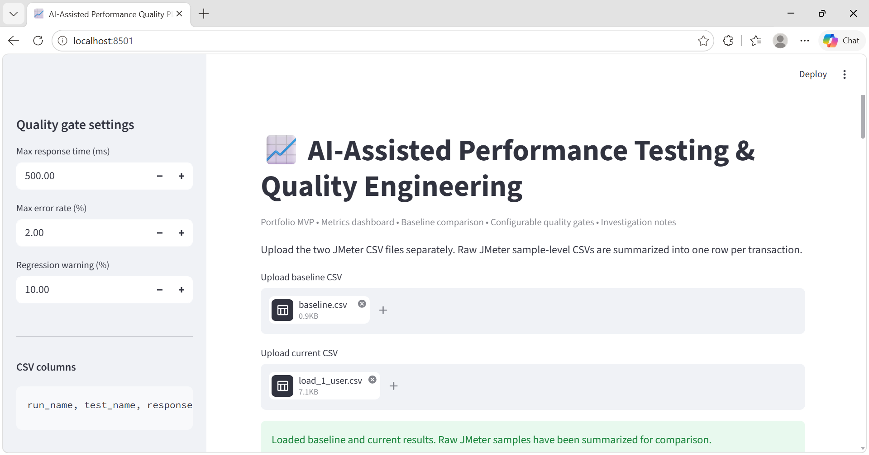
Screenshot 1 — CSV upload controls and successful-load message.
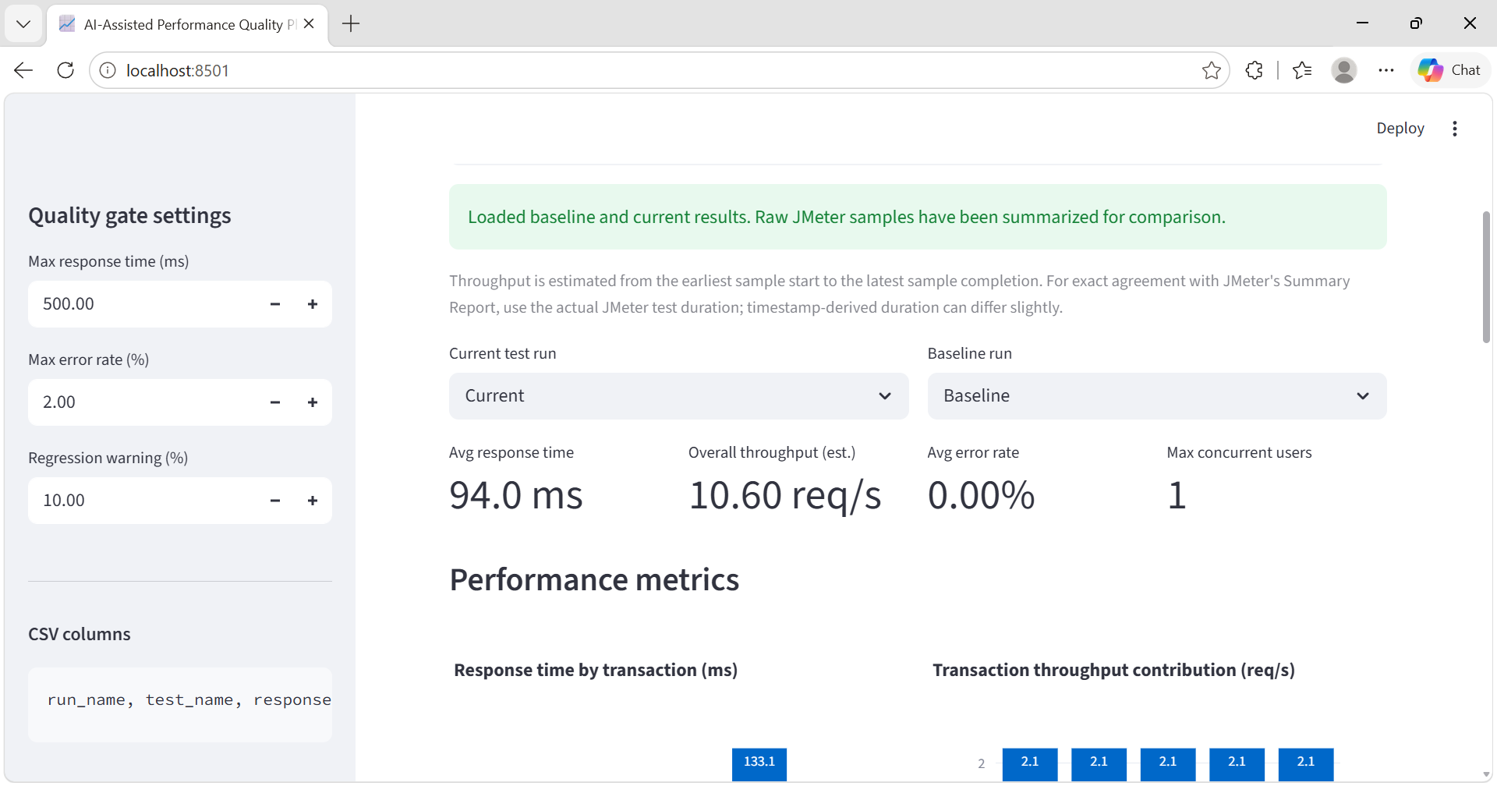
Screenshot 2 — Summary metrics and initial performance charts.

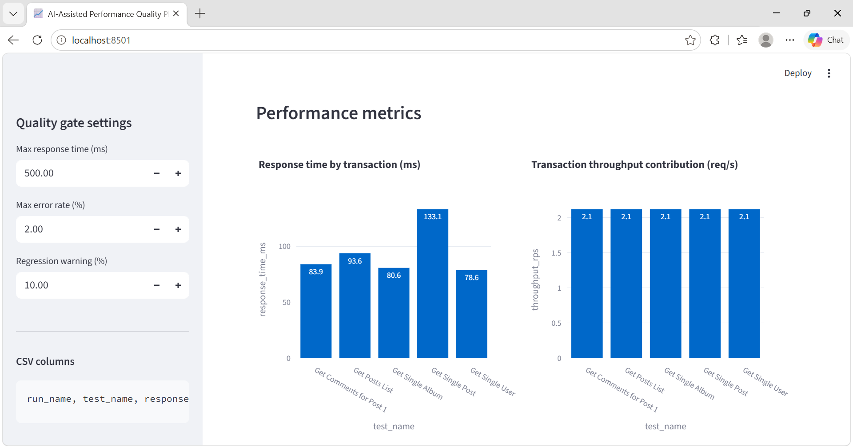
Screenshot 3 — Performance charts and baseline regression analysis.
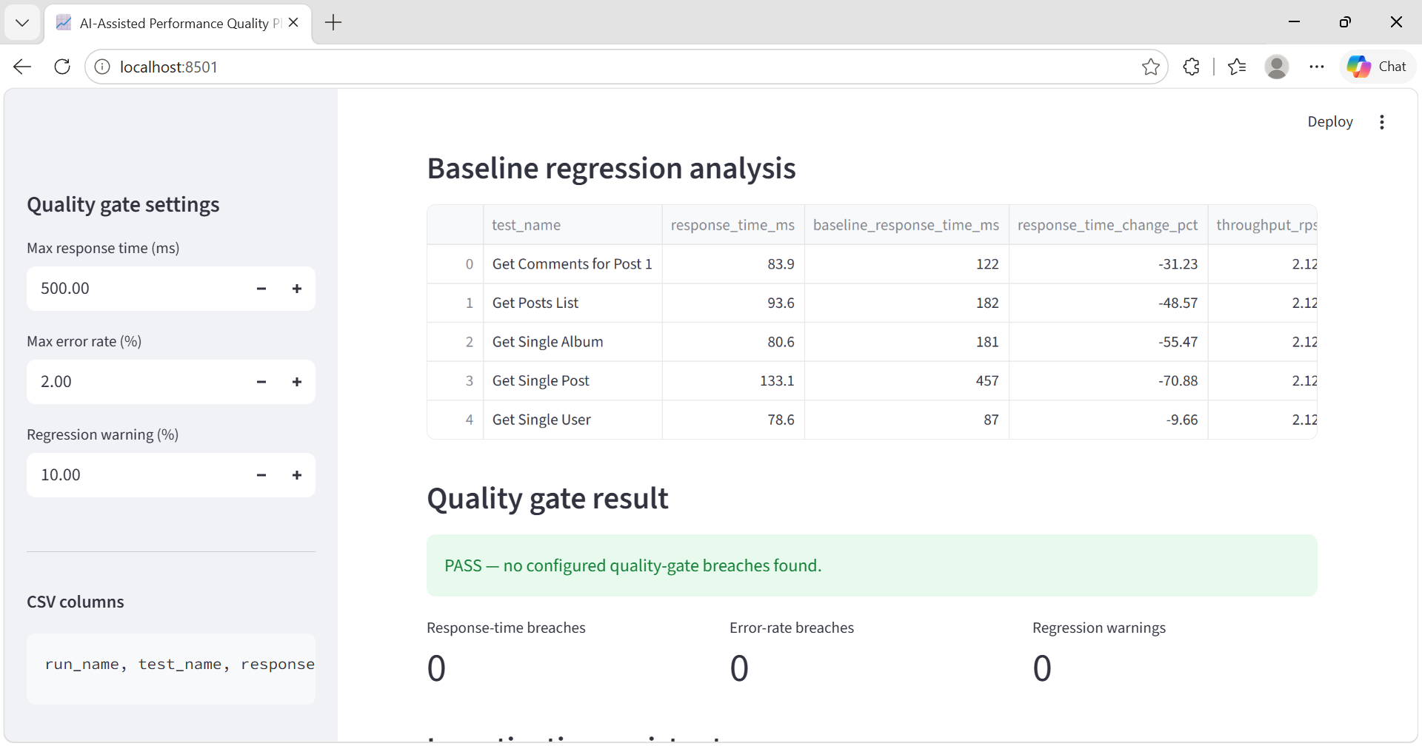
Screenshot 4 — Investigation assistant and current-run data.

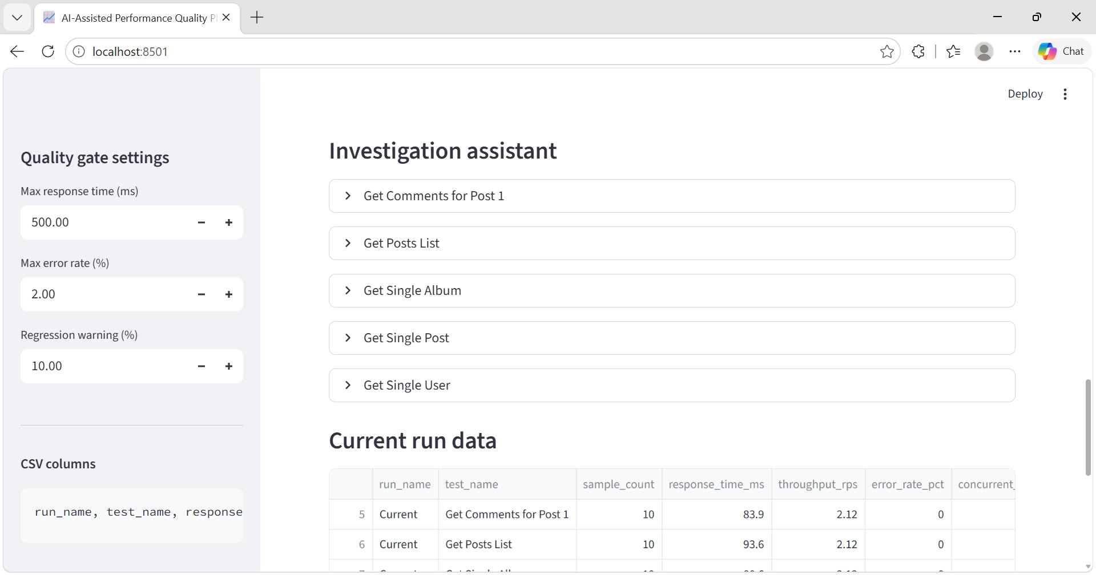
Screenshot 5 — Current-run table and report download controls.
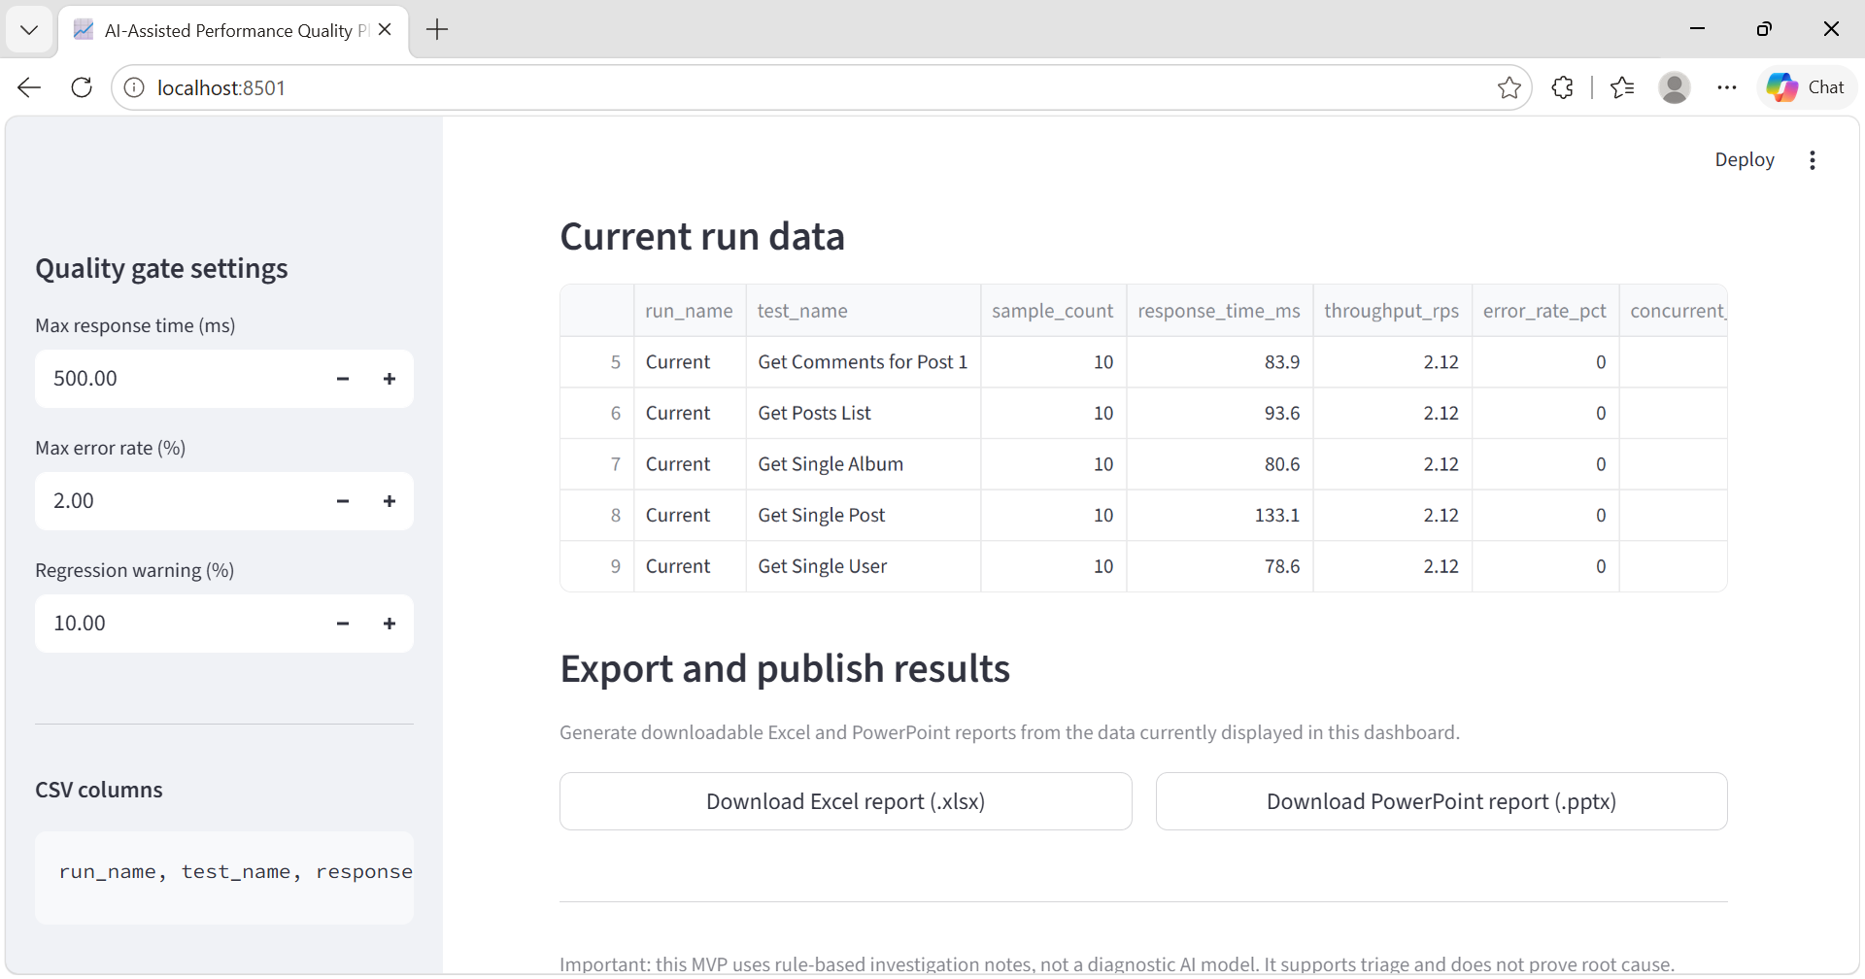
Screenshot 6 — Additional dashboard capture.

Validation conclusion
The screenshots demonstrate that the dashboard interface and main reporting sections are present. This is a visual/interface validation, not a complete functional or numerical validation. Excel/PowerPoint export integrity, edge-case handling, failed-request handling, and metric calculations should be tested before describing the application as fully validated.

