SIMATS ENGINEERING

ASSESSMENT TOOL 2 : Scenario-Based

COURSE NAME: Cloud Computing and
Big Data Analytics
COURSE CODE: CSA15

COURSE OUTCOME COVERED
CO2: Analyze virtualization architectures to identify performance and security issues in cloud computing environments. (BL3)

Dave's Taxonomy: Manipulation (Level 2) Question Count: 5

Total Marks: 25

Code of Conduct
I Y.VINODHKUMAR(192472359) (Name / Reg No) certify that this submission is my original work and that I have adhered to the guidelines specified for this assessment.
I understand that any violation of academic integrity rules will result in disciplinary action. Signature of the student: VINODH

Assessment Tasks Scenario-Based Questions

- A media company wants to migrate its video streaming platform to the cloud. The system must handle millions of concurrent users with minimal buffering. Design a cloud architecture using scalability and caching techniques.
Explain how load balancing and auto-scaling can ensure smooth streaming. Discuss cost optimization strategies for such high-demand workloads.

Cloud Architecture for Large-Scale Video Streaming

Scalable Streaming Architecture

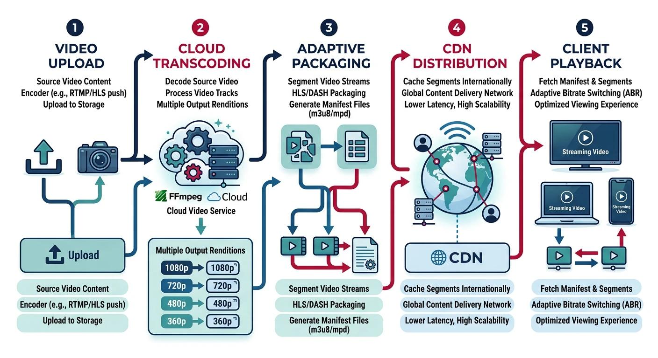

Proposed Cloud Design
1. Content Ingestion & Processing
- Upload videos to cloud storage (object storage like S3/Blob)
- Use transcoding services to create multiple resolutions (240p–4K)
- Store encoded content for adaptive bitrate streaming (ABR)

2. Storage Layer
- Distributed object storage (high durability)
- Use multi-region replication for availability
- Store video chunks (HLS/DASH format)

3. Content Delivery Network (CDN)
- Cache video content at edge locations
- Deliver content from nearest server → reduces latency & buffering
Key benefit: Minimizes load on origin servers

4. Application Layer
- Stateless streaming servers (APIs, authentication, recommendations)
- Deployed on VMs or containers (Kubernetes)

5. Load Balancer
- Distributes incoming traffic across multiple servers
- Ensures no single server is overloaded

Role of Load Balancing
- Distributes millions of user requests
- Prevents hotspots and server crashes
- Supports:
  - Round-robin / least connections
  - Geo-based routing
Ensures:
- High availability
- Reduced response time
- Smooth streaming experience

Auto-Scaling for Demand Handling
- Automatically adds/removes compute instances based on:
  - CPU usage
  - Network traffic
  - Number of requests
Types:
- Horizontal scaling: Add more servers (preferred)
- Vertical scaling: Increase server capacity
Benefits:
- Handles traffic spikes (e.g., live events)
- Avoids over-provisioning
- Maintains consistent performance

Caching Strategies (Critical for Low Buffering)
Multi-Level Caching
- CDN Edge Cache (most important)
- Regional cache
- Origin cache
Techniques:
- Cache popular videos (hot content)
- Use cache invalidation for updates
- Segment-based caching (video chunks)
Result:
- Faster playback start time
- Reduced latency
- Lower backend load

Cost Optimization Strategies
1. Efficient Resource Usage

- Use auto-scaling to avoid idle resources
- Shut down unused instances

2. Storage Optimization
- Tiered storage:
  - Hot storage → frequently accessed videos
  - Cold storage → rarely watched content

3. CDN Offloading
- Serve most traffic via CDN (reduces origin costs)
- Pay less for compute & bandwidth at core

4. Spot/Reserved Instances
- Use reserved instances for baseline load
- Use spot instances for non-critical processing (e.g., encoding)

5. Compression & Encoding Efficiency
- Use efficient codecs (H.265, AV1)
- Reduces bandwidth cost

6. Monitoring & Optimization
- Track usage patterns
- Scale based on real demand

End-to-End High-Scale Video Streaming Flow
Component |  | Dynamic Function / Technical Responsibility
User Device |  | Initiates playback request, automatically routed via Anycast DNS to the nearest node.
CDN Edge |  | Checks local cache. Cache Hit: Instantly delivers video chunks; Cache Miss: Forwards request.
Load Balancer |  | Intercepts edge misses and balances concurrent client threads smoothly to avoid hot-spotting.
Auto-Scaled Fleets |  | Multi-instance web app cluster that dynamically scales up/down based on active CPU/traffic load.
Object Storage |  | Central repository storing segmented multi-bitrate chunks (e.g., 2s–6s discrete file slices).
Adaptive Streaming |  | Client player continuously adjusts resolution (HLS/DASH) in real time based on active network bandwidth.

Final Insight
Load balancing ensures traffic is evenly distributed
Auto-scaling adapts to millions of users dynamically
CDN + caching minimize buffering and latency
Cost optimization balances performance with efficiency
Result: A highly scalable, low-latency, cost-efficient video streaming platform capable of handling massive concurrent users.
- A fintech startup is deploying applications using containers across multiple cloud providers. They face challenges in maintaining consistency and managing deployments.
Propose a solution using container orchestration and multi-cloud strategies. Explain how service discovery and scaling can be handled efficiently.
Highlight the benefits and risks of a multi-cloud deployment model.

Multi-Cloud Container Deployment with Orchestration
Proposed Architecture (Consistent Across Clouds)

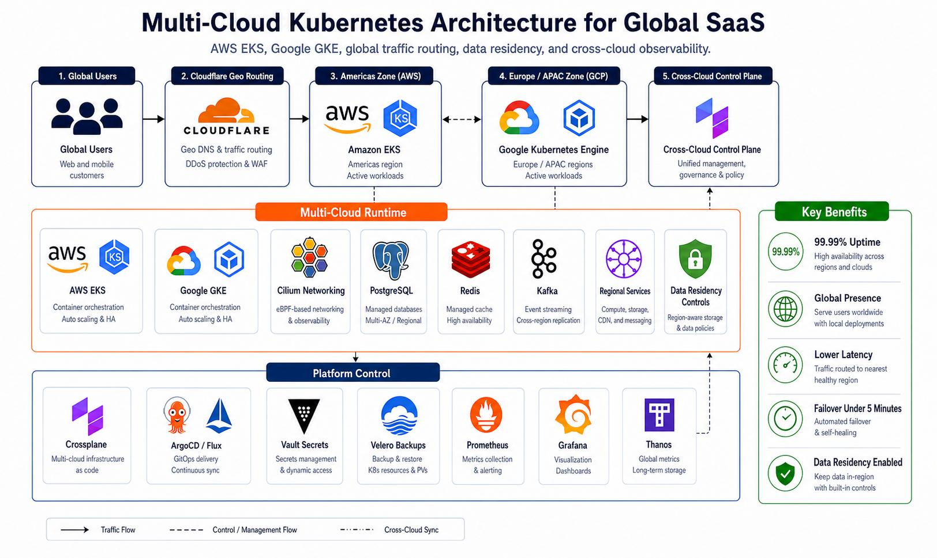

Solution Overview
To ensure consistency and manageable deployments, the fintech startup should adopt:
1. Container Orchestration (Kubernetes-Based)
- Use Kubernetes (K8s) clusters in each cloud provider
- Maintain consistency via:
  - Same container images
  - Same deployment manifests (YAML)
- Use Helm charts / GitOps (ArgoCD, Flux) for automated deployment
Ensures:
- Standardized environments across AWS, Azure, GCP
- Declarative, repeatable deployments

2. Multi-Cloud Strategy
Option A: Federated Kubernetes
- Use Kubernetes Federation (KubeFed)
- Synchronize deployments across clusters
Option B: Independent Clusters + Central Control
- Each cloud has its own cluster
- Managed via:

  - CI/CD pipelines
  - Central monitoring & policy tools
Recommended: Independent clusters + GitOps (simpler, more reliable)

Service Discovery & Communication
Service Discovery Mechanism

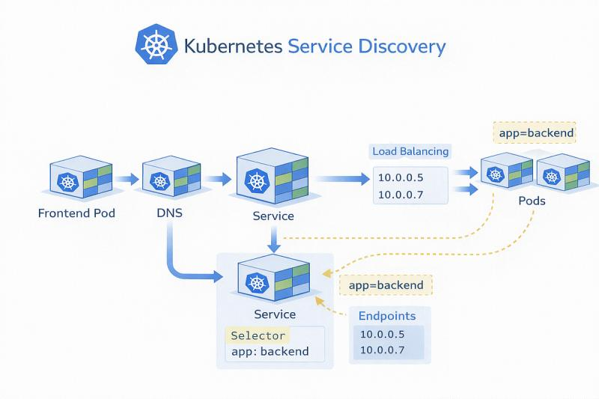

Inside a Cluster:
- Kubernetes DNS-based service discovery
- Services exposed via:
  - ClusterIP
  - NodePort / LoadBalancer
Across Clouds:
- Use Service Mesh (Istio / Linkerd)
  - Enables cross-cluster service discovery
  - Handles routing, retries, failover
Benefits:
- Seamless communication between microservices
- Traffic control & observability

Efficient Scaling
Horizontal Pod Autoscaling (HPA)
- Scales pods based on:
  - CPU / memory
  - Custom metrics (e.g., requests/sec)
Cluster Autoscaling
- Adds/removes nodes dynamically
Multi-Cloud Scaling Strategy
- Distribute workloads across clouds
- Use geo-based routing to direct users to nearest cluster

Result:
- Handles fintech traffic spikes (e.g., trading peaks)
- Ensures high availability

Deployment Consistency Techniques
- CI/CD Pipelines (GitOps):
  - Code → Build → Test → Deploy automatically
- Infrastructure as Code (IaC):
  - Terraform for multi-cloud provisioning
- Container Registry:
  - Centralized image storage

Benefits of Multi-Cloud Deployment
Advantages
- High Availability: Avoid single cloud failure
- Vendor Independence: No lock-in
- Performance Optimization: Serve users from nearest cloud
- Compliance: Store data in region-specific clouds
- Cost Flexibility: Choose cheapest provider per workload

Risks & Challenges
Complexity
- Managing multiple environments is difficult
Security Risks
- Inconsistent policies across clouds
- Larger attack surface
Data Consistency
- Syncing databases across clouds is hard
Cost Overhead
- Data transfer between clouds is expensive
Skill Requirements
- Requires expertise in multiple platforms

Summary
Aspect | Solution
Deployment consistency | Kubernetes + GitOps
Multi-cloud management | Independent clusters
Service discovery | Kubernetes DNS + Service Mesh
Scaling | HPA + Cluster Autoscaler
Reliability | Multi-cloud redundancy

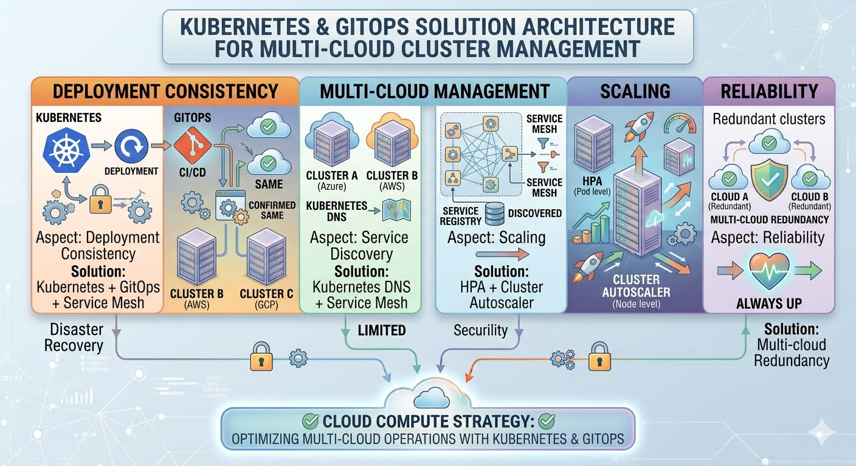
Final Insight
By combining Kubernetes orchestration, service mesh, and GitOps, the fintech startup can achieve:
- Consistent deployments across clouds
- Efficient service discovery
- Automatic scaling under load
However, they must carefully manage complexity, security, and cost to fully benefit from a multi-cloud strategy.

- An e-learning platform experiences data loss due to accidental deletion in the cloud. The organization needs a robust backup and disaster recovery strategy. Design a solution using cloud-native backup, replication, and versioning Explain how recovery time objective (RTO) and recovery point objective (RPO) are achieved. Provide steps to ensure business continuity during failures.

Cloud Backup & Disaster Recovery Architecture
Proposed Solution (Backup + Replication + Versioning)
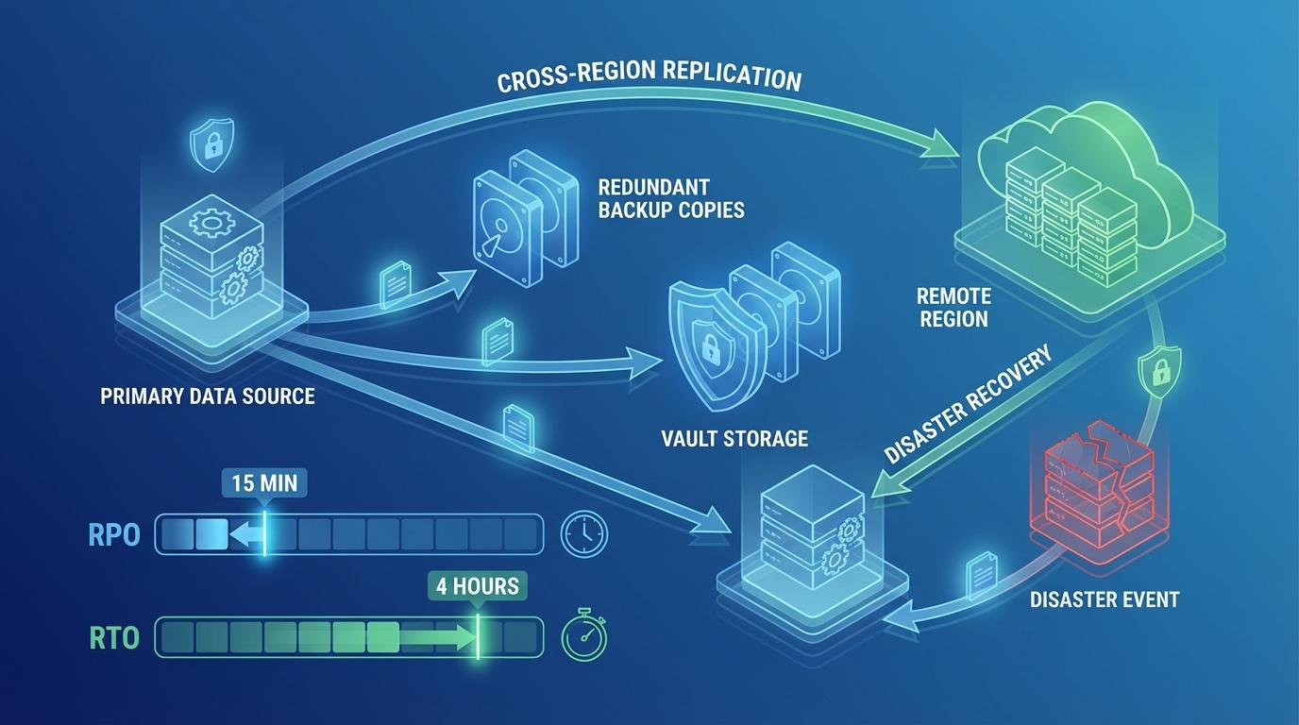

1. Cloud-Native Backup Design

Backup Strategy
- Automated Backups
  - Schedule daily/continuous backups of databases and storage
- Snapshot-based Backup
  - Take periodic VM and volume snapshots
- Incremental Backups
  - Store only changed data → reduces cost and time
Versioning
- Enable object versioning in storage (e.g., S3-like systems)
- Maintains multiple versions of files
- Protects against:
  - Accidental deletion
  - Data corruption
Deleted files can be restored instantly from previous versions

2. Replication Strategy
Multi-Region Replication
- Replicate data to a secondary region
- Use:
  - Asynchronous replication (cost-efficient)
  - Synchronous replication (for critical data)
Cross-Zone Redundancy
- Store copies across multiple availability zones
Ensures:
- Data durability
- Protection from regional failures

3. Achieving RTO & RPO
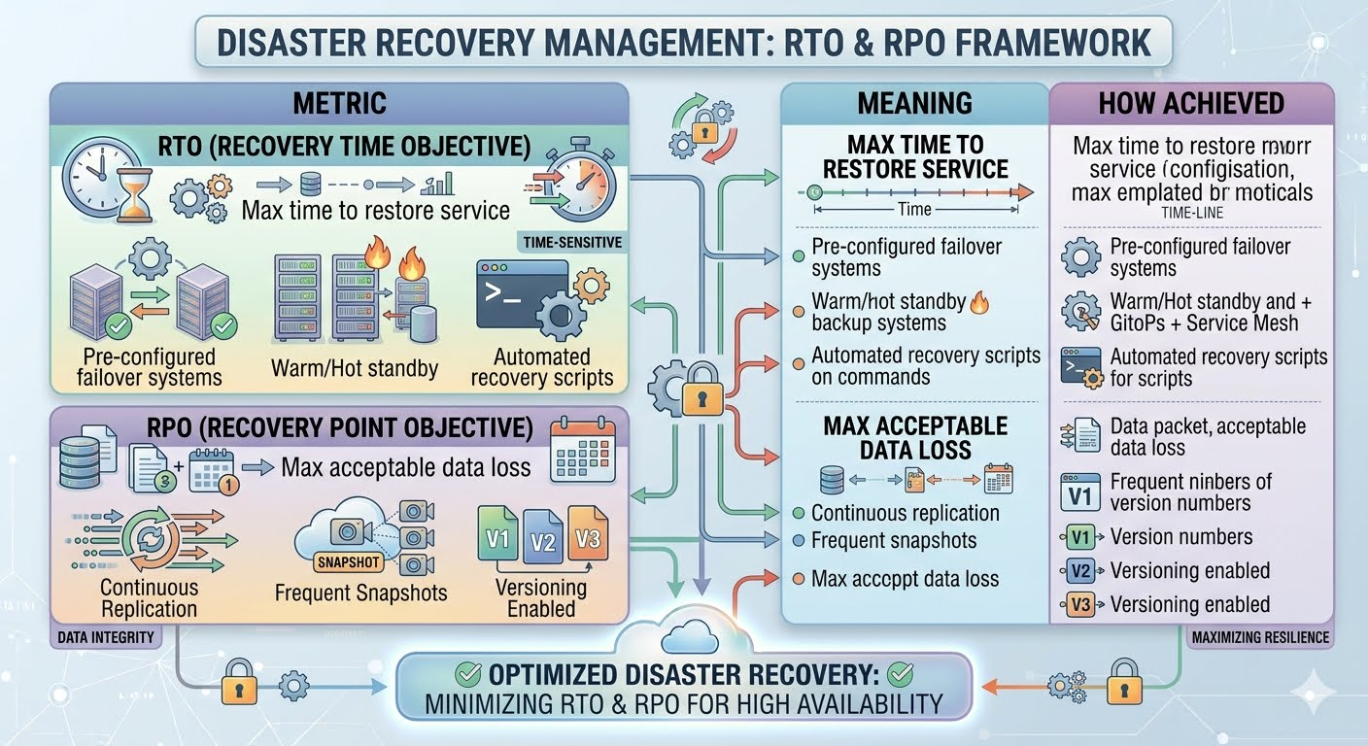
Example:
- RTO = 5 minutes → Use hot standby servers
- RPO = near zero → Use synchronous replication

4. Recovery & Failover Process
Disaster Recovery Workflow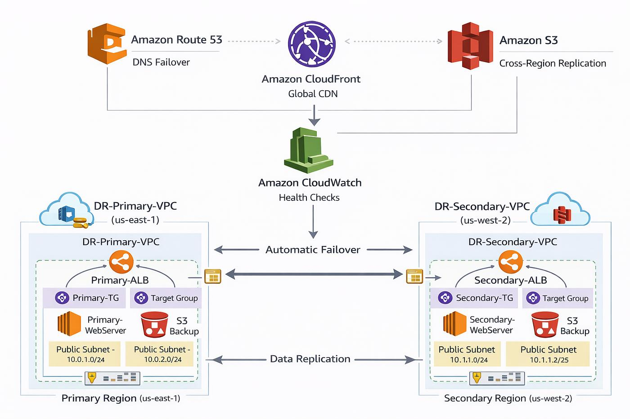

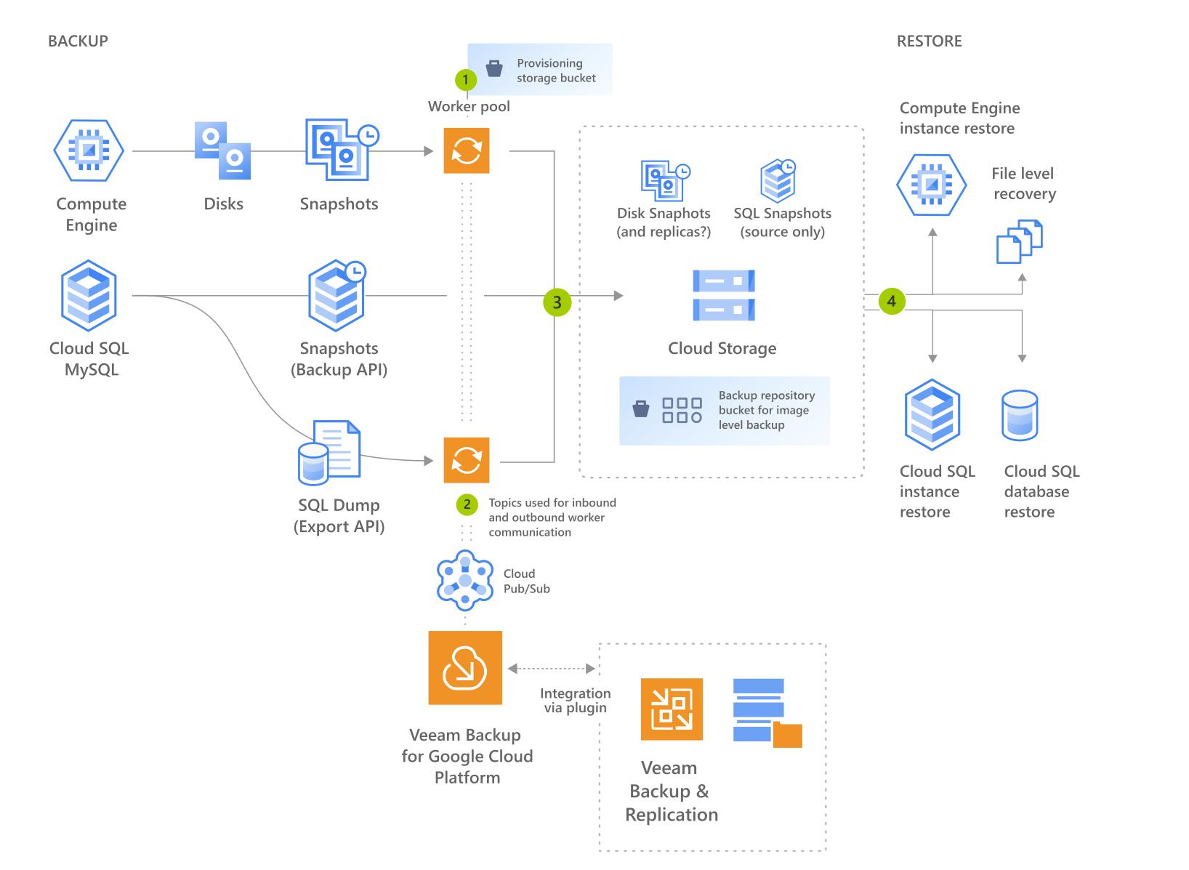

Steps:
- Failure Detection
  - Monitoring tools detect outage
- Traffic Redirection
  - DNS / load balancer redirects users to backup region
- Data Restoration
  - Restore latest snapshot or version
- Service Restart
  - Spin up VMs/containers in backup region
- Validation
  - Ensure system integrity before full traffic

5. Ensuring Business Continuity
Key Practices
1. High Availability Setup
- Deploy applications across multiple zones
2. DR Testing
- Perform regular disaster recovery drills
3. Backup Policies
- Define retention rules (e.g., 30–90 days)
4. Automation
- Use Infrastructure as Code (IaC) for quick recovery
5. Monitoring & Alerts
- Real-time alerts for failures
6. Security
- Encrypt backups
- Restrict access using IAM policies

Summary Architecture
Component | Role
Backup (Snapshots) | Point-in-time recovery
Versioning | Protects against deletion
Replication | Disaster resilience
Failover System | Ensures quick recovery
Monitoring | Detects failures early

Final Insight
By combining backup + versioning + multi-region replication, the e-learning platform can:
- Recover lost data quickly
- Minimize downtime (low RTO)
- Prevent data loss (low RPO)
- Maintain continuous service even during failures
This ensures a robust, resilient, and highly available cloud system.

- A government agency is adopting a hybrid cloud model for sensitive and non-sensitive data. Some applications must remain on-premises due to compliance requirements.
Design a hybrid architecture that ensures secure communication between environments. Explain how identity management and encryption should be implemented.
Discuss challenges in managing hybrid cloud environments.

Hybrid Cloud Architecture for Government Agency
Secure Hybrid Cloud Design (On-Prem + Public Cloud)

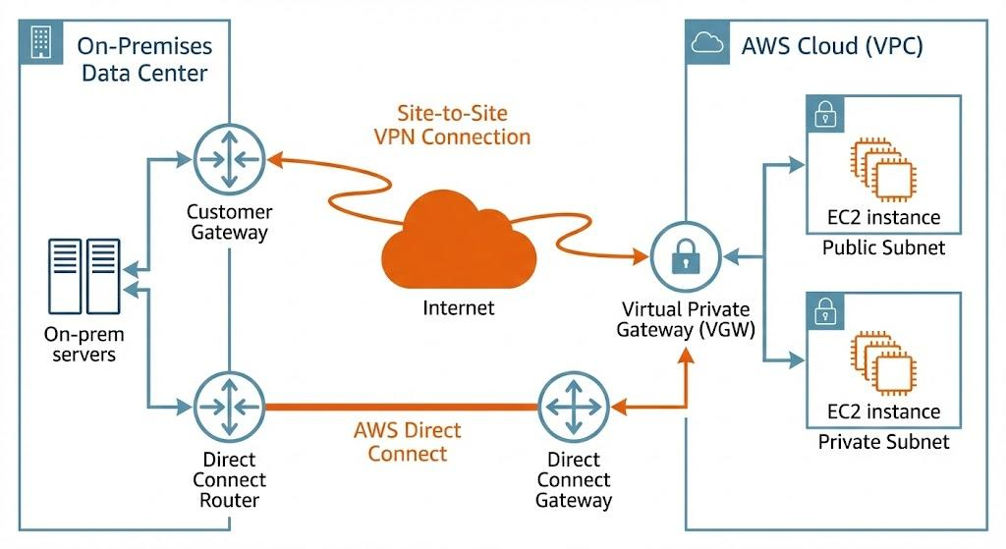
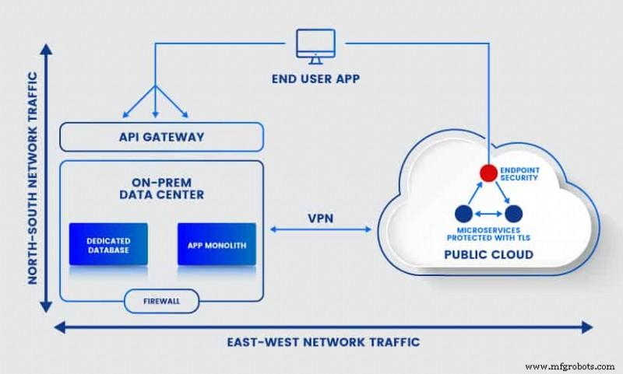

1. Proposed Hybrid Architecture
Core Design Components
- On-Premises Data Center
  - Hosts sensitive applications & classified data
  - Controlled by strict compliance policies
- Public Cloud Environment
  - Hosts non-sensitive workloads (portals, analytics, public services)
- Secure Connectivity
  - VPN (IPSec tunnels) or dedicated private links (e.g., Direct Connect / ExpressRoute)
  - Ensures encrypted communication between environments
- DMZ Layer
  - Acts as a buffer zone for external access
  - Protects internal systems
- API Gateway
  - Secure communication between cloud and on-prem apps

2. Secure Communication Mechanisms
Network Security
- Use site-to-site VPN for encrypted tunnels
- Implement Zero Trust Architecture
  - Never trust, always verify
Access Control
- Firewalls & network segmentation
- Micro-segmentation to isolate workloads
Ensures:
- No direct exposure of sensitive systems
- Controlled data flow

3. Identity Management Strategy
Centralized Identity System
- Use federated identity management
  - Single Sign-On (SSO) across environments
Key Concepts
- Identity Federation
  - Integrate on-prem directory (e.g., Active Directory) with cloud IAM
- Role-Based Access Control (RBAC)
  - Assign permissions based on roles
- Multi-Factor Authentication (MFA)
  - Adds extra layer of security
Benefits
- Unified user access
- Reduced identity duplication
- Strong compliance enforcement

4. Encryption Strategy
Data Protection Layers
1. Data in Transit
- Use:
  - TLS/SSL encryption
  - VPN encryption (IPSec)

2. Data at Rest
- Encrypt:
  - Databases
  - Storage volumes
- Use Key Management Services (KMS)
3. Key Management
- Store keys securely (HSM or cloud KMS)
- Rotate keys regularly
Ensures:
- Confidentiality
- Protection against data breaches

5. Challenges in Hybrid Cloud Management
1. Complexity
- Managing two environments (on-prem + cloud) increases operational overhead
2. Integration Issues
- Compatibility between legacy systems and cloud services
3. Security Consistency
- Maintaining uniform security policies across environments
4. Monitoring & Visibility
- Hard to get centralized logs and insights
5. Cost Management
- Hidden costs (data transfer, infrastructure duplication)
6. Skill Requirements
- Requires expertise in both cloud and traditional infrastructure

Summary
Area | Solution
Secure communication | VPN / Private link + Zero Trust
Identity management | Federation + SSO + MFA
Encryption | TLS (in transit) + KMS (at rest)
Compliance | Keep sensitive data on-prem
Challenges | Complexity, cost, integration

Final Insight
A well-designed hybrid cloud ensures:
- Data sovereignty & compliance (on-prem for sensitive data)
- Scalability & flexibility (cloud for non-sensitive workloads)
- Strong security through identity federation and encryption
However, success depends on effectively managing complexity, security consistency, and operational control across both environments.

- A SaaS provider needs to ensure high availability and fault tolerance for its application. The system must continue operating even if one region goes down.
Propose a multi-region deployment strategy in the cloud.
Explain how data replication and failover mechanisms should be configured. Discuss monitoring and alerting strategies for proactive issue detection.

Multi-Region High Availability Architecture (SaaS)
Proposed Deployment Strategy

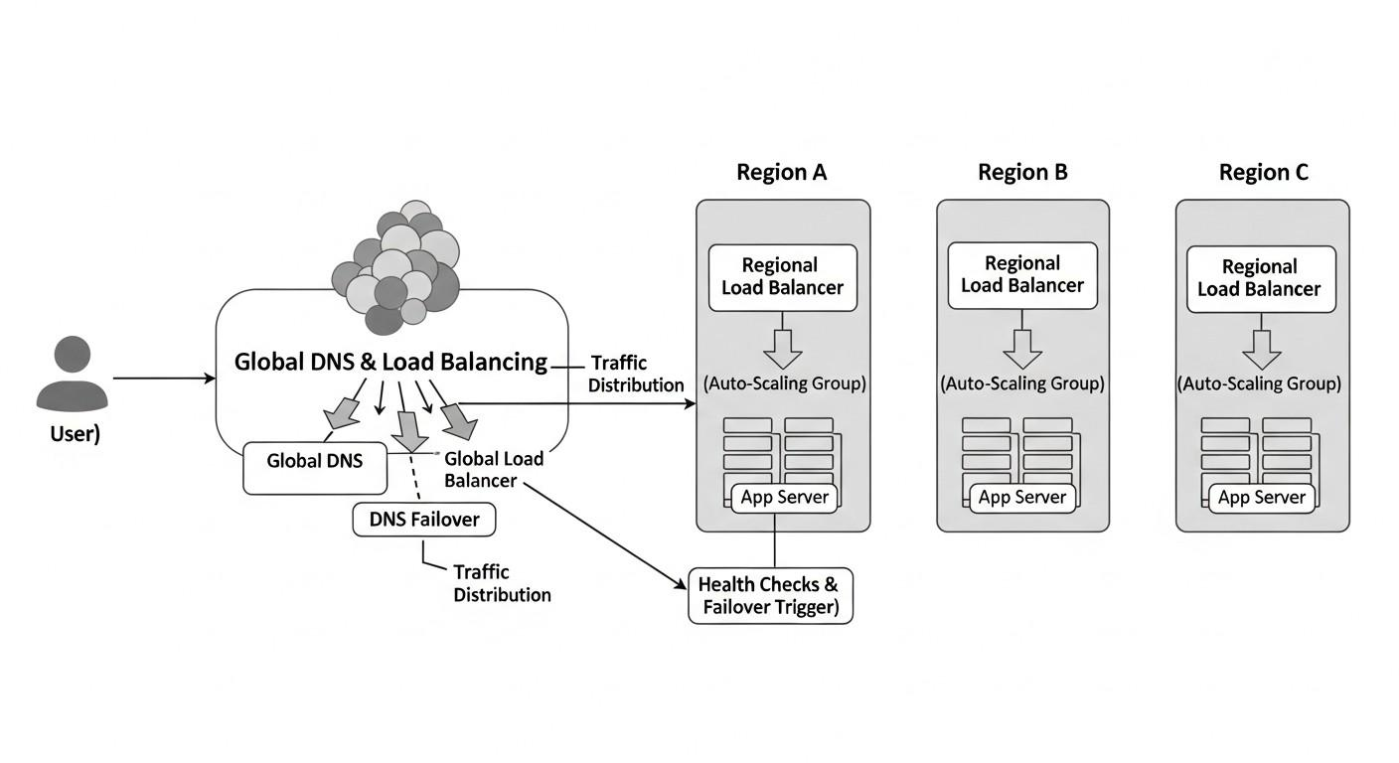

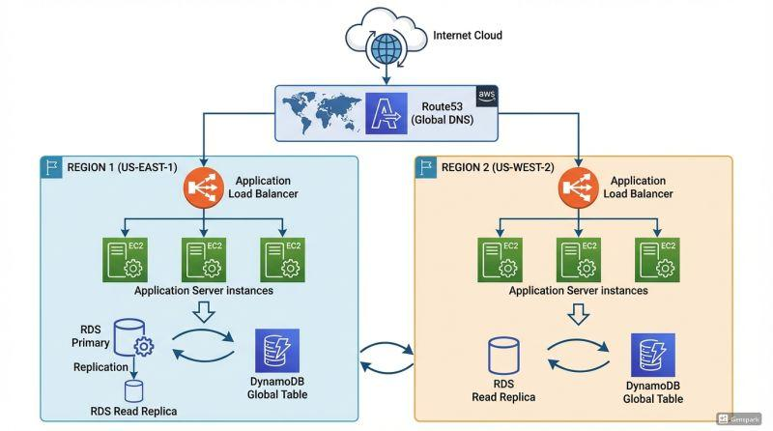

1. Multi-Region Deployment Models
Option A: Active–Active (Recommended)
- Deploy application in multiple regions simultaneously
- Traffic distributed using:
  - Global load balancer / DNS routing
- All regions serve users in parallel
Benefits:
- Zero downtime
- Better performance (users routed to nearest region)

Option B: Active–Passive
- Primary region handles traffic
- Secondary region stays on standby
Benefits:
- Simpler setup
- Lower cost
Drawback: Slight delay during failover

2. Data Replication Strategy
Database Layer
- Use multi-region database replication
Types:
- Synchronous Replication
  - Real-time data copy
  - Near-zero data loss (low RPO)
  - Slight latency overhead
- Asynchronous Replication
  - Data copied with delay
  - Faster performance
  - Small risk of data loss
Best Practice:
- Critical data → synchronous
- Less critical → asynchronous

Storage Layer
- Enable:
  - Cross-region object storage replication
  - Backup snapshots in multiple regions

3. Failover Mechanisms
Automatic Failover Process

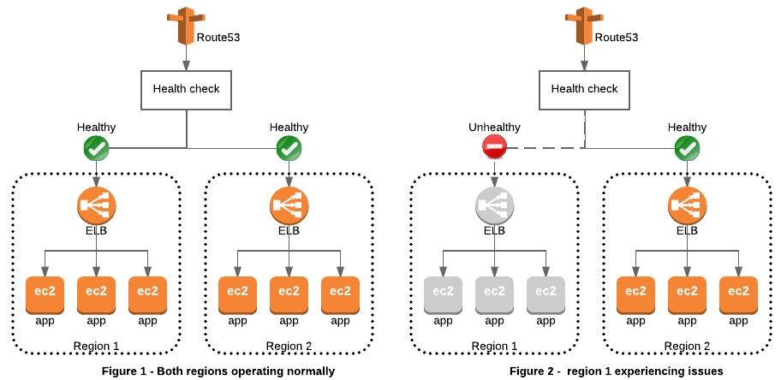
Steps:
- Health Checks
  - Continuously monitor application endpoints
- Failure Detection
  - Region marked unhealthy
- Traffic Rerouting
  - DNS/load balancer redirects to healthy region
- Recovery Activation
  - Secondary region scales up automatically

4. Monitoring & Alerting Strategy
Monitoring Components
- Infrastructure Monitoring
  - CPU, memory, network
- Application Monitoring
  - Response time, errors
- User Experience Monitoring
  - Latency, availability

Alerting Setup
- Real-time alerts via:
  - Email / SMS / dashboards
- Define thresholds:
  - High latency
  - Server failures
  - replication lag

Advanced Monitoring
- Centralized Logging
- Distributed Tracing
- AI-based anomaly detection
Enables:
- Early detection of failures
- Faster incident response

5. Additional High Availability Techniques
- Auto Scaling
  - Adjust resources dynamically
- Content Delivery Network (CDN)
  - Cache content globally
- Stateless Application Design
  - Easier failover between regions
- Circuit Breaker Pattern
  - Prevent cascading failures

Summary
Component | Strategy
Deployment | Active–Active multi-region
Data Replication | Sync + Async hybrid
Failover | Automated DNS / LB switching
Monitoring | Real-time + centralized logs
Availability | Auto-scaling + CDN

Final Insight
A multi-region active–active architecture ensures:
- High availability (no single point of failure)
- Fault tolerance (region failure doesn’t stop service)
- Low latency (geo-distributed access)
Combined with robust replication, automated failover, and proactive monitoring, the SaaS provider can guarantee continuous operation even during regional outages.

Scenario-Based Rubric

Criteria | Weightage | Level 4 - Exemplary | Level 3 - Proficient | Level 2 - Developing | Level 1 - Beginning
Understanding of Scenario | 20% | Demonstrates complete understanding of the scenario  context | Good understanding with minor gaps | Partial understanding | Fails to understand the scenario
Identification of Risks / Issues | 20% | Identifies all major issues correctly | Identifies most issues | Limited issue identification | Misses major issues
Application of Concepts | 25% | Applies virtualization concepts  effectively | Applies concepts with minor mistakes | Partially correct application | Weak application
Decision Justification | 20% | Decisions are well justified and technically strong | Reasonable justification | Weak justification | No useful justification
Clarity | 15% | Clear and  well-organized response | Generally clear | Somewhat unclear | Poorly presented

