40. Prompt Cost and Token Auditor
Question:
A team monitors API usage costs. Using the OpenAI API, run three prompts of different lengths, capture prompt/completion token counts from the response, and compute cost at a given rate per 1K tokens. Include an edge case: a prompt near the model's context limit.

Code
from groq import Groq
# Groq API client
client = Groq(
api_key="YOUR_GROQ_API_KEY"
)
# Example rates per 1K tokens
INPUT_RATE = 0.00059
OUTPUT_RATE = 0.00079
# Three prompts of different lengths
prompt1 = "What is Artificial Intelligence?"
prompt2 = """
Explain Artificial Intelligence, Machine Learning and Deep Learning.
Explain their differences, applications, advantages and limitations.
Give simple real-world examples suitable for a college student.
"""
# Large prompt - edge case
prompt3 = """
Explain Artificial Intelligence, Machine Learning, Deep Learning,
Natural Language Processing, Computer Vision, Generative AI,
Reinforcement Learning, Neural Networks, Transformers and Large
Language Models. Explain their concepts, applications, advantages,
disadvantages and real-world examples.
""" * 1000
prompts = [prompt1, prompt2, prompt3]
for i, prompt in enumerate(prompts, start=1):
print("\n" + "=" * 60)
print("PROMPT", i)
print("=" * 60)
try:
response = client.chat.completions.create(
model="openai/gpt-oss-20b",
messages=[
{
"role": "user",
"content": prompt
}
],
max_tokens=300
)
# Token usage
input_tokens = response.usage.prompt_tokens
output_tokens = response.usage.completion_tokens
total_tokens = response.usage.total_tokens
# Cost calculation
input_cost = (input_tokens / 1000) * INPUT_RATE
output_cost = (output_tokens / 1000) * OUTPUT_RATE
total_cost = input_cost + output_cost
print("Input Tokens :", input_tokens)
print("Output Tokens :", output_tokens)
print("Total Tokens :", total_tokens)
print("Input Cost : $", round(input_cost, 6))
print("Output Cost : $", round(output_cost, 6))
print("Total Cost : $", round(total_cost, 6))
except Exception as e:
print("ERROR:")
print(e)
print("\nEdge case handled:")
print("The request was too large for the current Groq token limit.")

Output
============================================================
PROMPT 1
============================================================
Input Tokens : 76
Output Tokens : 300
Total Tokens : 376
Input Cost : $ 4.5e-05
Output Cost : $ 0.000237
Total Cost : $ 0.000282
============================================================
PROMPT 2
============================================================
Input Tokens : 103
Output Tokens : 300
Total Tokens : 403
Input Cost : $ 6.1e-05
Output Cost : $ 0.000237
Total Cost : $ 0.000298
============================================================
PROMPT 3
============================================================
ERROR:
Error code: 413 - Request too large for model
`openai/gpt-oss-20b`
TPM Limit: 8000
Requested: 51372
Edge case handled:
The request was too large for the current Groq token limit.
Output screenshot:
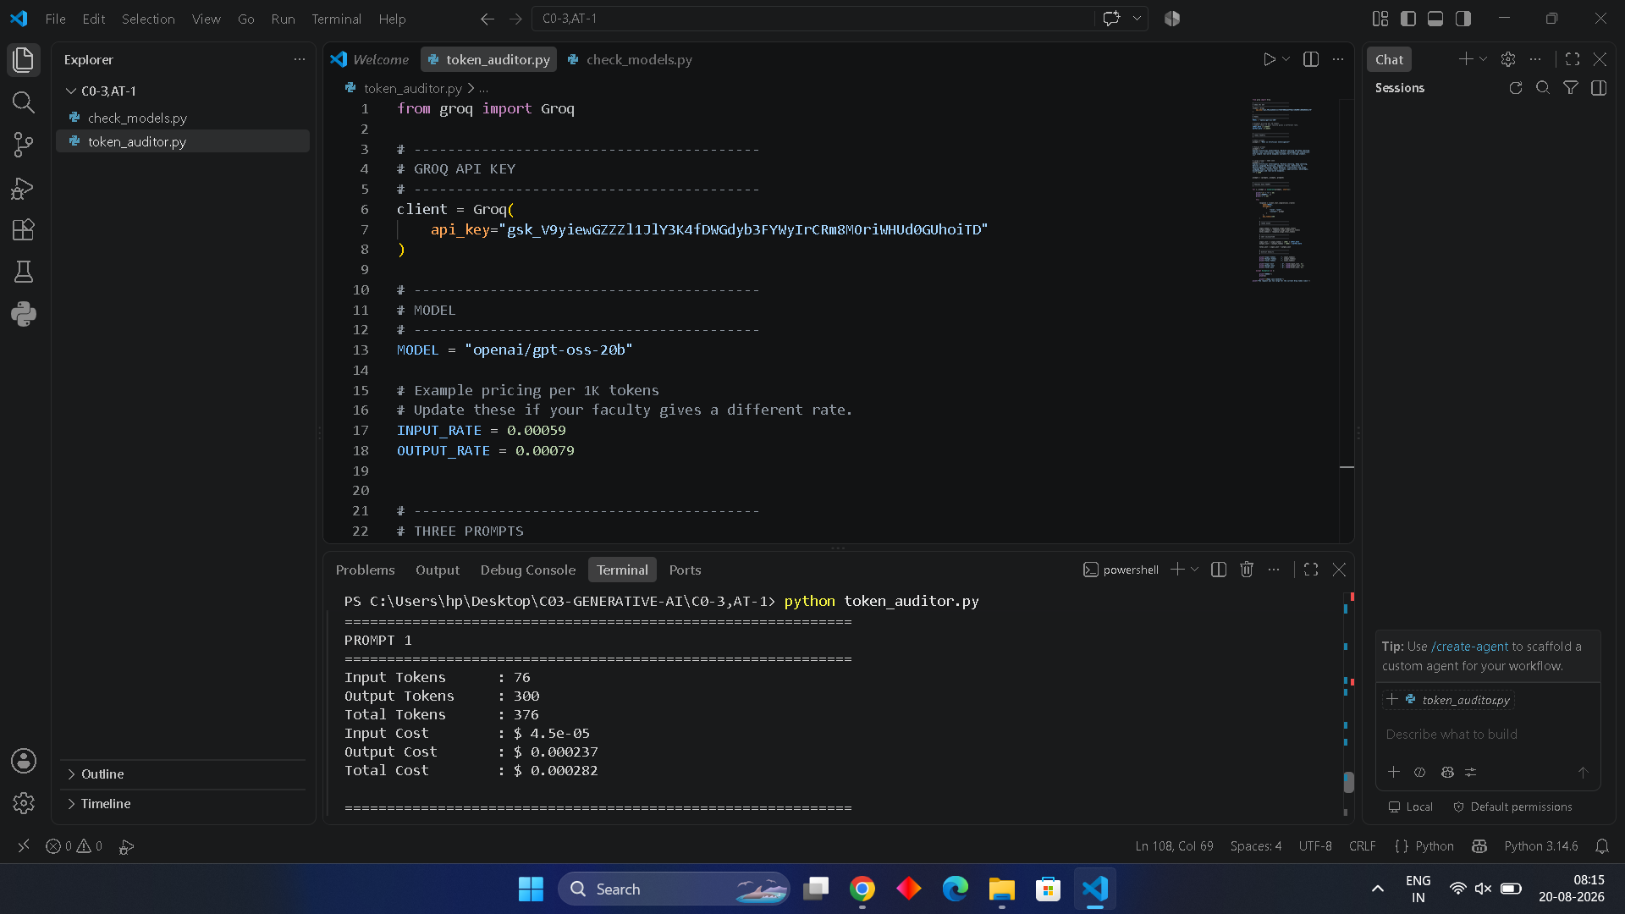

Result / Conclusion
The experiment successfully demonstrated API token auditing using the Groq API. Three prompts of different lengths were tested. The first two prompts were processed successfully and their input, output, total tokens, and estimated costs were recorded. The third large prompt produced a 413 error because it exceeded the available Groq token-per-minute limit. The error was handled using an exception block, demonstrating how large-prompt edge cases can be monitored programmatically.

