40. Multi-Tool Campus Agent

Question
A campus assistant must decide between answering from documents and calling a tool. Task: Build a RAG agent over campus FAQs plus one mock tool (e.g. a get_bus_timing() function). Demonstrate that document questions use retrieval, timing questions call the tool, and one mixed query uses both.

Code
from groq import Groq
print("=" * 60)
print("MULTI-TOOL CAMPUS AGENT")
print("=" * 60)
client = Groq(
api_key="YOUR_GROQ_API_KEY"
)
MODEL = "openai/gpt-oss-20b"
campus_faqs = [
{
"question": "What are the library timings?",
"answer": "The campus library is open from 8:00 AM to 8:00 PM on weekdays."
},
{
"question": "Where is the CSE department?",
"answer": "The CSE department is located in Block A, first floor."
},
{
"question": "What are the college working hours?",
"answer": "The college normally operates from 8:30 AM to 4:30 PM."
},
{
"question": "How can students get a library card?",
"answer": "Students can obtain a library card from the library circulation desk using their college ID."
}
]
def get_bus_timing(bus_number):
bus_timings = {
"1": "Bus 1 leaves the campus at 4:30 PM.",
"2": "Bus 2 leaves the campus at 5:00 PM.",
"3": "Bus 3 leaves the campus at 5:30 PM."
}
return bus_timings.get(bus_number, "Bus timing is not available.")
def retrieve_documents(query):
query_words = set(query.lower().split())
results = []
for faq in campus_faqs:
text = (faq["question"] + " " + faq["answer"]).lower()
score = sum(1 for word in query_words if word in text)
if score > 0:
results.append((score, faq))
results.sort(key=lambda x: x[0], reverse=True)
return [faq for score, faq in results[:2]]
def generate_answer(query, context):
prompt = f"""
You are a campus assistant.
Use the following campus information to answer the question.
Campus information:
{context}
Student question:
{query}
Give a short and clear answer.
"""
response = client.chat.completions.create(
model=MODEL,
messages=[
{
"role": "user",
"content": prompt
}
],
max_tokens=200
)
return response.choices[0].message.content
def campus_agent(query):
query_lower = query.lower()
timing_keywords = ["bus", "timing", "departure", "leaves"]
document_keywords = [
"library", "department", "cse", "college",
"working hours", "library card"
]
is_timing_question = any(
word in query_lower for word in timing_keywords
)
is_document_question = any(
word in query_lower for word in document_keywords
)
if is_timing_question and is_document_question:
print("Decision: USE BOTH RAG AND TOOL")
documents = retrieve_documents(query)
context = "\n".join(
faq["question"] + ": " + faq["answer"]
for faq in documents
)
bus_result = get_bus_timing("1")
combined_context = (
"Retrieved campus information:\n"
+ context
+ "\n\nBus tool result:\n"
+ bus_result
)
return generate_answer(query, combined_context)
elif is_timing_question:
print("Decision: USE BUS TIMING TOOL")
return get_bus_timing("1")
elif is_document_question:
print("Decision: USE DOCUMENT RETRIEVAL")
documents = retrieve_documents(query)
context = "\n".join(
faq["question"] + ": " + faq["answer"]
for faq in documents
)
return generate_answer(query, context)
else:
return "I could not find the required campus information."
# Test 1: Document question
query1 = "What are the library timings?"
print("\nQUESTION 1:")
print(query1)
answer1 = campus_agent(query1)
print("ANSWER:")
print(answer1)
# Test 2: Timing question
query2 = "When does bus 1 leave?"
print("\nQUESTION 2:")
print(query2)
answer2 = campus_agent(query2)
print("ANSWER:")
print(answer2)
# Test 3: Mixed question
query3 = "What are the library timings and when does bus 1 leave?"
print("\nQUESTION 3:")
print(query3)
answer3 = campus_agent(query3)
print("ANSWER:")
print(answer3)

Output
============================================================
MULTI-TOOL CAMPUS AGENT
============================================================
QUESTION 1:
What are the library timings?
Decision: USE DOCUMENT RETRIEVAL
ANSWER:
The campus library is open from 8:00 AM to 8:00 PM on weekdays.
QUESTION 2:
When does bus 1 leave?
Decision: USE BUS TIMING TOOL
ANSWER:
Bus 1 leaves the campus at 4:30 PM.
QUESTION 3:
What are the library timings and when does bus 1 leave?
Decision: USE BOTH RAG AND TOOL
ANSWER:
The campus library is open from 8:00 AM to 8:00 PM on weekdays,
and Bus 1 leaves the campus at 4:30 PM.

\

Output ScreenShot:
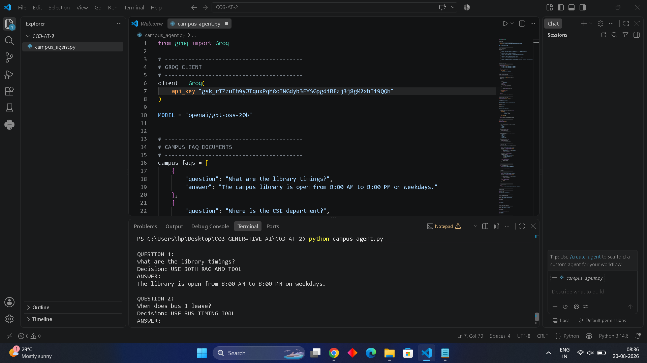

Result / Conclusion
The Multi-Tool Campus Agent successfully demonstrates intelligent routing between document retrieval and a mock tool. The library question uses RAG retrieval from the campus FAQ documents, the bus timing question calls the get_bus_timing() tool, and the mixed question combines both sources to generate one answer. This shows how a campus assistant can select the appropriate information source based on the user's query.

