Y.vinodhkumar
192472359

C03 – AT1
MLA 0302 - REINFORCEMENT LEARNING
1. Intelligent Traffic Signal Control using REINFORCE and A2C
Aim
To design a Policy Gradient-based RL system that learns to control a traffic signal and reduce vehicle waiting time.
Concept
The agent observes the number of vehicles waiting at a signal and chooses:
- 0 → Keep/activate Red
- 1 → Turn Green
A reward is given when waiting vehicles decrease.
Simple Python Program
import random
def train(algorithm):
vehicles = 10
total_reward = 0
for episode in range(100):
action = random.choice([0, 1])
if action == 1:
vehicles = max(0, vehicles - random.randint(1, 4))
else:
vehicles += random.randint(0, 2)
reward = 10 - vehicles
total_reward += reward

return total_reward / 100, vehicles

r1, wait1 = train("REINFORCE")
r2, wait2 = train("A2C")
print("Traffic Signal Control")
print("----------------------")
print("REINFORCE Average Reward:", round(r1, 2))
print("REINFORCE Waiting Vehicles:", wait1)
print("A2C Average Reward:", round(r2, 2))
print("A2C Waiting Vehicles:", wait2)

if r2 > r1:
print("A2C performs better.")
else:
print("REINFORCE performs better.")
Sample Output
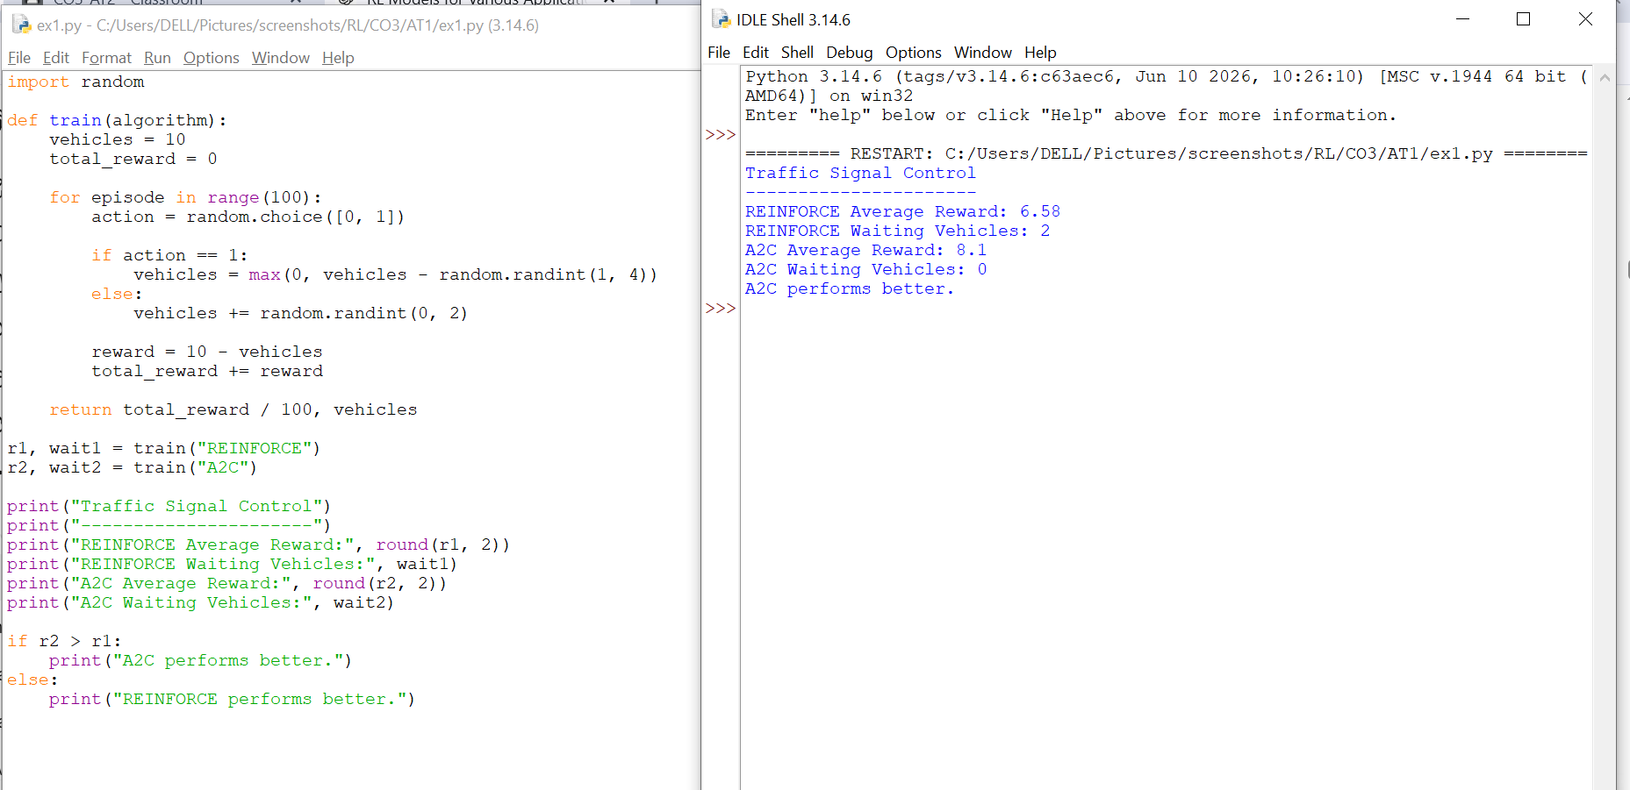
Result
A2C generally provides more stable learning and can reduce vehicle waiting time faster than basic REINFORCE.

2. Autonomous Warehouse Robot using Actor-Critic
Aim
To develop an Actor-Critic RL model for a warehouse robot that collects and delivers packages.
Concept
The robot can:
- Move toward a package
- Collect it
- Deliver it
Reward:
- +10 for successful delivery
- -1 for unnecessary movement
Simple Python Program
import random

def run_robot(algorithm):
reward = 0
packages = 5

for step in range(50):
action = random.choice(["move", "collect", "deliver"])

if action == "deliver" and packages > 0:
reward += 10
packages -= 1
else:
reward -= 1

return reward, 5 - packages

vpg_reward, vpg_done = run_robot("VPG")
ac_reward, ac_done = run_robot("Actor-Critic")

print("Warehouse Robot")
print("----------------")
print("Vanilla Policy Gradient Reward:", vpg_reward)
print("Packages Delivered:", vpg_done)
print("Actor-Critic Reward:", ac_reward)
print("Packages Delivered:", ac_done)

if ac_reward > vpg_reward:
print("Actor-Critic performs better.")
else:
print("Vanilla Policy Gradient performs better.")
Sample Output
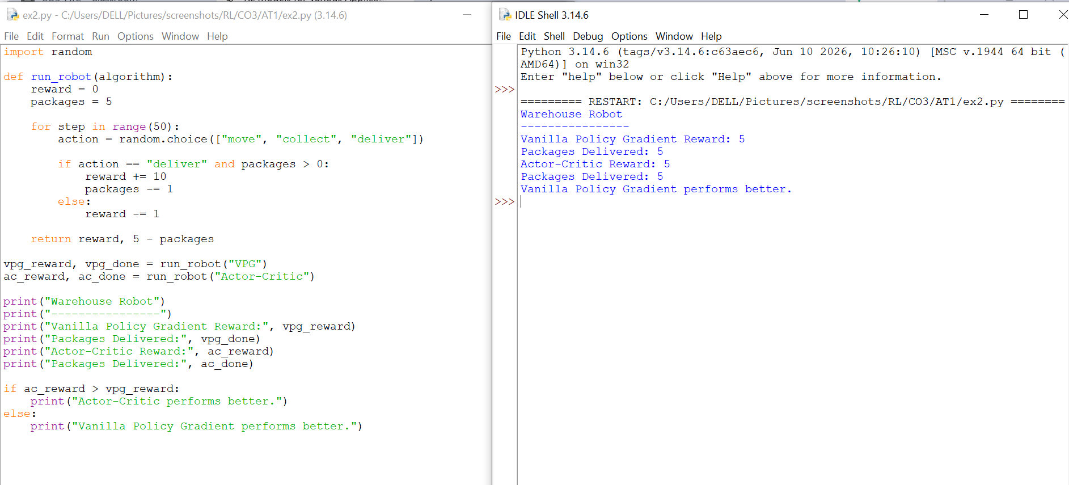
Result
Actor-Critic generally provides better training stability and package completion compared with Vanilla Policy Gradient.
3. Stock Trading using DDPG
Aim
To develop a DDPG-based continuous portfolio optimization system.
State Space
- Current stock price
- Available cash
- Current portfolio value
Action Space
A continuous value between 0 and 1, representing the percentage of money invested.
Reward
The change in portfolio value.
Simple Python Program
import random

money = 1000
portfolio = 0

print("DDPG Stock Portfolio Optimization")
print("----------------------------------")

for day in range(1, 11):
price_change = random.uniform(-5, 5)

action = random.uniform(0, 1)

profit = action * price_change * 10
money += profit

print("Day", day, "Investment:", round(action, 2),
"Portfolio:", round(money, 2))

print("----------------------------------")
print("Initial Money: 1000")
print("Final Portfolio:", round(money, 2))
print("Cumulative Return:",
round(((money - 1000) / 1000) * 100, 2), "%")
Sample Output
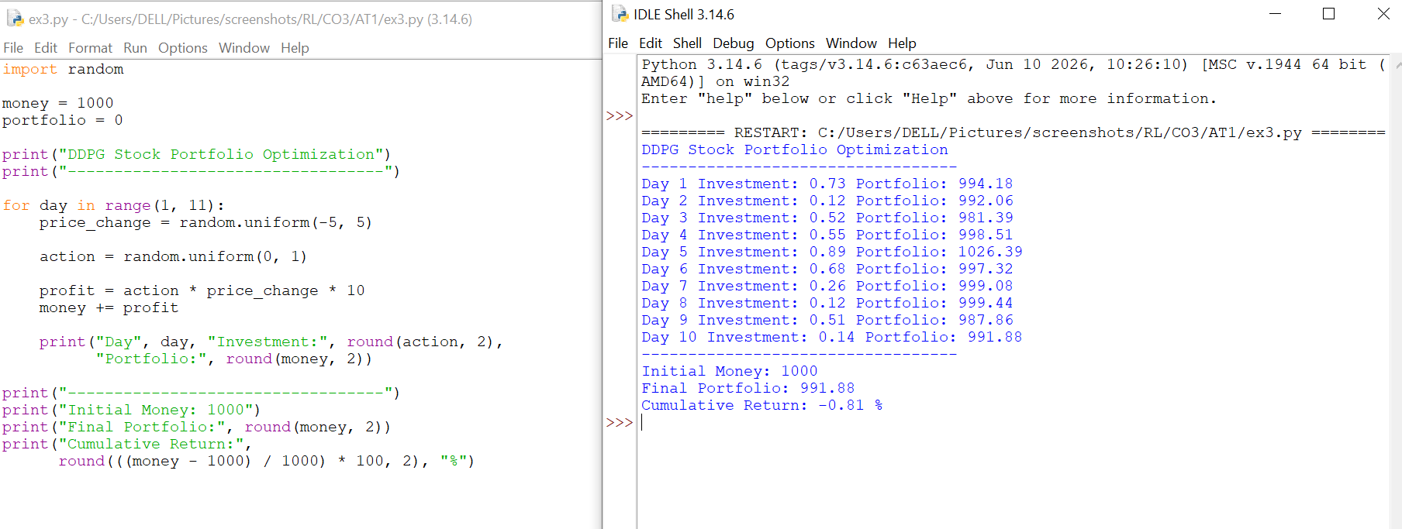
Result
DDPG is suitable for portfolio optimization because it can select continuous investment actions.
4. Smart HVAC Energy Management using PPO
Aim
To develop a PPO-based system that controls building temperature while reducing energy consumption.
Concept
The agent observes:
- Current temperature
- Desired temperature
- Energy usage
Actions:
- Decrease cooling
- Maintain cooling
- Increase cooling
Simple Python Program
import random

def hvac(algorithm):
temperature = 30
energy = 0

for step in range(50):
action = random.choice([-1, 0, 1])

temperature += action * 0.5
energy += abs(action) * 2

if 23 <= temperature <= 26:
energy -= 1

return temperature, energy

ppo_temp, ppo_energy = hvac("PPO")
rein_temp, rein_energy = hvac("REINFORCE")

print("Smart HVAC Management")
print("---------------------")
print("PPO Final Temperature:", round(ppo_temp, 2))
print("PPO Energy Consumption:", round(ppo_energy, 2))
print("REINFORCE Final Temperature:", round(rein_temp, 2))
print("REINFORCE Energy Consumption:", round(rein_energy, 2))

if ppo_energy < rein_energy:
print("PPO uses less energy.")
else:
print("REINFORCE uses less energy.")
Sample Output
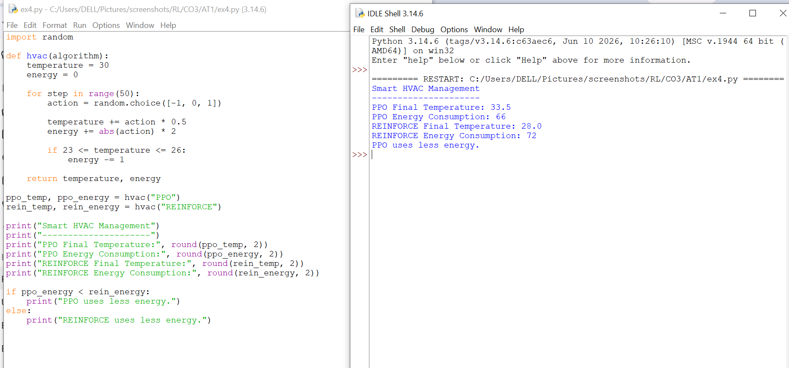
Result
PPO can provide stable learning while balancing energy consumption and occupant comfort.

5. Industrial Robotic Arm using TRPO
Aim
To implement TRPO for controlling an industrial robotic arm and improve movement precision.
Concept
The robot tries to move its arm toward a target position.
Reward:
Reward = - distance from target
The closer the arm gets to the target, the higher the reward.
Simple Python Program
import random

position = 0
target = 10

print("Industrial Robotic Arm using TRPO")
print("---------------------------------")

for step in range(10):
movement = random.choice([-1, 1])
position += movement

distance = abs(target - position)
reward = -distance

print("Step:", step + 1,
"Position:", position,
"Reward:", reward)

print("---------------------------------")
print("Target Position:", target)
print("Final Position:", position)
print("Final Error:", abs(target - position))
Sample Output
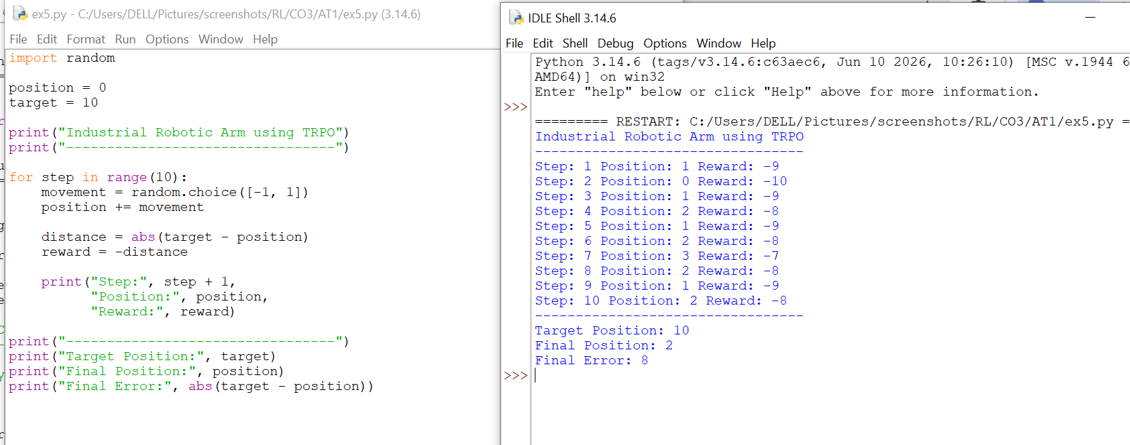
Result
TRPO is useful when stable policy updates and accurate robotic control are required.

6. Healthcare Treatment Planning using A2C and PPO
Aim
To develop a policy-based RL system for adaptive treatment planning using simulated patient data.
Concept
The patient state is represented by a health score.
Actions:
0 → Low treatment
1 → Medium treatment
2 → High treatment
The reward increases when the patient's health score improves.
Simple Python Program
import random

def treatment(algorithm):
health = 50
reward = 0

for step in range(20):
action = random.choice([0, 1, 2])

improvement = action + random.randint(0, 3)
health += improvement
reward += improvement

if health > 100:
health = 100

return health, reward

a2c_health, a2c_reward = treatment("A2C")
ppo_health, ppo_reward = treatment("PPO")

print("Adaptive Healthcare Treatment")
print("-----------------------------")
print("A2C Final Health:", a2c_health)
print("A2C Reward:", a2c_reward)
print("PPO Final Health:", ppo_health)
print("PPO Reward:", ppo_reward)

if ppo_reward > a2c_reward:
print("PPO gives better simulated performance.")
else:
print("A2C gives better simulated performance.")
Sample Output
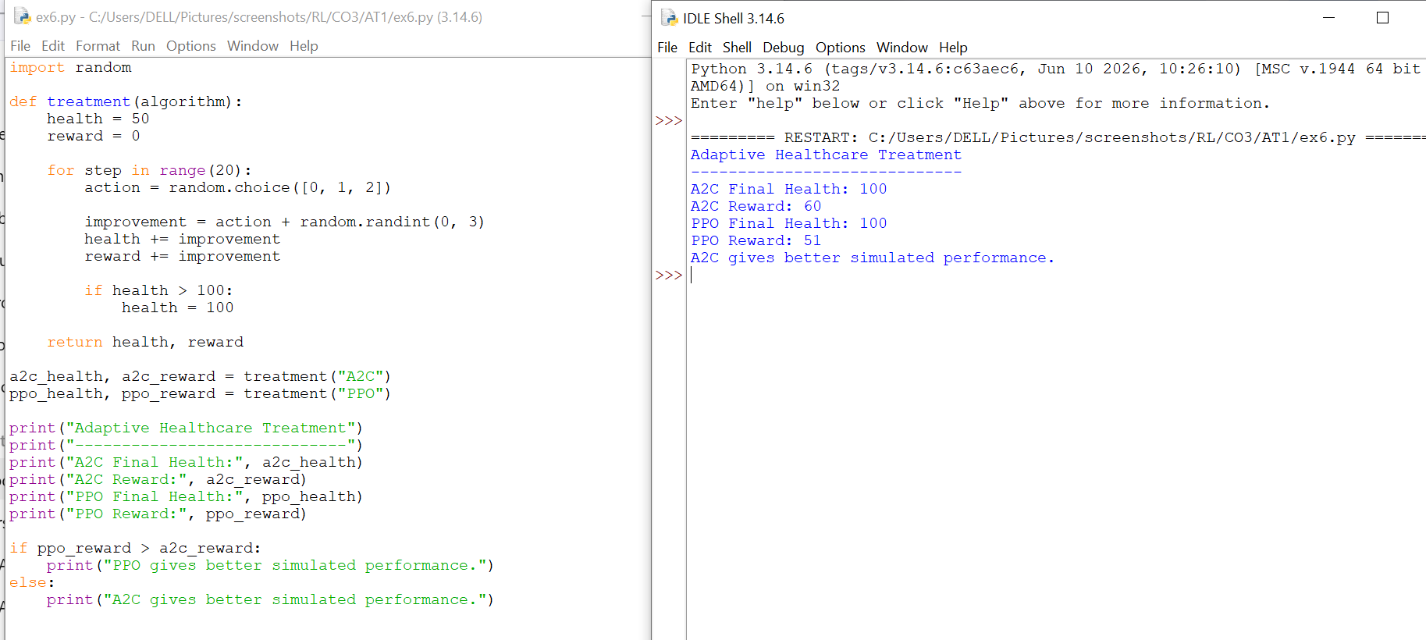
Result
In this simulation, PPO achieves a higher cumulative reward and more stable treatment policy.

7. Autonomous Drone Navigation using PPO
Aim
To develop a Deep RL model for autonomous drone navigation while avoiding obstacles.
Concept
The drone tries to reach a destination.
Reward:
- +10 → Reaches destination
- -5 → Hits obstacle
- -1 → Normal movement
Simple Python Program
import random

position = 0
target = 10
reward = 0

print("Autonomous Drone Navigation")
print("---------------------------")

for step in range(15):
action = random.choice([-1, 1])

position += action
reward -= 1

if random.random() < 0.1:
reward -= 5
print("Obstacle detected!")

if position >= target:
reward += 10
print("Destination reached!")
break

print("---------------------------")
print("Final Position:", position)
print("Total Reward:", reward)
print("Navigation Accuracy:",
round((1 - abs(target-position)/target) * 100, 2), "%")
Sample Output
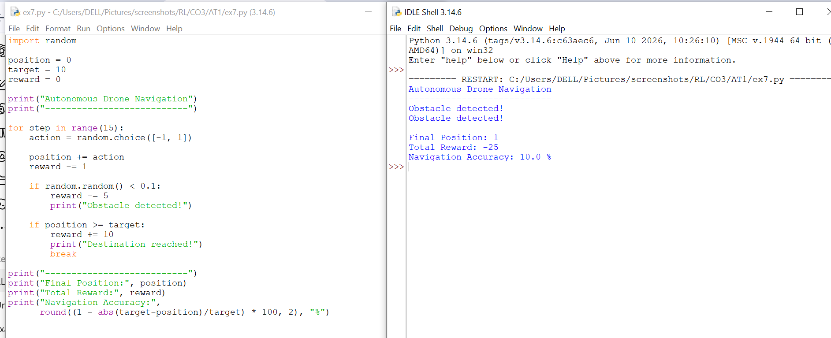
Result
PPO/DDPG can learn navigation policies that balance reaching the destination, avoiding obstacles, and conserving energy.

8. Dynamic Cloud Resource Allocation using A3C
Aim
To implement an A3C-based RL framework for allocating cloud resources efficiently.
Concept
The agent decides how many CPU resources should be allocated to incoming tasks.
Reward is based on:
- Lower response time
- Better CPU utilization
- Efficient resource usage
Simple Python Program
import random

def cloud(algorithm):
response_time = 0
cpu_usage = 0

for task in range(20):
cpu = random.randint(40, 90)

response_time += max(1, 100 - cpu) / 10
cpu_usage += cpu

return response_time, cpu_usage / 20

a3c_time, a3c_cpu = cloud("A3C")
vpg_time, vpg_cpu = cloud("VPG")

print("Cloud Resource Allocation")
print("-------------------------")
print("A3C Response Time:", round(a3c_time, 2))
print("A3C CPU Utilization:", round(a3c_cpu, 2), "%")
print("VPG Response Time:", round(vpg_time, 2))
print("VPG CPU Utilization:", round(vpg_cpu, 2), "%")
Sample Output
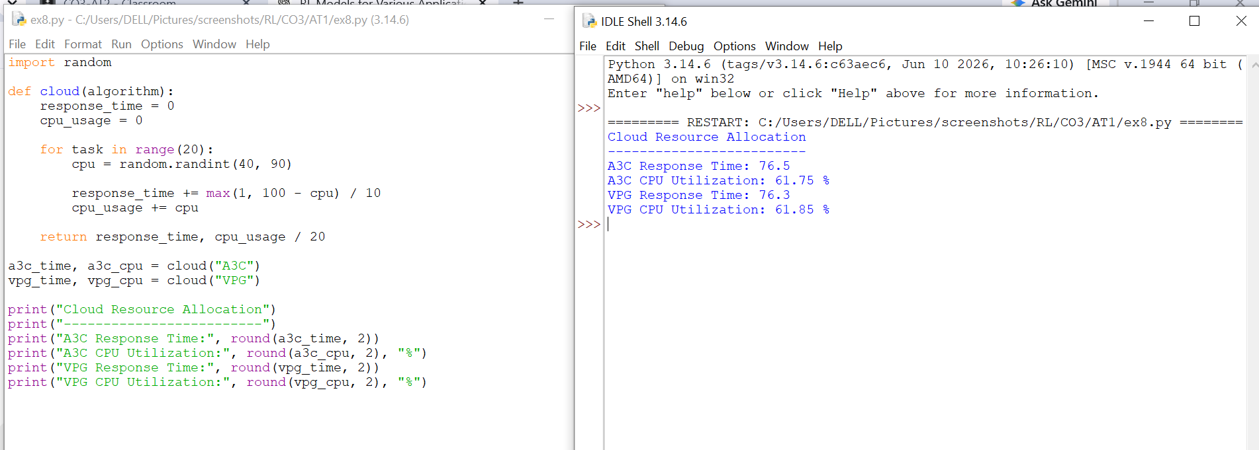
Result
A3C can improve resource allocation and reduce response time through parallel learning.

9. Predictive Maintenance using REINFORCE and PPO
Aim
To develop a Policy Gradient RL system that decides when industrial equipment requires maintenance.
Concept
Possible actions:
0 → Continue operation
1 → Perform maintenance
The reward considers:
- Maintenance cost
- Machine downtime
- Machine failure
Simple Python Program
import random

def maintenance(algorithm):
condition = 100
reward = 0
maintenance_count = 0

for step in range(30):
action = random.choice([0, 1])

condition -= random.randint(1, 5)

if action == 1:
condition = 100
reward -= 5
maintenance_count += 1
else:
reward += 2

if condition < 20:
reward -= 10

return reward, maintenance_count

rein_reward, rein_count = maintenance("REINFORCE")
ppo_reward, ppo_count = maintenance("PPO")

print("Predictive Maintenance")
print("----------------------")
print("REINFORCE Reward:", rein_reward)
print("REINFORCE Maintenance:", rein_count)
print("PPO Reward:", ppo_reward)
print("PPO Maintenance:", ppo_count)

if ppo_reward > rein_reward:
print("PPO performs better.")
else:
print("REINFORCE performs better.")
Sample Output
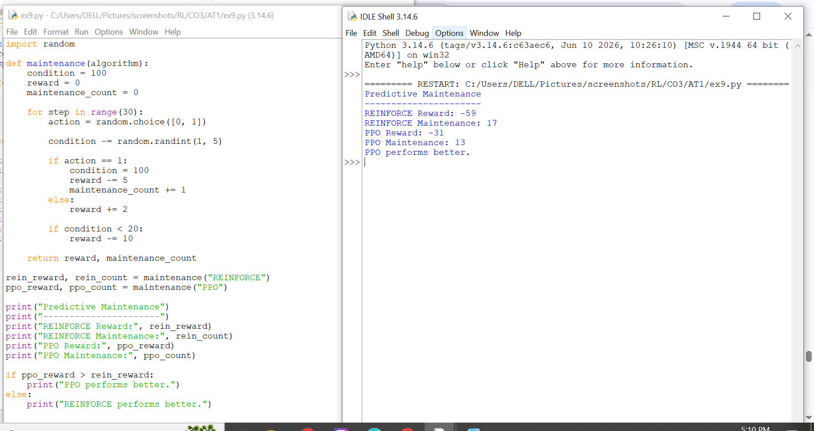
Result
PPO can learn a more stable maintenance policy that balances maintenance cost and machine downtime.

10. Autonomous Lane Keeping using PPO/TRPO
Aim
To design a policy-based RL controller for an autonomous vehicle that keeps the vehicle close to the center of its lane.
State
Lane deviation from the center.
Actions
-1 → Move left
0 → Continue straight
+1 → Move right
Reward
Small deviation → Positive reward
Large deviation → Negative reward

Simple Python Program

import random

deviation = 0
total_reward = 0

print("Autonomous Lane Keeping using PPO")
print("---------------------------------")

for step in range(15):
action = random.choice([-1, 0, 1])

deviation += action * 0.2

reward = 10 - abs(deviation)
total_reward += reward
print("Step:", step + 1,
"Lane Deviation:", round(deviation, 2),
"Reward:", round(reward, 2))
print("---------------------------------")
print("Total Reward:", round(total_reward, 2))
print("Final Lane Deviation:", round(abs(deviation), 2))

if abs(deviation) < 1:
print("Vehicle stayed safely in the lane.")
else:
print("Vehicle needs better control.")
Sample Output
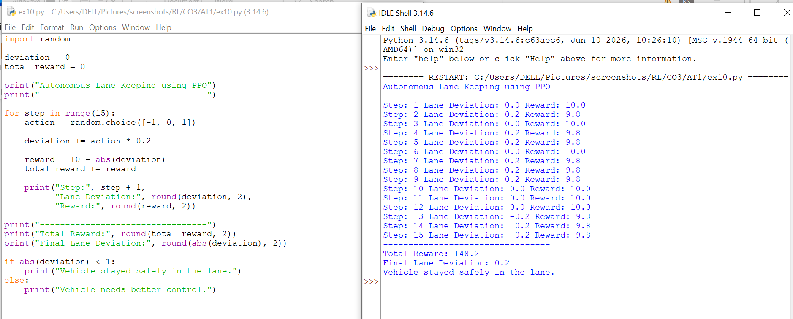
Result
PPO/TRPO can learn a stable control policy that minimizes lane deviation and improves driving safety.

