EXP-1
Aim:
To design a bus booking app using Figma.
Algorithm:
- Log in to Figma.
- Open the design page in Figma.
- Design the app screens according to the required layout.
- Give each screen a name and arrange the screens in order.
- Connect the screens using the Prototype/Pen connection tool.
Implementation:
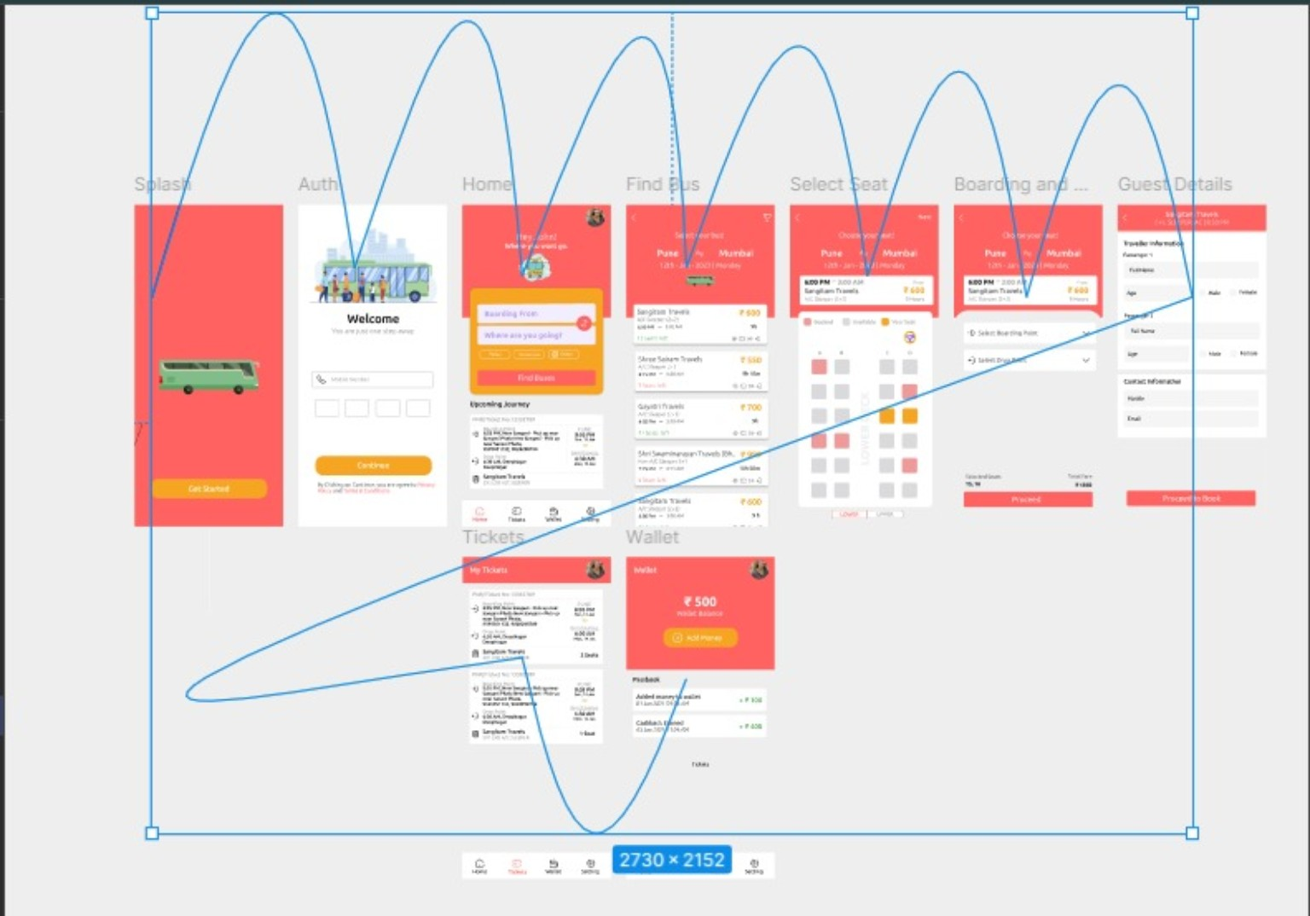
Result:
Thus, the bus booking app was successfully designed using Figma.

