HRMS ERP Portal: Product Workflow & Modules Blueprint
Executive Workflow Blueprint & Entra ID Integration Guide

1. Visual Workflow Chart
The following diagram illustrates the user flow, navigation routing paths, and subsystem modules available inside the portal:
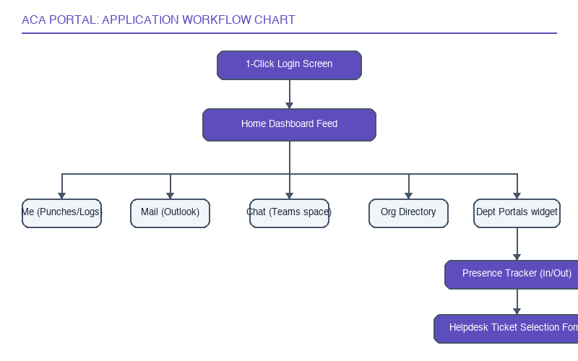

2. Main Portal Modules
The ERP application restructures standard navigation logs down to five key interactive modules:
- Home (Dashboard): Horizontal quick-launch department portals + announcements feed.
- Me (Personal Log): Attendance punches, personal leave balance counters, and profile details.
- Mail (Outlook Client): Integrated outlook-style email client sync, read detail viewer, and composing.
- Chat (Teams Workspace): Slack/Teams-style workspace channels, DMs, status indicators, and messages.
- Org (Corporate Hierarchy): colleague search lookup and visual report hierarchy tree.

3. Quick-Launch Department Portals
Tapping any of the department widgets (Media, Maintenance, Finance, CPD, HR, Inventory, HOB) launches the customized overlay sheet containing:
- Team Presence: Visual overview displaying which specific department teammates are logged clocked IN/OUT.
- Service ticket composer: Custom targeted helpdesk selector (e.g. plumbing repairs, AC issues, livestream setups).

Department Operations Details Table
Department | Team Presence Tracker | Ticketing Category Options
Media | AV team attendance logs | Video editing, stream setup, photography booking
Maintenance | Facilities & utility logs | Light bulb change, plumbing, carpentry, AC repair
Finance | Accounts team presence | Expense claims, salary query, tax declaration help
CPD | Training coordinators | Register for workshop, study material request
HR | HR representatives presence | Onboarding logs, profile updates, policy queries
Inventory | Storekeeper presence logs | Asset requests, stationeries, accessories request
HOB | Bakery & kitchen presence | Catering orders, kitchen feedback, pantry issue

4. Microsoft Entra ID (Azure AD) Registration Procedure
Follow these exact steps to register the application and obtain your active Client credentials:
Step 1: App Registration
Log into the Entra Admin Center (https://entra.microsoft.com). Navigate to 'Identity' -> 'Applications' -> 'App registrations' and select 'New registration'. Enter 'ACA ERP Portal' as the name, choose Supported Account Types (e.g. Single-tenant for your org, or Multi-tenant if external domains participate), and click 'Register'.
Step 2: Note Directory Credentials
Once registered, navigate to the app 'Overview' screen. Copy and save the 'Application (client) ID' and 'Directory (tenant) ID'. These keys are required in the Flutter configuration.
Step 3: Configure Authentication & Redirect URIs
Under 'Authentication', add target platforms. Select 'Single-page application' (for Flutter Web) and enter the URL (e.g. https://your-domain.com/). Select 'iOS/macOS' and 'Android' platforms and enter your App Bundle ID (com.acaindia.frontend) to auto-generate the iOS Redirect URI scheme (msauth.com.acaindia.frontend://auth). Check both ID Tokens and Access Tokens options in Implicit Grant flow if needed.
Step 4: Grant API Permissions (Microsoft Graph)
Navigate to 'API Permissions' -> 'Add a permission' -> 'Microsoft Graph' -> 'Delegated permissions'. Search and check the following permissions:
- User.Read (Sign-in and read user profile)
- Mail.ReadWrite (Sync inbox mails and save drafts)
- Mail.Send (Compose and send emails to anyone)
- offline_access (Retrieve refresh tokens for background silent renewals)
Click 'Add permissions', and then select 'Grant admin consent for <your_org>' to pre-approve it for your users.
Step 5: Code Integration (PKCE Flow)
Plug the Client ID and Tenant ID into the Flutter application's configuration config (e.g. utilizing the aad_oauth package). Ensure you use standard Authorization Code Flow with PKCE to bypass client secret requirements on mobile and single-page apps securely.

