DDOS ATTACK USING TRAFFIC GENERATOR

we create a wired Network maximum we set 200 nodes , 2 attacker and 2 zombie nodes and 1 victim(server) nodes

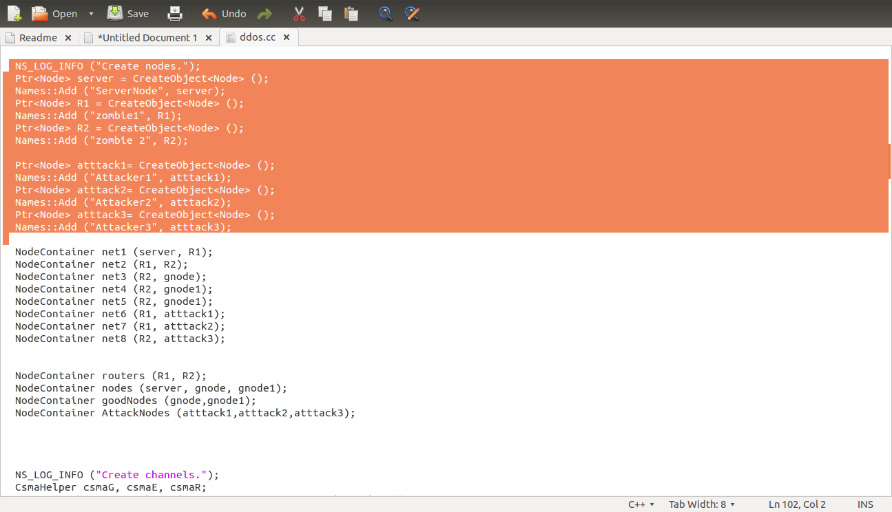

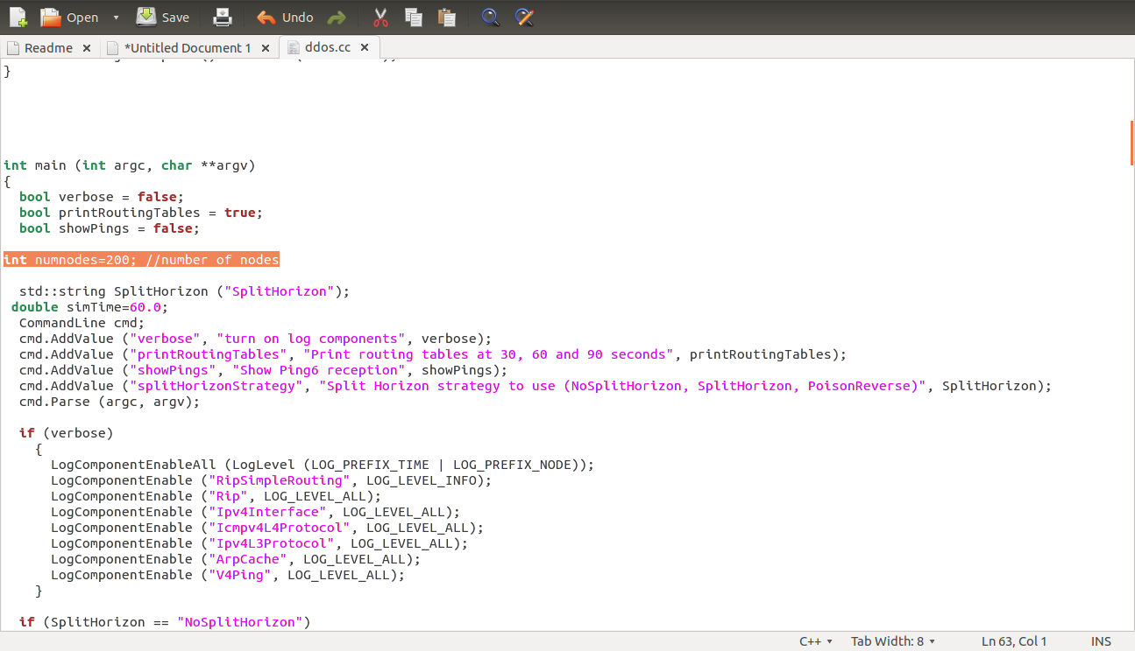
next we zombie nodes from the attacker node and ensure that they attack target on instruction that is From attacker node, with the help of zombie nodes, launch a DDoS attack on Targeted node

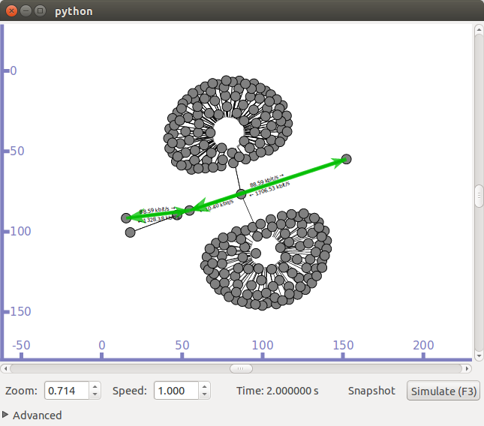
next we create http traffic and Select a target and launch DDOS through zombies
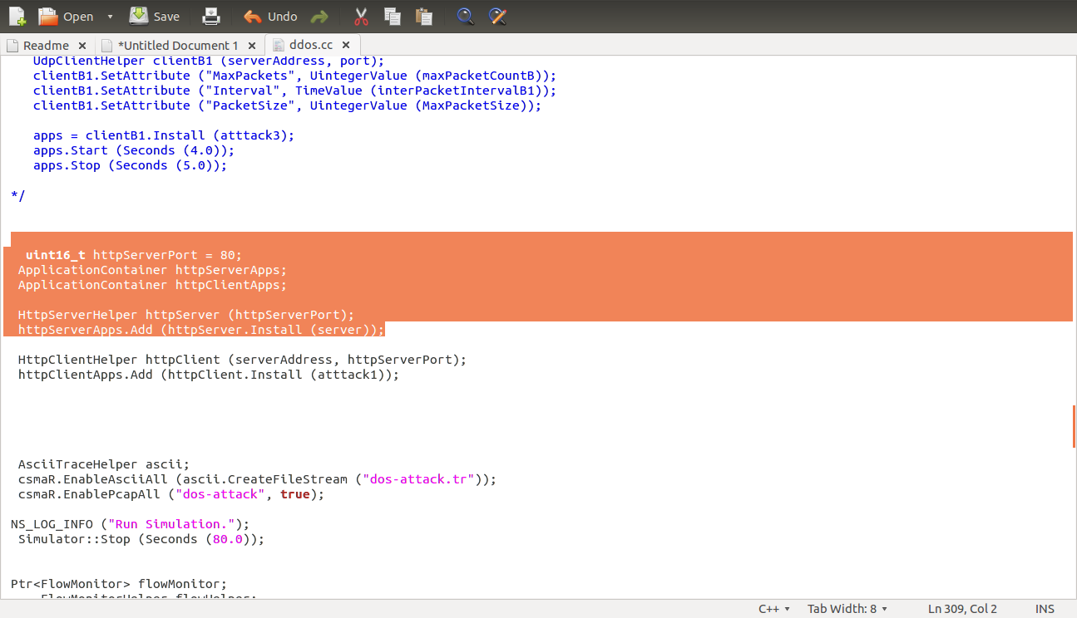
ns-3 application module we create http traffic generate packets that access the port is 80 and DataRate we use 100Gb/s and Httpclient connected to RemoteAddress and RemotePort(80) http server
Attachments area

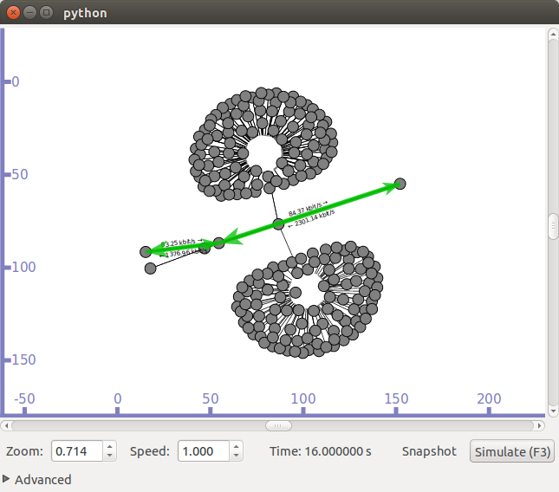

plot the results are throughput and delay
