Vinod Halaharvi

HUID 80778287

[halavin@iit.edu](mailto:halavin@iit.edu), [vinod.halaharvi@gmail.com](mailto:vinod.halaharvi@gmail.com)

CSCIE 93, Computer Architecture

HW1

# PROBLEM 1.17

Takes as input two 2-bit numbers and produces as output a 3-bit sum.

|  |  |  |  |  |  |  |
| --- | --- | --- | --- | --- | --- | --- |
| **A** | **B** | **C** | **D** | **Cout** | **O1** | **O0** |
| 0 | 0 | 0 | 0 | 0 | 0 | 0 |
| 0 | 0 | 0 | 1 | 0 | 0 | 1 |
| 0 | 0 | 1 | 0 | 0 | 1 | 0 |
| 0 | 0 | 1 | 1 | 0 | 1 | 1 |
| 0 | 1 | 0 | 0 | 0 | 0 | 1 |
| 0 | 1 | 0 | 1 | 0 | 1 | 0 |
| 0 | 1 | 1 | 0 | 0 | 1 | 1 |
| 0 | 1 | 1 | 1 | 1 | 0 | 0 |
| 1 | 0 | 0 | 0 | 0 | 1 | 0 |
| 1 | 0 | 0 | 1 | 0 | 1 | 1 |
| 1 | 0 | 1 | 0 | 1 | 0 | 0 |
| 1 | 0 | 1 | 1 | 1 | 0 | 1 |
| 1 | 1 | 0 | 0 | 0 | 1 | 1 |
| 1 | 1 | 0 | 1 | 1 | 0 | 0 |
| 1 | 1 | 1 | 0 | 1 | 0 | 1 |
| 1 | 1 | 1 | 1 | 1 | 1 | 0 |

# PROBLEM 2.6

$$\left(X+Y\right)\left(X+Y'\right)$$

$$XX+XY'+XY+YY'$$

$$X+X (Y'+ Y)+YY'$$

$$X+ X(1)+YY'$$

$$X+ X+YY'$$

$$X+ 0$$

$$X$$

(b)

$$X\left(X+Y\right)$$

$$XX+XY$$

$$X+XY$$

$$X (1+Y)$$

$$X(1)$$

$$X$$

(c)

$$(X+ Y')Y$$

$$XY+YY'$$

$$XY+0$$

$$XY$$

(d)

Let’s prove in the reverse direction.

$$XZ+ X^{'}Y=X^{'}Y\left(Z+Z^{'}\right)+ XZ\left(Y+Y^{'}\right)$$

$$X^{'}YZ+X^{'}YZ^{'}+ XYZ+XY^{'}Z →eqn 1$$

Writing the terms $X^{'}YZ, XYZ twice$, we get: We can do this because X + X = X

$$X^{'}YZ+X^{'}YZ^{'}+ XYZ+XY^{'}Z+ X^{'}YZ+XYZ$$

$$X^{'}YZ+X^{'}YZ^{'}+ XYZ+XY^{'}Z+ YZ ( X+X^{'})$$

$$But X^{'}YZ+X^{'}YZ^{'}+ XYZ+XY^{'}Z was already XZ+X^{'}Y from eqn 1 so we have$$

$$X^{'}YZ+X^{'}YZ^{'}+ XYZ+XY^{'}Z+ YZ \left( X+X^{'}\right)=$$

$$XZ+ X'Y+ YZ ( X+X^{'})$$

$$XZ+ X'Y+ YZ Hence proved.$$

# PROBLEM 2.17

(a)

$$XY+ XY^{'}$$

$$X\left(Y+ Y^{'}\right) distributive$$

$$X(1) complementarity$$

$$X identity$$

$$Reduced by 3 literals$$

(b)

$$(X+Y)(X+ Y')$$

$$XX+XY'+XY+YY' distributive$$

$$X+XY'+XY+YY' idempotent$$

$$X+XY'+XY+0 complementarity$$

$$X\left(1+ Y'+Y\right) distributive$$

$$X\left(1+0 \right) complementarity$$

$$X\left(1\right) operations of 0s and 1s$$

$$X identity$$

$$Reduced by 3 literals$$

(c)

$$Y^{'}Z+X^{'}YZ+XYZ$$

$$Y^{'}Z+YZ\left(X^{'}+X\right) distributive$$

$$Y^{'}Z+YZ\left(1\right) complimentarity$$

$$Y^{'}Z+YZ identity$$

$$Z\left(Y^{'}+ Y\right) distributive$$

$$Z \left(1\right) complimentarity$$

$$Z identity$$

$$Reduced by 7 literals$$

(d)

$$\left(X+Y \right)\left(X^{'}+Y+Z\right)\left(X^{'}+Y+Z^{'}\right)$$

$$\left(X+Y \right)\left(\left(X^{'}+Y\right)+Z\right)\left(\left(X^{'}+Y\right)+Z^{'}\right) associativity$$

$$\left(X+Y \right) \left\{ \left(X^{'}+Y\right)\left(X^{'}+Y \right)+\left(X^{'}+Y\right)Z^{'}+\left(X^{'}+Y \right)Z+ZZ^{'}\right\} distributive$$

$$\left(X+Y \right) \left\{ \left(X^{'}+Y\right)+\left(X^{'}+Y\right)Z^{'}+\left(X^{'}+Y \right)Z+ZZ^{'}\right\} idempotent$$

$$\left(X+Y \right) \left\{ \left(X^{'}+Y\right)\left(1+Z^{'}\right)+\left(X^{'}+Y \right)Z+ZZ^{'}\right\} associativity$$

$$\left(X+Y \right) \left\{ \left(X^{'}+Y\right)\left(1 \right)+\left(X^{'}+Y\right)Z^{'}+\left(X^{'}+Y \right)Z+ZZ^{'}\right\} operations of 0 and 1$$

$$\left(X+Y \right) \left\{ \left(X^{'}+Y\right)+\left(X^{'}+Y\right)Z^{'}+\left(X^{'}+Y \right)Z+ZZ^{'}\right\} identity$$

$$\left(X+Y \right) \left\{ \left(X^{'}+Y\right)\left(1+Z^{'}\right)+\left(X^{'}+Y \right)Z+ZZ^{'}\right\} distributive$$

$$\left(X+Y \right) \left\{ \left(X^{'}+Y\right)\left(1\right)+\left(X^{'}+Y \right)Z+ZZ^{'}\right\} operations of 0 and 1$$

$$\left(X+Y \right) \left\{ \left(X^{'}+Y\right)+\left(X^{'}+Y \right)Z+ZZ^{'}\right\} operations of 0 and 1$$

$$\left(X+Y \right) \{ \left(X^{'}+Y\right)( 1+ Z)+ZZ^{'} associativity\}$$

$$\left(X+Y \right) \left\{ \left(X^{'}+Y\right) \left(1\right)+ZZ^{'}\right\} oprations of 0 and 1$$

$$\left(X+Y \right) \left\{ \left(X^{'}+Y\right) \left(1\right)+0\right\} complimentarity$$

$$\left(X+Y \right) \left(X^{'}+Y\right) identity and operations of 0 and 1$$

$$XX^{'}+XY+X^{'}Y+YY distributive$$

$$0+XY+X^{'}Y+YY complimentarity$$

$$XY+X^{'}Y+Y idempotent$$

$$Y \left(1+X+X^{'}\right) distributive$$

$$Y \left(1+0\right) complimentarity$$

$$Y operations of 0 and 1$$

$$Reduced by 7 literals$$

(e)

$$X+XYZ+X^{'}YZ+X^{'}Y+WX+WX^{'}$$

$$X \left( 1+YZ\right)+ X^{'}Y\left(1+Z\right)+ W \left(X+X^{'}\right)$$

$$X+X^{'}Y+W$$

$$X+Y+W$$

$$Reduced by 10 literals$$

# PROBLEM 2.30

(a)

$$A’BC’ + A’BC + AB’C’ + AB’C$$

$$A^{'}\left(BC'+BC\right)+ B^{'}\left(AC^{'}+AC\right)$$

$$A'(B) + B'(A)$$

$$A^{'}B+AB'$$

Using K-Map

|  |  |  |  |  |
| --- | --- | --- | --- | --- |
|  | A’B’ | A’B | AB | AB’ |
|  |  | 1 |  | 1 |
|  |  | 1 |  | 1 |

(b)

$$A^{'}B^{'}C^{'}+ A^{'}BC+AB^{'}C^{'}+ ABC$$

$$B^{'}C^{'}\left(A+A^{'}\right)+ BC( A+A^{'})$$

$$B^{'}C^{'}+ BC$$

Using K-Map

|  |  |  |  |  |
| --- | --- | --- | --- | --- |
|  | A’B’ | A’B | AB | AB’ |
| C’ | 1 |  |  | 1 |
| C |  | 1 | 1 |  |

# PROBLEM 2.40

(a) 2 bit wide shifter

|  |  |  |  |  |
| --- | --- | --- | --- | --- |
| **I0** | **I1** | **S** | **O0** | **O1** |
| 0 | 0 | 0 | 0 | 0 |
| 0 | 1 | 0 | 0 | 1 |
| 1 | 0 | 0 | 1 | 0 |
| 1 | 1 | 0 | 1 | 1 |
| 0 | 0 | 1 | 0 | 0 |
| 0 | 1 | 1 | 0 | 0 |
| 1 | 0 | 1 | 0 | 1 |
| 1 | 1 | 1 | 0 | 1 |

(b) 1 – bit demultiplexer

|  |  |  |  |
| --- | --- | --- | --- |
| $$I_{0}$$ | **S** | **O0** | **O1** |
| 0 | 0 | 0 | 0 |
| 0 | 1 | 0 | 0 |
| 1 | 0 | 1 | 0 |
| 1 | 1 | 0 | 1 |

(c) 2 – bit multiplexer

|  |  |  |  |
| --- | --- | --- | --- |
| $$I_{0}$$ | $$I_{1}$$ | S | O0 |
| 0 | 0 | 0 | 0 |
| 0 | 0 | 1 | 0 |
| 0 | 1 | 0 | 0 |
| 0 | 1 | 1 | 1 |
| 1 | 0 | 0 | 1 |
| 1 | 0 | 1 | 0 |
| 1 | 1 | 0 | 1 |
| 1 | 1 | 1 | 1 |

# PROBLEM 2.41

(a)

O0 =

O0 = S’

|  |  |  |  |  |
| --- | --- | --- | --- | --- |
|  | '' | ' |  | ' |
| S' |  |  | 1 | 1 |
| S |  |  |  |  |

O1 = S’ + S

|  |  |  |  |  |
| --- | --- | --- | --- | --- |
|  | '' | ' |  | ' |
| S' |  | 1 | 1 |  |
| S |  |  | 1 | 1 |

(b)

O0 =S’

|  |  |  |
| --- | --- | --- |
| O0 | S' | S |
| ' |  |  |
|  | 1 |  |

O1 = S

|  |  |  |
| --- | --- | --- |
| O1 | S' | S |
| ' |  |  |
|  |  | 1 |

(C)

|  |  |  |  |  |
| --- | --- | --- | --- | --- |
|  | '' | ' |  | ' |
| S' |  |  | 1 | 1 |
| S |  | 1 | 1 |  |

O = $I_{1}$ S + $I_{0}$ S’

# PROBLEM 2.42

(a) O0 = S’; O1 = S’ + S

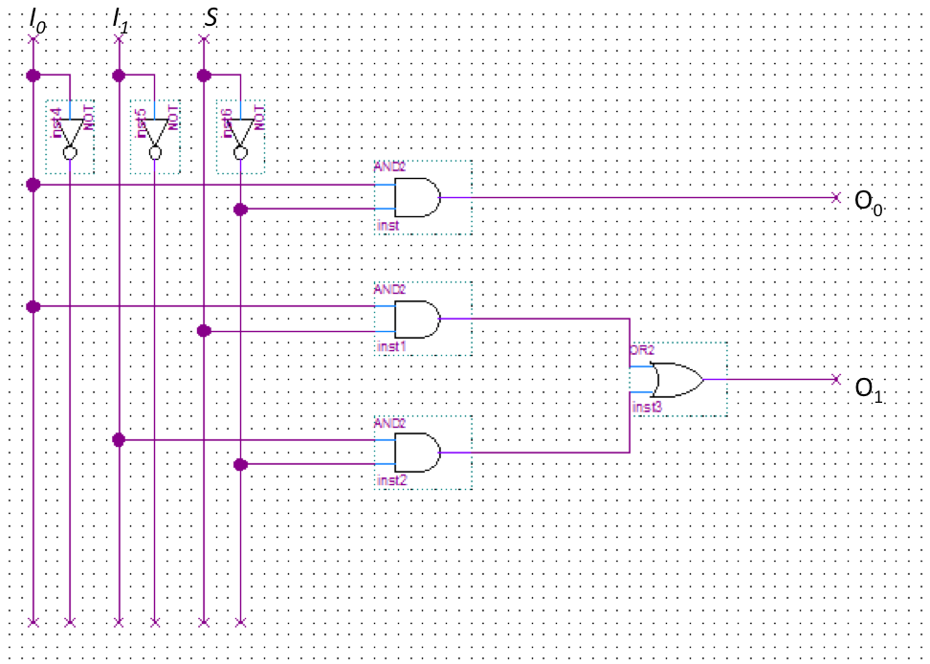

(b) O0 =S’; O1 = S

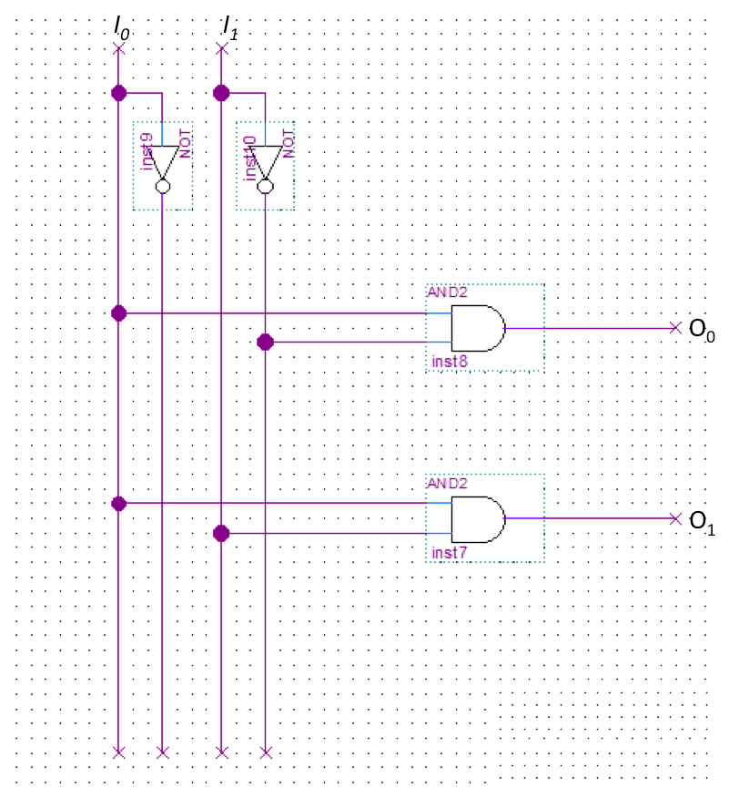

(c)

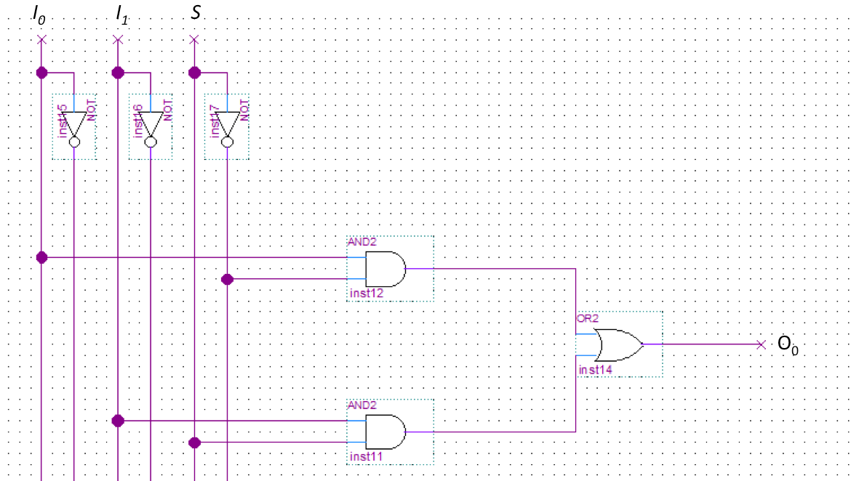

|  |  |  |  |  |  |
| --- | --- | --- | --- | --- | --- |
| N1 | N1 | N2 | N2 |  |  |
| **A** | **B** | **C** | **D** | **F** | **G** |
| X | X | X | X | X | X |
| 0 | 0 | 0 | 0 | 0 | 0 |
| 0 | 1 | 0 | 0 | 0 | 1 |
| 0 | 1 | 0 | 1 | 0 | 0 |
| 1 | 0 | 0 | 0 | 1 | 0 |
| 1 | 0 | 0 | 1 | 0 | 1 |
| 1 | 0 | 1 | 0 | 0 | 0 |
| 1 | 1 | 0 | 0 | 1 | 1 |
| 1 | 1 | 0 | 1 | 1 | 0 |
| 1 | 1 | 1 | 0 | 0 | 1 |
| 1 | 1 | 1 | 1 | 0 | 0 |