UI HomePage:
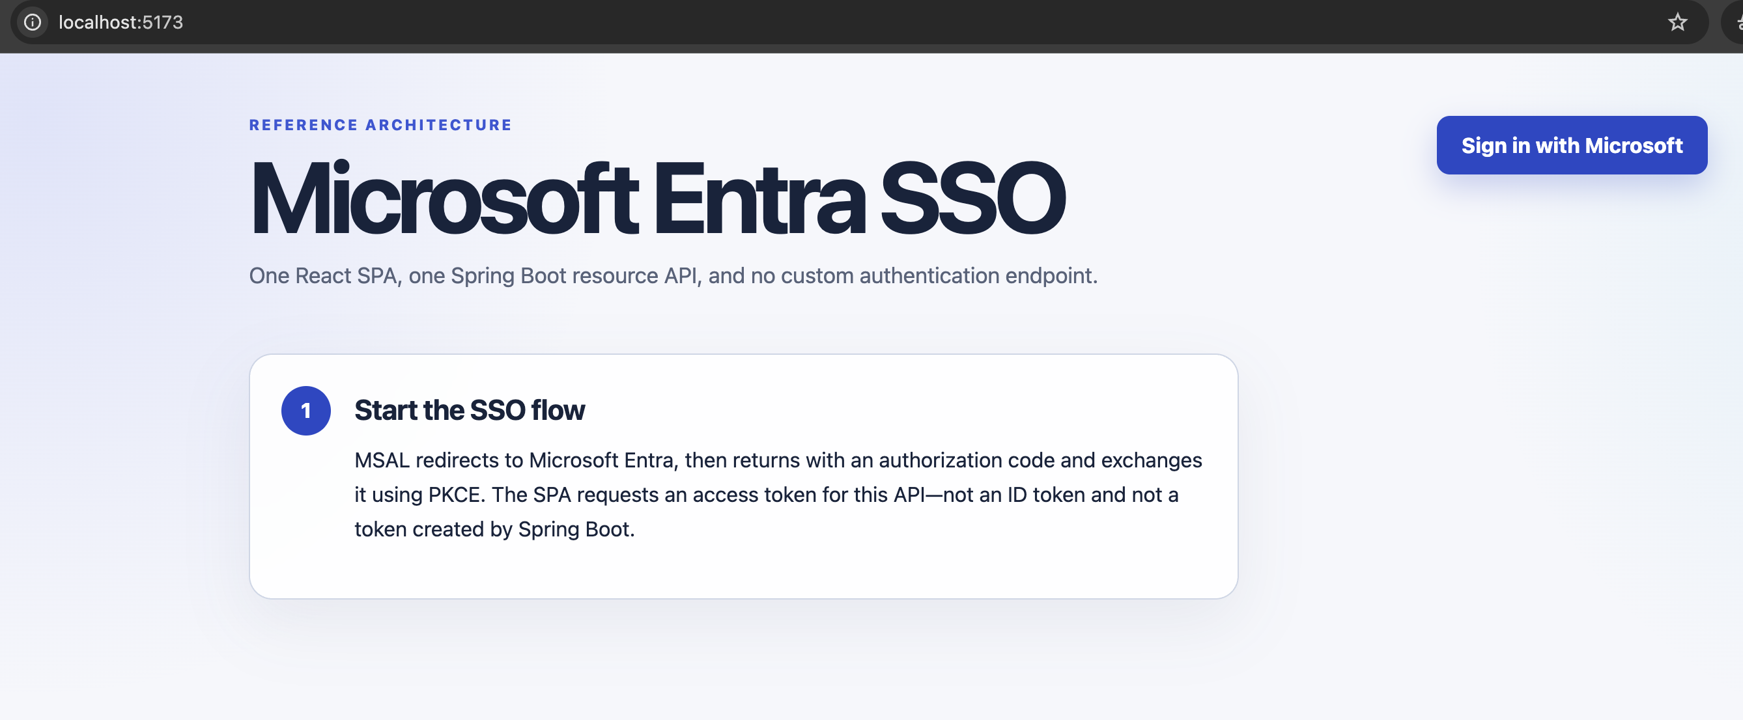

Login as Admin User:
1. Call to Entra with the tenant and request ID
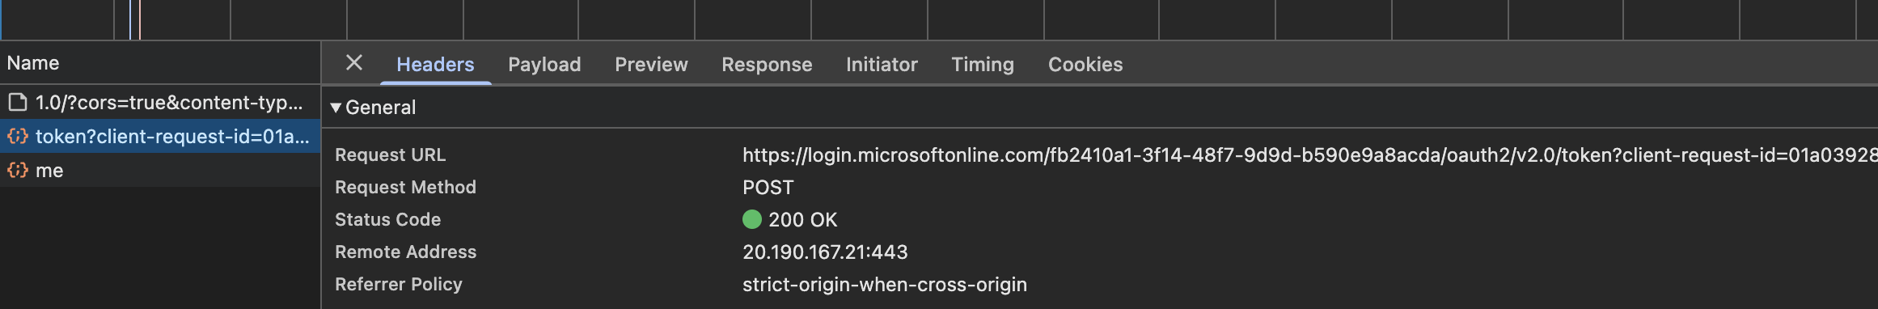

2. As a response we it gets the access token
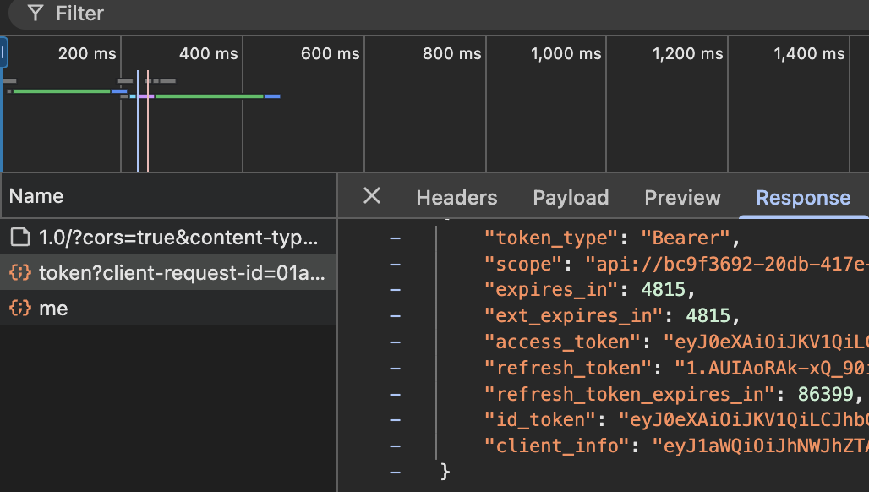

3. UI then calls /api/me with that access_token value as Bearer token and receives the below response.
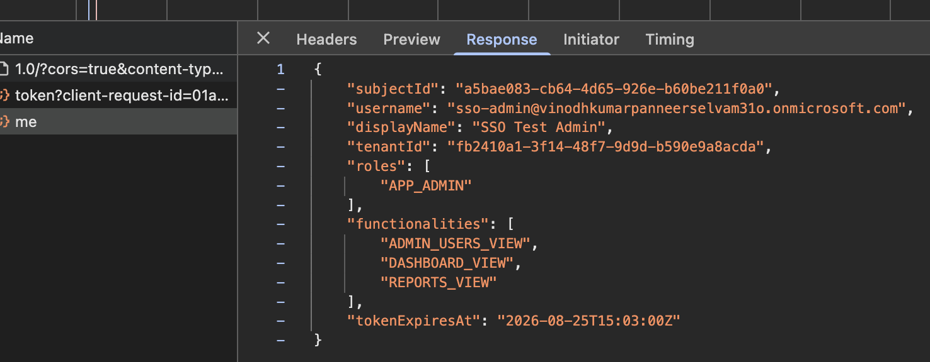

4. Based on the response UI paints as below.
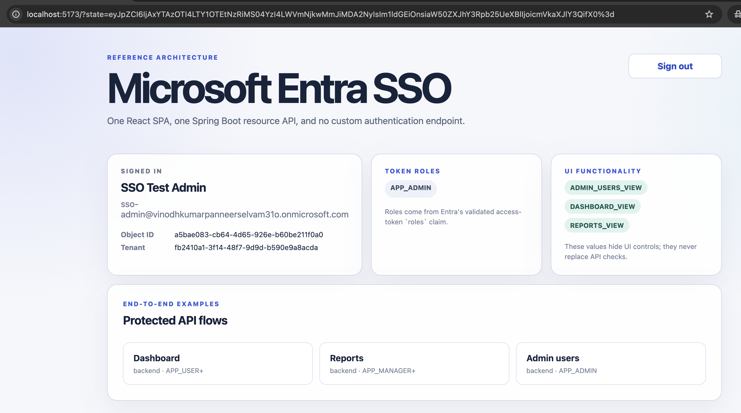

Login as Manager:

1. Steps remain the same and the /api/me return the below as response.
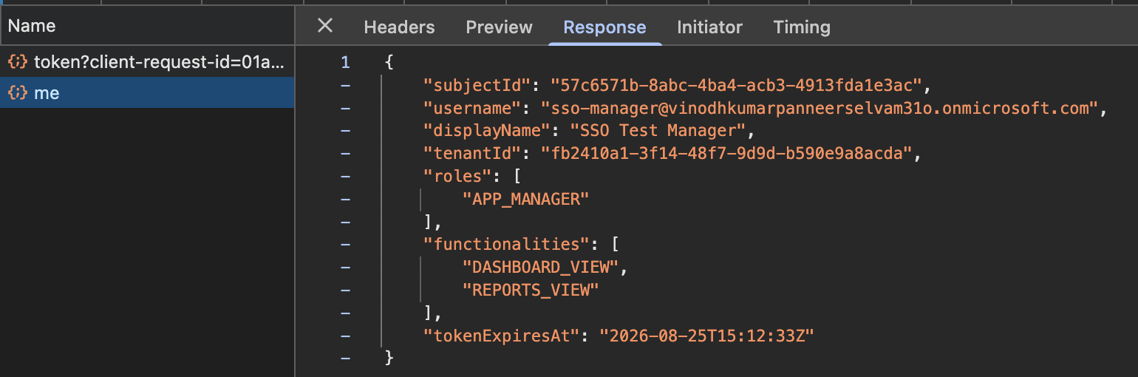

2. UI paints as below
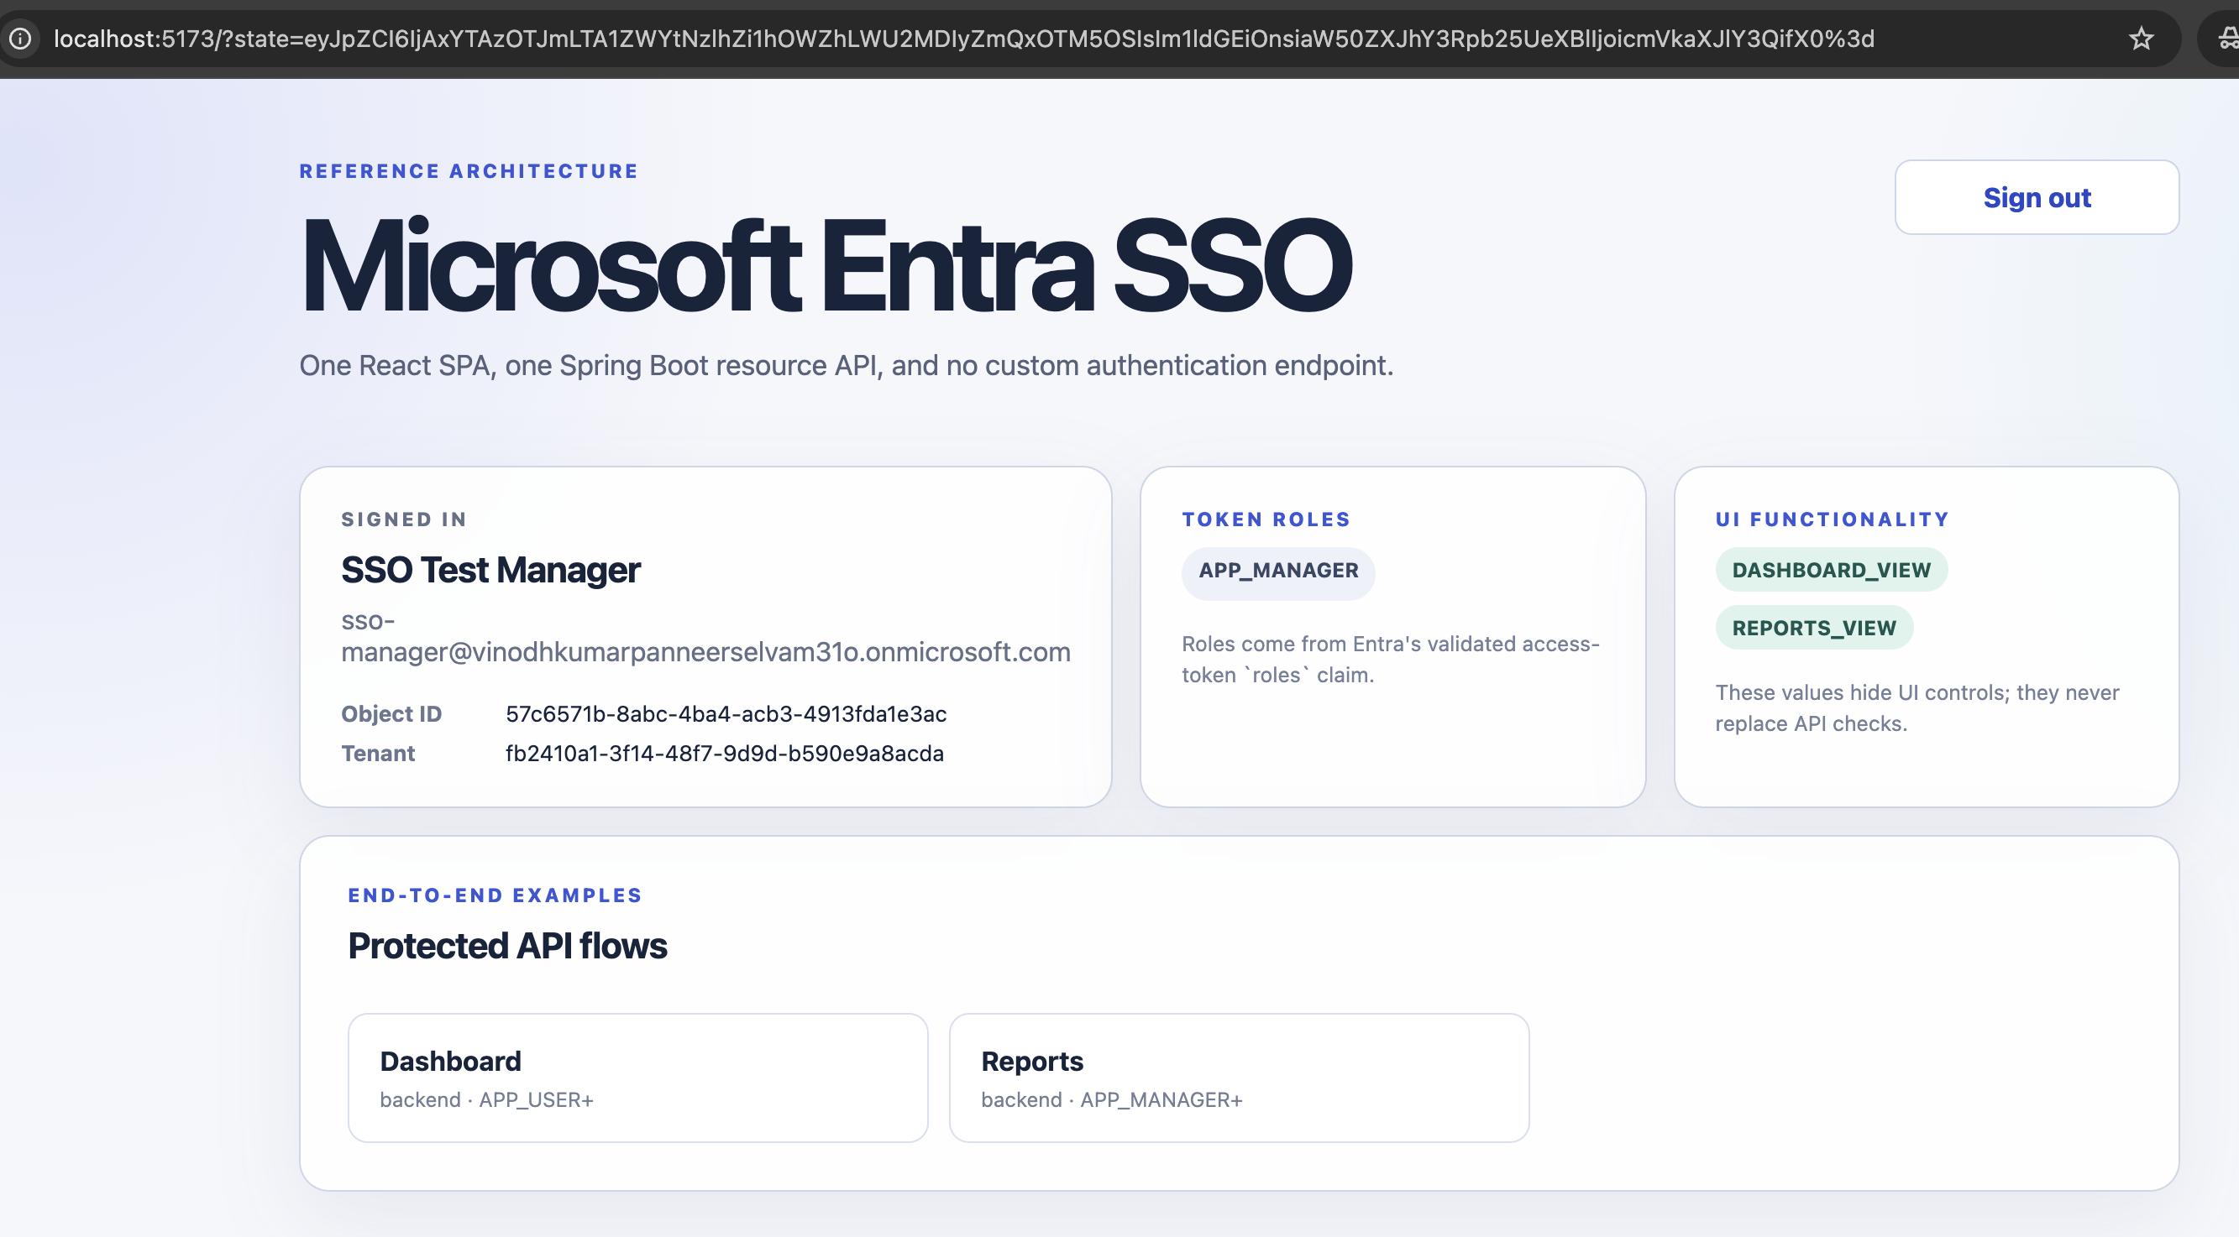

Login as Normal User:

1. Steps remain the same and the /api/me return the below as response.
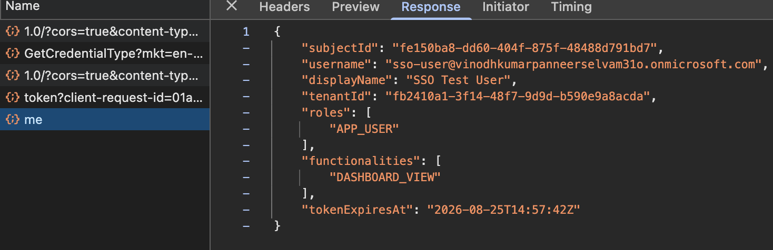

2. UI paints as below
