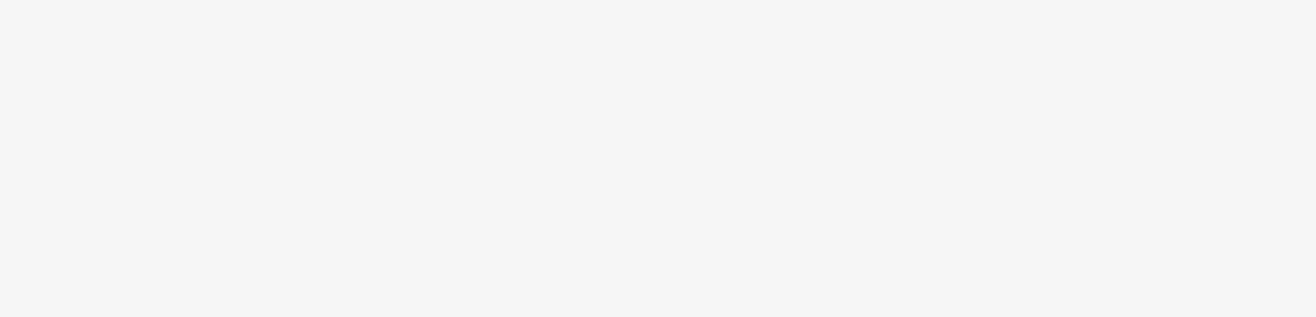

COMPUTER SCIENCE RESUME SAMPLE

E

C:\Users\abdou\Desktop\Resumes for Customer\Customer Project\Resume 2\icon6.pngC:\Users\abdou\Desktop\Resumes for Customer\Customer Project\Resume 2\icon5.pngC:\Users\abdou\Desktop\Resumes for Customer\Customer Project\Resume 2\icon4.pngC:\Users\abdou\Desktop\Resumes for Customer\Customer Project\Resume 2\icon3.pngC:\Users\abdou\Desktop\Resumes for Customer\Customer Project\Resume 2\icon2.pngC:\Users\abdou\Desktop\Resumes for Customer\Customer Project\Resume 2\icon1.png

**SOFTWARE ENGINEERING INTERN**

*Macroworks , Ann Arbor, MI / July 2018­–May 2019*

* Used Swift to develop a productivity app for iOS to help architects render and edit blueprints
* Worked with the development team to refine the debugging process
* Leveraged my knowledge of Java and Python to write interfaces to manage backup log data
* Fixed bugs in existing apps, contributing to an overall 20% reduction in customer complaints
* Helped implement a new process to streamline communication between the development team and operations

**WEB DEVELOPMENT INTERN**

*Spin.io, Detroit, MI / May 2016–August 2016*

* Fixed 300+ bugs on the website and implemented numerous enhancements to improve the overall user experience
* Used HTML, CSS, and JavaScript to contribute to a full revamp of the flagship app’s homepage, leading to a 16% increase in click rates
* Maintained and regularly updated webpages on WordPress
* Assisted in developing a widget to help cyclists locate the nearest bike lane, which is now one of Spin.io’s most popular products

Recent Computer Science graduate seeking to use my backend development experience in an entry-level position at Whisker Software. Possess more than 1 year of hands-on experience building and testing applications for Android, iOS, and Windows.

**B.S. / COMPUTER SCIENCE**

University of Michigan, Ann Arbor, Michigan 2015–2019

**Email:**

Will.Sudo@gmail.com

**Phone:**

206 527 1366

**Address:**

241 Prospect St., Seattle, WA 98112

**Linkedin:**

linkedin.com/in/Will.Sudo

CONTACT

SOFT SKILLS

HARD SKILLS

EDUCATION

Visual Basic, C, C++, Java, JavaScript, Python, Swift HTML, CSS, Linux, WordPress

Adaptability

Strong Work Ethic

Quick Learner

from Resume Genius

CAREER OBJECTIVE

EXPERIENCE