# Calculator

## Add functionality has developed using **Django python**

Eg:- 12345+1 = 12346

# Invoke the Calculator Apps

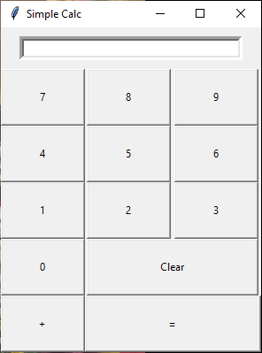

## Enter Number like 12345

## Click the + button and enter Number like 1

## Click = button and Answer to be displayed in system

