# exportDatafromMysqlToCsv_gui

## System support to export the data from MySQL To CSV files using **Django python**

# Windows display the home screen

## Enter Required details

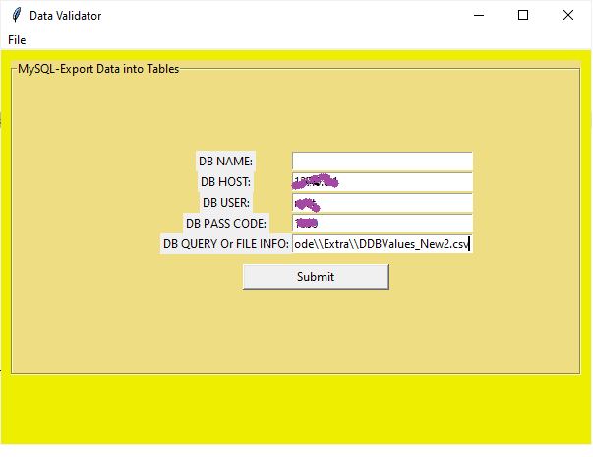

## Verify the Tables data in MySql with tables

## Verify the Tables data in MySql with tables

## Open the files E:\\PythonCode\\Extra\\DDBValues_New3.csv

