**Steps Involved in testing of Rabobook-Git-OAuth2 Project**

**Getting the OAuth Token**

1. Open the Postman App
2. Select request as POST from pull down and enter the URL below URL as shown

<https://rabobank-git-oauth2-io.cfapps.io/oauth/token>

1. Credentials (configured in application.properties)
   1. Rabobank Client ID: rabobank
   2. Rabobank Client Secret: rabobank
   3. Rabobank Customer Username: rabobank
   4. Rabobank Customer Password: password
   5. Rabobank Grant Type: password
2. In Authorization tab, choose type as Basic Auth and enter Client ID and Client Secret in username and password field (Screen Shot 1).
3. In Body tab, enter Customer username/password and grant_type (screen Shot 2)
4. Click on Send button, Bearer Token(access_token), configured in the way, valid for 10 mins will be generated as output of request (Screen Shot 3)

**Screen Shot 1**

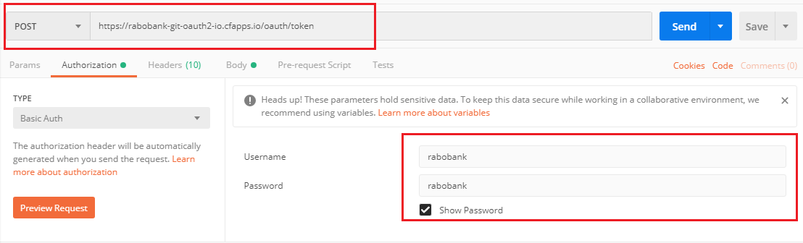

**Screen Shot 2**

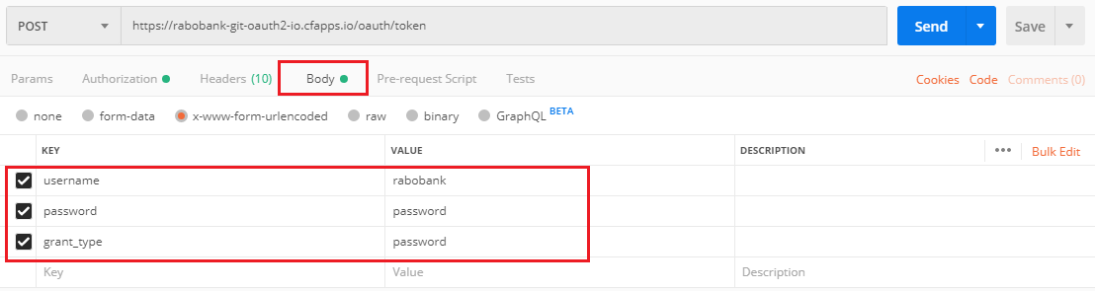

**Screen Shot 3**

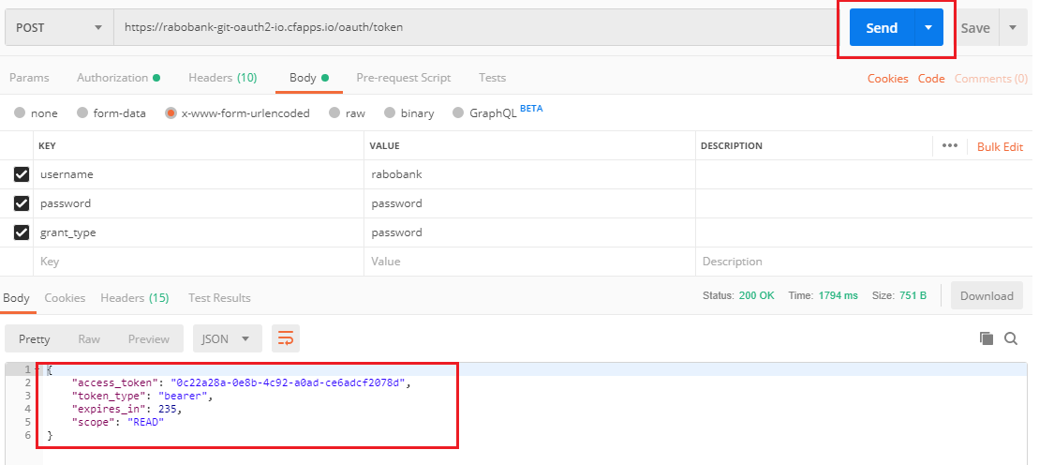

**Invoking the Secured Resource**

1. Secured Resource is [https://rabobank-git-oauth2-io.cfapps.io/repos/{username}](https://rabobank-git-oauth2-io.cfapps.io/repos/%7busername%7d).
2. Configure the GET request with above API and select Type as Bearer Token and paste the copied access_token in Token field and hit on send button.
3. Response will be generated as shown in Screen Shot 4
4. Provided invalid token, results in unauthorized response.

**Screen Shot 4**