Delhivery LastMile –Magento Integration

***Usage Document***

Purpose: 3

License: 3

Installation: 4

Configuration: 8

Pin code Manager: 10

AWB Manager: 12

Add Tracking Number: 14

Pin Code Validation: 15

Submit Manifest: 16

Print Shipping Label: 18

Un-Installation: 19

FAQ: 20

**Purpose:**

The purpose of this plug-in is to integrate Delhivery LastMile processes with ecommerce stores running on Magento. It provides following feature

* Download and Store client specific AWB series from Delhivery system.
* Download and Store list of serviceable Pin Code from Delhivery system.
* Allocate AWB to Order automatically from stored list while shipping order and Delhivery selected as Carrier
* Pin code Check while shipping order.
* Facility to submit manifest for the allocated AWB.
* Facility to print shipping label for the selected AWB.

**License:**

This plug-in is being release as part of [Commons Creative License.](https://creativecommons.org/licenses/)

**Installation:**

This plug-in will be installed as regular Magento Plug-in.

**PRe-Installation Steps:**

Downloaded “Delhivery_Lastmile-0.2.0.tgz” file from the link provided by Delhivery.

**Installation Steps:**

* **Go To: System > Magento Connect Manager**
* **Login as “admin” again.**
* **Click Choose File Button, Browse the (Delhivery_Lastmile-0.2.0.tgz) File and Click Upload.**

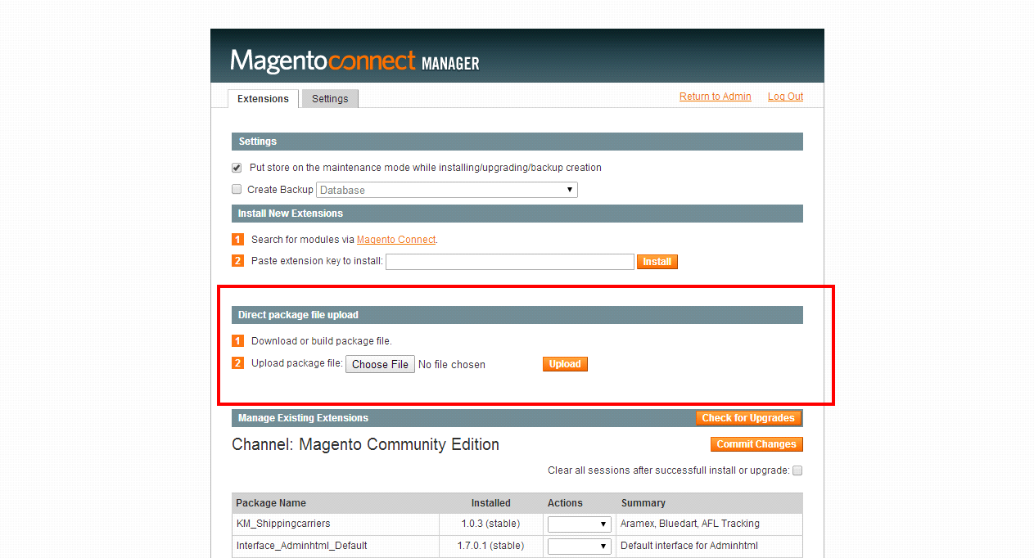

**Step 4: Package Installation will start.**

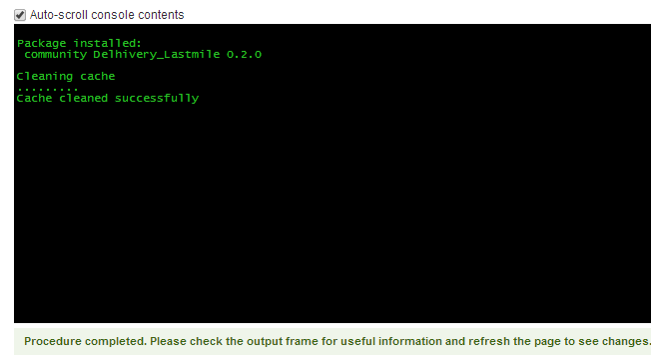

**Post installation changes**

* **New Option (Delhivery ) in Header Menu  
  Note:** Clear your magento cache and try logout/login if you don’t see these option in admin

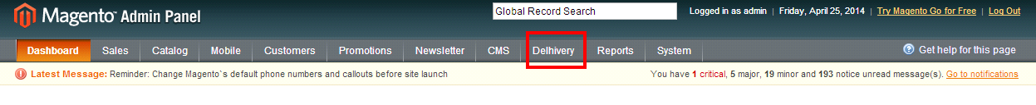

* **Folder and File Structure**

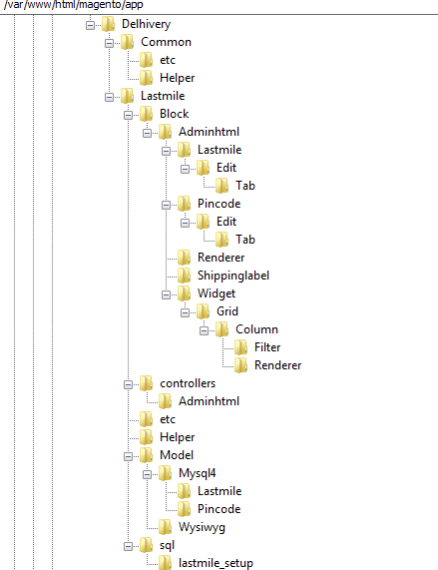

* **Database Changes**
* Created two new tables
* [delhivery_lm_awb](http://54.209.226.116/phpmyadmin/sql.php?db=magento&token=f3bba175b64af3ab1213eaa5e72ebc65&table=delhivery_lm_awb&pos=0)
* [delhivery_lm_pincode](http://54.209.226.116/phpmyadmin/sql.php?db=magento&token=f3bba175b64af3ab1213eaa5e72ebc65&table=delhivery_lm_pincode&pos=0)
* Insert one record in <core_resource> table , as show below:

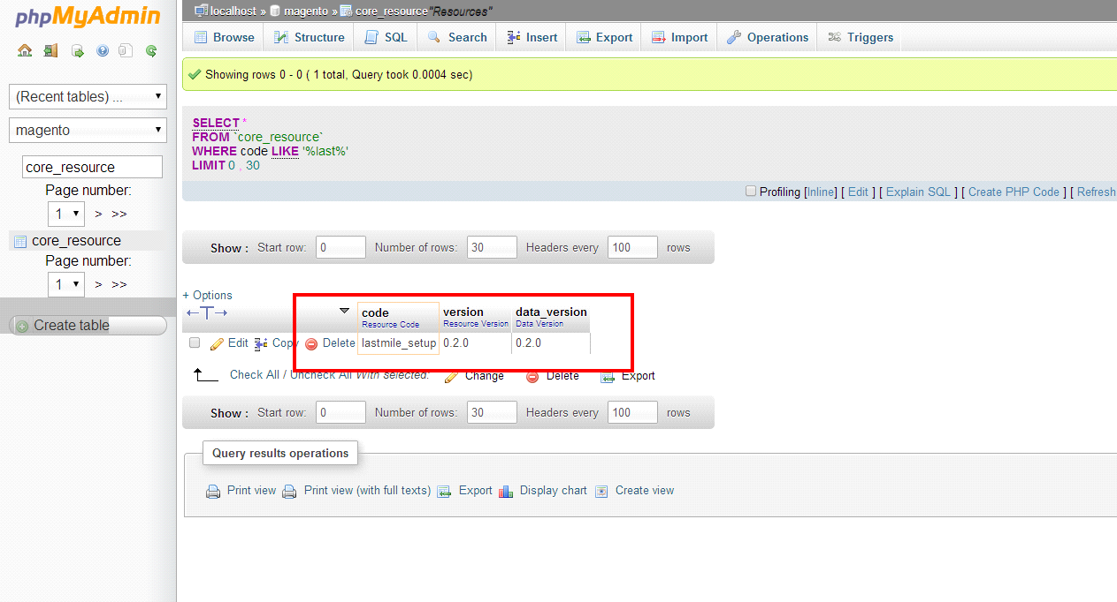

**Configuration:**

After installation configure settings to run this plug-in. Reach out to <lm-tech@delhivery.com>, for Client Id and License Key.

* Go To: System > Configuration > Shipping Methods

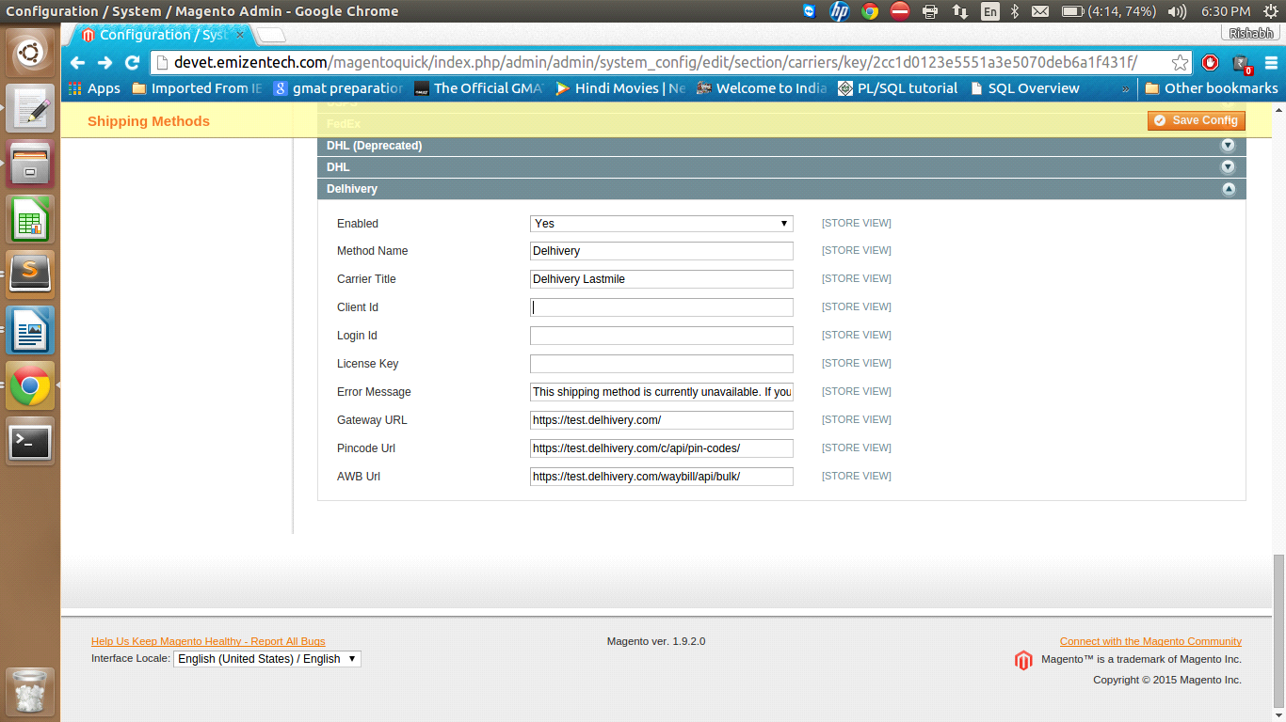

|  |  |
| --- | --- |
| **Option** | **Purpose** |
| **Enabled** | No →Delhivery will not appear as carrier in shipping options on store view [DEFAULT].  Yes →Delhivery will appear as carrier in shipping options on store view |
| **Method Name** | Always Delhivery |
| **Carrier Title** | Always Delhivery |
| **Client ID** | Name of the Store, specific to client. |
| **Login Id** | Future Use |
| **License Key** | Token provided by Delhivery, specific to client |
| **Enter Message** | This message appears when plug-in is disabled. |
| **GateWay URL** | Delhivery Server URL, change to production URL when ready to go live. |
| **Pin Code URL** | URL for fetching Pin Code, changes to production URL when ready to go live. |
| **AWB URL** | URL for fetching AWB, changes to production URL when ready to go live. |

**Pin code Manager:**

This option shows list of all serviceable Pin Code by Delhivery

* Press **[Download Pincode]** button to refresh the list. [Note: It will take considerable amount of time depending upon bandwidth available. If you see blank page kindly refresh and click refresh and go to Manage Pin Code option again.]

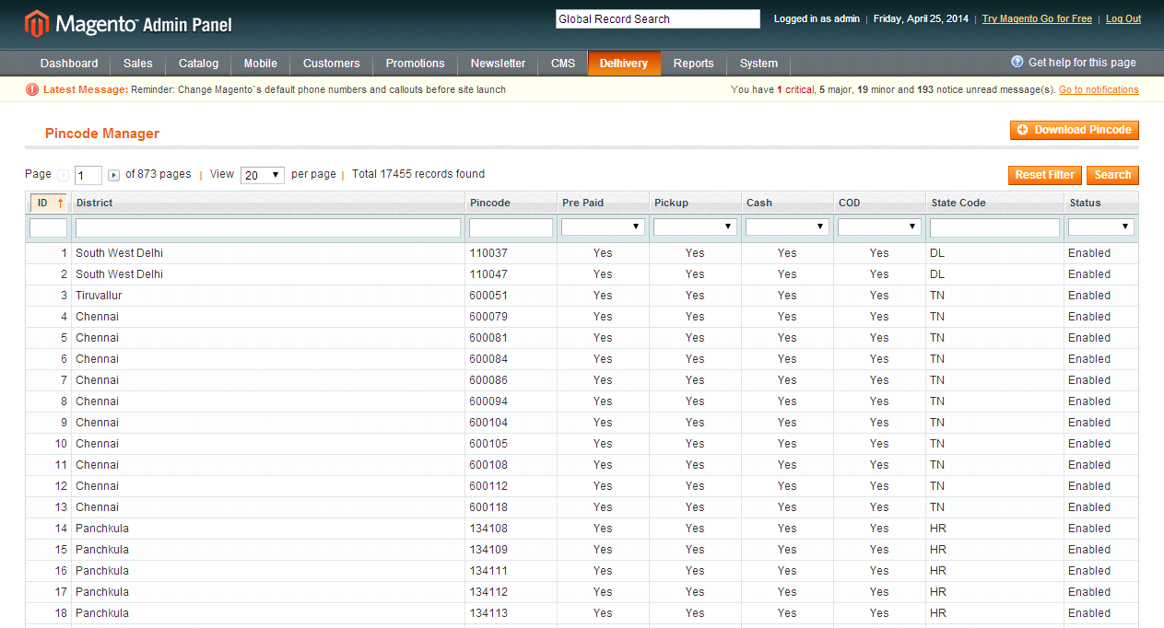

* Not Serviceable Pin codes

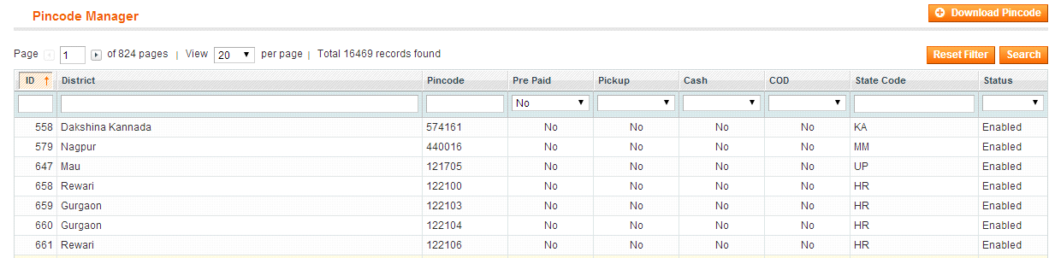

**AWB Manager:**

* This option shows list of all AWBs downloaded from Delhivery.

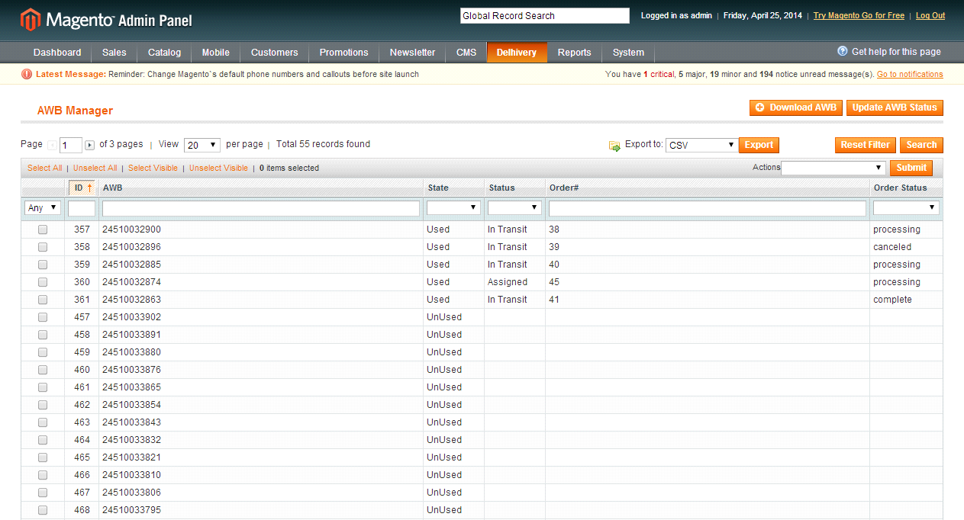

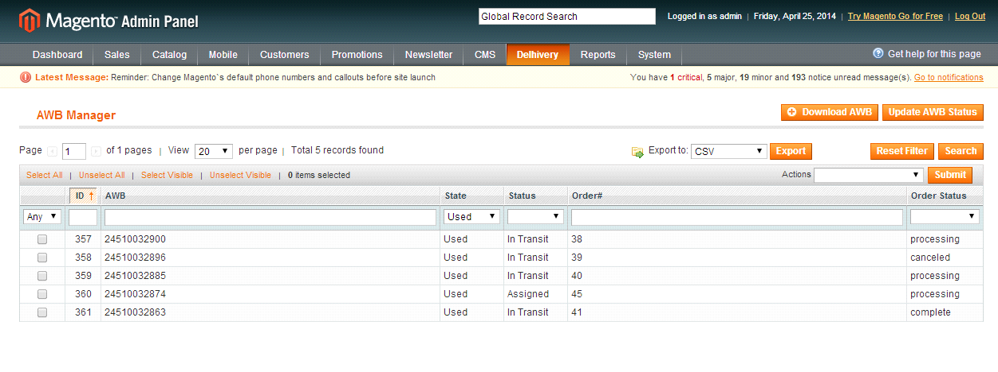

|  |  |
| --- | --- |
| **Option** | **Purpose** |
| **AWB** | Downloaded AWB series(50) from Delhivery server, AWB series is specific to client and determines by the token provided to client by Delhivery. |
|  |  |
| **State** | Used →Allocated to Order  Unused →Not Allocated to Order |
| **Statue** | Current Tracking Status of AWB |
| **Order#** | Assigned Order# |
| **Order Status** | Current Status of Order |

* Click **[Download AWB]** button for download new AWB series.
* Click **[Update AWB Status]** button to update current tracking status.



**Add Tracking Number:**

* Click **[add Tracking number]** button for adding tracking number in Order.

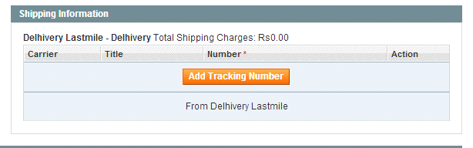

* Click **[Delhivery Last Mile]** from the option, AWB no will be added automatically.

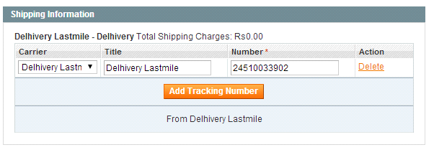

**Pin Code Validation:**

* Will not allocate AWB if Pin Code not serviceable.

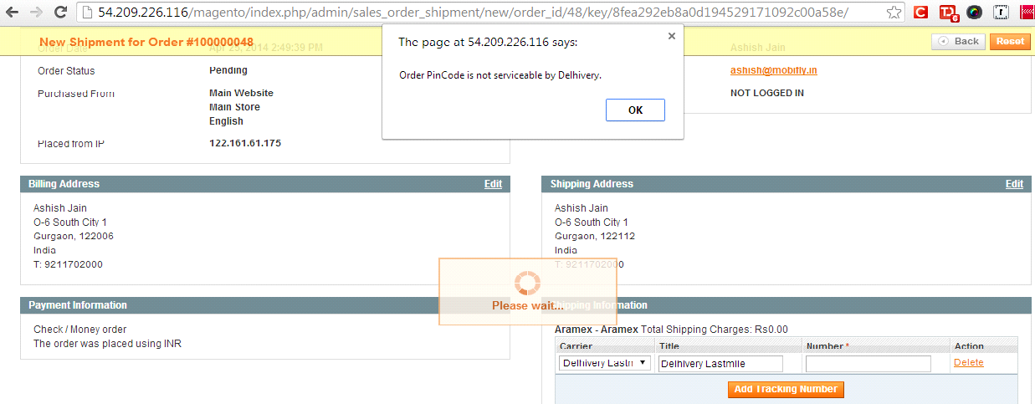

**Submit Manifest:**

This option allows to Submit Manifest for selected AWB(s). Once manifest submitted successfully Delhivery systems will be notified pickup is ready for the given AWB.

* AWB state will be ‘Used’ and status will be ‘Assigned’ once allocated to order.

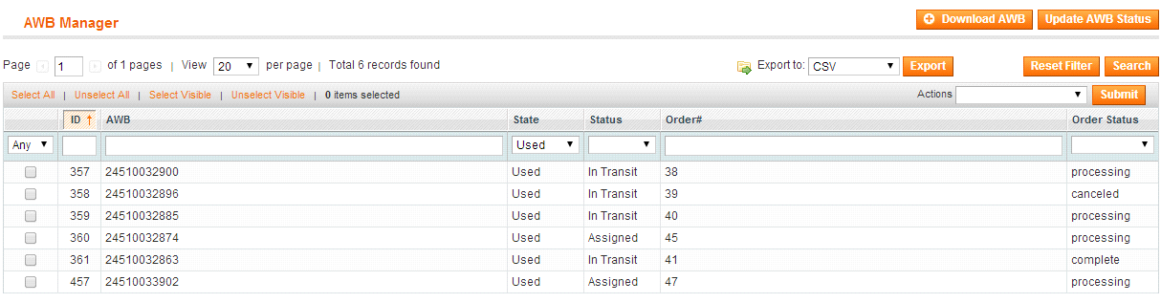

* AWB status will be In Transit once manifest submitted successfully.

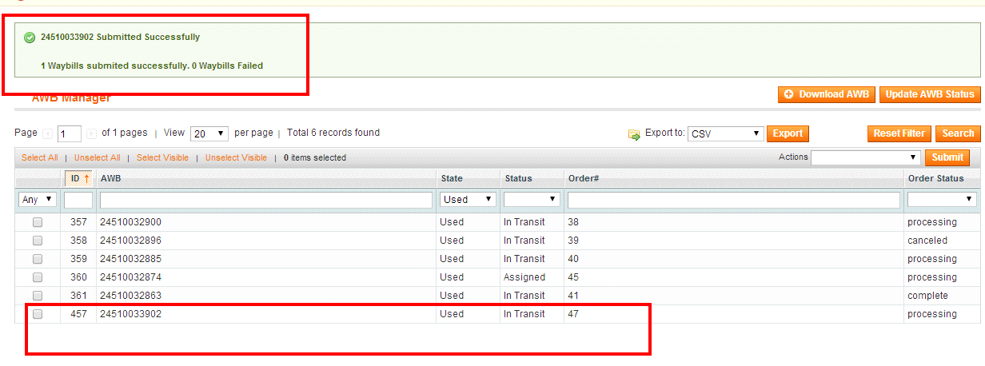

* Will not submit manifest for same AWB again.

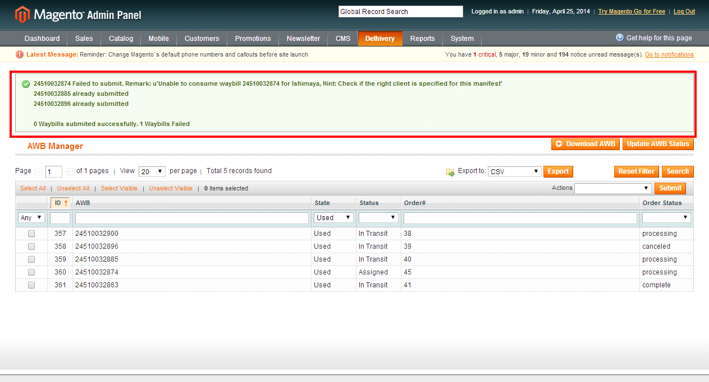

**Note:**

* Shipping change done in order after manifest submission will not be notified to Delhivery.
* Order status change done in order after manifest submission will not be notified to Delhivery.

**Print Shipping Label:**

This option allows downloading of shipment label PDF for selected AWB(s). Below is the format of shipping label, each page will have 4 shipping labels.

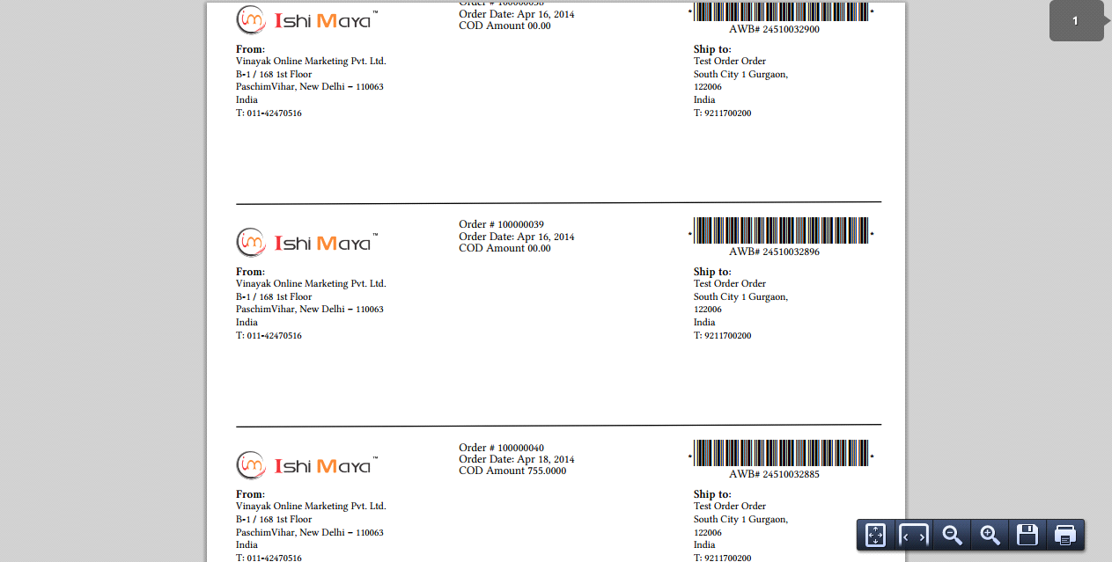

Un-Installation:

* Delete following file → app/etc/modules/Delhivery_Lastmile.xml
* Delete following folder → app/code/community/delhivery
* Delete following file → app/design/adminhtml/default/default/template/delhiverlastmile
* Delete FROM `core_resource` WHERE code = 'lastmile_setup'

Log Files are available at:

../magento/var/log/system.log

FAQ:

* What will be the status of AWB once allocated?
* **Status of AWB will be “Assigned” once its allocated to any order**
* What will be the status of AWB once manifest submitted?
* **Status of AWB at this stage will be “In Transit”**
* What if Pin Code / Address changed after allocating AWB no?  
  **A. In such case System will not notify Delhivery for the changes. Should be handled by vendor outside the system.**
* What if order cancelled before manifest submission?
* **In that case associated AWB will be marked as unused and that can be used for new orders**
* What if order cancelled after manifest submission?
* **AWB cannot be used for any other order after manifest submission, so it will stay as used**
* Can I add Tracking Number Manually?
* **No, Tracking number will be assigned automatically whenever Delhivery is selected from the careers list**
* Can I delete Shipment Tracking Number?
* **Yes tracking number can be deleted from a shipment. If it’s a tracking number from Delhivery, corresponding AWB number will be marked as unused and will be ready to be used for new order**
* Can I submit manifest multiple times?
* **No, Manifest to Delhivery can be submitted only once for each AWB number. It status can keep updating after successful submission of manifest.**
* Can I print shipping label without manifest submission?
* **Shipping Label can be printed once an AWB is assigned to an order. Manifest submission is not required for that.**