**METHODOLOGY**

The proposed system is an embedded system which will closely monitor and control the environmental parameters of rearing house on regular basis. The dissection of a system into its component pieces to study how these component pieces interact and work. System design is the process of defining the architecture, components, modules interfaces and data for a system to satisfy specified requirements.

**3.1 Modules:**

* Android
* Mobile Data
* Sericulture system

**3.1.1 Android:**

Android is a free, open source mobile platform. It is a Linux-based, multiprocess, multithreaded Operating System. It is a software stack for mobile devices that include an operating system, middleware and key applications. By providing an open development platform, Android offers developers the ability to build extremely rich and innovative applications.Android offers a unified approach to application development for mobile devices which means developers need only develop for Android, and their applications should be able to run on different devices powered by Android.

The first beta version of the Android Software Development Kit (SDK) was released by Google in 2007. On June 27, 2012, at the Google I/O conference, Google announced the next Android version, 4.1 Jelly Bean.

Beginning with Android 4.1 "Jelly Bean”, "expandable notifications" allow the user to tap an icon on the notification in order for it to expand and display more information and possible app actions right from the notification. Jelly Bean is an incremental update, with the primary aim of improving the user interface, both in terms of functionality and performance.

The source code has been used to develop variants of Android on a range of other electronics, such as game consoles, [digital cameras](https://en.wikipedia.org/wiki/Digital_camera), [PCs](https://en.wikipedia.org/wiki/Personal_computer) and others, each with a specialized user interface.

The Android SDK provides the tools and APIs necessary to begin developing applications on the android platform using the java programming language.

API Level is an integer value that uniquely identifies the framework API revision offered by a version of the Android platform.

Android operating system is a stack of software components which is roughly divided into five sections and four main layers as shown below in the architecture diagram in figure 4.1.1

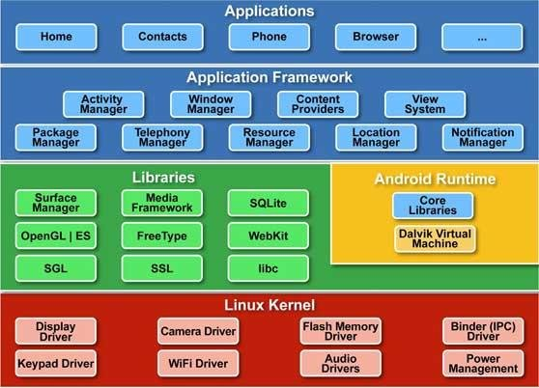

Fig 3.1: Android Architecture

**Applications:** These are applications written in Java. Some of the basic applications include calendar, email client, SMS program, maps, making phone calls, accessing the web browser, accessing contact list and others. This is the layer which an average user uses the most, rest of the layers are used by programmers, developers and hardware manufacturers.

**Application Framework:** This is the skeleton or framework which all android developers have to follow. The developers can access all framework APIs and manage phone’s basic functions like resource allocation, switching between processes or programs, telephone applications, and keeping track of the phone’s physical location.

The architecture is well designed to simplify the reuse of components. Any application can publish its capabilities and any other application can then make use of those capabilities. Content providers enable application to access data from other applications. Resource manager provides access to non code resources such as graphics, localized strings and layout. Notification manager displays custom alerts in the status bar. Activity manager manages the life cycle of an application and provides common navigation. Application framework is a set of basic tools with which a developer can build much more complex tools.

**Libraries:** This layer consists of Android libraries written in C,C++ ,and used by various systems. These libraries tell the device how to handle different kinds of data and are exposed to Android developers via Android application framework. Some of these libraries include media, 3D graphics, SQLite, Web browser library etc. The android runtime layer which includes set of core java libraries and DVM (Dalvik Virtual Machine) is also located in same layer.

**Runtime Android:** This layer includes set of base libraries that are required for java libraries. Every Android application gets its own instance of Dalvik Virtual Machine. Dalvik has been written so that a device can run multiple VMs efficiently and it executes files in executable (.Dex) optimized for minimum memory.

**Kernel-Linux:** Android relies on Linux version. This layer includes Android’s memory management programs, security settings, power management software and several drivers for hardware, file system access, networking and inter- process communication. The kernel also acts as an abstraction layer between hardware and the rest of the software stack.

The Activity Life Cycle of Android is as shown below:

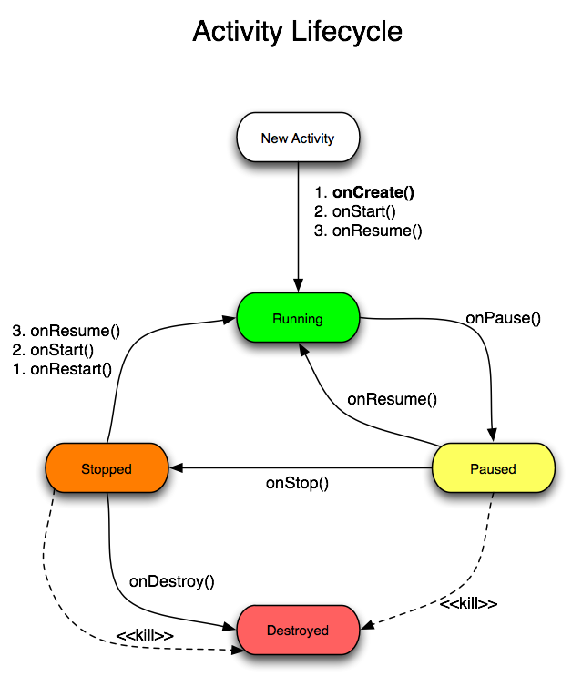

Fig 4.2: Activity Life Cycle Of Android

The set of functions are explained below :

* onCreate(Bundle): This is called when the activity first starts up . You can use it to perform one-time initialization such as creating the user interface. onCreate() takes one parameter that is either equal to null or some state information previously saved by the onSaveInstance() method.
* onStart( ): This indicates that the activity is about to br displayed to the user .
* onResume( ): This is called when your activity can start interacting with the user . This is a good place to start animations and music
* onPause( ): This runs when the activity is about to go into the background, usually because another activity has been launched in front of it . This is where you should save your programs persistent state , such as a database record being edited .
* onStop( ): This is called when your activity is no longer visible to the user and it wont be needed for a while. If the memory is tight , onStop() may never be called (the system may simply terminate your process).
* onRestart( ): If this method is called , it indicates that your activity is being redisplayed to the user from a stop state .
* onDestroy( ): This is called right before your activity is destroyed . if the memory is tight , onDestroy() may never be called ( the system may simply terminate your process).
* onSaveInstanceState( Bundle) : Android will call this method to allow the activity to save per instance state such as a cursor position within a text field .usually you won’t need to overwrite it because the default implementation saves the state for all user interface controls automatically.
* onRestoreInstanceState( Bundle) : This is called when the activity is being reinitialized from a state previously saved by the onSaveInstanceState ( ). The default implementation restores the state of your user interface .

**3.1.2 Mobile Data:**



Mobile data is Internet content delivered to mobile devices such as smartphones and tablets over a wireless cellular connection Mobile data is what allows your phone to get online when you’re away from Wi-Fi. Mobile-enabled devices can send and receive information over a wireless cellular connection. As long as you have a cellular connection, you can use the Internet. Mobile data allows your phone to access the Internet even when you’re not on Wi-Fi. Mobile data gives you an Internet connection anywhere as long as you’re connected to a cellular network. The mobile data can be used to your Internet browser, email and syncing to the cloud. Mobile data usage is measured in megabytes (MB) and gigabytes (GB). There are 1,000 MB in 1 GB of data. Everything you send to (upload) or receive from (download) the Internet will require some amount of data. Smartphones give you the option of turning mobile data on or off altogether. This can be a helpful trick if you’re used to using data wherever you are and want to try a more conscious method of consumption.

**3.1.3 Sericulture System:** The system has the following major components:-

1. **SST 89E516RD2 MICROCONTROLLER**

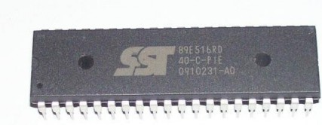

Fig 4.3: SST 89E516RD2 Microcontroller

**Description:**

The main centre part of the project is the microcontroller. Here we are using the 8051 based Philips SST 89E516RD2 microcontroller.

The 89E516RD2 are 80C51 microcontrollers with 64kB flash and 1024 B of data RAM. A key feature of the 89E516RD2 is its X2 mode option. The design engineer can choose to run the application with the conventional 80C51 clock rate (12 clocks per machine cycle) or select the X2 mode (six clocks per machine cycle) to achieve twice the throughput at the same clock frequency.

The flash program memory supports both parallel programming and in serial ISP. Parallel programming mode offers gang-programming at high speed, reducing programming costs and time to market. ISP allows a device to be reprogrammed in the end product under software control. The capability to field/update the application firmware makes a wide range of applications possible.

**Features:**

* 80C51 CPU with 5V operating voltage from 0 to 40 MHz
* 64 kB of on-chip flash user code memory with ISP and IAP.
* SPI and enhanced UART.
* Four 8-bit I/O ports with three high-current port 1 pins.
* Three 16-bit timers/counters.
* Programmable watchdog timer.
* Eight interrupt sources with four priority levels.
* Second DPTR register
* Low EMI mode (ALE inhibit)
* TTL- and CMOS-compatible logic levels
* Brownout detection
* Low power modes
  + Power-down mode with external interrupt wake-up
  + Idle mode

**Pin configuration:**

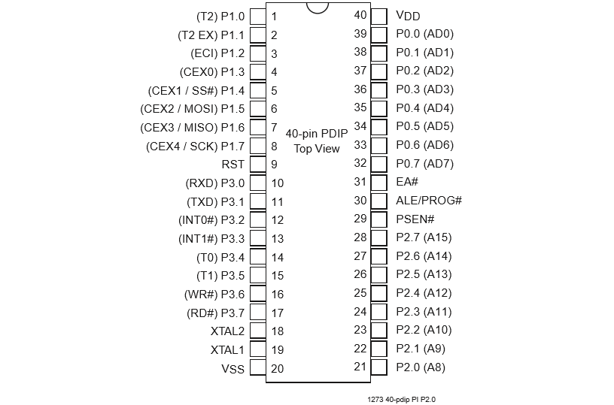

Fig 4.4: Pin configuration of SST 89E516RD2

ALE/PROG: Address Latch Enable output pulse for latching the low byte of the address during accesses to external memory. ALE is emitted at a constant rate of 1/6 of the oscillator frequency, for external timing or clocking purposes, even when there are no accesses to external memory. (However, one ALE pulse is skipped during each accesses to external Data Memory). This pin is also the program pulse input(PROG) during EPROM programming.

PSEN: Program Store Enable is the read store be to external Program Memory. When the device is executing out of external Program Memory, PSEN is activated twice each machine cycle (except that two PSEN activations are skipped during accesses to external Data Memory). PSEN is not activated when the device is executing out of internal Program Memory.

EA: External Access Enable: EA must be driven to VIL in order to enable the device to fetch code from the External Program Memory. EA must be driven to VIH for internal program execution. However, Security lock level 4 will disable EA, and program execution is only possible from internal program memory. The EA pin can tolerate a high voltage2 of 12V.

XTAL1: Input to the inverting oscillator amplifier.

XTAL2: Output from the inverting oscillator amplifier.

Port0: Port0 is an 8-bit open drain bi-directional I/O Port. As output Port, each pin can sink eight TTL inputs. When are written to Port0 pins, the pins can be used as high impedance inputs.Port0 can also be configured to be the multiplexed low-order address/data bus during accesses to external program and data memory. In this mode, P0 has internal pull-ups. Port0 also receives the code bytes during Flash programming and outputs the code bytes during program verification. External pull-ups are required during program verification.

Port1: Port1 is an 8-bit bi-directional I/O port with internal pull-ups. The Port1 output buffers can sink/source four TTL inputs. When logic 1s are written to Port1 pins, they are pulled high by the internal pull-ups and can be used as inputs. As inputs, Port1 pins that are externally being pulled low will source current because of the internal pull-ups. PORT1 also receives the lower order address bytes during flash programming and verification. In addition, P1.0 and P1.1 can be configured to be the timer/counter 2 external count input (P1.0/T2) and the timer/counter 2 trigger input (P1.1/T2EX).

Port2: Port2 can also be used as an 8-bit bi-directional I/O Port with internal pull-ups. The Port2 output buffers can sink/source four TTL inputs. When ones are written to Port2 pins, they are pulled high the internal pull-ups and can be used as inputs. As inputs, Port2 pins that are externally being pulled low will source current because of the internal pull-ups.The alternate use of Port 2 is to supply a high order address byte in conjunction with the Port0 low order byte to address external memory. It uses strong internal pull-ups when emitting ones.It also receives the higher order address bytes and some control signals during flash programming and verification.

# Port3: Port3 is an 8-bit bi-directional I/O Port with internal pull-ups The Port3 output buffers can sink/source four TTL inputs. When ones are written to Port3 pins, they are pulled high by the internal pull-ups and can be used as inputs. As inputs, Port3 pins that are externally being pulled low will source current because of the pull-ups.

Port3 also serves the functions of various special features of the AT89C51, as shown below

P3.0 RXD (serial input port)

P3.1 TXD (serial output port)

P3.2 INT0 (external interrupt 0)

P3.3 INT1 (external interrupt 1)

P3.4 T0 (timer 0 external input)

P3.5 T1 (timer 1 external input)

P3.6 WR (external data memory writes strobe)

P3.7 RD (external data memory read strobe)

Timers

The two 16-bit Timer/counter registers: Timer 0 and Timer 1 can be configured to operate either as timers or event counters. In the ‘Timer’ function, the register is incremented every machine cycle. Thus, one can think of it as counting machine cycles. Since a machine cycle consists of six oscillator periods, the count rate is 1¤6 of the oscillator frequency.

In the ‘Counter’ function, the register is incremented in response to a 1-to-0 transition at its corresponding external input pin, T0 or T1. In this function, the external input is sampled once every machine cycle.

When the samples show a high in one cycle and a low in the next cycle, the count is incremented. The new count value appears in the register in the machine cycle following the one in which the transition was detected. Since it takes two machine cycles (12 oscillator periods) for 1-to-0 transition to be recognized, the maximum count rate is 1/12 of the oscillator frequency. There are no restrictions on the duty cycle of the external input signal, but to ensure that a given level is sampled at least once before it changes, it should be held for at least one full machine cycle. In addition to the ‘Timer’ or ‘Counter’ selection, Timer 0 and Timer 1 have four operating modes from which to select.

The ‘Timer’ or ‘Counter’ function is selected by control bits C/T in the Special Function Register TMOD. These two Timer/counters have four operating modes, which are selected by bit-pairs (M1, M0) in TMOD. Modes 0, 1, and 2 are the same for both Timers/counters. Mode 3 is different. The four operating modes are described in the following text.

1. **ALARM SYSTEM**

Analarm system is a system designed to detect intrusion – unauthorized entry – into a building or other area such as a home or school. Security alarms are used in residential, commercial, industrial, and military properties for protection against rodents, pests or property damage, as well as personal protection against intruders like rats, lizards etc. Some alarm systems serve a single purpose of insects protection; combination systems provide both fire and intrusion protection. Intrusion alarm systems may also be combined with closed-circuit television surveillance systems to automatically record the activities of intruders, The most basic alarm consists of an alerting device to detect intruders, These indicate an alarm condition. Most commonly, these are bells, sirens, and/or flashing lights. Alerting devices serve the dual purposes of warning occupants of intrusion, and potentially scaring off burglars. These devices may also be used to warn occupants of a fire or smoke condition. In addition to the system itself, security alarms are often coupled with a monitoring service. In the event of an alarm, the premises control unit contacts a central monitoring station. Operators at the station see the signal and take appropriate action, such as contacting property owners, notifying police, or dispatching private security forces. Such signals may be transmitted via dedicated alarm circuits, telephone lines, or the internet.

1. **EMBEDDED C**

C is the most widely used programming language for **embedded** processors/controllers. Assembly is also used but mainly to implement those portions of the code where very high timing accuracy, code size efficiency, etc. are prime requirements.

As time progressed, use of microprocessor-specific assembly-only as the programming language reduced and embedded systems moved onto C as the embedded programming language of choice. C is the most widely used programming language for embedded processors/controllers. Assembly is also used but mainly to implement those portions of the code where very high timing accuracy, code size efficiency, etc. are prime requiretments.

Initially C was developed by Kernighan and Ritchie to fit into the space of 8K and to write(portable) operating systems. Originally it was implemented on UNIX operating systems. As it was intended for operating systems development, it can manipulate memory addresses. Also, it allowed programmers to write very compact codes. This has given it the reputation as the language of choice for hackers too.

As assembly language programs are specific to a processor, assembly language didn’t offer portability across systems. To overcome this disadvantages, several high level languages, including C, came up. Some of there languages like PLM, modula-2, Pascal, etc. also came but couldn’t find wide acceptance. Amongst those, C got wide acceptance for not only embedded systems, but also for desktop applications. Even though C might have lost its sheen as mainstream language for general purpose applications, it still is having a strong-hold in embedded programming. Due to the wide acceptance of C in the embedded systems, various kinds of support tools like compilers and cross compilers, ICE, etc. came up and all this facilitated development of embedded systems using C.

Embedded systems often have the real time constraints, which is usually not there with desktop computer applications. Embedded systems often do not have a console, which is available in case of desktop applications.

For embedded applications, we need to optimally use the resources, make the program code efficient, and satisfy real time constraints, if any. All this is done using the basic constructs, syntaxes, and function libraries of ‘c’.

**CHAPTER 4**

**SYSTEM REQUIREMENTS SPECIFICATIONS**

System requirements specifications(SRS) is a text written to specify in detail the system components, both hardware and software, which are needed for the system implementation, along with functional and non-functional requirements, as anticipated from the system.

**4.1 Hardware Specification**

This section gives details of the hardware components required for the system implementation and deployment. Sericulture system requires the following components:-

1. **SST 89E516RD2 Microcontroller**

The SST stands for silicon storage technology. A microcontroller plays a crucial role when it comes to project. This system uses the 8051 based Philips SST 89E516RD2 Microcontroller. It has a RAM of 1kb,ROM of 64kb and three timers t1,t2,t3 for feature purpose.8051 CPU with 5V operating voltage from 0 to 40MHz.SST 89E516RD2 is the 40 pins microcontroller with 4 ports as P0,P1,P2 and P3 of 8 bit each and also 32 pins of I/O ports. Three 16 bit clocks/counter and a programmable watch dog timer which is used in case of a hardware timers where the device can reset if some failure occurs. Four, 8bit bidirectional ports P0, P1,P2, P3 each consisting of 8 pins respectively.

1. **Temperature Sensor**

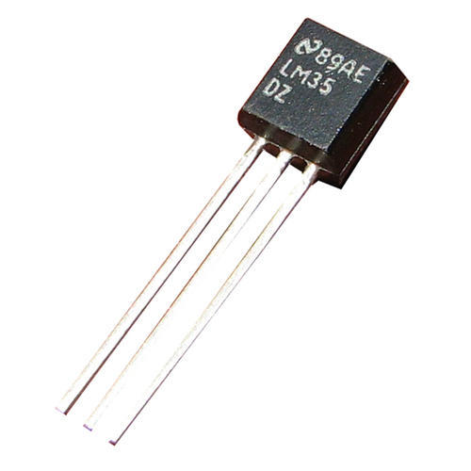

LM35 is a temperature measuring devices which provides output voltage in centigrade. It does not require any external calibrations to give accuracies of ± ¼ °C at room temperature and ± ¾°C over a full -55 to +150 C temperature range. It can be used with solo power supplies with both positive and negative supplies. It reassures a low cost for any external calibrations. LM35 provides output which is more accurate than thermistor output. It has a low impedance output of 0.1Ω for 1mA load and low self-heating, of 0.08 °C in still air. This temperature sensor is more suitable for remote applications. The LM35 operates from 4 to 30 volts with less than 60µA current drain.

1. **Humidity sensor**

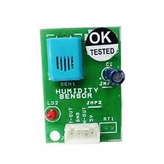

The module of HSM-20G is requisite for those applications where the relative humidity can be converted to standard output voltage. It includes various applications such as humidifiers and dehumidifiers, air-conditioner, humidity data loggers, automotive climate control and other applications. The characteristics of HSM-20G has got an input and output voltage range of DC 5.0 ±0.2V and DC 1.0 – 3.0V. This humidity sensor has a measurement accuracy of ±5% RH. It also has a storage RH ranging from 0 to 99% RH.

1. **Fire sensor**

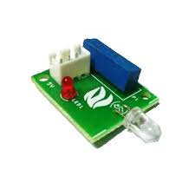

Fire sensor works by detecting smoke or heat. The module makes use of fire sensor and comparator to catch fire up to a range of 1 meter. In this system when any fire producing object is brought to the fire sensor within a range of 1M it produces fire alarm. The calibrations of the range adjustment is done beforehand. The fire sensor is utilized as a basic and minimized gadget if there is an emergency. The presence of fire is seen through an LED with 3 pins which is a very easy interface controller. The fire sensor produces an input voltage of +5VDC.

1. **Infrared sensor**

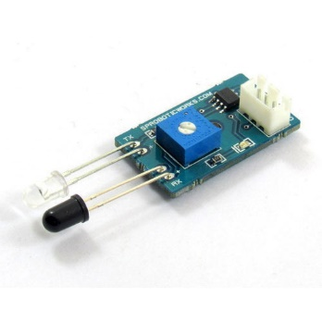

An infrared sensor is an electronic device which is used in the detection of some characteristics of its environment. It is also known as multi purpose infrared sensor which can be used for optical sensing, colour detection as well detects the motion of an object. This sensor gives both digital and an analog output. At the digital output, if there is an object in front of the sensor then the output will be logic1(5V) and logic) otherwise(0V). At the analog output, this sensor displays an analog voltage between 0V and 5V. The infrared sensor has a maximum range of around 40-50cm within doors and around 15-20cm outdoor.

1. **MAX-232**

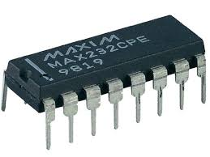

Max 232 is a dual driver/receiver to convert transistor transistor logic(TTL) voltage level to RS232 and vice-versa. It is an integrated circuit which comprises 16 pins and functions with single 5V power supply upto 120kbits. This is used as a hardware layer converter and typically consists of two transmitters and two receivers which can obtain ±30V input levels. Transmitters T1 and T2 receive the input from microcontroller and output is transferred to the receiver of RS232. The receiver on the author side accepts the input from the transmission pin of RS232 serial port and the output is given to receiver pin of microcontroller.

1. **GSM**

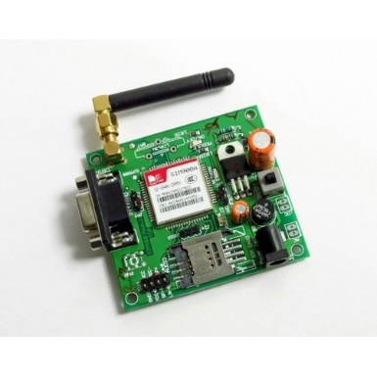

GSM stands for global system for mobile communication and is a mobile communication modem. It is a globally accepted standard used to communicate with a computer/processor over the network. It is a unique type of modem which acquires a sim card, and works over a subscription to a mobile operator similar to a mobile phone. GSM was developed as a digital system using time division multiple access. GSM network is categorized as switching system (SS), Base station(BSS), Operation support and system(OSS). The switching system is referred for executing functions related to calls. All functions that are pertaining to radio are performed in BSS and OSS is system that monitors and controls the activities inside the environment.

1. **LCD**

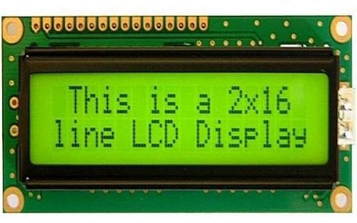

An LCD is a display of information that becomes visible when current is passed through them. It stands for liquid crystal display and consists of 32 characters in total with 16 coloumns and 2 rows. A constrict in the third pin of and LCD is used to adjust the brightness of LCD. LCD has got fixed commands for its operations. In the 4th pin, this has got a register select RS which can be differentiated into two. They are the code register when RS=0 and data register when RS=1.

1. **Relay**

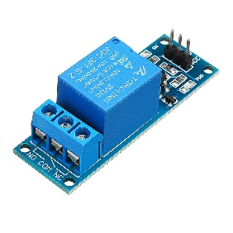

Electromagnetic waves operated switches are known as relays. This is a remote controlled switch capable of switching multiple circuits, either solely, together or in a series. It performs basic functions on galvanic separation of the primary and load circuits. A single input with multiple output capability is provided.

**4.2 Software Specification**

This section gives of the software components required by the intended system under development. Sericulture system requires the following software components.

1. **Keil development tool**



KEIL software gives the effortless writing code either in C or assembly level language. This software introduces a recently developed IDE called U-VISION 2 which has the capacity to merge program debugging, project management and source code editing into one single system for working. It acts as a cross compiler.

1. **Flash Magic**



A flash magic is a computer side software which is executed that receives Intel HEX format file generated from compiler keil to be sent to target microcontroller. Flash magic notices the hardware connected to serial port. Flash microcontroller can be cleared and can be written again multiple times.

1. **JDK**



JDK stands for java development kit. It is a software development surrounding used for creating java applets and applications. A JDK incorporates JRE, an interpreter, a Java c, Jar, document generator known as Javadoc and various different tools necessary.

**4.3 Functional Requirements**

This section describes the basic functionality of the system, as expected once the system is deployed. System meets the following functional requirements:

* **Sericulture activities must be performed with minimal effect:** In sericulture farm all the climatic variations must be normal for the growth of silkworms because silkworms are very sensitive creature which cannot survive extreme temperature for their survival.
* **The Application developed must be easily usable:** The minimum requirement for the user is to know how to operate the smart phone. The user should contain application before going to next step.
* **The farmer must be able to start or stop any activity effortlessly and with minimum time:** The farmer must have an android phone with an application and internet connection. The camera present in the rearing house can captures the activities taking place in the rear house and provides the information to the remote user in order for the farmer to know the status of the rear house situation.
* **The farmer before requesting the information of the rear house should have android phone and an app with him:** The remote user will have an IoT app through which he can request for any information needed. The user presses the photo button in the app, then the camera placed in the farm will automatically capture the image of the present situation at rearing house and sends to the user.
* **The activities of the sensor update all ready messages to the GSM module:** When their occurs any changes in the climatic conditions, when the sensors value exceeds the threshold values the sensors detect the changes and the messagedisplayed on the LCD screen. The gsm module will contain a sim through which the messages are sent to the destination immediately.
* **The farmer will be present at the remote location who receive the information:** the farmer or the remote user can be present anywhere around the world but he receive the necessary important messages and images of the rearing house as and when he wishes to look at it.
* **The usage of location:** first usage of the location comes into picture when the remote user can access the location of the salt region. The second place is when the location can be sent to nearby emergency services automatically in case of severe damage.

**4.4 Non-Functional Requirements**

This section describes additional performance criteria which the proposed system is aimed to meet. Some non-functional requirements are

* **Portability:** it is the degree to which software running on one platform can be easily converted to run on another. Portability is hard to quantify, because it is hard to predict on what other platforms will the software app be required to run. Portability for a given software app should be given priority for system that makes have to run on different platforms in the near future.

In this system the software and hardware is portable. The software app can be put into use by just installing the app for any users and the hardware can be setup the any sericulture part

* **Reliability:** reliability of a software system is defined as the ability of the system to behave consistently in a user acceptable manner. When operating within the environment for which it was intended.

Reliability can be defined in terms of an availability percentage say 99.999% for sensor, it should be reliable that is should not break down often. For a remote user he must be comfortable with the usage of app in his android phone.

* **Efficiency:** efficiency refers to the level of use of scars computational resources, storage space and communications channel. Efficiency can be categorized as capacity and degradation of service. A farmer should find it efficient in terms of both cost and computational efficiency. The system should be able to handle activity required by the user.
* **Safety:** safety is a critical requirement for certain types of software system where failure may result in loss of human life and economic loss. Analysis or safety requirements often entails hazards analysis and fault occurrences, these are technique adopted from engineering principles. A hazard is condition which may cause human death or injury. In this system safety is ensured by the fire detecting sensor which acts as a precautionary measure to avoid destructions. For example, when there is a fire in the rearing house, the fire sensor detects the fire and displays an alert message in the LCD as well as alerts the workers with a buzzer. Then, a message is notified to the remote user and the owner can take necessary actions from his app by dialing to nearby emergency services through the location fetching specialty.