# CMPE – 202

## PENTAGON (TEAM -5)

### PROJECT PRESENTATION

## PROJECT MEMBERS:

Hari Krishna Pariveda

Manvitha Challagundla

Radhika Srinivasan

Sanjay Raghavendra Karnati

Vinod Katta

## UML CLASS DIAGRAM:

## FINAL TASK BOARD:

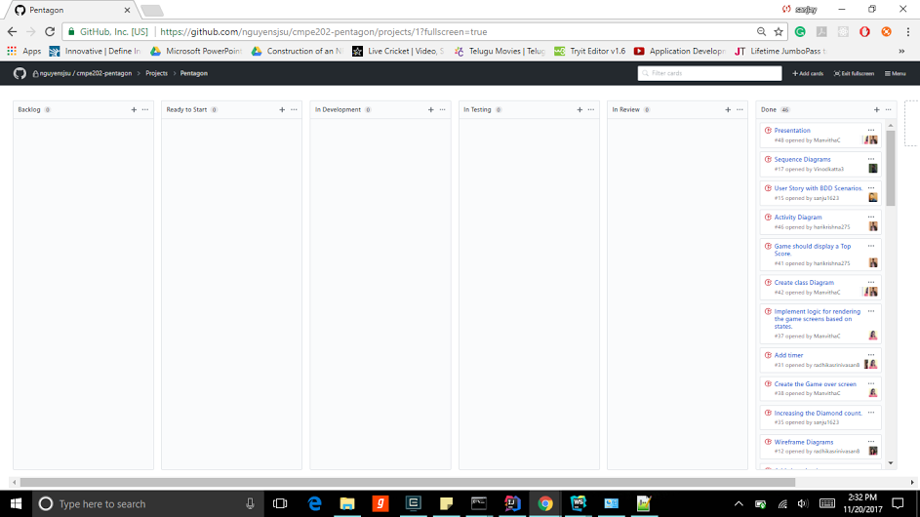

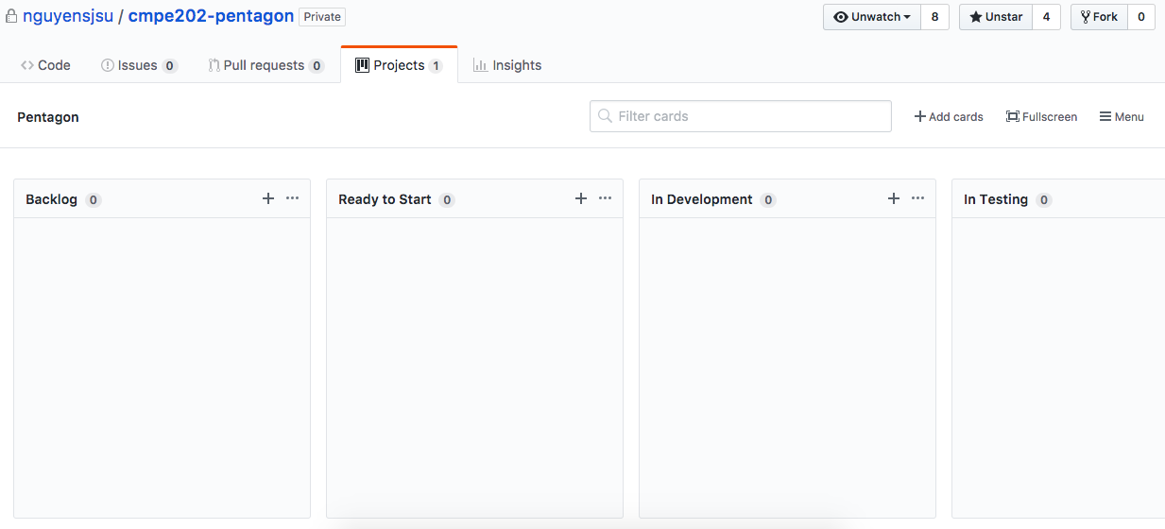

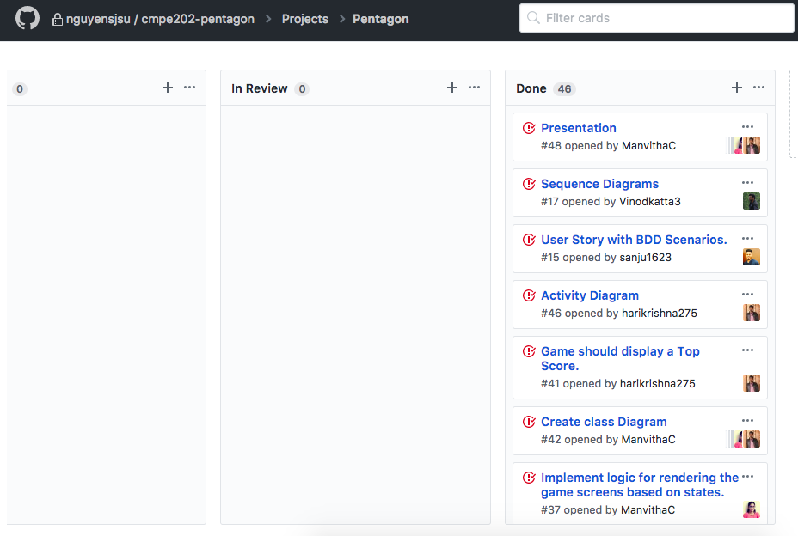

## FINAL CUMULATIVE FLOW DIAGRAM:

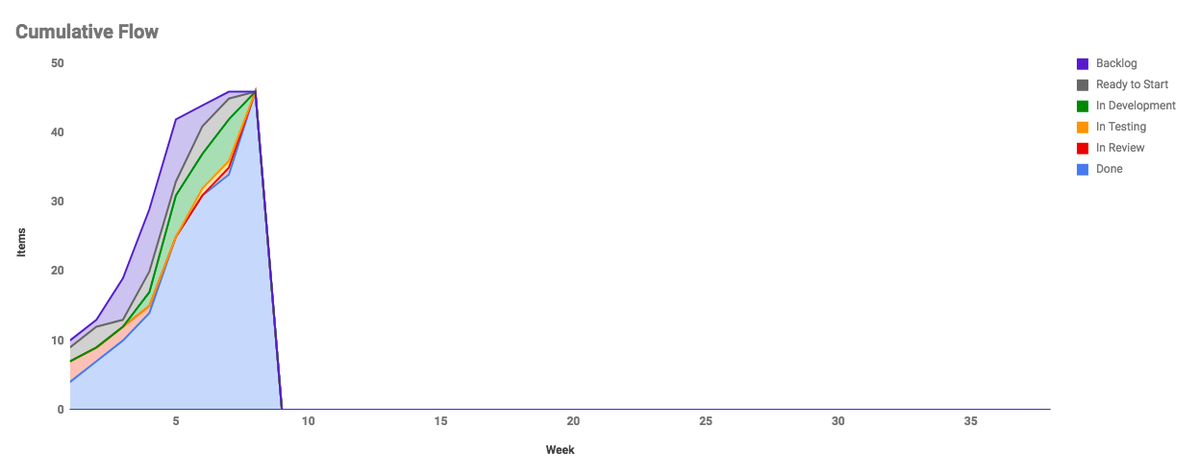



## FINAL SCRUM BURNDOWN CHART:

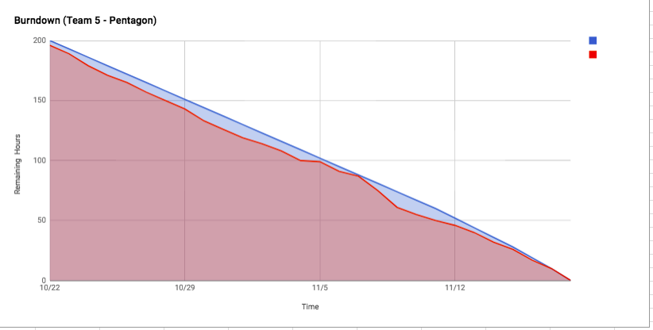

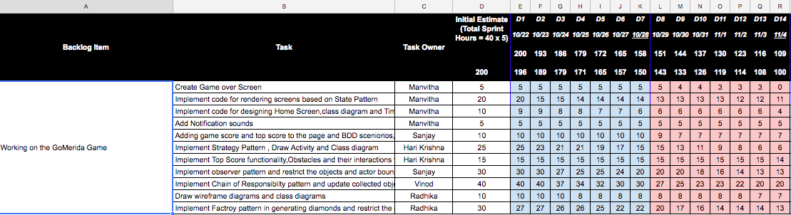

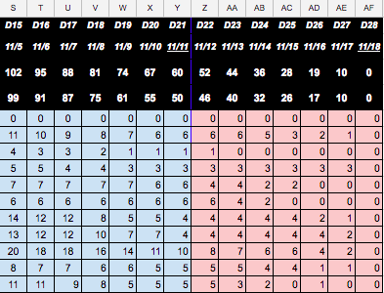

## PROJECT RETROSPECTIVE:

C:\Users\manvi\AppData\Local\Microsoft\Windows\INetCache\Content.Word\bar.png

