# 

# CMPE – 202, Fall 2017

## PENTAGON (TEAM -5)

### PROJECT PRESENTATION

## PROJECT MEMBERS:

Hari Krishna Pariveda

Manvitha Challagundla

Radhika Srinivasan

Sanjay Raghavendra Karnati

Vinod Katta

UML Class Diagram:

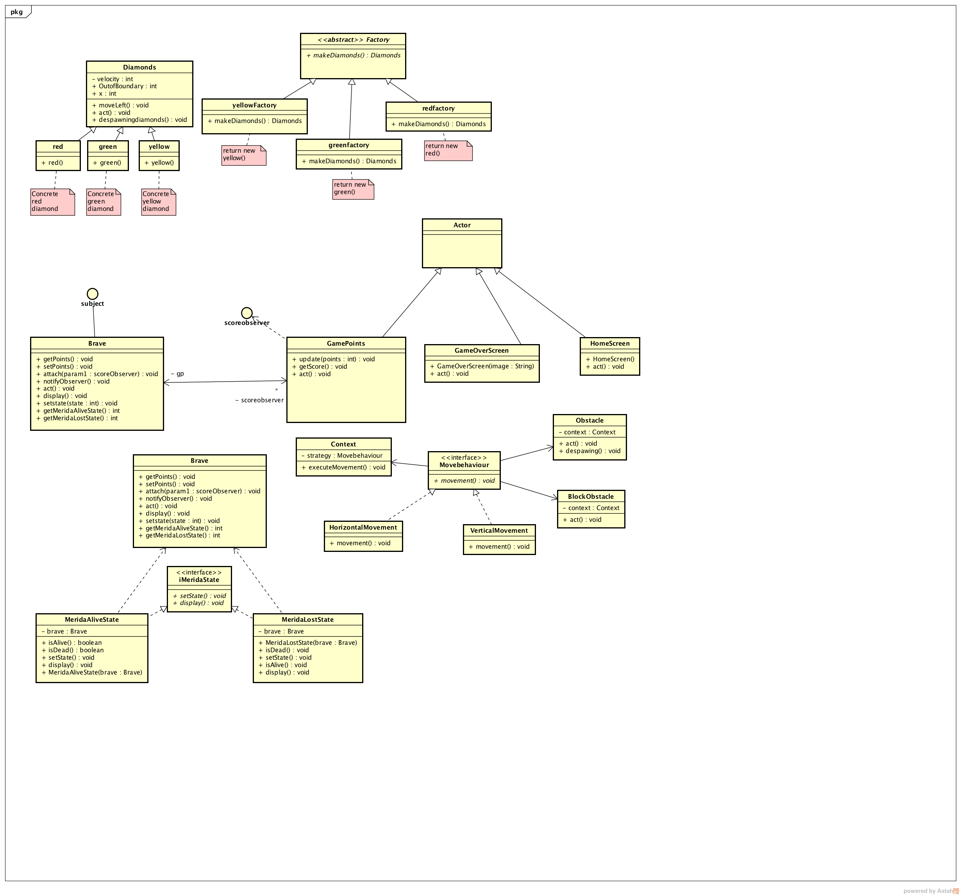

## UML Use case Diagram:

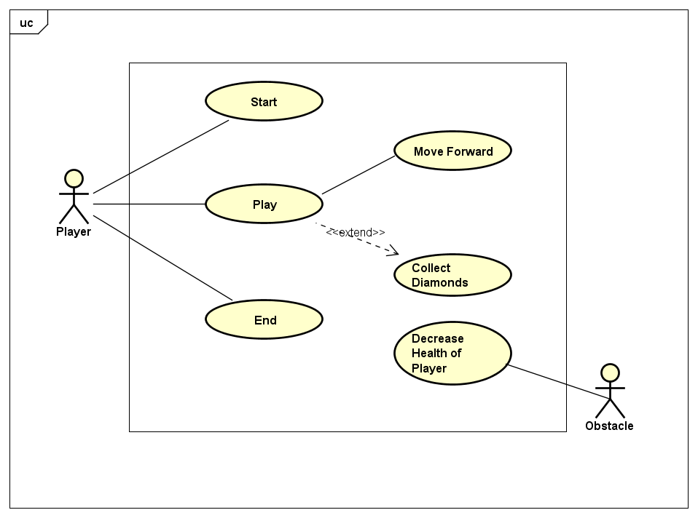

## Use Case Specification:

**Use case name** Play

**Related Requirements** Once the user starts the game, the user should be able to move forward, change lanes by pressing up and down arrows, collect diamonds along the way and the game should end when hit by an obstacle more than 3 times.

**Goal in context** User should be able to start and complete the game.

**Preconditions** The user machine should have a browser & must have Greenfoot installed or active Internet connectivity to play the game.

**Successful end condition** User should be able to complete the game under timed conditions.

**Failed end condition** The game does not start even when the user clicks “play” button.

**Primary actor** Player

**Trigger** The player clicks on “Play” button.

**Main flow Step Action**

1. The player starts the game.
2. The player selects “Play” option.
3. The player plays the game.
4. The player ends the game.

**Extensions Step Branching Action**

**3.1** The player moves forward.

**3.2** The player collects diamonds.

**3.3** The player Jumps when faced with obstacle

## UML Wireframe Diagram

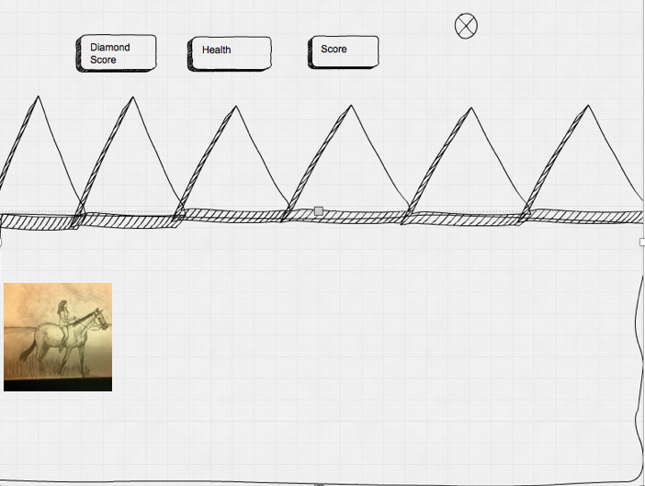

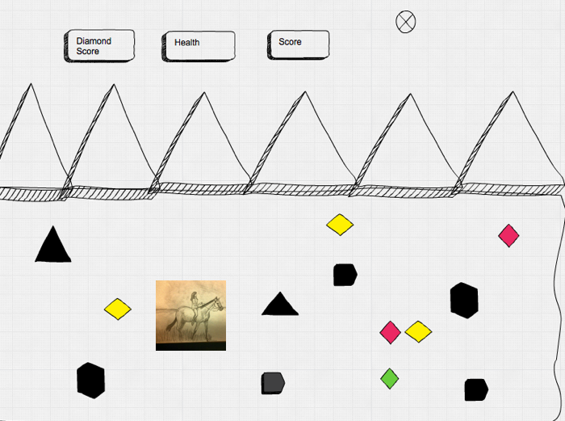

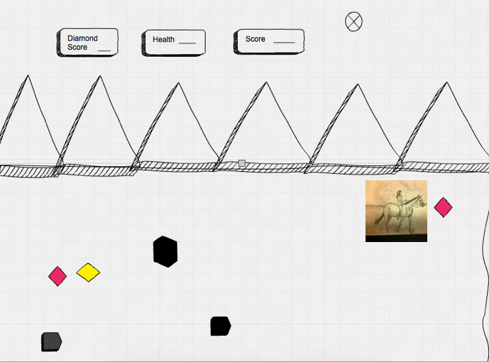

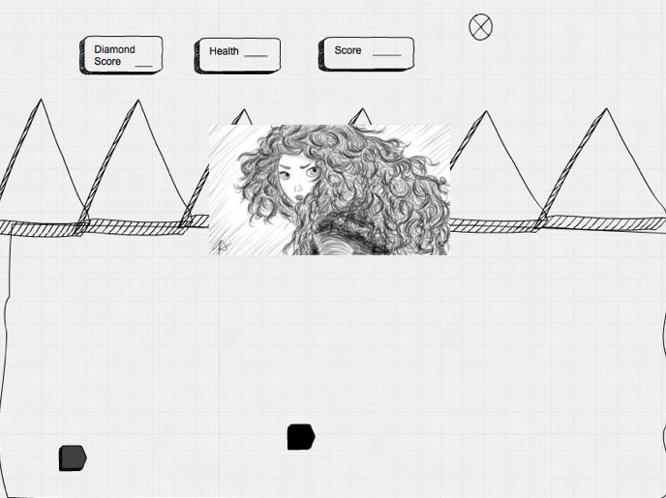

## BDD scenarios:

Story: Player plays the Brave game

As a player I want to play the Brave game by clicking on the play button.

**Scenario 1**:Player starts the game by clicking the play button and enters the game world.

Given player will easily see that horse is running

and the player can see the diamond score and health on the game screen

when player click up arrow button horse changes direction and move leftwards.

**Scenario 2**:Player can collect the diamonds which are in the path.

Given player can move the horse freely by clicking up and down can collect the diamonds on his way

and collect the three type of diamonds

when player collects the diamonds the diamond score is incremented by one on the game screen.

and player can see the total diamonds collected score on the screen.

**Scenario 3**: Player should be aware of obstacle on his way.

Given player can collect the diamonds

and can move freely

when player touches the obstacle brave health is decremented by one

and player can see the updated health score on the game screen.

**Scenario 4**: Player should be aware of time while playing.

Given player can play the game

and can move freely

when the time reaches 2 minutes the game is completed

and player will be seen the game over screen.

## UML Activity Diagram

## C:\Users\HARIKRISHNA\Desktop\Activity Diagram-Final.png.bak

## FINAL TASK BOARD:

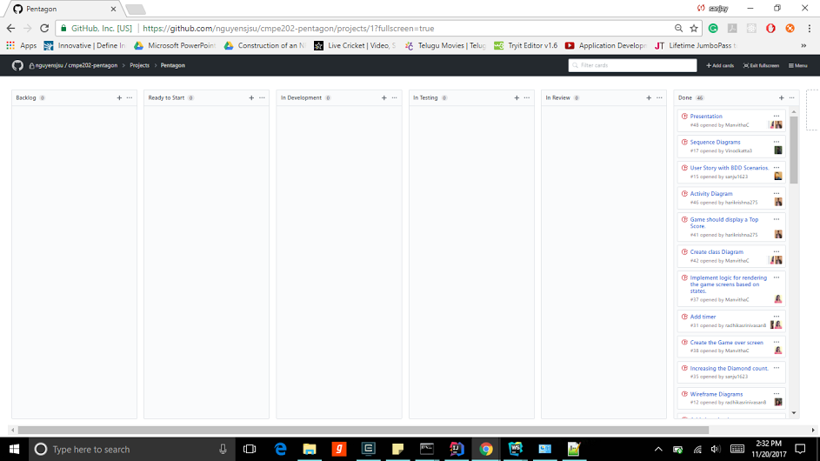

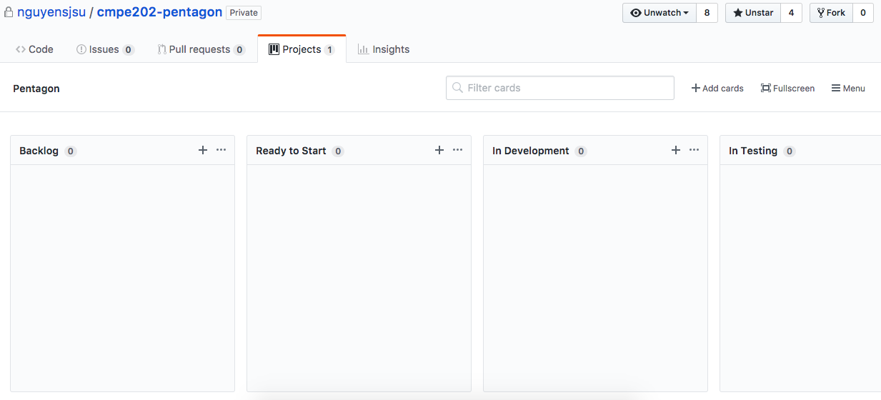

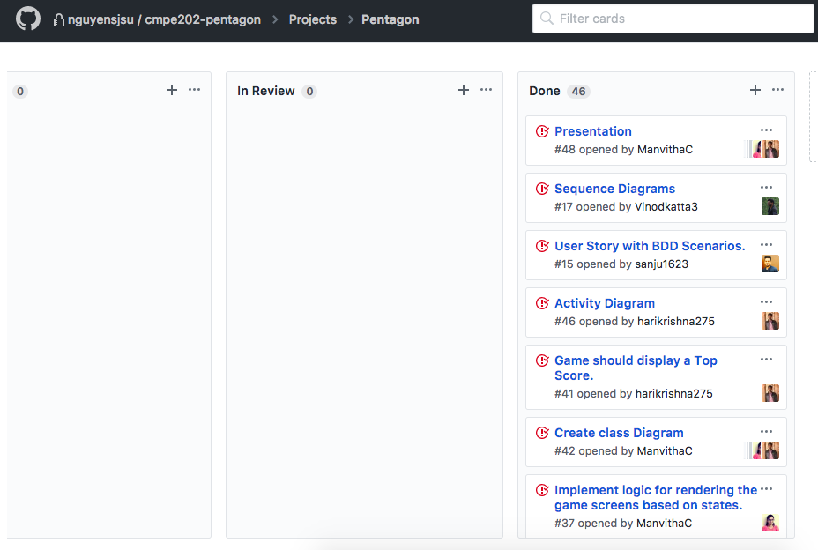

## FINAL CUMULATIVE FLOW DIAGRAM:

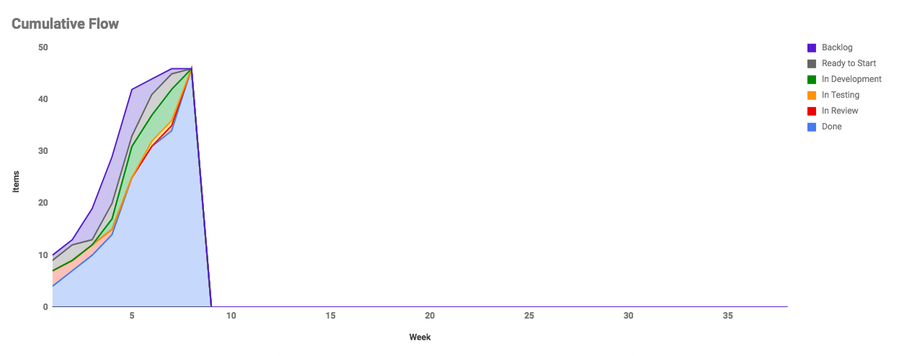



## FINAL SCRUM BURNDOWN CHART:

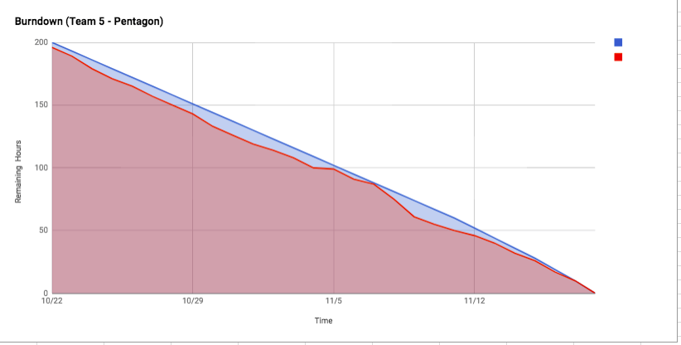

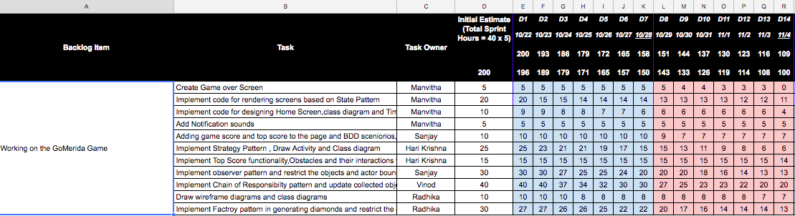

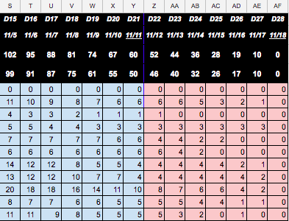

## PROJECT RETROSPECTIVE:

C:\Users\manvi\AppData\Local\Microsoft\Windows\INetCache\Content.Word\bar.png

