Software Design Document
OF
BANKING SYSTEM

Sparsh Saurabh, Naman Gupta, Samya Ranjan Patro and Vinod Kumar
P6-0 ~A Group of DB Practicum, B.Tech(2nd Year) Computer Science and Technology Indian Institute of Technology Mandi
E-mail:bankmanproject@gmail.com

November 2014
The BankMan Systems
Requirements Document
Revision History
Version | Date | Author(s) | Description
v1.0 | 17/11/14 | Sparsh Saurabh | Initial version
v1.1 | 18/11/14 | Samya Ranjan Patro | Refrences added
v1.2 | 18/11/14 | Vinod Kumar | Architecture edited
v1.3 | 18/11/14 | Naman Gupta | Interface edited

Table of Contents
1Introduction 1
1.1Design Overview 1
1.2Intended Audience 1
1.3References 2
2Detailed Design 2
2.1Architecture 2
Components 2
Interfaces 3
2.2Algorithms and Data Structures 3
2.3External Data 3
Databases 3
Files 3
2.4Performance 3
Appendix A 3

Introduction

Design Overview
The Bank Management System is based on the Apache Server and uses MySQL database system and PHP based pages for accessing it. It uses Relational Database Management Systems to handle data. It can be accessed using a web-browser by the user. Bank Management System is based on LAMP(Linux Apache MySQL PHP) software bundle, but can be edited, modified or extended using using any other equivalent bundle based on Apache and PHP.

Intended Audience
This document is intended for software managers, coders and testers.

References
[1] www.purecss.io/layouts/marketing
[2] www.mysql.com
[3] www.php.net
[4] www.apache.org
[5] www.stackoverflow.com
Books Referred :
[6] Fundamentals of Database Systems, Sixth edition By Elmasri,Navathe.
[7] Practical PHP and MySQL By Jono Bacon.
[8] PHP and MySQL Web Development Third Edition, By Luke Welling Laura Thomson
[9] MySQL Building User Interfaces, By Matthew Stucky, New Riders Publishing
[10] Build Your Own Database-Driven Website Using PHP & MySQL by Kevin Yank

Detailed Design
For rapid implementation and future expansion, the LAMP software bundle is used as the platform for Bank Management System.
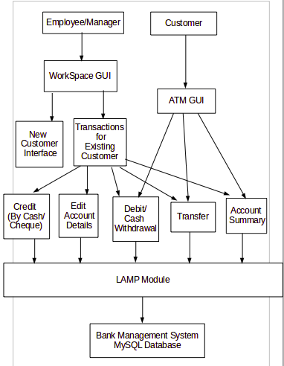Fig. 1: BankMan Architecture

Architecture
The Bank Management System architecture (Fig. 1) conforms to the basic requirements of functions performed by an employee and an ATM system in a general bank.

Components
The LAMP module is used as-is. Any additional tables can be created using MySQL or PHPmyadmin features.
The WorkSpace GUIs and ATM GUIs are written as a PHP page with CSS and HTML-5 based design and interface. Parts of these GUIs are also written using above applications. Extensive data validation is done in the to minimize mistakes made by novice users.
The various categories of users access Bank Management System through a browser. Authentication is done by the ATM GUI and Workspace GUI using PHP webpages by verifying username/ATM Number and PIN/Password for each employees, managers and customers. Nobody can access any internal features without proper authentication.

Interfaces
The interface between the brower and the ATM and Workspace GUIs is PHP and MySQL. The internal interfaces are all based on PHP.

Algorithms and Data Structures
There are no significant algorithms developed for this product. The important tables used for this implementations are the record of Transactions, list of customers, managers and employees with there respective access details ( See Appendix A for ER Diagram).

External Data

Databases
Bank Management System use MySQL based database tables. It creates MySQL entities using PHP. The Management System doesnot creates tables, rather it only maintains them, as necessary for storing these entities and editing them.

Files
The Bank Management System requires the database file in MySQL and the PHP pages are also required. No additional files are needed.

Performance
The product will be benchmarked on different entry-level and server-class PCs. This will result in a table giving the PC configuration required for a given number of accounts in the bank.

Appendix A

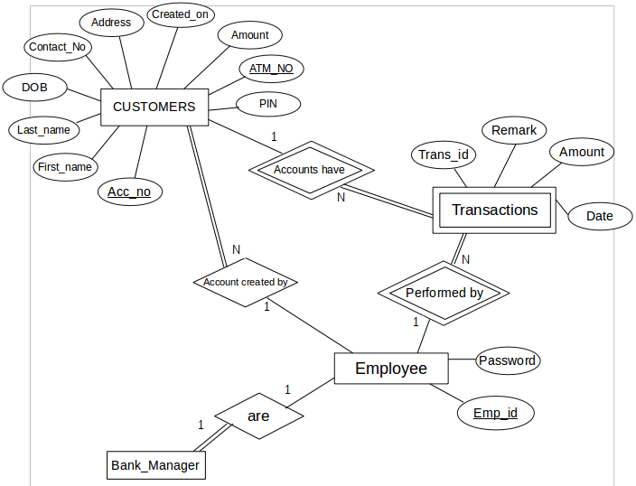
Fig.2: Entity Relation Schema for Bank Management System

