**Azure DevOps Assignment**

Contents

Reference 1

Create a Pipeline 1

Use the PowerShell task 2

Deploy like below architecture shown 3

# Reference

**Create a virtual network**

<https://docs.microsoft.com/en-us/azure/virtual-network/quick-create-template>

**Create a WebApp using ARM template**

<https://docs.microsoft.com/en-us/azure/app-service/quickstart-arm-template?pivots=platform-windows>

**Create a Azure SQL server using ARM template**

<https://github.com/Azure/azure-quickstart-templates/tree/master/quickstarts/microsoft.web/web-app-sql-database>

**Deploy App**

<https://docs.microsoft.com/en-us/azure/app-service/tutorial-dotnetcore-sqldb-app?tabs=azure-cli%2Cvisualstudio-deploy%2Cdeploy-instructions-azure-portal%2Cazure-cli-logs%2Cazure-portal-resources>

# Create a Pipeline

* download the opensource dot net code from google
* save the application source code to Azure repo
* save the ARM template in Azure repo
* create a pipeline+release

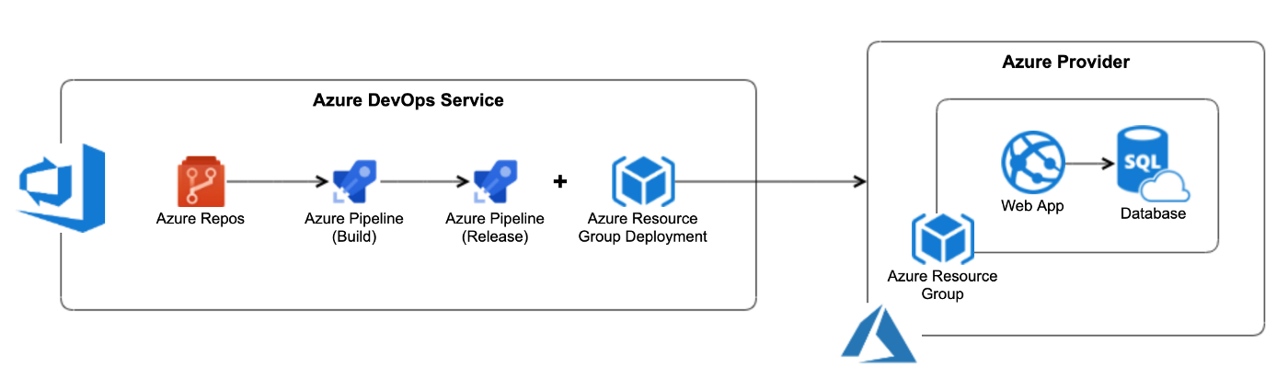

# Use the PowerShell task

Use the PowerShell tasks like below example.

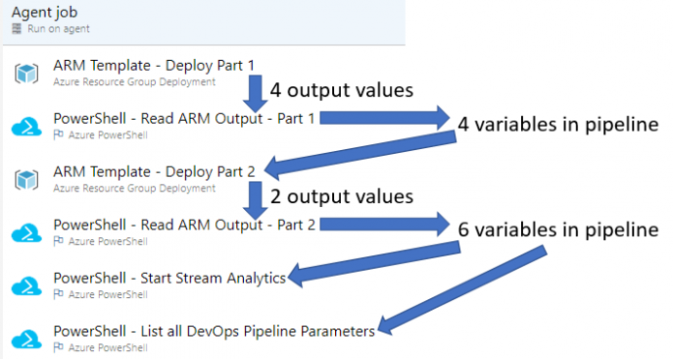

* Run all ARM templates using PowerShell
* Read Arm output using PowerShell
* Ignore logs streaming

# Deploy like below architecture shown

* Create architecture like below shown diagram
* Instead of GitHub use azure repo
* Add ip in whitelisting and blacklisting using PowerShell

<https://docs.microsoft.com/en-us/azure/azure-sql/database/firewall-configure>

* Add NSG rules(if applicable) using PowerShell
* Once application deployed on Web app check the application availability using PowerShell

