**Navigator Configuration Changes**

* First copy acds_nav_layer. json in below paths:

**/opt/so/saltstack/local/salt/nginx/files**



**/opt/so/conf/navigator**

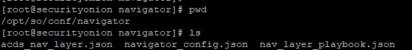

* For adding our **ACDS JSON** as default layer in SO we have to modified below fields in **init.sls** and **navigator_config.json**

1. Add our acds json path always first so when we open SO Navigator, we will be able to see ACDS navigator in first tab as default layer and then playbook layer.

**init.sls**

1. In init.sls under **navigatordefaultlayer** , Add acds default json path

navigatordefaultlayer:

file.managed:

- name: /opt/so/conf/navigator/acds_nav_layer.json

- source: salt://nginx/files/acds_nav_layer.json

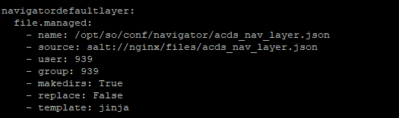

2) In init.sls under **ATT&CK Navigator binds** , Add acds json path as first before nav_layer_playbook.json

**/opt/so/conf/navigator/acds_nav_layer.json:/opt/socore/html/navigator/assets/acds_nav_layer.json:ro**

/opt/so/conf/navigator/nav_layer_playbook.json:/opt/socore/html/navigator/assets/playbook.json:ro



**navigator_config.json**

1. In navigator_config.json under **default_layers** array ,Add acds_nav_layer.json before playbook.json

"default_layers": {

"enabled": true,

"urls": [

**"assets/acds_nav_layer.json",**

"assets/playbook.json"

]

},

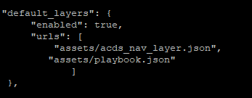

* After restart docker UI will look like below SS

so-soctopus-restart

so-nginx-restart

