**Date of Start:07.06.2011 Date of Completion: 13.06.2011**

**Nevigation**

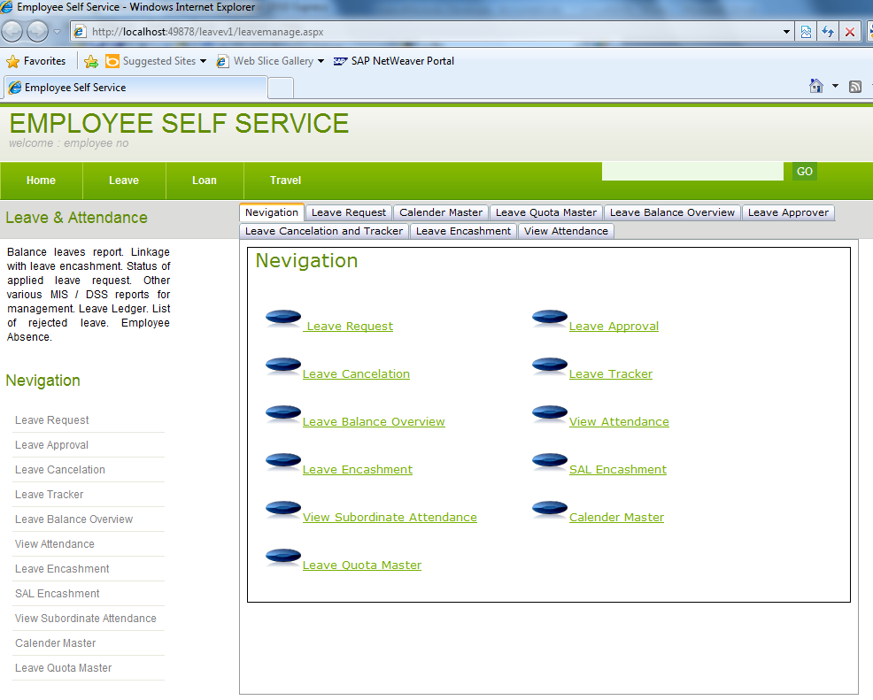

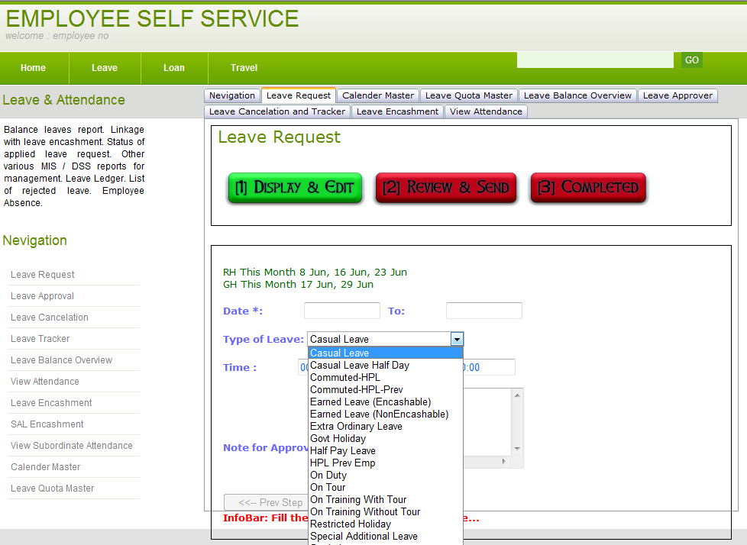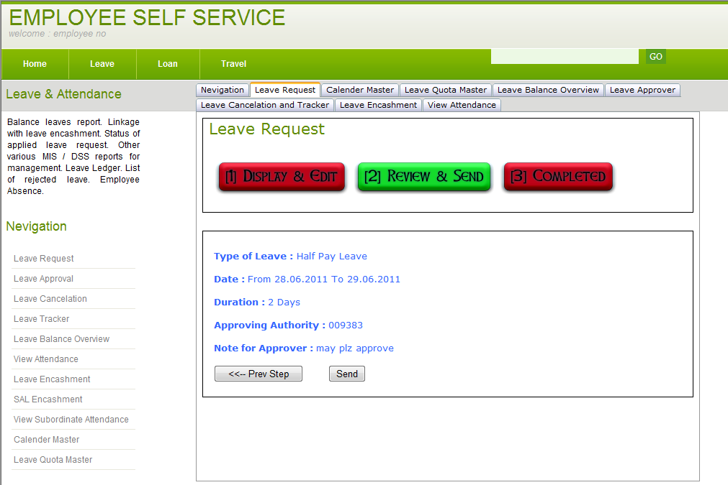

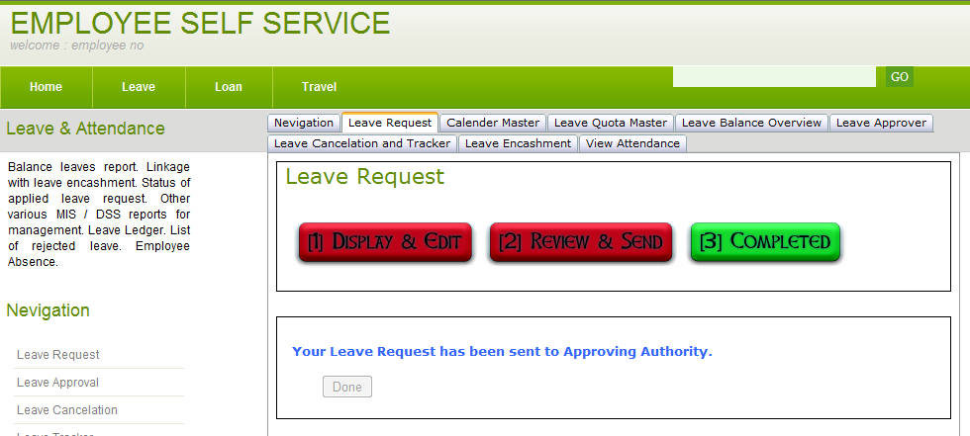

**Leave Approver**

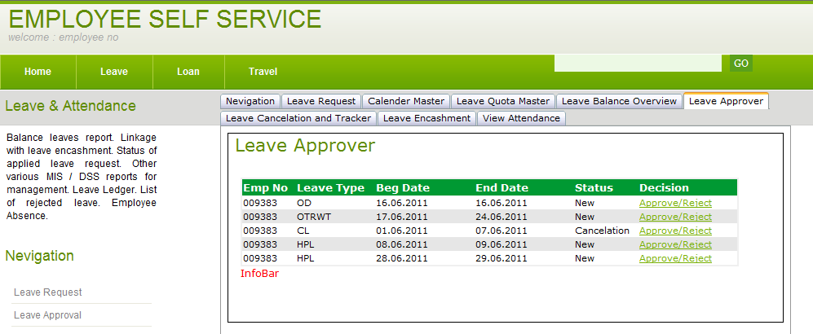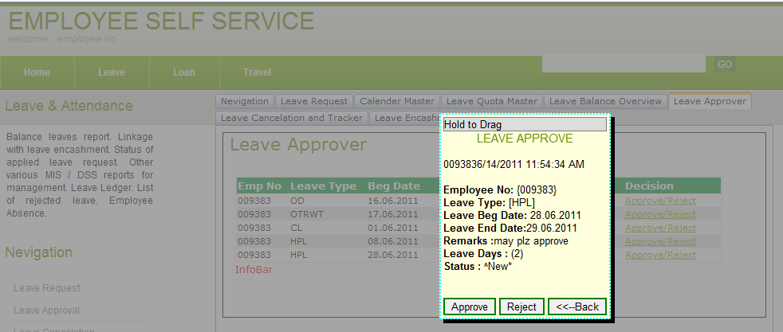

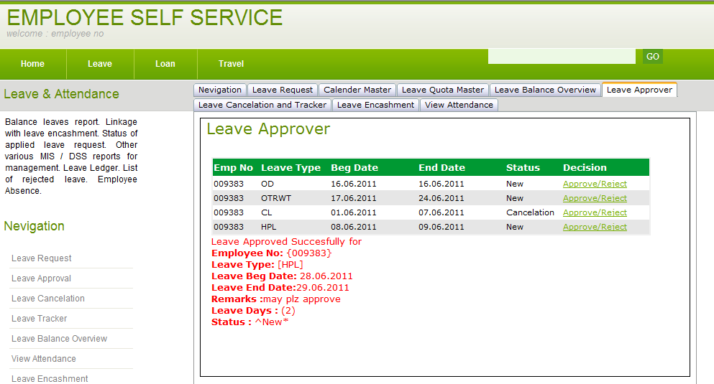

**Leave Tracker/Cancelation**

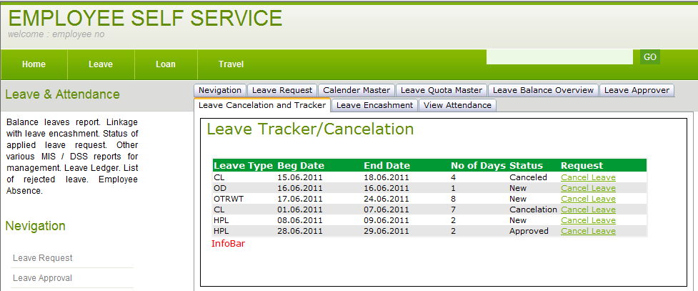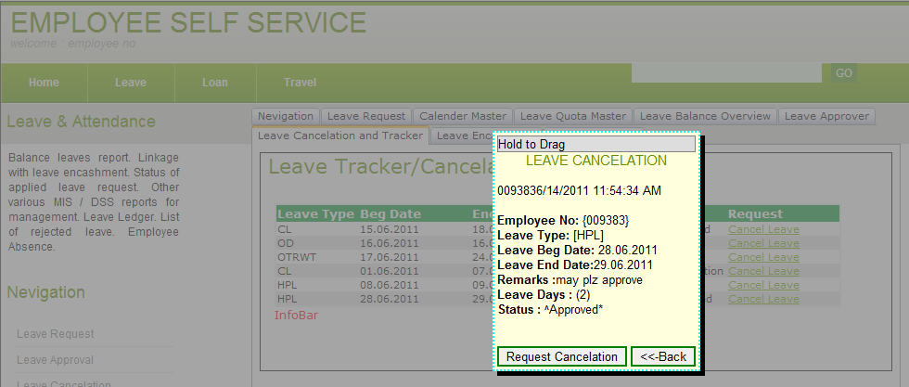

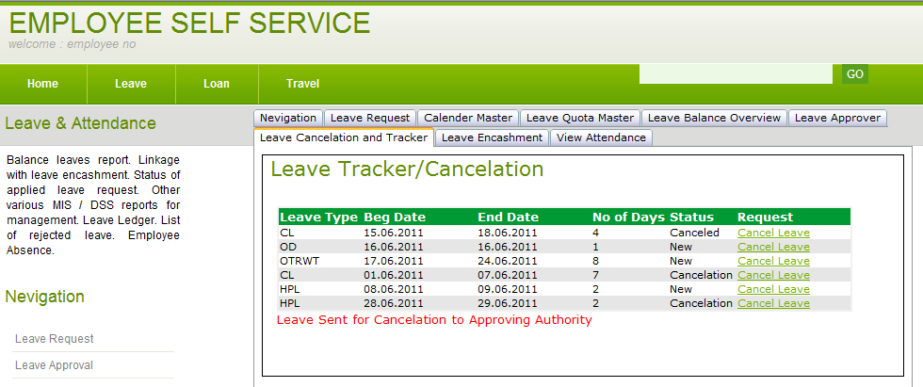

**Leave Balance OverView**

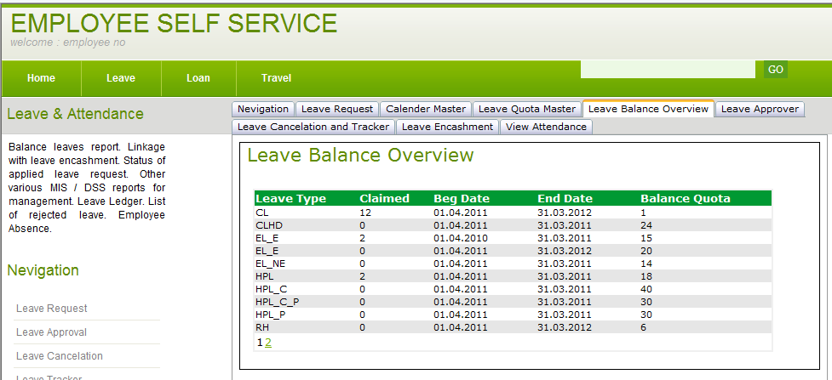

**Leave Encashment**

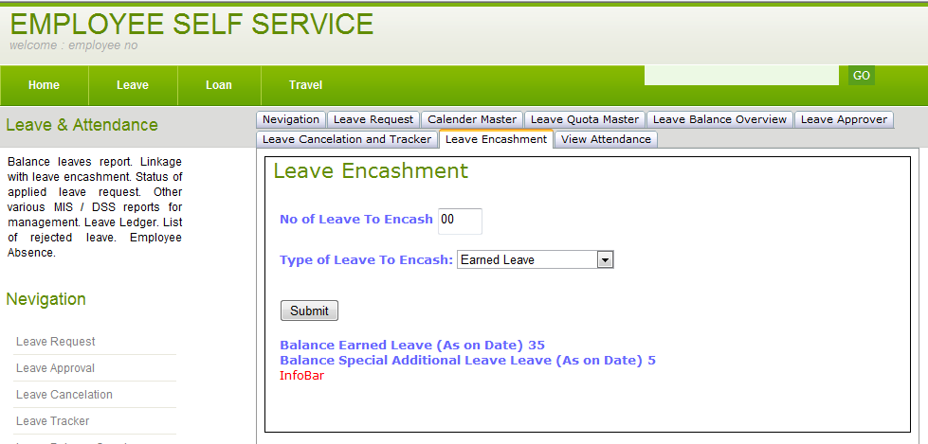

**View Attendance/Subordinate Attendance**

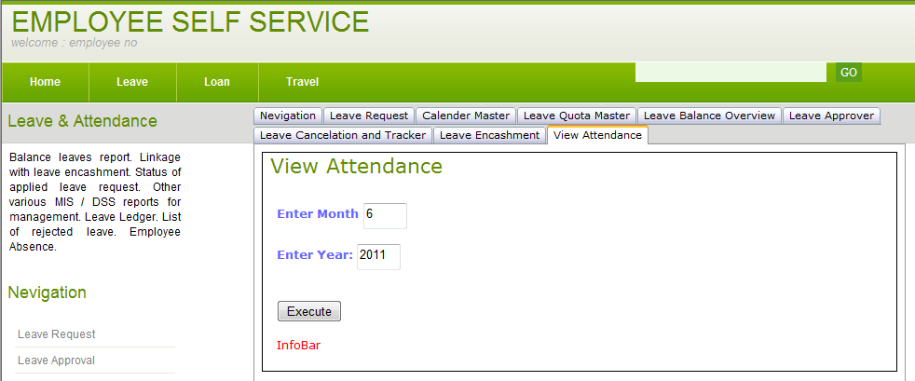

**Calender Master Entry**

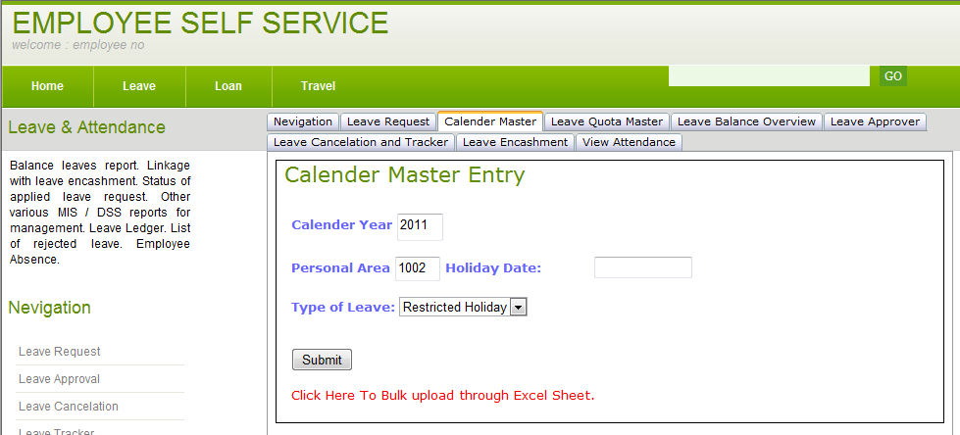

**Leave Quota Entry**

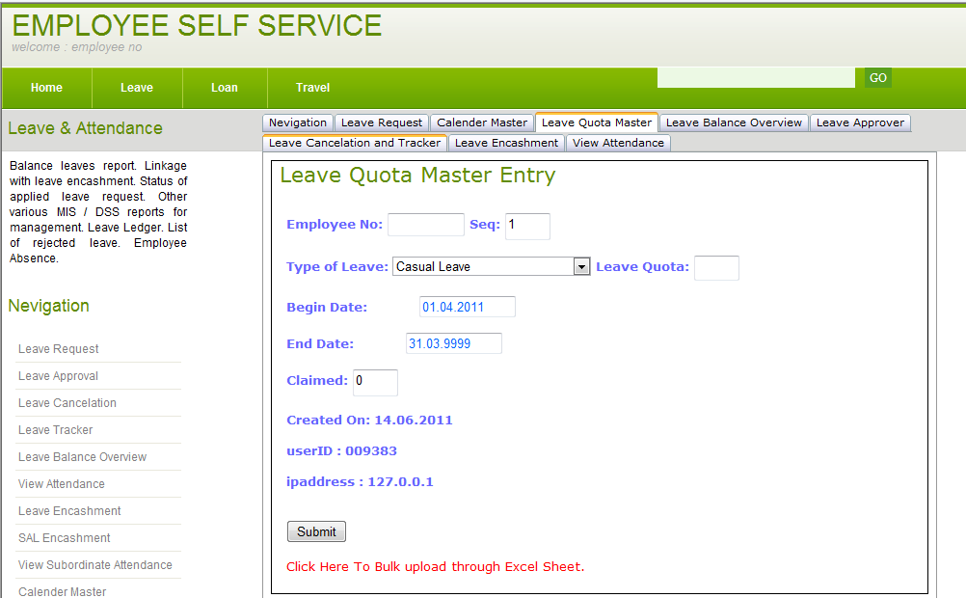

**Classes**

1. **LeaveClass**
2. **DatabaseOperation**
3. **GridManager**

Public Class LeaveClass

''##########################################################################

''' <summary>

''' ' class contains the validation and rules for applying leaves and data entry in leave tables.

''' Written by Vinod Kotiya +919411103810

''' </summary>

''' <remarks></remarks>

Public Shared Function getHolidayTypes(ByVal groupid As String) As String()

'' this function will return array of leave types to populate the text part of drop down

End Function

Public Shared Function getHolidayCodes(ByVal groupid As String) As String()

'' this function will return array of leave codes to populate value part of the drop down

End Function

Public Shared Function checkLeaveRuleBook(ByVal begdate As Date, ByVal enddate As Date, ByVal leavedays As Integer, ByVal eid As String, ByVal perarea As String, ByVal holi_code As String) As String

''' this function will check the validity of leave appied as per rules.. have few supporting functions too

End Function

Public Shared Function getLeaveQuota(ByVal eid As String, ByVal holi_code As String) As String

''this function will check the leave quota for applied leave.. part of rulebook

End Function

Public Shared Function checkCalenderMaster(ByVal thedate As Date, ByVal holi_code As String, ByVal perarea As String) As Boolean

''this function will check from calender master for applied leave.. part of rulebook

End Function

Public Shared Function IsLeaveTransactionsExist(ByVal begdate As Date, ByVal enddate As Date, ByVal eid As String) As String

''this function will check leave is already approved/inprocess in leavetransaction.. part of rulebook

End Function

Public Shared Function InsertLeaveTransaction(ByVal begdate As Date, ByVal enddate As Date, ByVal eid As String, ByVal Tx_no As String, ByVal holi_code As String, ByVal remarks As String, ByVal work_flow_id As String, ByVal status As String, ByVal leavedays As String, ByVal currdate As Date, ByVal ipaddress As String) As String

'' this function will insert the transaction data for new leave

End Function

Public Shared Function InsertINCalenderMaster(ByVal holidate As Date, ByVal holi_code As String, ByVal calyear As String, ByVal perarea As String) As String

'' this function will insert the data for calender master

End Function

Public Shared Function InsertINLeaveQuotaMaster(ByVal eid As String, ByVal holi_code As String, ByVal begdate As Date, ByVal enddate As Date, ByVal seq As String, ByVal quota As String, ByVal claimed As String, ByVal createdon As Date, ByVal userid As String, ByVal ipaddress As String) As String

'' this function will insert the data for leave quota master

End Function

Public Shared Function SetLeaveTransactionDetails(ByVal tx_no As String, ByVal status As String, ByVal ref_tx_no As String) As String

'' this function will update the leave transaction details as per Tx _ no

End Function

Public Shared Function SetLeaveQuotaMasterOnApproval(ByVal eid As String, ByVal leavecode As String, ByVal leavedays As String) As String

'' this function will update the leave quota master on event of approval

'' This function needs to be refined further for entry of applied leave in different rows after split.

End Function

End Class

Public Class dboperations

''##########################################################################

''' <summary>

''' ' class contains the function required for database operation.

''' +919411103810

''' </summary>

''' <remarks></remarks>

Public Shared Function insertRecord(ByVal mysql As String) As String

' This function will insert/update the record based on mysql

End Function

Public Shared Function checkDatabase(ByVal myQuery As String) As Boolean

''this function will check any record exist or not in table according to myQuery

End Function

End Class

Public Class GridManager

''##########################################################################

''' <summary>

''' ' class contains the fuctions to show datagrid in webpage.

''' +919411103810

''' </summary>

''' <remarks></remarks>

Public Shared Function GetCompareStatement(ByVal firstValue As String, ByVal secondValue As String, ByVal operation As String) As String

End Function

Public Shared Sub rebindGridView(ByVal query As String, ByVal gridViewControl As GridView)

'Binds Paging/Sorting GridView with data from the specified query

' Bind GridView to current query & always store ur query into session("currentquery") before calling

' reason is whenever page indexed changed or sort.. then it will show data from currentquery

End Function

Public Shared Function SortDataTable(ByVal dataTable As DataTable, ByVal isPageIndexChanging As Boolean) As DataView

End Function

Public Shared Property GridViewSortExpression() As String

End Property

Private Shared Function GetSortDirection() As String

End Function

Public Shared Property GridViewSortDirection() As String

End Property

End Class

Database Design:

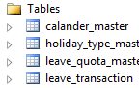

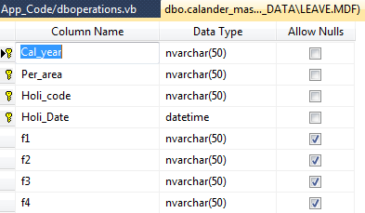

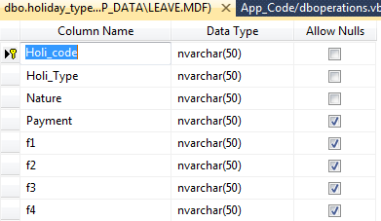

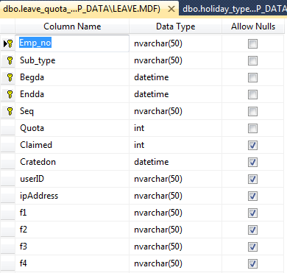

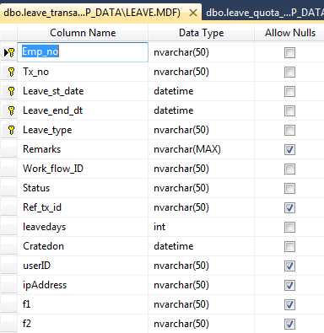

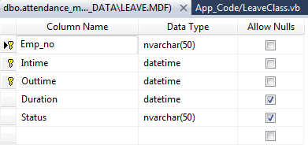

Requirement Specification

Green colored have been covered.

* Interface for leave application. - done
* Workflow for leave approval/cancellation.
* Time management (recording) system (optional).
* Absences Recording in the System.
* Feedback regarding UA and other Workflow through email/SMS to the Employees (optional).
* Leave accrual and Entitlements.
* Leave Balances in the System.
* Accrual of Leave as Regular Exercise.
* Effect of Absences on the Remuneration.
* Impact of Leave availed on the Leave Balances.
* Leave can be converted from one type to another.
* Carry Forward of Earned leave and HPL balances at Fiscal year-end.
* Encashment of leave with payroll and separation.
* Effect of eligibility for various absence types / quotas in case of any promotion / regularization action.
* Cancellation of leave already approved by the reporting officer/ authority.
* Some group of employees in PA which are stationed at some client site may follow client’s calendar. Without making a separate PSA for them, the system should allow to assign different calendar for that group of employees and if the apply for leave then their balance should get affected.
* Leave approval should be through workflow (except some leaves like extra-ordinary leave etc.).
* Once the employee applies for a leave, it should to for approval to a employee in the reporting chain as per the DOP.
* Setting up of Absence type and Holiday schedule administration tables.
* Application for Extra-Ordinary Leave and Study Leave.
* Generation of various reports as and when required.