ScreenShots

Ekasmin.com Home Page

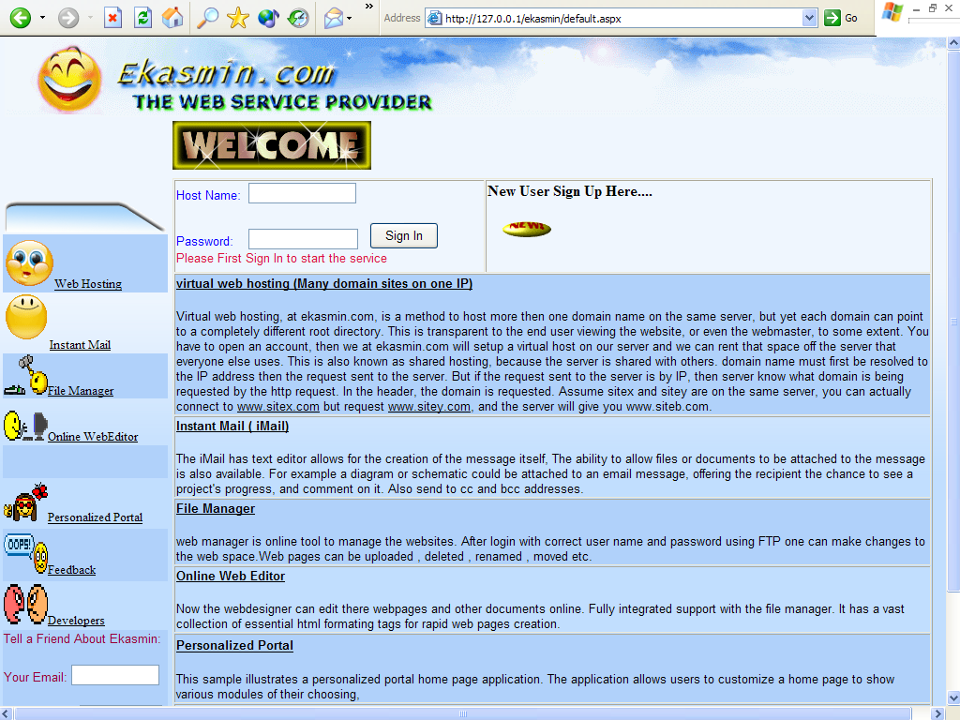

Ekasmin.com Registration Page

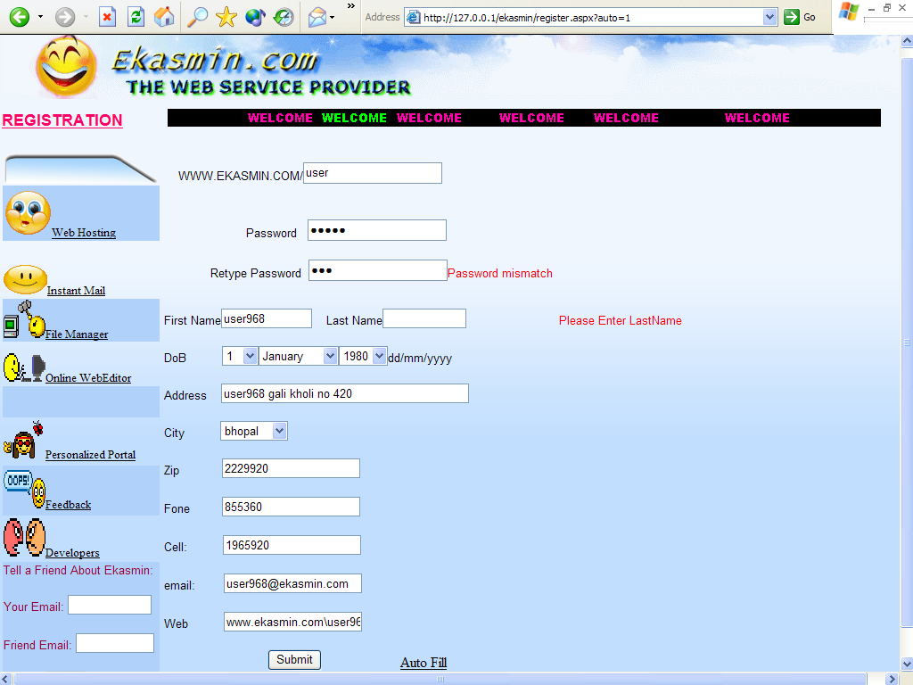

Ekasmin.com File Manager Page

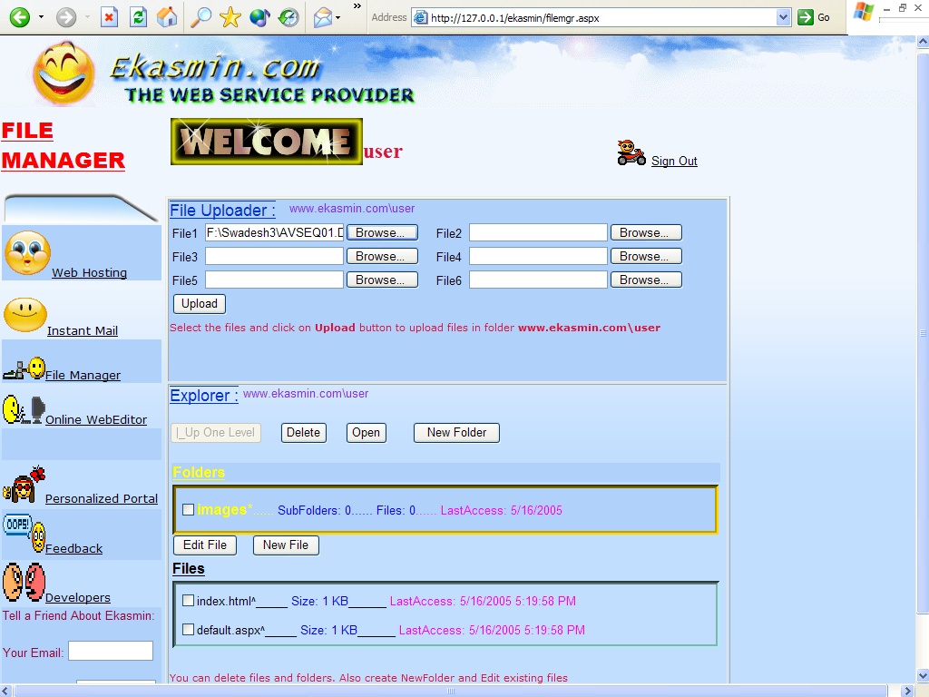

Ekasmin.com Online Web Editor Page

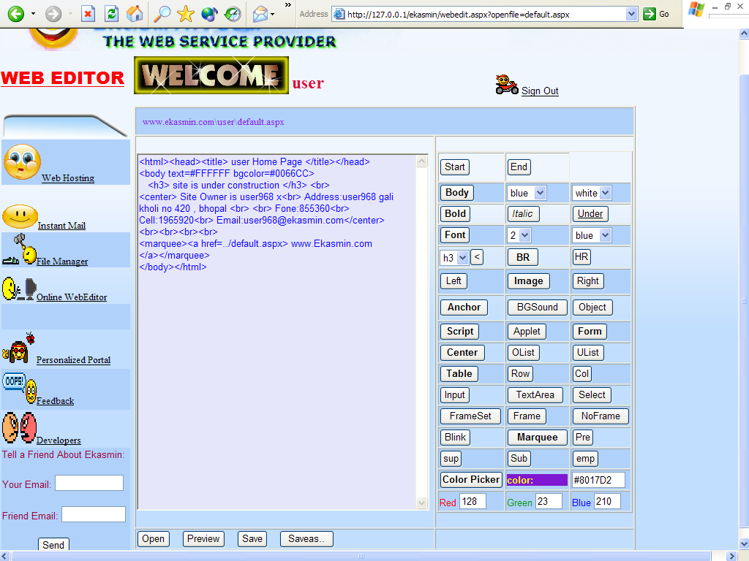

Ekasmin.com Instant Mail Page

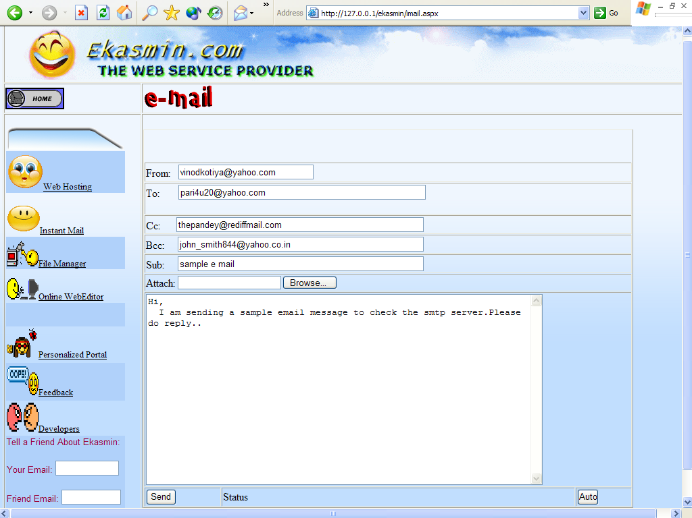

Ekasmin.com Feed Back Page

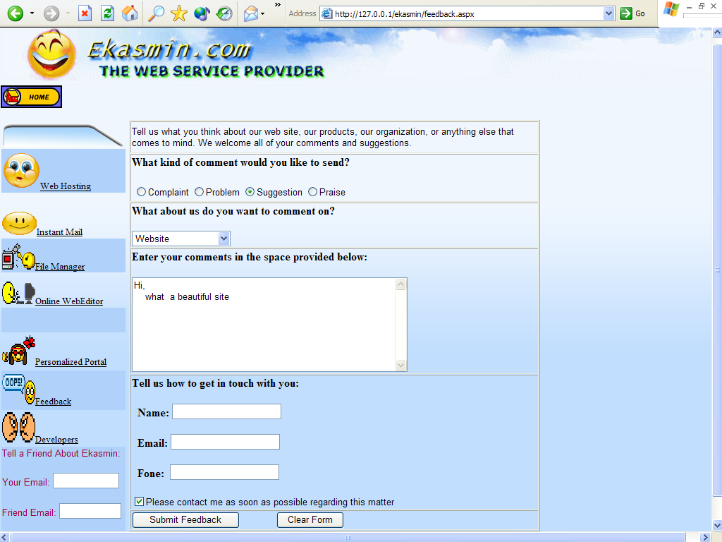

Personalized Portal Page

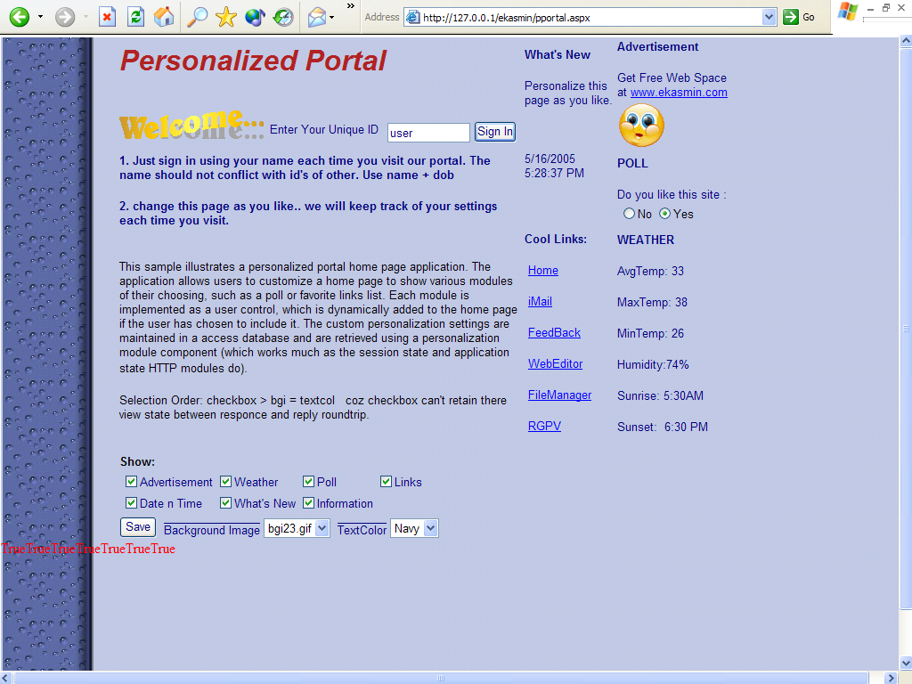

Ekasmin.com Administrator Page

