**Distillery Line application setup**

This tutorial will teach you how to install software’s required for DistilleryLine application and configuration.

**Required Software’s :**

1. Postgresql Database9.2
2. PHP 5.3
3. Lighttpd Web server1.4.32

**Installation:**

**Installation of Postgresql DB:**

PostgreSQL was developed for UNIX-like platforms, however it was designed to be portable. It means that PostgreSQL can also run on other platforms such as Mac OS X, Solaris and Windows.Since version 8.0, PostgreSQL offers an installer for Windows systems that makes the installation easier and faster. For development purpose, we will install PostgreSQL version 9.2  on Windows 7.

There are three steps to complete the PostgreSQL installation:

1. Download PostgreSQL installer for Windows or Copy postgresql-9.3 exe file from CD provided for you
2. Install PostgreSQL
3. Verify the installation

## Download PostgreSQL Installer for Windows

You need to download the installer from PostgreSQL Official website.

* Go to the PostgreSQL official website, download section for Windows <http://www.postgresql.org/download/windows/>
* Click on the [download installer from EnterpriseDB](http://www.enterprisedb.com/products/pgdownload.do#windows)
* Choose the latest version to download. It will take few minutes to complete the download.

## Install PostgreSQL step by step

Double click on the installer file, an installation wizard will appear and guide you through multiple steps where you can choose different options that you would like to have in PostgreSQL.

The following illustrates each step and its options for installation. If you install a different version, you may get additional steps.

**[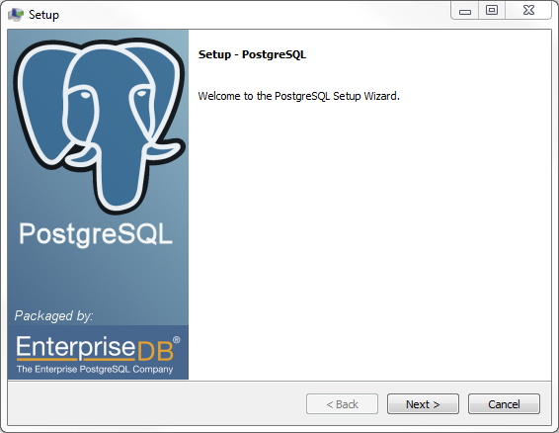](http://www.postgresqltutorial.com/wp-content/uploads/2012/08/Install-PostgreSQL-Step-1.png)**

**Start Installing PostgreSQL**

**[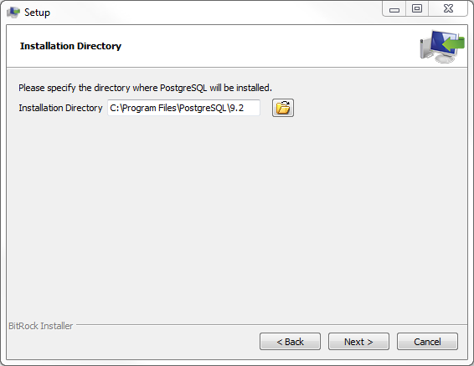](http://www.postgresqltutorial.com/wp-content/uploads/2012/08/Install-PostgreSQL-Step-2.png)**

**Specify installation directory, choose your own or keep the default**

**[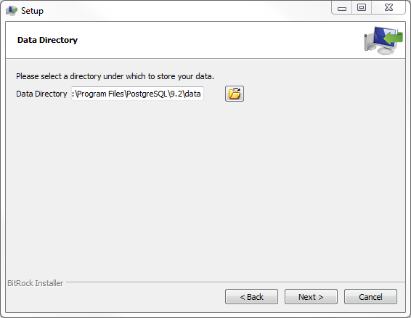](http://www.postgresqltutorial.com/wp-content/uploads/2012/08/Install-PostgreSQL-Step-3.png)**

**Specify the directory where you want to store the data**

**[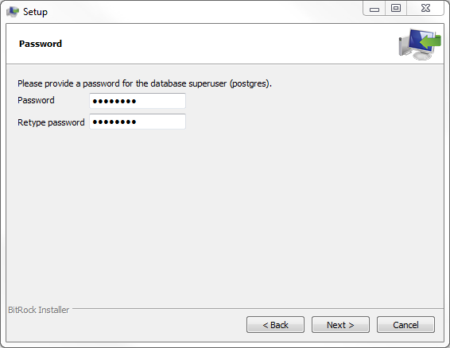](http://www.postgresqltutorial.com/wp-content/uploads/2012/08/Install-PostgreSQL-Step-4.png)**

**Enter the password for the database superuser and service account.**

**[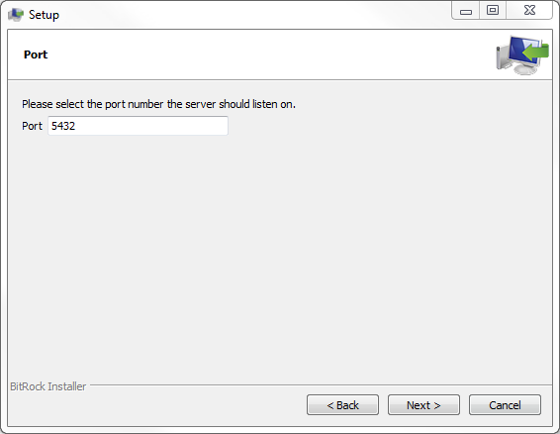](http://www.postgresqltutorial.com/wp-content/uploads/2012/08/Install-PostgreSQL-Step-5.png)**

**Enter the port for PostgreSQL. Make sure that no other applications are using this port. Leave it as default if you are unsure.**

**[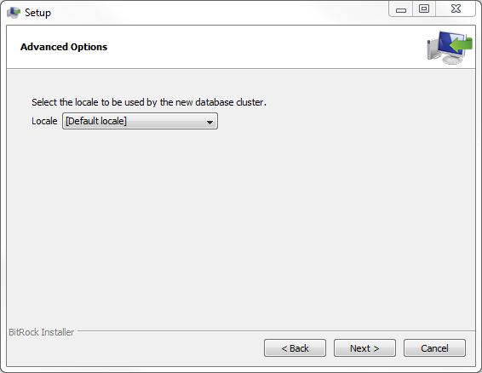](http://www.postgresqltutorial.com/wp-content/uploads/2012/08/Install-PostgreSQL-Step-6.png)**

**Choose the default locale**

**[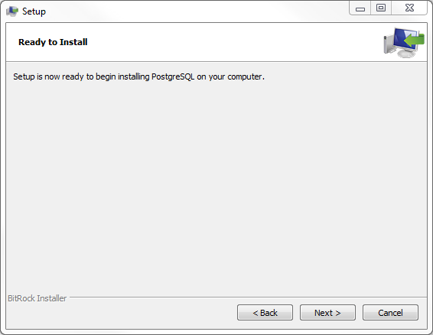](http://www.postgresqltutorial.com/wp-content/uploads/2012/08/Install-PostgreSQL-Step-7.png)**

**You’ve finished providing information for the PostgreSQL installer. Click the Next button to let PostgreSQL installer to install PostgreSQL**

**[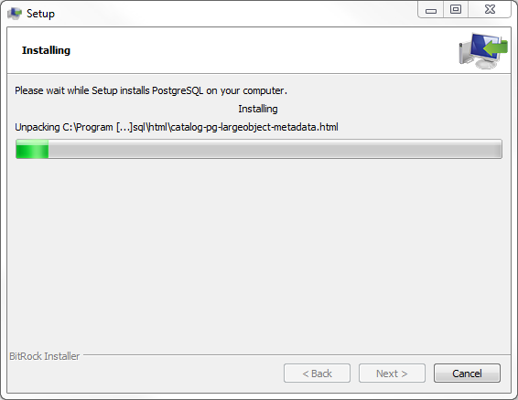](http://www.postgresqltutorial.com/wp-content/uploads/2012/08/Install-PostgreSQL-Progress.png)**

**The installation may take few minutes to complete**

**[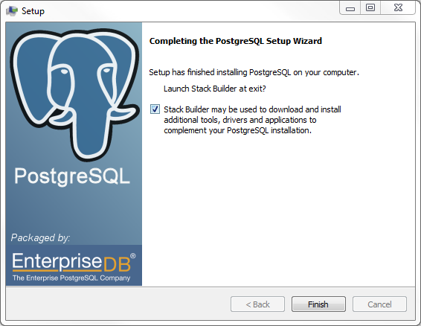](http://www.postgresqltutorial.com/wp-content/uploads/2012/08/Install-PostgreSQL-Finish.png)**

**Click Finish button to complete the installation**

## Verify the Installation

There are several ways to verify the installation. You can try to [connect to the PostgreSQL](http://www.postgresqltutorial.com/connect-to-postgresql-database/)database server from any client application e.g.,  psql, pgAdmin, etc.

The quick way to verify the installation is through the pgAdmin application.

First, click on pgAdmin III to launch it. The pgAdmin III GUI will display.

[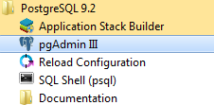](http://www.postgresqltutorial.com/wp-content/uploads/2012/08/Launch-pgAdmin.png)

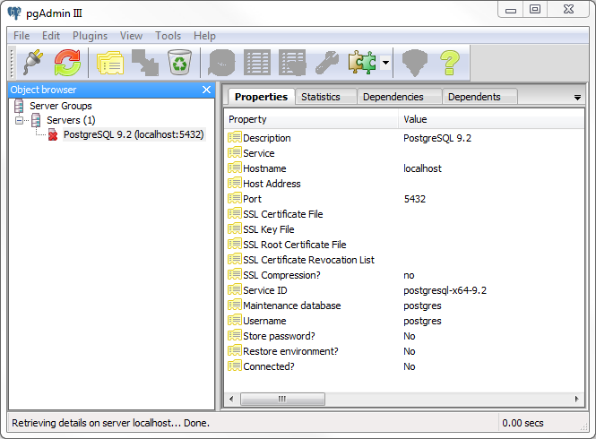

Second, double click on**PostgreSQL 9.2** on the object browser. It will ask you for admin password. Just enter the password you’ve used in the installation step.

[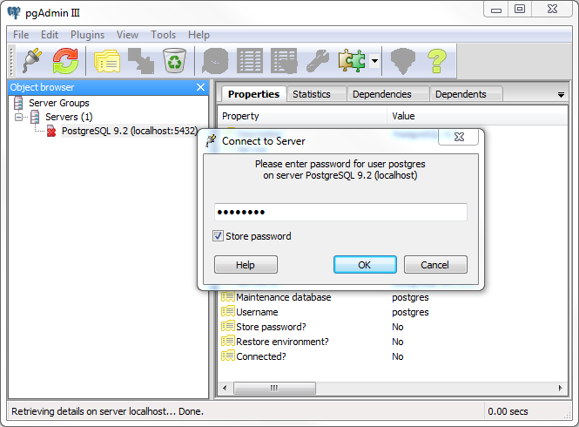](http://www.postgresqltutorial.com/wp-content/uploads/2012/08/pgAdmin-Enter-Password.png)

Third, if everything is fine, the pgAdmin will display all the objects that belong to the server.

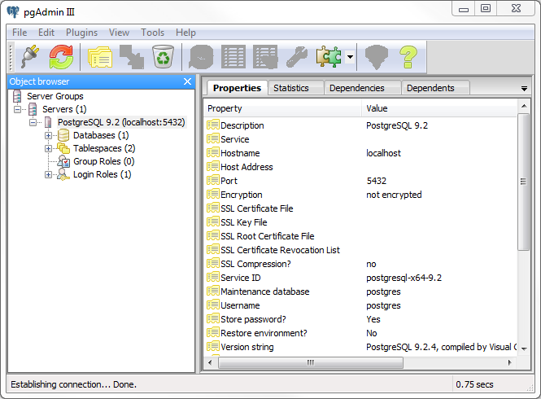

Congratulation! you’ve successfully installed PostgreSQL database server in your local system.

**2. Installation of PHP5.3**

There are three steps to complete the PostgreSQL installation:

1. Copy the php installation file from CD provided for you or Download PHP5.3 from the internet

<http://windows.php.net/download/>

1. Install PHP
2. Verify the installation

## Install PHP step by step

Double click on the installer file, an installation wizard will appear and guide you through multiple steps

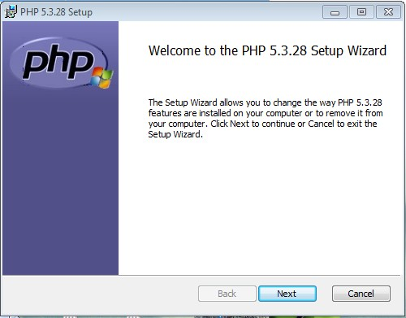

**Starts Installation process**

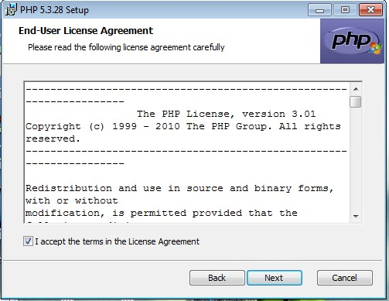

**Accept the terms in License Agreement**

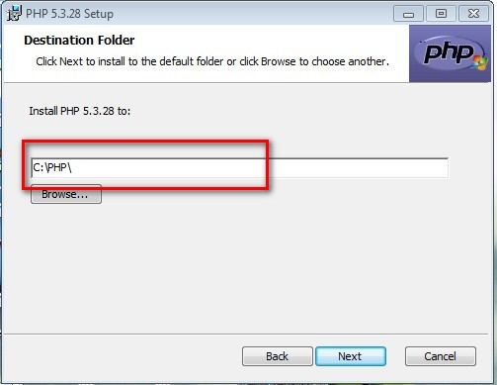

**Choose the path** C:\PHP **to install PHP**

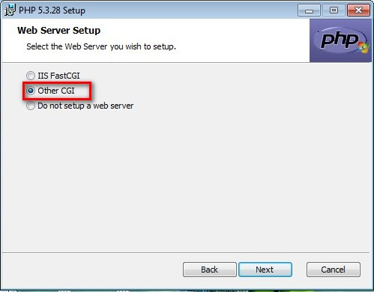

**Choose the webserver as** Other CGI

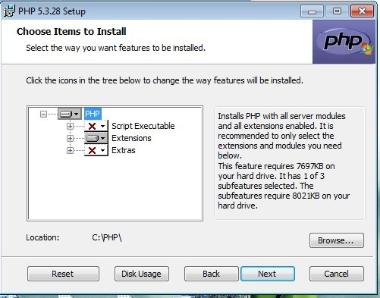

**Select PHP and Click on Next Button**

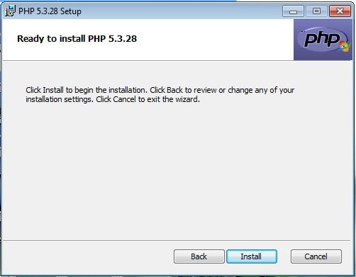

**Click on Install button**

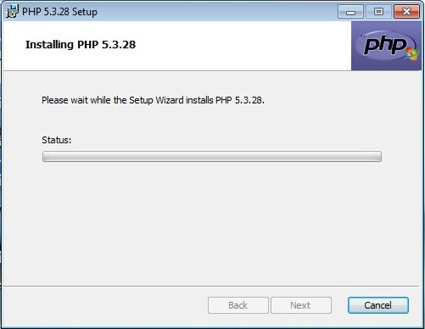

**Here it asks prompt like do you want to install or not? Click on Yes button.**

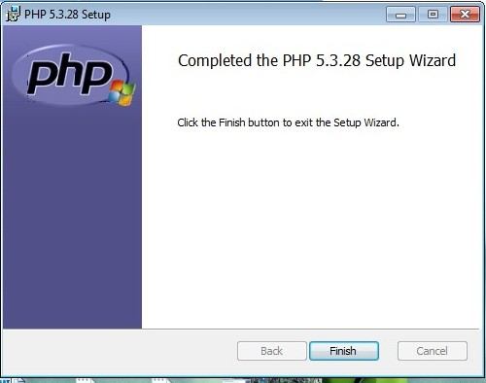

**Click on Finish button to complete Installation of PHP**

Verify the Installation:

Go to Run(press Windows+R) and type cmd

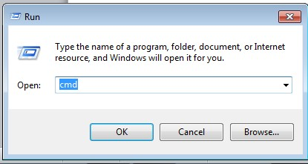

Click on OK button

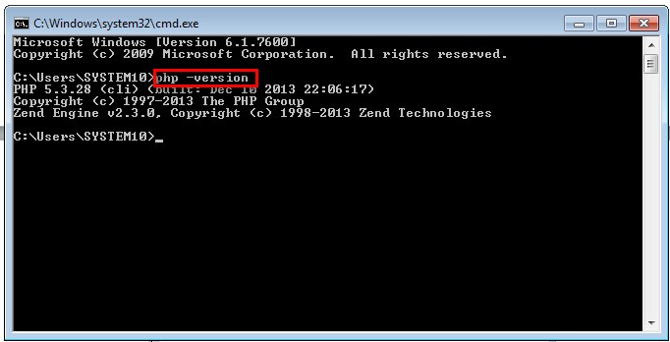

Type **php –version**  will gives php version.

Yes, You are successfully completed PHP installation.

**3. Installation of Lighttpd**

lighttpd is a secure, fast, compliant, and very flexible web-server that has been optimized for high-performance environments. It has a very low memory footprint compared to other webservers and takes care of cpu-load. Its advanced feature-set (FastCGI, CGI, Auth, Output-Compression, URL-Rewriting and many more) make lighttpd the perfect webserver-software for every server that suffers load problems.

There are three steps to complete the Lighttpd installation:

1. Copy the Lighttpd installation file from CD provided for you or Download Lighttpd.exe from the internet

http://en.wlmp-project.net/downloads.php?cat=lighty

1. Install Lighttpd
2. Verify the installation

Step by Step Installation of Ligthtpd

Double click on the installer file, an installation wizard will appear and guide you through multiple steps where you can choose different options that you would like to have in Lighttpd.

The following illustrates each step and its options for installation. If you install a different version, you may get additional steps.

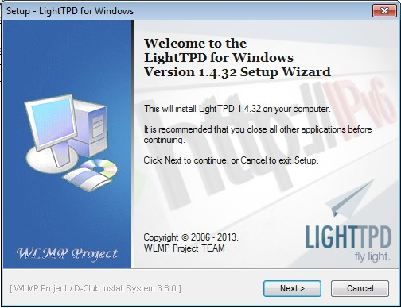

**Click on Next > button to start installation process.**

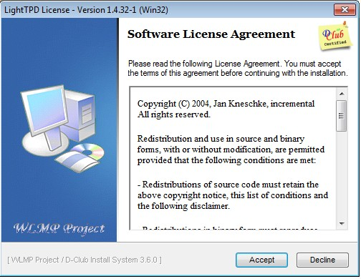

**Click on Accept button to accept software License Agreement.**

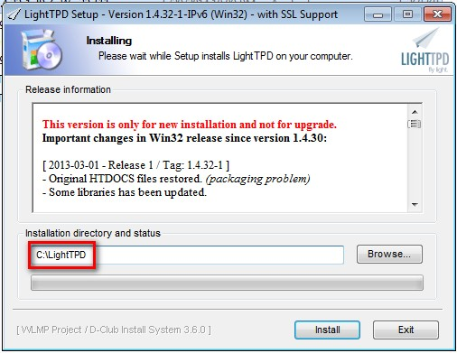

**Choose the path where the Lighttpd to be install, Path should be C:\lightTPD.**

**And click on Install button to complete the installation process.**

**Configuration of PHP and Lighttpd server:**

1. Copy lighttpd configuration file from CD provided for you and paste it on the location of Lighttpd > conf folder[ C:\LightTPD\conf ]
2. Open the services folder in Lighttpd [C:\LightTPD\service] and install services.

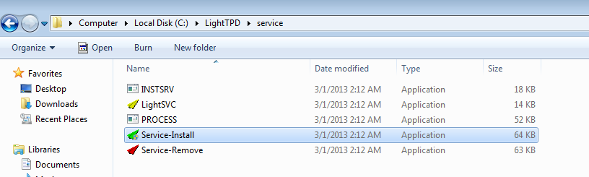DoubleClick on Service-Install (This will installs Lighttpd services and starts automatically at system boot)

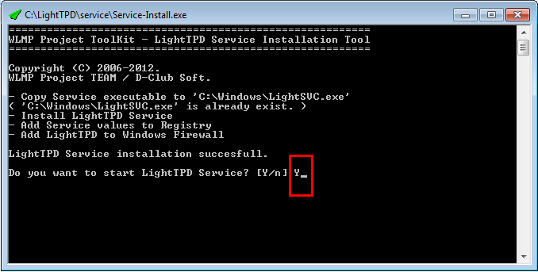

It will ask for service install or not? Give the option Y for installation.

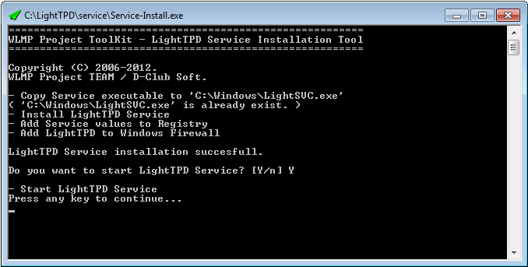

Press any key…

1. Copy php_pdo_pgsql.dll file from CD and paste it on location C:\PHP\ext.
2. Replace the php.ini file from CD and paste in on location C:\PHP.
3. Copy phpinfo.php file from CD and paste in on location C:\LightTPD\htdocs

**After completing all the configurations you must restart the system to effect all the changes on the system..**