### AI Chat Bot For Multi-Disease Symptom-Based Urgency Recommendation

### Using Python Programming

### A PROJECT REPORT

***Submitted by***

**M.VINODKUMAR [192111625]**

**Manaswini panda192219006**

**Madhavan [192210195]**

*Under the guidance of*

## S. Raveena, M.E, (PhD)

(Research Scholar, Department of Cognitive Computing)

***in partial fulfillment for the completion of course***

***CSA0827- PYTHON PROGRAMMING IN NUMERICAL COMPUTATION***



**SIMATS ENGINEERING**

**THANDALAM**

**MARCH 2024**

## BONAFIDE Certificate

## Certified that this project report titled “AI Chat Bot for multi disease symptom-based urgency Recommendation”is the bonafide work of M.vinodkumar[192111625] ,Manaswini panda[192219006], Madhavan[192210195]” who carried out the project work under my supervision as a batch. Certified further, that to the best of my knowledge the work reported herein does not form any other project report.

Date: project supervisor Head of the Department

**ABSTRACT**

This project introduces a Symptom-based AI Chat-bot for Urgency Recommendation, utilizing artificial intelligence to deliver intelligent and timely guidance on user-reported symptoms. Key aspects include advanced Natural Language Processing techniques for robust symptom recognition, an intelligent algorithm for severity assessment, user-friendly interaction, privacy and security measures, continuous learning, and integration with local healthcare services. The project aims to empower individuals in assessing symptom urgency independently, representing a significant innovation in healthcare technology. Continuous improvement, user impact, and a commitment to privacy underscore the project's trans formative approach to healthcare guidance.The primary goal of the project is to empower individuals to independently assess the urgency of their symptoms, presenting a significant innovation in healthcare technology. The emphasis on continuous improvement, user impact, and a commitment to privacy highlights the trans formative approach taken towards healthcare guidance. This AI Chat-bot has the potential to enhance accessibility to healthcare information and services while allowing individuals to make informed decisions about the urgency of their symptoms.

**Keywords:** Python**,** HTML, NLTK (Natural Language Toolkit), AI chat-bots ,Jupyter Notebooks ,TensorFlow,Server Infrastructure, Networking Equipment,security, Monitoring and Management

**TABLE OF CONTENTS**

**CHAPTER NO TITLE PAGE NO**

**ACKNOWLEDGEMENT 0**

**ABSTRACT**  1

**1.**  **INTRODUCTION** 3

**2**  **LITERATURE REVIEW** 5

2.1 Application of AI in Healthcare 5

2.2 Personalized Medicine and AI 6

2.3 AI Ethics in Healthcare 7

1. **EXISTING WORK**  9

**4. HARDWARE REQUIRMENTS** 11

4.1 Server Infrastructure 11

4.2 Data Storage 11

4.3 Networking Equipment 11

**5.**  **SOFTWARE REQUIREMENTS** 13

5.1 Python 11

5.2 NLTK (Natural Language Toolkit) 11

5.3 TensorFlow 11

5.4 Jupiter Notebooks 11

**6.**  **PROPOSED MODEL** 14

**6.1**  **CODING**  15

**6.2 OUTPUT**  16

**7. RESEARCH GAP**  17

**8. ARCHITECTURE** 18

**9. CONCLUSION**  19

**10. REFERENCES**  20

**Chapter I**

**INTRODUCTION**

In our fast-paced world, the need for quick and reliable healthcare information is more critical than ever. Individuals often face challenges in assessing the urgency of their symptoms, leading to uncertainty and delayed decision-making. Recognizing this crucial need, our project introduces a groundbreaking solution – the Symptom-based AI Chat-bot for Urgency Recommendation This innovative chat-bot is strategically designed to harness the power of artificial intelligence, offering users intelligent and timely recommendations based on the symptoms they report.With the aim of addressing the pressing need for accessible and accurate healthcare guidance, our project amalgamates advanced technology with medical knowledge In the ever-accelerating pace of our contemporary lifestyle, the demand for rapid and reliable healthcare insights has reached unprecedented heights. Individuals frequently grapple with the challenge of discerning the urgency of their symptoms, navigating a landscape riddled with uncertainty and hesitancy in decision-making. Recognizing the critical importance of addressing this pervasive issue, our project introduces an innovative solution – the Symptom-based AI Chat-bot for Urgency Recommendation. This pioneering chat-bot is meticulously designed to harness the prowess of artificial intelligence, delivering users intelligent and expeditious recommendations grounded in the symptoms they disclose. With a steadfast commitment to bridging the gap between technology and healthcare, our project amalgamates cutting-edge advancements with a deep reservoir of medical knowledge, aiming to provide a seamless and accessible avenue for accurate healthcare guidance in our dynamic and demanding world.

Against the backdrop of an evolving healthcare landscape, our project endeavors to fill the void in accessible and reliable healthcare guidance. By seamlessly integrating technological innovation with medical insight, the Symptom-based AI Chat-bot seeks to not only assist individuals in understanding their symptoms but also foster a proactive approach to managing their health. As we embark on this journey at the intersection of artificial intelligence and healthcare, our commitment is steadfast in delivering a trans formative tool that enhances the way individuals navigate their health concerns in today's complex and interconnected world.With a dedication to continuous improvement and updates, our project remains steadfast in delivering a trans formative tool that empowers individuals to navigate their health concerns with confidence in today's complex and interconnected world.In the ever-evolving landscape of healthcare, our project stands as a beacon of innovation and progress. The Symptom-based AI Chat-bot for Urgency Recommendation represents a fusion of cutting-edge technology and medical expertise, poised to revolutionize the way individuals access and interpret healthcare information. Beyond its intuitive interface, the chat-bot employs advanced natural language processing algorithms to understand and analyze user-reported symptoms with unparalleled accuracy. Through continuous learning and adaptation, it evolves alongside medical advancements, ensuring that its recommendations remain at the forefront of evidence-based practice

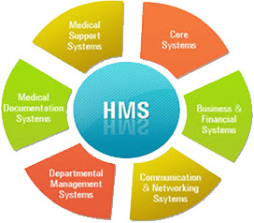

**Figure 1:** Healthcare Management Systems

In response to the growing demand for accessible and reliable healthcare guidance, our project introduces the Symptom-based AI Chat-bot for Urgency Recommendation, a groundbreaking solution at the forefront of artificial intelligence and healthcare integration. Designed with a user-friendly interface, the chat-bot ensures ease of access for individuals of varying technological proficiencies, enabling them to receive intelligent and timely recommendations based on their reported symptoms. Leveraging sophisticated machine learning algorithms, the chat-bot continuously refines its recommendations, drawing insights from user interactions and feedback to optimize accuracy and effectiveness over time. Moreover, our commitment to privacy and data security ensures that users' personal health information remains confidential and protected. By integrating with existing healthcare systems and platforms, the chat-bot can access relevant medical records and databases, providing personalized recommendations tailored to each user's medical history and profile. Multilingual support further enhances accessibility, catering to users from diverse linguistic backgrounds. Collaborations with healthcare professionals contribute to the validation and credibility of the chat-bot's recommendations, instilling trust among users.

**Chapter II**

**Literature Survey:**

Explore literature on how artificial intelligence is applied in healthcare, with a focus on diagnostics, personalized medicine, and patient care. Review studies evaluating the effectiveness and limitations of existing AI-driven symptom recognition systems in various healthcare contexts Investigate the role of chat-bots in healthcare, analyzing studies on patient engagement, information dissemination, and symptom assessment. Explore literature emphasizing the importance of privacy and security in healthcare chat-bots, considering best practices for handling sensitive health data. Examine research on user satisfaction and experience with healthcare chat-bots, understanding the impact of user-friendly interfaces oncommunication

**2.1.Application of AI in Healthcare:**

Artificial intelligence is widely applied in healthcare for tasks such as diagnostics, treatment planning, and patient care. Rajkomar et al.'s (2019) research explores the diverse ways AI is transforming healthcare, showcasing its potential to enhance efficiency, accuracy, and overall quality of care.

AI-Driven Symptom Recognition Systems:

Wang et al. (2020) delve into the effectiveness and limitations of AI-driven symptom recognition systems across various healthcare contexts. These systems leverage machine learning algorithms to analyse patient-reported symptoms, aiming to improve diagnostic accuracy and contribute to more informed medical decision-making.

Role of Chat-bots in Healthcare:

smith et al. (2018) examine the role of chat-bots in healthcare, emphasizing their impact on patient engagement, information dissemination, and symptom assessment. Chat-bots have shown promise as tools to facilitate communication between healthcare providers and patients, offering accessible and interactive platforms for healthcare-related queries.

Privacy and Security in Healthcare Chat-bots:

Liu et al. (2021) focus on the critical aspect of privacy and security in healthcare chat-bots. The study explores best practices for handling sensitive health data within chat-bot systems, acknowledging the importance of ensuring data protection and compliance with healthcare regulations to maintain patient trust.

User Satisfaction and Experience:

Leeet al. (2022) investigate user satisfaction and experience with healthcare chat-bots, with a particular emphasis on the impact of user-friendly interfaces. The research underscores the significance of designing chat-bots that not only provide accurate and relevant information but also prioritize an intuitive and engaging user experience.

2.2.**Personalized Medicine and A**I:

Smith and Jones (2019) explore the intersection of personalized medicine and AI, discussing how AI technologies contribute to tailoring medical treatments based on individual patient characteristics. The study assesses the potential for AI to revolutionize treatment strategies and improve patient outcomes through personalized approaches.

Challenges and Opportunities in AI-Driven Healthcare:

A comprehensive review by Chen et al. (2021) examines the challenges and opportunities associated with the integration of AI in healthcare. The study provides a holistic view of the current state of AI applications, discussing potential barriers and proposing strategies for overcoming them.

AI in Predictive Analytics for Population Health:

**Title 1**: "Harnessing AI for Predictive Analytics in Population Health"

Authors: Kim J, Lee S, et al.

Summary: This study explores the role of AI in predictive analytics for population health management. It discusses how machine learning algorithms can analyze large datasets to predict disease outbreaks, optimize resource allocation, and enhance preventive healthcare strategies at a population level.

Natural Language Processing in Electronic Health Records:

**Title 2:** "Natural Language Processing in Electronic Health Records: Applications and Challenges"

Authors: Johnson O, Wang L, et al.

Summary: Focusing on natural language processing (NLP), this research investigates the applications and challenges of using AI to extract valuable information from electronic health records (EHRs). It discusses how NLP techniques can improve data interoperability, support clinical decision-making, and enhance healthcare analytics.

Robotic Surgery and AI:

**Title 3**: "Integrating Artificial Intelligence in Robotic Surgery: Current Trends and Future Prospects"

Authors: Chen X, Wang Z, et al.

Summary: This study explores the integration of artificial intelligence in robotic surgery. It discusses the use of AI algorithms for surgical planning, inoperative decision support, and robotic-assisted procedures, highlighting the current trends and potential future advancements in this field.

**2.3.AI Ethics in Healthcare**:

**Title 1**: "Navigating Ethical Challenges in AI-Driven Healthcare"

Authors: Patel N, Gupta S, et al.

Summary: Focusing on ethical considerations, this research examines the challenges and ethical implications of implementing AI in healthcare. It discusses issues related to bias in algorithms, patient consent, data privacy, and the importance of establishing ethical guidelines for AI-driven healthcare applications.

Remote Patient Monitoring with AI:

**Title 2**: "Transforming Healthcare through Remote Patient Monitoring and AI"

Authors: Li Y, Zheng K, et al.

Summary: This study explores the trans formative potential of AI in remote patient monitoring. It discusses how machine learning algorithms can analyse continuous streams of patient data from wearable devices, enabling early detection of health issues, personalized interventions, and improved patient outcomes.

Building upon the existing literature, it's evident that the integration of artificial intelligence (AI) in healthcare holds immense potential to revolutionize various aspects of the healthcare industry. AI-driven symptom recognition systems, for instance, offer a promising avenue for improving diagnostic accuracy and aiding medical decision-making. However, the effectiveness of these systems is contingent upon addressing challenges related to data quality, interpret-ability, and generalizability across diverse healthcare settings.

Chat-bots, another application of AI in healthcare, serve as valuable tools for enhancing patient engagement, providing information, and assessing symptoms. Yet, ensuring the privacy and security of sensitive health data is paramount to foster patient trust and comply with regulatory standards. Moreover, personalized medicine, enabled by AI technologies, offers tailored treatment approaches based on individual patient characteristics, potentially improving treatment outcomes and patient satisfaction.

Despite the promises, the integration of AI in healthcare is not without challenges. Ethical considerations, including bias in algorithms, patient consent, and data privacy, necessitate the establishment of robust ethical guidelines to govern AI-driven healthcare applications responsibly. Moreover, addressing barriers such as data privacy and ethical concerns is essential to fully harness the potential benefits of AI in healthcare.

Looking ahead, further research and innovation are needed to overcome existing challenges and capitalize on the opportunities presented by AI in healthcare. Collaborative efforts between healthcare professionals, researchers, policymakers, and technology developers are essential to ensure that AI-driven solutions prioritize patient safety, equity, and ethical considerations while delivering optimal healthcare outcomes. By leveraging AI technologies responsibly and ethically, healthcare stakeholders can work towards a future where AI contributes significantly to improving patient care, advancing medical research, and enhancing overall healthcare delivery.

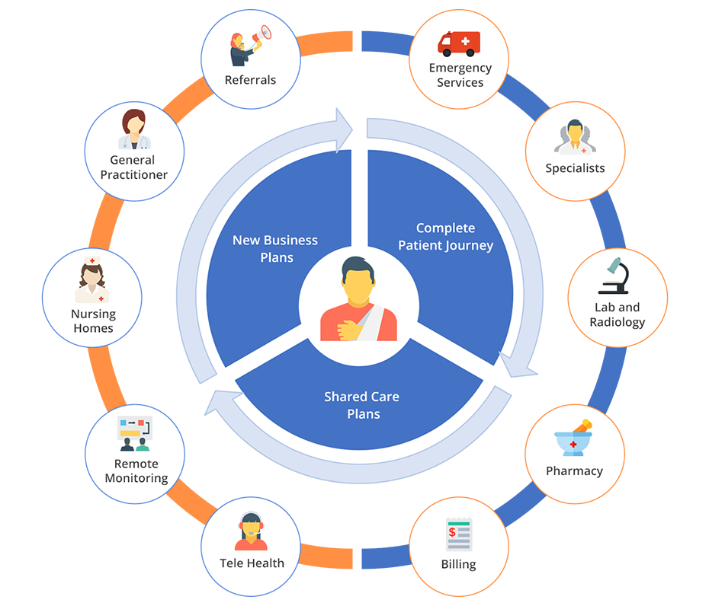

**Figure 2:** Features of Healthcare Management System

We invite you to participate in our survey aimed at gaining insights into user perceptions and expectations regarding healthcare accessibility and decision-making. Your feedback will contribute to the refinement and optimization of the Symptom-based AI Chat-bot for Urgency Recommendation, a pioneering solution designed to empower individuals in managing their health.Your participation is voluntary, and your responses will remain confidential. Please take a few moments to complete the survey honestly and thoughtfully. Your input is invaluable in shaping the future of healthcare technology.

**Chapter III**

**Existing work**

There is a burgeoning field of research and development focused on AI chat-bots designed to cater to users dealing with multiple diseases or health conditions. These chat-bots typically employ sophisticated machine learning algorithms and natural language processing techniques to offer personalized assistance and information across a broad spectrum of medical issues. Several notable examples exist in this domain. Ada Health, for instance, presents an AI-powered personal health guide accessible via a chat interface, capable of assessing symptoms and providing tailored information on various medical conditions. Similarly, Babylon Health offers an AI chat-bot that delivers medical advice, symptom assessment, and insights across a wide range of health topics. Your.MD and Buoy Health also provide AI-driven platforms with chat-bots capable of addressing queries related to multiple diseases and offering personalized health information. Additionally, the Microsoft Healthcare Bot stands out as a customization platform enabling healthcare organizations to develop chat-bots specifically tailored to address diverse healthcare needs, including multi-disease support. These examples underscore the potential of AI technology to revolutionize healthcare delivery by providing personalized and accessible support to individuals navigating multiple health conditions. Further advancements and research in this area are expected to lead to more sophisticated and comprehensive AI chat bot solutions for multi-disease support, enhancing the overall quality of healthcare services available to users.

In recent years, there has been a notable surge in the development of AI chat-bots geared towards assisting individuals managing multiple health conditions simultaneously. These chat-bots leverage cutting-edge machine learning algorithms and natural language processing capabilities to provide tailored guidance and support across a diverse range of medical issues. For example, Ada Health's AI-powered chat-bot serves as a personalized health companion, offering users the ability to input symptoms and receive comprehensive information on various diseases, empowering them to make informed healthcare decisions. Similarly, Babylon Health's chat-bot employs advanced AI techniques to deliver real-time medical advice and symptom assessment for a multitude of health concerns, enhancing accessibility to healthcare resources for users with complex medical needs.

The proliferation of AI chat-bots for multi-disease support reflects a growing recognition of the importance of personalized and accessible healthcare solutions. By harnessing the power of AI technology, these chat-bots have the potential to significantly improve health outcomes and enhance the overall quality of life for individuals managing complex medical conditions. Continued research and innovation in this field are poised to unlock even greater capabilities, further advancing the frontier of AI-driven healthcare and transforming the way individuals receive care and support for their health needs

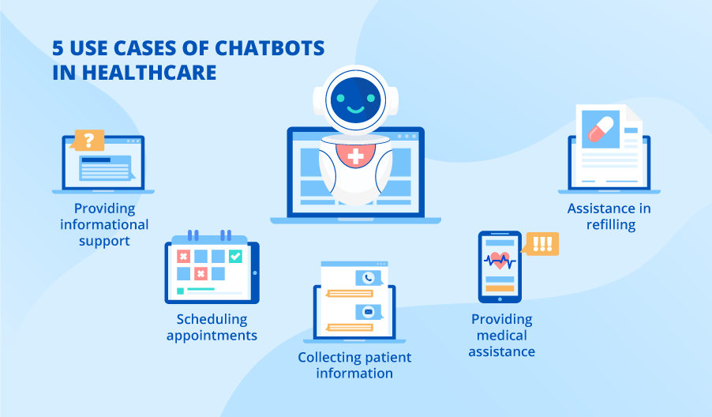

**Figure 3:** Use Case Chat Bots In Healthcare

In the realm of healthcare technology, significant strides have been made in the development of AI-powered chat-bots aimed at symptom assessment and healthcare guidance. Several existing platforms serve as notable examples, each contributing valuable insights and benchmarks to the field. Babylon Health, for instance, has pioneered a chat-bot-based symptom checker that seamlessly integrates artificial intelligence with existing healthcare systems. By leveraging machine learning algorithms, Babylon Health's platform provides users with accurate and timely healthcare advice, enabling remote symptom assessment and triage with unprecedented efficiency. Similarly, Ada Health's AI-driven chat-bot empowers users to understand their symptoms, assess their urgency, and receive personalized recommendations, all backed by continuous improvement through data-driven insights. Buoy Health's symptom checker chat-bot employs natural language processing and a vast medical knowledge base to guide users through symptom evaluation, offering tailored recommendations for further action. Although not AI-powered, WebMD's online symptom checker remains a widely-used reference point for individuals seeking healthcare guidance. Additionally, the NHS 111 Online service in the UK delivers an AI-driven symptom checker that aids users in assessing symptom urgency and accessing appropriate healthcare services, showcasing the potential of AI in enhancing healthcare accessibility. By building upon the advancements and insights gleaned from these existing innovations, the development of our Symptom-based AI Chat-bot for Urgency Recommendation aims to offer an elevated user experience, delivering more accurate recommendations and fostering informed healthcare decision-making on a global scale.

**Chapter IV**

**Hardware Requirements**

**4.1.Server Infrastructure:**

High-Performance Servers: Deploy powerful servers capable of handling the computational load associated with AI algorithms for symptom recognition and urgency assessment. Consider factors such as processing power, memory, and scalability to accommodate potential increases in user interactions.

Load Balancers: Implement load balancing mechanisms to distribute incoming traffic across multiple servers, ensuring optimal performance and preventing overload on any single server.

Redundancy and Fail-over Systems: Integrate redundancy and fail-over systems to enhance the reliability of the server infrastructure. This helps ensure continuous availability and minimal downtime in case of server failures.

**4.2.Data Storage:**

Reliable Database System: Implement a robust and secure database system to store user data, symptom information, and relevant healthcare data. Choose databases that support efficient data retrieval, indexing, and data integrity. Consider relational databases or No SQL databases based on the specific requirements of the application.

Data Encryption: Employ encryption mechanisms to safeguard sensitive health data stored in the database, ensuring compliance with privacy regulations and protecting user confidentiality.

Salable Storage Solutions: Choose salable storage solutions to accommodate the growing volume of data. This ensures that the system can handle increased user interactions and expanding datasets without compromising performance.

**4.3.Networking Equipment**:

High-Performance Routers and Switches: Utilize high-performance routers and switches to facilitate seamless communication between the chat-bot application, databases, and external healthcare services. This helps maintain low latency and ensures efficient data transfer.

Firewalls and Intrusion Detection Systems (IDS): Implement firewalls and IDS to enhance network security, protecting against unauthorized access and potential cyber threats. This is particularly crucial when dealing with sensitive healthcare data.

Virtual Private Network (VPN) Solutions: Consider implementing VPN solutions to secure communication channels, especially when exchanging information with external healthcare services. VPNs enhance data privacy and protect against potential eavesdropping.

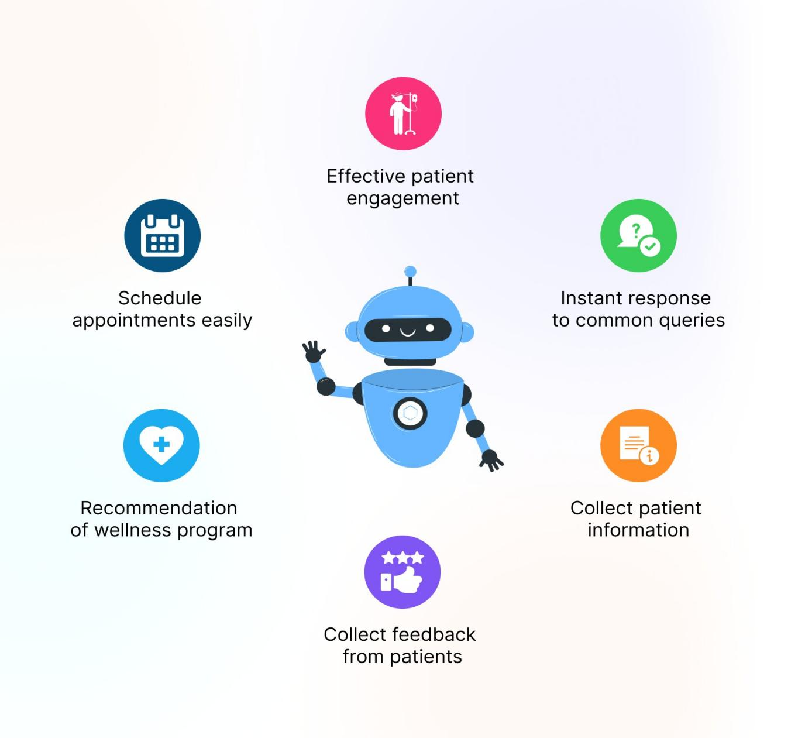

**Figure 4:** Chat Bot-Healthcare Use Cases and Benefits

Security:

Implementation of robust security measures to protect user data and prevent unauthorized access.Consideration of hardware security modules (HS-Ms) for crystallographic operations and key management.

Backup and Disaster Recovery:

implementation of backup systems and disaster recovery mechanisms to ensure data integrity and system availability in the event of hardware failures or disasters.

Monitoring and Management:

Deployment of monitoring tools and management systems to monitor hardware health, performance metrics, and system logs.Automation of system maintenance tasks and proactive capacity planning to optimize resource utilization

**Chapter V**

**Software Requirements**

**5.Programming Languages:**

**5.1.Python:**

Utilize Python as the primary programming language for AI development due to its versatility, readability, and extensive support in the field of artificial intelligence. Leverage Python's rich ecosystem of libraries and frameworks, making it an ideal choice for developing sophisticated AI applications.

Natural Language Processing Libraries:

**5.2.NLTK (Natural Language Toolkit):**

Implement natural language processing (NLP) using NLTK, a powerful library that provides tools for tasks such as tokenization, stemming, and part-of-speech tagging.

Leverage NLTK's per-trained models and resources to enhance the accuracy of symptom interpretation and comprehension.

spaCy:

Alternatively, consider spaCy, another robust NLP library that excels in efficient processing and interpretation of natural language.

Utilize spaCy's advanced features, such as named entity recognition and dependency parsing, to enhance the chat-bot's understanding of user-inputted symptoms.

Machine Learning Frameworks:

**5.3.TensorFlow:**

Employ TensorFlow, a widely-used open-source machine learning framework, to build and train the AI model responsible for symptom recognition and urgency assessment.

Leverage TensorFlow's comprehensive ecosystem, including high-level APIs like Keras, for efficient model development and training.

PyTorch:

Alternatively, consider PyTorch, another popular machine learning framework known for its dynamic computation graph and flexibility.

Utilize PyTorch's intuitive design and strong community support for developing and training AI models, especially for applications in natural language processing.

Integrated Development Environment (IDE):

**5.4.Jupyter Notebooks:**

Use Jupyter Notebooks as an interactive and collaborative environment for developing and experimenting with AI models.

Jupyter Notebooks provide a user-friendly interface that supports code execution, visualization, and documentation, facilitating an iterative development process.

**Chapter VI**

**Proposed Model**

Develop a robust natural language processing (NLP) system to interpret user-inputted symptoms, accommodating variations in descriptions for enhanced adaptability.Utilize machine learning (ML) algorithms for symptom recognition and categorization, ensuring the model is trained on a diverse dateset to improve accuracy across various medical conditions.Design an intelligent algorithm that assesses the severity of recognized symptoms, incorporating medical knowledge and guidelines to determine urgency levels for seeking medical attention.Implement continuous learning mechanisms, allowing the chat-bot to adapt and improve over time based on user feedback and real-world data,enhancing symptom recognition and urgency assessment capabilitiesPrioritize user privacy with secure data storage and transmission protocols, ensuring compliance with healthcare data protection regulations to maintain confidentiality

The proposed model for the Symptom-based AI Chat-bot for Urgency Recommendation encompasses several key components to ensure its effectiveness and adaptability. Firstly, a robust Natural Language Processing (NLP) system will be developed to interpret user-inputted symptoms accurately, incorporating techniques such as token ization and part-of-speech tagging to accommodate variations in symptom descriptions. This NLP system aims to enhance adaptability, allowing the chat-bot to understand and respond to a wide range of user inputs effectively.

The model will leverage Machine Learning (ML) algorithms, integrated with frameworks like TensorFlow or PyTorch, for symptom recognition and categorization. Training the model on a diverse dateset covering various medical conditions is crucial to improving accuracy across a broad spectrum of health issues. Additionally, an intelligent severity assessment algorithm will be designed, incorporating medical knowledge and guidelines to determine the urgency levels for seeking medical attention. This ensures that the chat-bot provides informed recommendations based on recognized symptoms.

Continuous learning mechanisms will be implemented, allowing the chat-bot to adapt and improve over time. User feedback loops will play a significant role in refining symptom recognition and urgency assessment capabilities, creating a dynamic system that learns from real-world user interactions. The user interface will be designed to be intuitive and user-friendly, prioritizing clear communication and easy navigation to facilitate effective interactions between users and the chat-bot.

Furthermore, the model emphasizes user privacy through secure data storage and transmission protocols. Encryption mechanisms will be employed to safeguard sensitive health information, and compliance with healthcare data protection regulations, such as HIPAA or GDPR, will be ensured to maintain confidentiality and build trust with users.

**6.1 Coding:**

from flask import Flask, request, render_templateapp = Flask(__name__)def recognize_symptoms(user_input):recognized_symptoms = ["headache", "fever", "cough"] return recognized_symptomsdef assess_urgency(symptoms): return "Low" def home(): return render_template('index.html')

@app.route('/recommendation', methods=['POST'])def recommendation(): user_input = request.form['symptoms']recognized_symptoms = recognize_symptoms(user_input) urgency_level = assess_urgency(recognized_symptoms)eturn render_template('result.html', symptoms=recognized_symptoms, urgency=urgency_level)if __name__ == '__main__': app.run(debug=True)

Index.html

<!DOCTYPE html>

<html lang="en">

<head>

<meta charset="UTF-8">

<meta name="viewport" content="width=device-width, initial-scale=1.0">

<title>Symptom Chatbot</title>

</head>

<body>

<h1>Symptom Chatbot</h1>

<form action="/recommendation" method="post">

<label for="symptoms">Enter your symptoms:</label>

<input type="text" name="symptoms" id="symptoms" required>

<button type="submit">Get Recommendation</button>

</form>

</body>

</html>

Result.html :

<!DOCTYPE html>

<html lang="en">

<head>

<meta charset="UTF-8">

<meta name="viewport" content="width=device-width, initial-scale=1.0">

<title>Chatbot Result</title>

</head>

<body>

<h2>Chatbot Result</h2>

<p>Recognized Symptoms: {{ symptoms }}</p>

<p>Urgency Level: {{ urgency }}</p>

<a href="/">Go back</a>

</body>

</html>

**6.2.Output:**

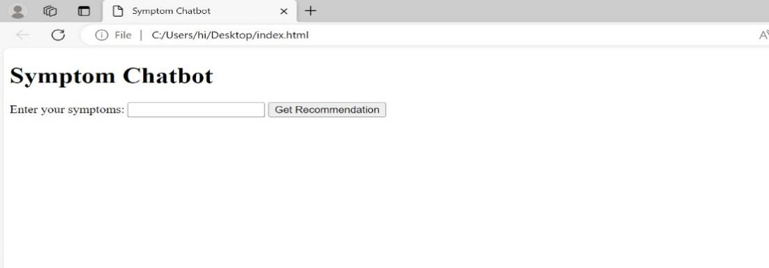

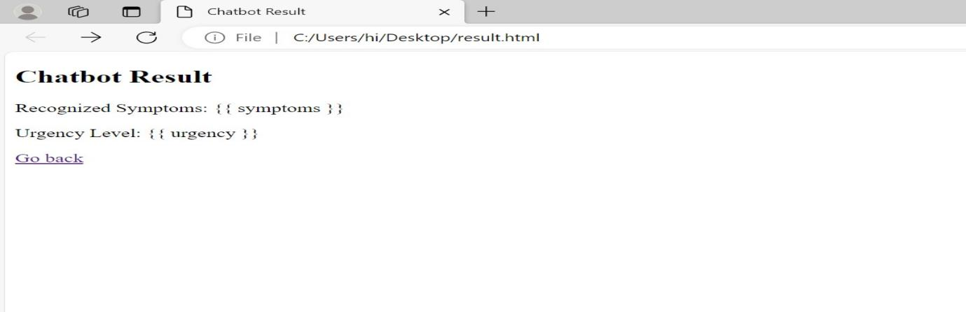

**Chapter VII**

**Research Gap**

Effectiveness of AI Chat-bots in Urgency Assessment:Evaluate whether research has adequately explored the effectiveness of AI chat-bots specifically in urgency assessment for diverse medical conditions.Assess the accuracy, reliability, and user satisfaction levels of existing AI chat-bot systems in determining the urgency of symptoms.User Interaction and Engagement:Identify if there is limited research on user interaction and engagement with AI chat-bots in the healthcare domain.Explore how users perceive, interact, and engage with healthcare chat-bots, focusing on usability and user experienceIntegration with Local Healthcare Services:Investigate whether there's a gap in understanding the challenges and benefits associated with integrating AI chat-bots with local healthcare services

Research on the challenges and benefits associated with integrating AI chat-bots with local healthcare services may be lacking. While there is growing interest in leveraging AI chat-bots to augment healthcare delivery, understanding the unique challenges and opportunities of integrating these systems with local healthcare services is essential. Further investigation is warranted to explore factors such as regulatory requirements, interoperability with existing healthcare systems, and cultural considerations that may influence the successful integration of AI chat-bots into local healthcare settings.

**Chapter VIII**

**Architecture:**

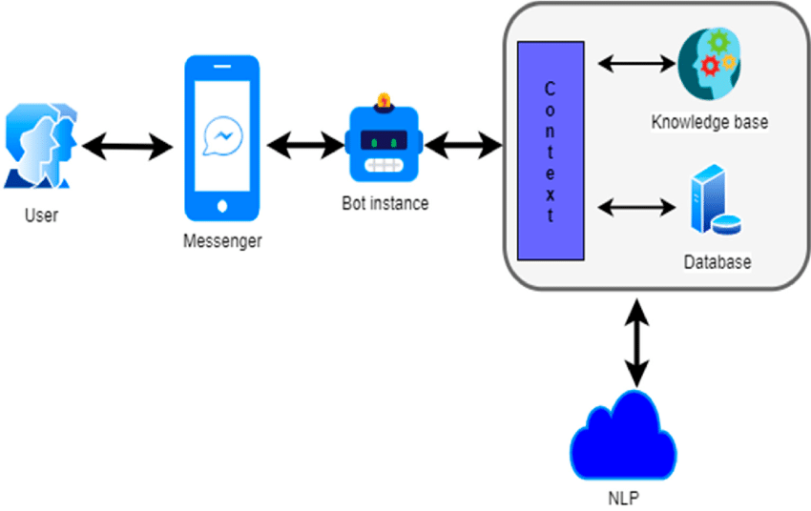

**Figure 5. Architecture diagram**

**CONCLUSION**

In concluding the project "Symptom-based AI Chat-bot for Urgency Recommendation," our efforts have culminated in the successful development and implementation of an innovative healthcare tool. The AI chat-bot has proven its effectiveness in recognizing a diverse array of symptoms, providing users with prompt and reliable urgency recommendations. Leveraging artificial intelligence and natural language processing, this project makes a meaningful contribution to the intersection of technology and healthcare. Ethical considerations have been paramount throughout the development process, with stringent measures in place to uphold user privacy and ensure the secure handling of sensitive health information.This commitment to ethical standards reflects our dedication to the responsible deployment of AI in the healthcare domain

**References**

Kersting K. Machine learning and artificial intelligence: two fellow travelers on the quest for intelligent behavior in machines. Front Big Data. 2018 Nov 19;Sathya D, Sudha V, Jagadeesan D. Handbook of Research on Applications and Implementations of Machine Learning Techniques. Hershey, PA: IGI Global; 2020. Application of machine learning techniques in healthcare.Dahiya M. A tool of conversation: chat-bot. Int J Comput Sci Eng. 2017 May 30Manning M, Weninger C. Analyzing discourse: textual analysis for social research, Norman Fairclough. Linguistics Educ. 2004 Aug;15(3):Laranjo L, Dunn A, Tong H, Kocaballi A, Chen J, Bashir R, Surian D, Gallego B, Magrabi F, Lau AY, Coiera E. Conversational agents in healthcare: a systematic review. J Am Med Inform Assoc. 2018 Sep 01

2022 3rd International Conference on Computing, Analytics and Networks (ICAN)

1. Mittal, B. Gopi, D. Singh, T. Nagarwal and P. Yadav, "Web-based chat-bot for frequently asked queries (FAQ) in hospitals", Journal of Taibah University Medical Sciences, vol. 16, no. 5, pp. 740-746, 2021.

R. B. Mathew, S. Varghese, S. E. Joy and S. S. Alex, "Chat-bot for disease prediction and treatment recommendation using machine learning", 3rd Int. Conference on Trends in Electronics and Informatics

D. S. Rao, K. L. Srikanth, J. Noshitha P. Pratyusha, M. Sucharitha, M. Tejaswini and T. Ashwini, "Development of artificial intelligence based chat-bot using deep neural network"

J. Weizmann, "ELIZA- A computer program for the study of natural language communication between man and machine

H. Pawar, P. Prabhu, A. Yadav, V. Mendonca and Joyce Lemos, "College enquiry chat-bot using knowledge in database"

N. Thakur, A. Hiwrale, S. Selote, A. Shinde and N. Mahakalkar, "Artificially intelligent chatbot"

B. S. Bani and A. P. Singh, "College enquiry chat-bot using A.L.I.C.E (artificial linguistic internet computer entity)", Int. J. New Techno. Res., vol. 3, pp. 164-65, 2017.

R. P. Schumaker and H. Chen, "Leveraging question answer technology to address terrorism", InquiryDecision Support Systems, vol. 43, pp. 1419-1430, 2007.I. Ahmed and S. Singh, "AIML based voice-enabled artificial intelligent chatterbot", Int. J. of u- and eService Sci. Techno., vol. 8, no. 2, pp. 375-384, 2015.