Asterisk CTI

1. Introduction
In my idea AsteriskCTI should be basically a multiplatform client/ server CTI solution integrated with the Open Source Digium’s Asterisk PBX Server.
C.T.I. is an acronym of Computer Telephony Integration: so a CTI is a software that make possible to transfer from the telephone interface to the client pc a set of useful informations like calling party telephone number, digits grabbed by IVRs and so on. These information should be made available to a client software for database queries and/or other usage.
Actually, the advent of Web 2.0 technologies have to reflect on the concept of CTI: today a lot of backoffice softwares runs like web pages into browsers, and thus the most important innovation that a new CTI platform can carry is the web integration. Call Data builded on the PBX logic should be passed to a middleware able ro perform the most disparate operations such as execute an external application or open a browser, allowing to transfer them the variables as telephone parameters.
This new model make possible to build callcenter logics without the knowledge of complex API manageable only with advanced C/C++ skills.
Finally, this application should be available and runnable, client and server, on all (or almost all) modern operating systems: to achieve this objective I’ve selected, after trying various solutions (like mono/.net on GTK) to use the QT toolkit and – by consequence - C++ language. QT seems to be easy to learn, very quick and stable, really multiplatform and now also with a multiplatform IDE. The same source can be ported from Win32 to Linux just compiling and packaging it.

2. Architecture
By initial design, AsteriskCTI is composed of various parts: the core is Digium’ Asterisk PBX with it’s AMI (Asterisk Manager Interface). The Asterisk Manager allows a client program to connect to an Asterisk instance and issue commands or read PBX events over a TCP/IP stream. The AMI is well documented on voip-info.org (http://www.voip-info.org/wiki/view/Asterisk+manager+API).
Actually, various mini-CTI application that make use of AMI opens a lot of AMI connections, once per client. This approach can slow down Asterisk PBX and generally decentralize on CTI Client the application logic.
For this reason, AsteriskCTI should provide a Server daemon that opens just one AMI connection and listen for AsteriskCTI clients connections. This means that on large installations, AsteriskCTI server can be run on a server different from the one that runs Asterisk PBX: calls, queues, ivrs runs separate from cti server and without a great waste of resources. The AsteriskCTI Server should also be able to watch dialplan flow and match the events that carry in variables and store them for the client.
For client integration AsteriskCTI should provide a Client software that have to be installed on all the PC of the callcenter seats. The AsteriskCTI Client will be paired to the seat’ telephone by the phone extension number: the Client will know by its configuration which phone the server should monitors for incoming calls. When the call is answered by that phone, the paired Client will perform the actions preconfigured on the Server.
This allows another reflection: not all the calls have to be notified from the server to the client: only the ones that arrive on a predetermined telephone service (this means a specified call queue).
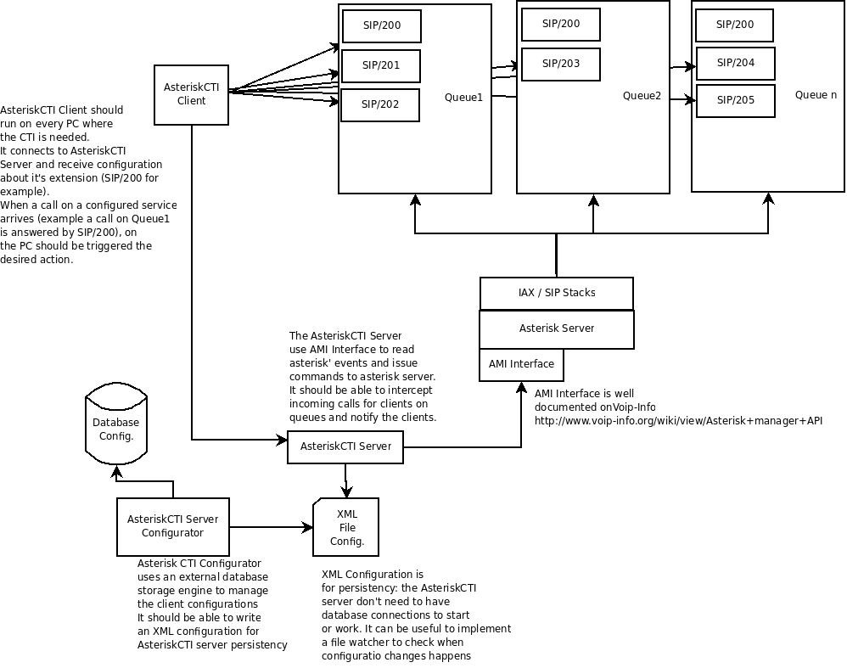
Figure 1 - Diagram
The last part of our software is a Configurator that can be a web application that reads and store CTI configuration in a database and persists them in a XML file. This persistency file will be used then by the AsteriskCTI Server to avoid that the absence of database connection can cause crashes.

