E-Commerce Sales Analysis

Import Data:
Q) ● Import “List of Orders.csv” into Power BI

A) Open power Bi desktop
Step 1

- Open The’’ POWER BI’’ in desktop
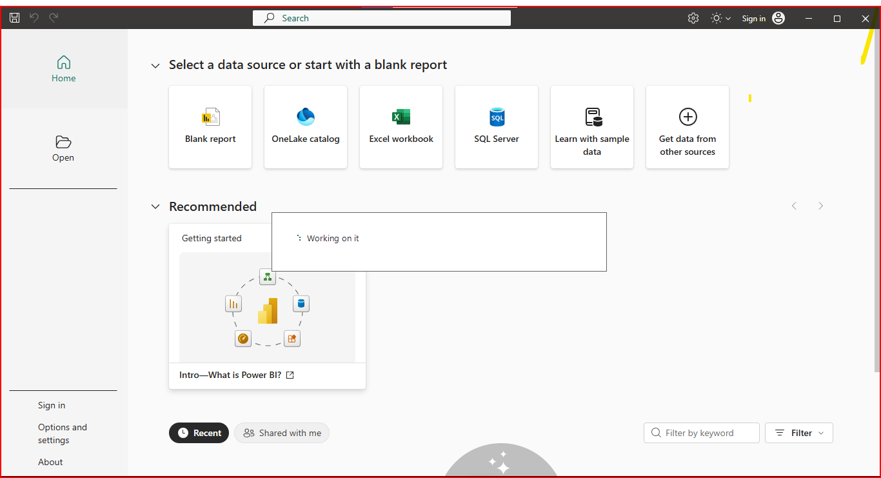
- Thise is POWER BI desktop interface
- Click a new blank report
E-Commerce Sales Analysis
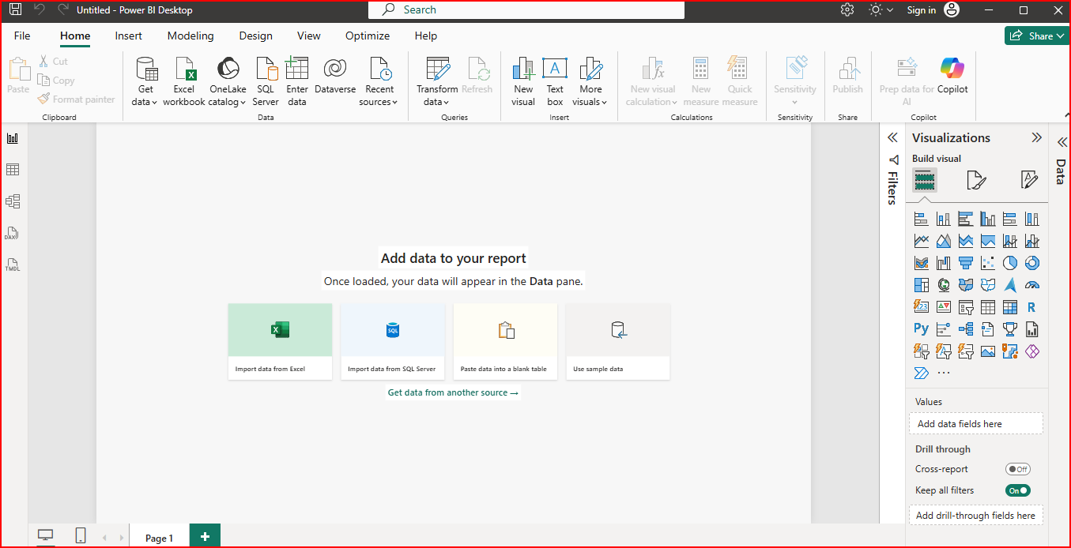
Then Get data select file and load
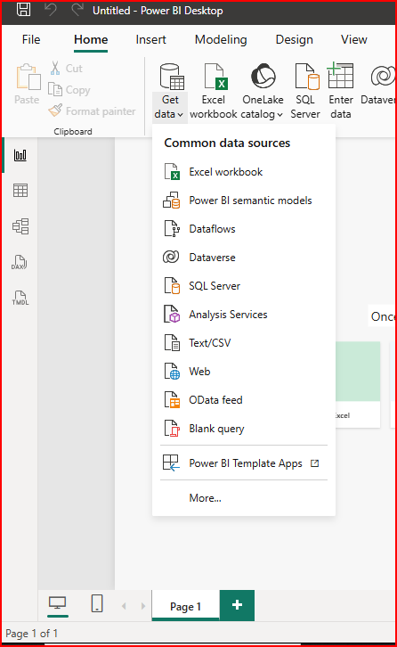
All data formats type here if want data select here and get a data
Q) ● Open “List of Orders” in Power Query Editor by clicking on ‘Transform’.
A) My file format is CSV file
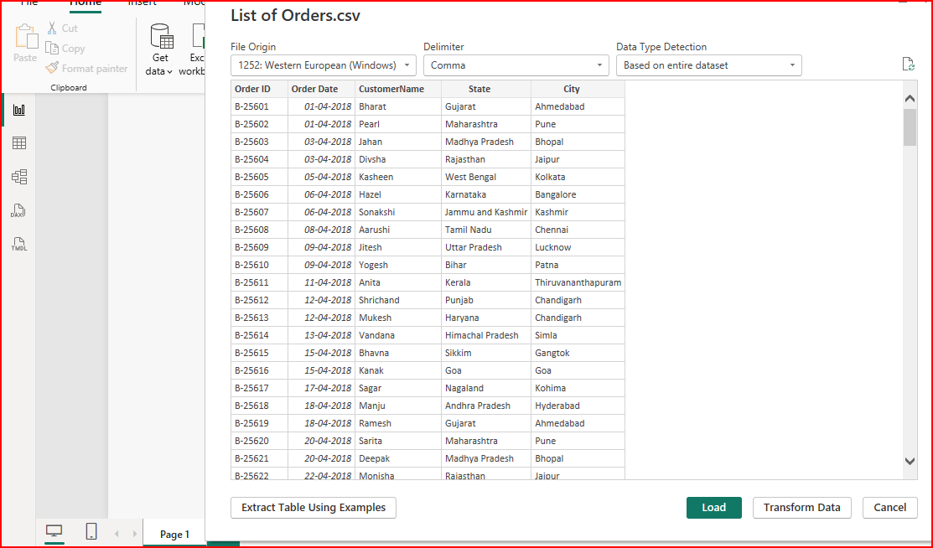
● Import “Order Details.csv” and “Sales ttarget.csv” into Power Query Editor.

If you want in corrective data cleaning Transform data open in Direct power Quary Editor than edit any

Q) ● Import “Order Details.csv” and “Sales target.csv” into Power Query Editor.
A) See this is power Query editor
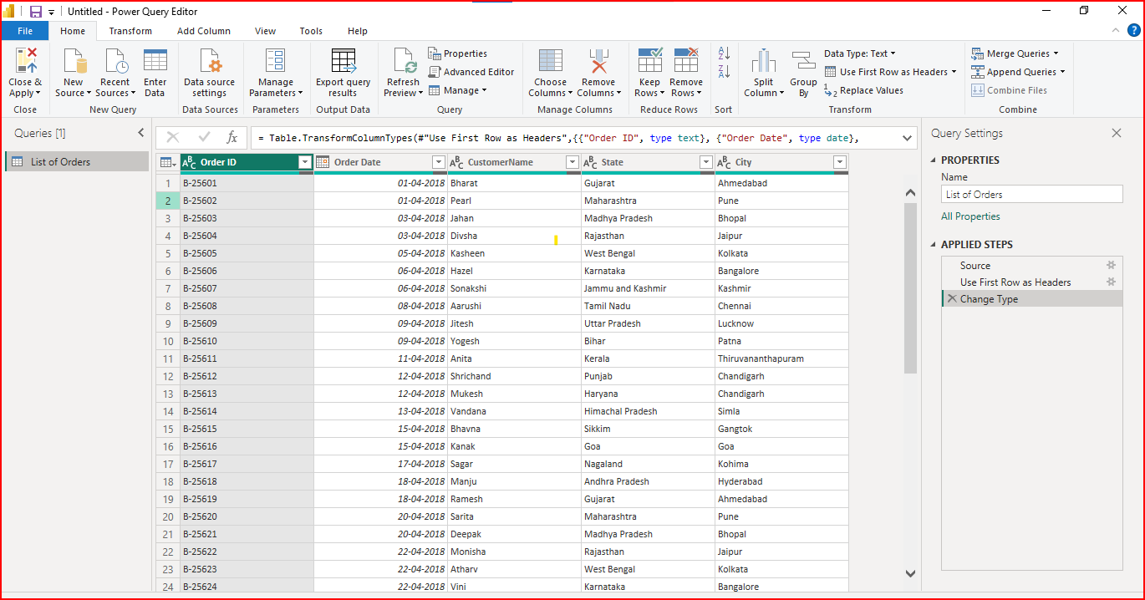

This data set open in Power Query Editor
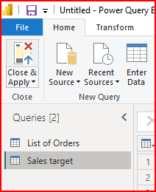

Data transformation
Q) ● Restrict the "List of Orders" table to only the first 500 rows
A) Keep 500 Rows in “List of Order file “
Select the list of order in power query then go to home tool bar keep row top 500 row s then ok
Step1 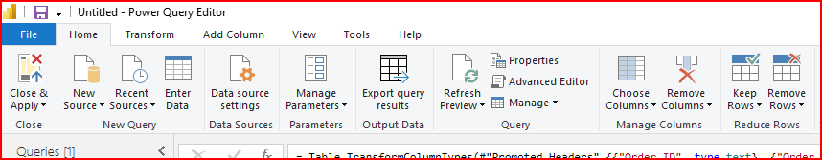
Step 2
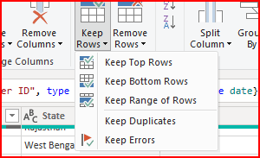
Step 3
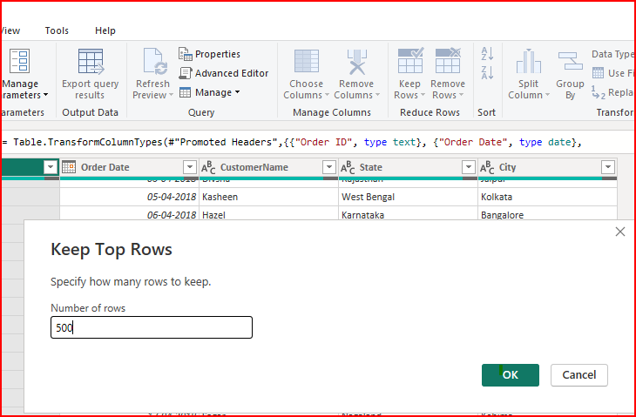

See 500 rows here
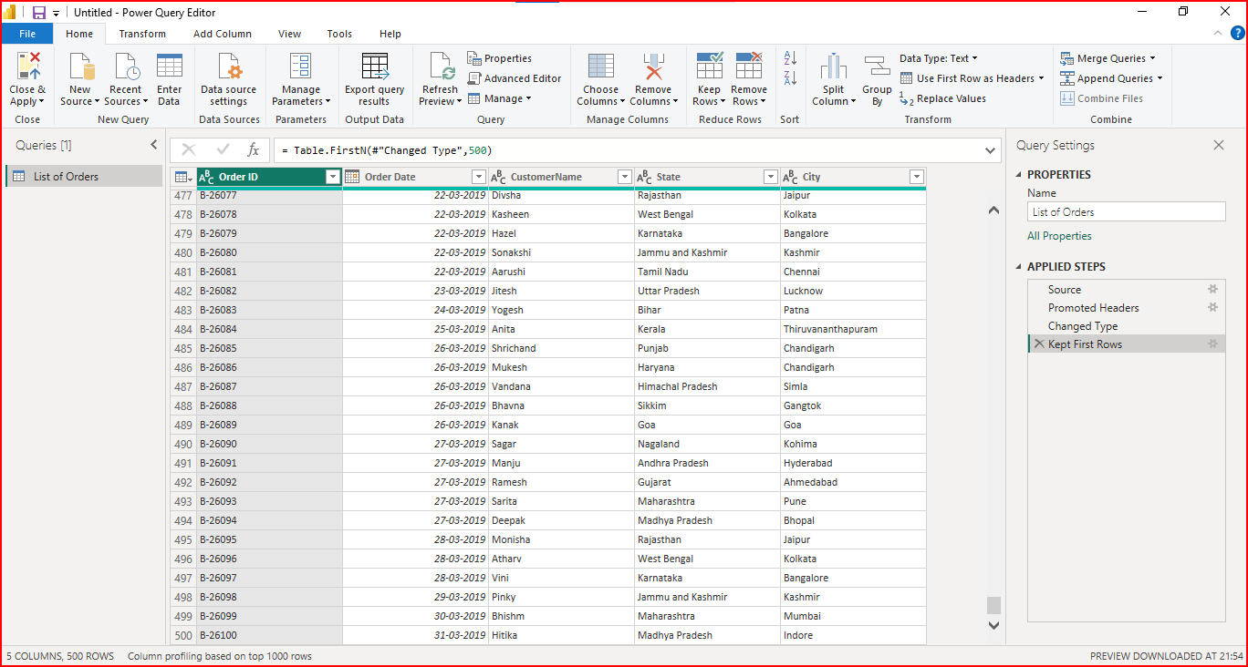

● Ensure the “Order Date” column in the “List of Orders” table is set to data type 'Date'
Select order date and data type date
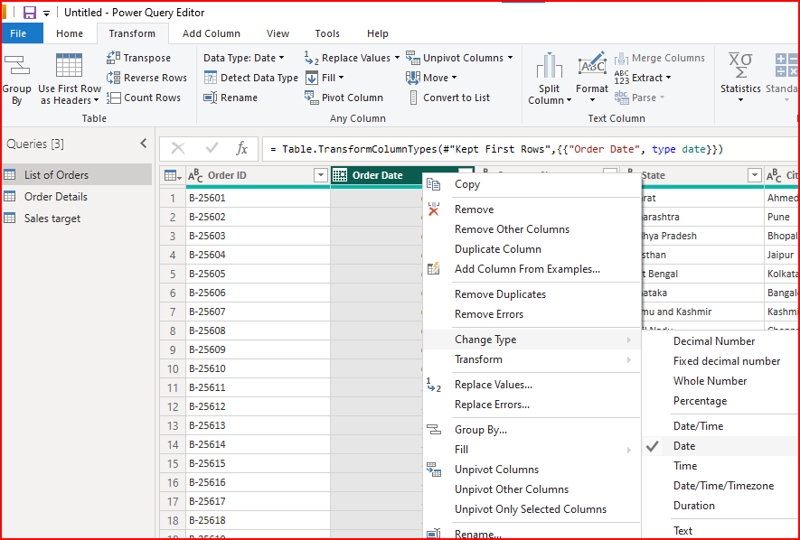

● Change the data type of “Amount” and “Target” columns to ‘Fixed Decimal Number’.
Step 1
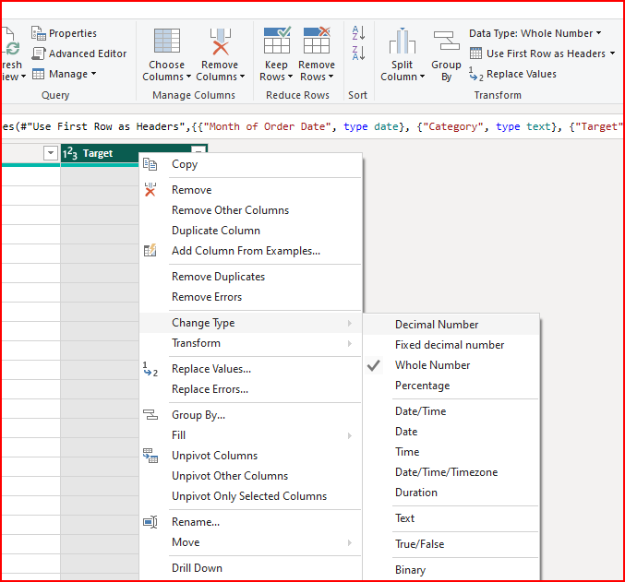
Step 2
step 1
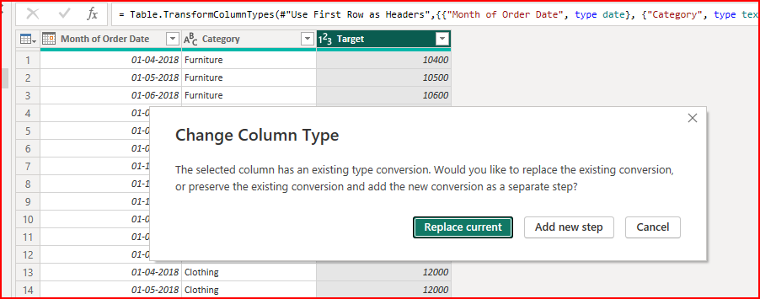
Step 3
Amount Target
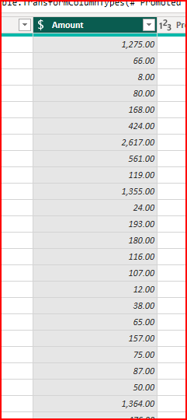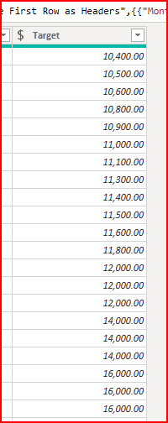

● Format the "Customer Name" column into proper case, ensuring consistent capitalization for each word.
Ans go to list of order table select customer name column than right click in mouse go to transform format select “Capitilization for each word “(Proper case)
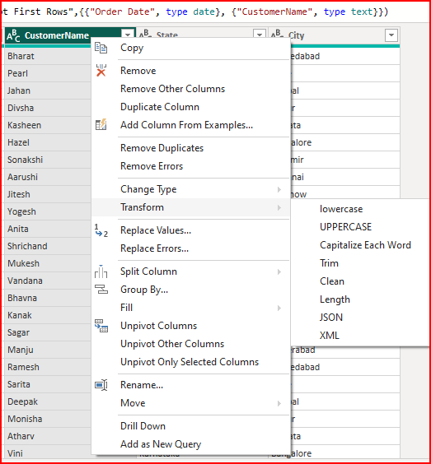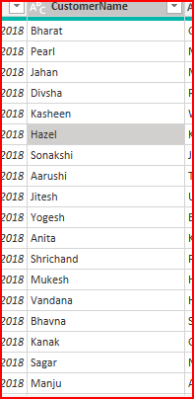
Capitalization for each word
Step 2
Step 1

● Merge the "State" and "City" columns to create a new column named "Location" in the format ‘City, State’.
Ans) select state and city go to Add columns in toolbar than merge columns and create named with new Location column and separated by space
Step 1
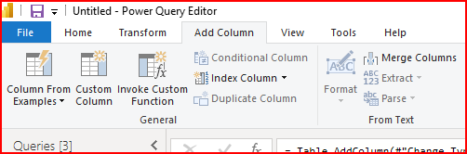
Step 2
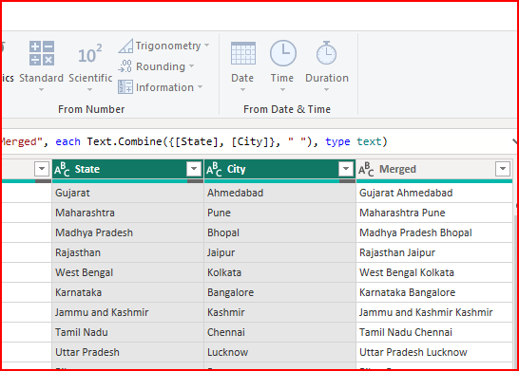

● Create a new custom column named "Profit Margin" as the percentage of "Profit" divided by "Amount".
Ans) select amount and profit columns go to Add columns in toolbar than
custom columns write syntax
if [Amount] = 0 then null else [Profit] / [Amount ]
Step 1
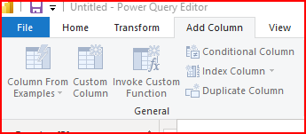
Step 2
2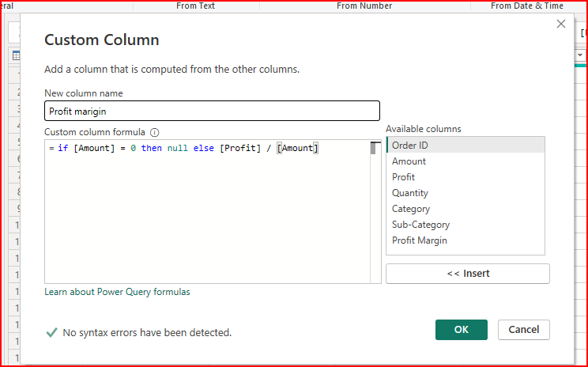
Step 3
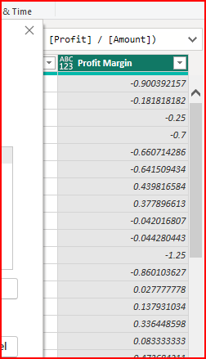

Add a new conditional column named "Profit Status" based on the values in the "Profit" column. The conditions are as follows: if the profit is less than 0, the label should be "Loss"; if the profit equals 0, the label should be "Break-Even"; and if the profit is greater than 0, the label should be "Profit".
Ans) Go to Add column in toobar Conditinoal column and named with Profit Status columns Give rules then enter ok
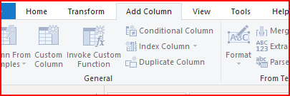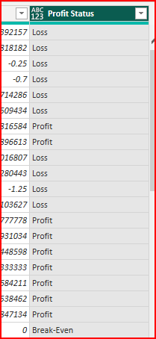
Step 4
Step2
Step 1
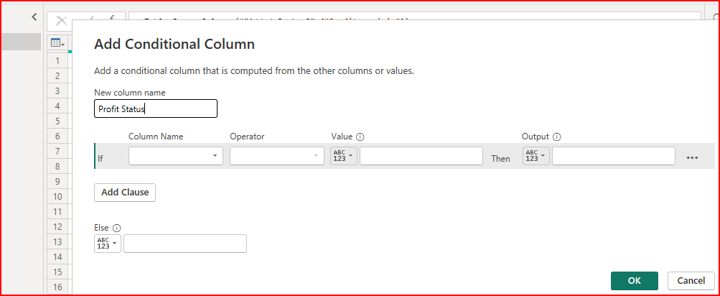
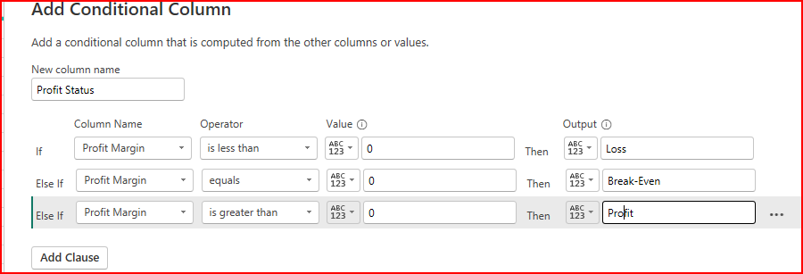
Step 3

.Merge the "List of Orders" and "Order Details" tables into a new single table named "Orders Data" based on the "Order ID" relationship.
Ans) Go to home tab in toolbar than go to merge query merge quires as new select wanted table and give a rule than ok automatically create new table than Re-name the table

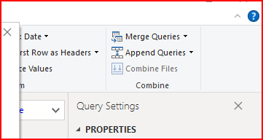
Step 1

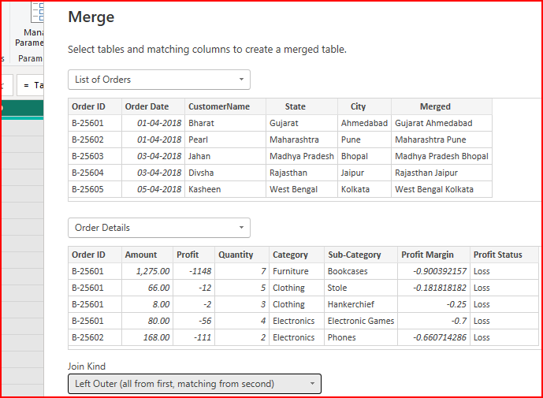
Step 2

Handling Missing Data & Duplicate Data:
● Identify missing values in the data and determine a strategy to address them.

ANS) NO DUPLICATES

● Check for duplicate rows and define a strategy to handle duplicates.
Go to home tab than select removes row than remove duplicates an order id doing with out checking row by row

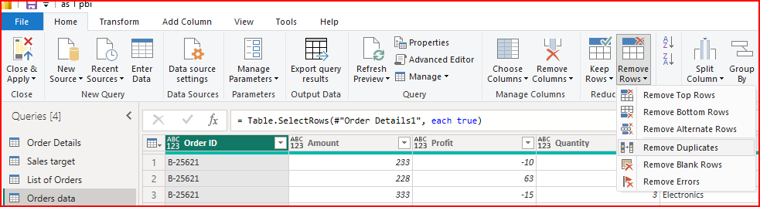

Sorting and Filtering Data:
◆ Sort the orders by Order Date in descending order to analyze recent trends.
. select order date column Right click than sort descending order
See this is Ascending order
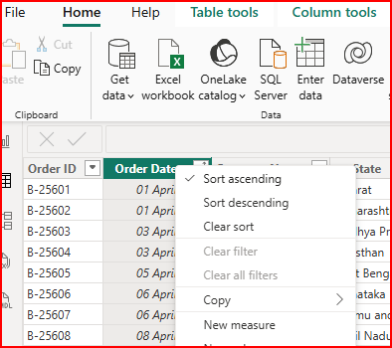
I want convert to descending order
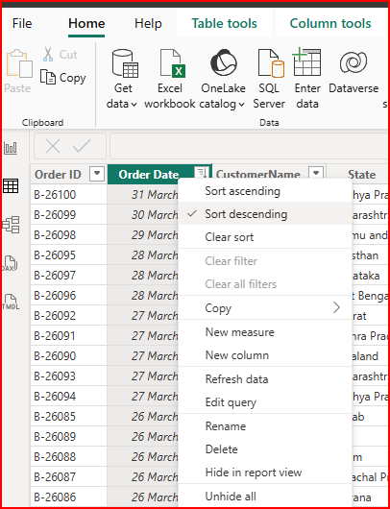
◆ Filter the orders to focus only on a specific state (e.g., Tamil Nadu) for regional analysis.

First select state column filter deselect all than select only Tamil Nadu
Step 1 Step 2
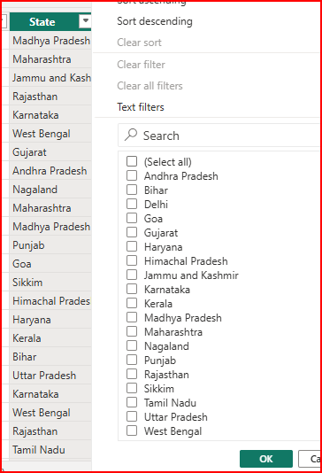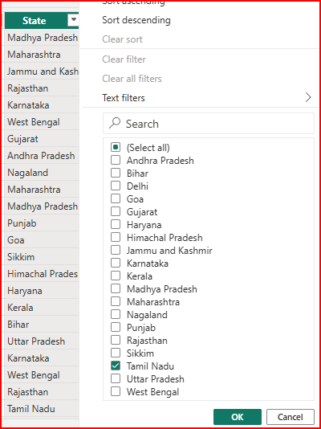

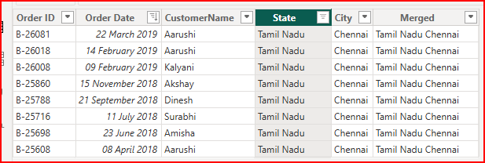

ONE TO MANY RELATION SHIP
