Bluestock Mutual Fund Analytics
Final Capstone Report
Prepared by: Vinod Kumar Vasantha
Date: August 2026
GitHub: vinodkumarvasantha/Mutual-Fund-Analytics

Table of Contents
Contents
1. Executive Summary 3
2. Data Sources 3
3. ETL Design 5
4. EDA Findings 6
5. Performance Analysis 7
6. Dashboard Screenshots 8
7. Limitations 10
8. Recommendations 11

Executive Summary

This report presents the findings of a comprehensive mutual fund analytics capstone project covering a universe of 40 Indian mutual fund schemes across Equity and Debt categories. The project combined data engineering, statistical performance analysis, and business intelligence dashboarding to evaluate fund performance, investor behavior, and industry trends over the period 2022–2026.

Using four years of daily NAV history, industry AUM data, SIP inflow trends, and investor transaction records, this analysis computed risk-adjusted performance metrics (Sharpe Ratio, Sortino Ratio), benchmark-relative measures (Alpha, Beta), and drawdown statistics for all 40 schemes. A composite 0–100 Fund Scorecard was developed to rank funds across five weighted dimensions: 3-year returns, Sharpe Ratio, Alpha, expense ratio, and maximum drawdown.

The top-performing funds by composite score were UTI Mid Cap Fund, HDFC Top 100 Fund, and Axis Small Cap Fund. Industry-level findings showed total AUM of approximately ₹62.74 lakh crore, monthly SIP inflows of ₹31,002 crore, and 26.12 crore investor folios as of the most recent reporting period.

A four-page interactive Power BI dashboard was built to make these findings accessible to non-technical stakeholders, covering industry overview, fund performance comparison, investor analytics, and SIP/market trend visualizations.

Data Sources

The analysis was built on ten structured datasets, each representing a distinct aspect of the mutual fund ecosystem:

1. Fund Master (01_fund_master.csv) — Scheme-level metadata for 40 funds including AMFI code, scheme name, category (Equity/Debt), sub-category, fund house, plan type, expense ratio, and benchmark index.

2. NAV History (02_nav_history.csv) — Daily Net Asset Value records for all 40 schemes from January 2022 to May 2026, totaling approximately 46,000 data points.

3. AUM by Fund House (03_aum_by_fund_house.csv) — Quarterly Assets Under Management and scheme counts, broken down by AMC.

4. Monthly SIP Inflows (04_monthly_sip_inflows.csv) — Industry-wide SIP inflow figures, SIP AUM, and year-over-year growth rates.

5. Category Inflows (05_category_inflows.csv) — Monthly net inflows by fund category (Large Cap, Mid Cap, Small Cap, Flexi Cap, ELSS, Debt categories, etc.) for FY24-FY25.

6. Industry Folio Count (06_industry_folio_count.csv) — Monthly investor folio counts, segmented by equity, debt, hybrid, and other categories.

7. Scheme Performance (07_scheme_performance.csv) — Pre-computed return, risk, Sharpe Ratio, and rating metrics per scheme.

8. Investor Transactions (08_investor_transactions.csv) — 32,778 individual transaction records including SIP, Lumpsum, and Redemption types, with investor demographics (state, city tier, age group, income).

9. Portfolio Holdings (09_portfolio_holdings.csv) — Fund portfolio composition snapshots.

10. Benchmark Indices (10_benchmark_indices.csv) — Daily closing values for seven market indices: Nifty 50, Nifty 100, Nifty Midcap 150, BSE Smallcap, Nifty 500, CRISIL Liquid, and CRISIL Gilt.

All data was provided in CSV format and represents a synthetic but realistic simulation of Indian mutual fund industry data, following AMFI conventions for scheme naming, NAV reporting, and categorization.

ETL Design

The data pipeline followed a structured Extract-Transform-Load approach:

Extract: Raw CSV files were ingested representing fund master data, live and historical NAV feeds, transactional records, and market benchmarks. A separate live NAV fetch script pulled real-time data from the mfapi.in public API for six sample schemes as a proof-of-concept for live data integration.

Transform: Data cleaning steps included forward-filling missing NAV values on non-trading days, validating date ranges for consistency across tables, flagging single-day return anomalies exceeding 20% (a data-quality safeguard), and converting text-based month fields into proper date types to support time-intelligence calculations.

Load: Cleaned data was loaded into two parallel destinations:
(a) A SQLite star-schema database with fact tables (fact_nav, fact_transactions, fact_performance, fact_aum) and dimension tables (dim_fund, dim_date), enabling efficient SQL-based analytical queries.
(b) A Power BI data model with a central Date dimension table (built via DAX CALENDAR function) connected to all date-based fact tables, and a shared amfi_code key linking fund-level tables (NAV history, scheme performance, transactions, portfolio holdings) back to the fund master dimension.

This two-destination approach allowed SQL-based ad-hoc analysis (ten analytical queries covering window functions, IQR-based anomaly detection, and net flow analysis) alongside interactive Power BI dashboarding for business-facing consumption.

EDA Findings

Fund Universe Composition: The 40-scheme universe skews heavily toward equity (34 schemes, 85%) versus debt (6 schemes, 15%). Within equity, Large Cap is the dominant sub-category (14 schemes), followed by Mid Cap (7) and Small Cap (6). Expense ratios across the universe range from 0.55% to 1.64%, consistent with typical Indian direct/regular plan structures.

Daily Return Distribution: Pooled daily returns across all 40 schemes were examined for data quality. No single-day moves exceeding 20% were detected, indicating a clean dataset free of stock-split-style anomalies or NAV recording errors. The distribution was approximately centered near zero with the expected fat-tailed shape typical of financial return series.

Industry Trends: Industry-wide AUM data (2022–2025) shows a generally upward trajectory, consistent with the broader growth narrative of Indian mutual funds during this period. SIP inflows reached ₹31,002 crore in the most recent month, reflecting continued retail participation via systematic investing. Total investor folios stood at 26.12 crore, split across equity (largest share), debt, hybrid, and other categories.

Category Inflow Patterns: Examining FY24–FY25 category-level net inflows revealed that certain categories (typically Flexi Cap, Mid Cap, and Small Cap in the broader Indian market context) tend to attract disproportionately higher net flows relative to their scheme counts, suggesting continued retail preference for higher-growth-potential categories during this period.

Investor Demographics: Transaction records (32,778 total) spanning 12 states, 5 age groups, and 2 city tiers (T30/B30) allowed segmentation of investment behavior. SIP transactions formed a distinct behavioral pattern compared to Lumpsum and Redemption activity, with variation in average ticket size observed across age groups.

Performance Analysis

Composite Fund Scorecard: The weighted 0–100 scorecard (30% 3yr return, 25% Sharpe, 20% Alpha, 15% expense ratio, 10% max drawdown) ranked UTI Mid Cap Fund (88.19), HDFC Top 100 Fund (88.13), and Axis Small Cap Fund (85.25) as the top three schemes overall. Notably, several top-ranked funds carried negative or modest raw 3-year returns, reflecting the composite methodology's emphasis on risk-adjusted quality (Sharpe, Alpha, cost efficiency) rather than raw return alone.

Sharpe Ratio Rankings: Mirae Asset Large Cap Fund led on risk-adjusted return (Sharpe 1.45), followed by Kotak Flexicap Fund (1.31) and Mirae Asset Tax Saver Fund (1.23), indicating these funds delivered the most favorable return-per-unit-of-volatility over the analysis window.

Alpha and Beta vs Nifty 100: SBI Small Cap Fund (30.3% annualized alpha), DSP Small Cap Fund (30.1%), and ICICI Pru Midcap Fund (29.3%) showed the strongest outperformance relative to the Nifty 100 benchmark. However, R-squared values across nearly all 40 funds were very low (well under 0.01 in most cases), indicating minimal statistical correlation between fund returns and the Nifty 100 benchmark in this dataset — a finding that warrants further validation against the source data, as real-world equity funds typically show much higher benchmark correlation (R-squared often 0.7+).

Maximum Drawdown: SBI Small Cap Fund (Direct Plan) recorded the deepest drawdown at -52.6%, with a prolonged decline from January 2023 to October 2025. Axis Small Cap Fund and ABSL Small Cap Fund followed with drawdowns of -51.7% and -35.4% respectively. Small Cap category funds were disproportionately represented among the worst drawdowns, consistent with their higher-volatility risk profile.

Tracking Error: Among the top 5 scorecard funds, tracking error against Nifty 100 ranged from 18.6% (Axis Bluechip Fund) to 29.3% (ABSL Small Cap Fund) on an annualized basis — relatively high figures that, combined with the low R-squared findings above, suggest these funds' return patterns diverge substantially from broad-market index movements in this dataset.

Dashboard Screenshots

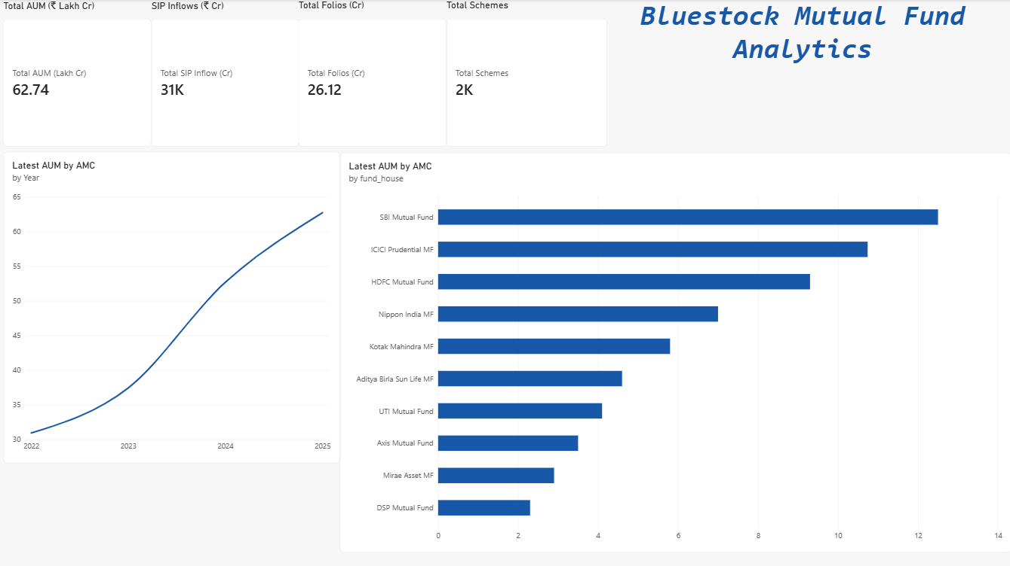

Figure 1: Industry Overview Dashboard

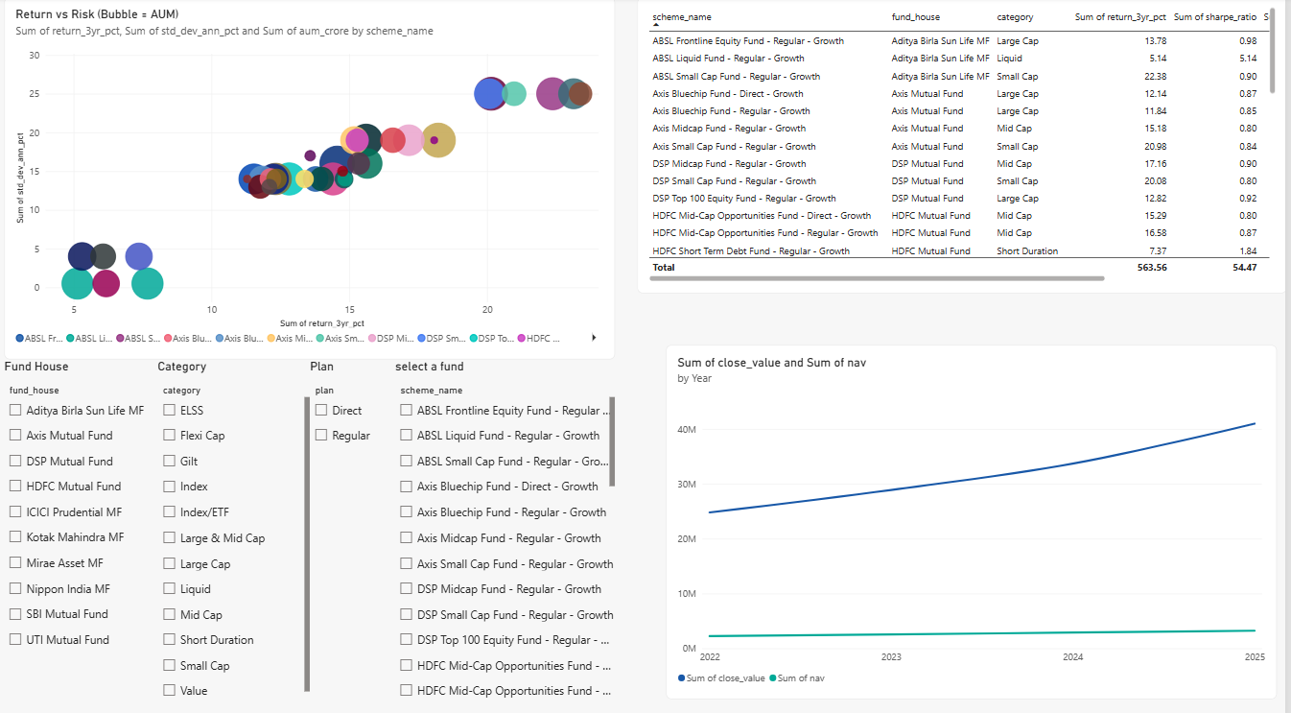
Figure 2: Page2_FundPerformance.png

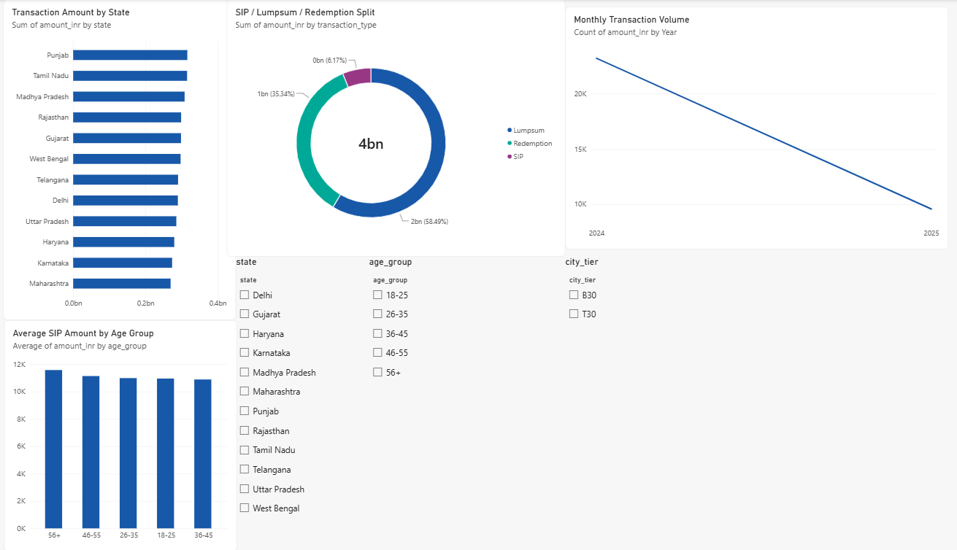
Figure 3: Page3_InvestorAnalytics.png

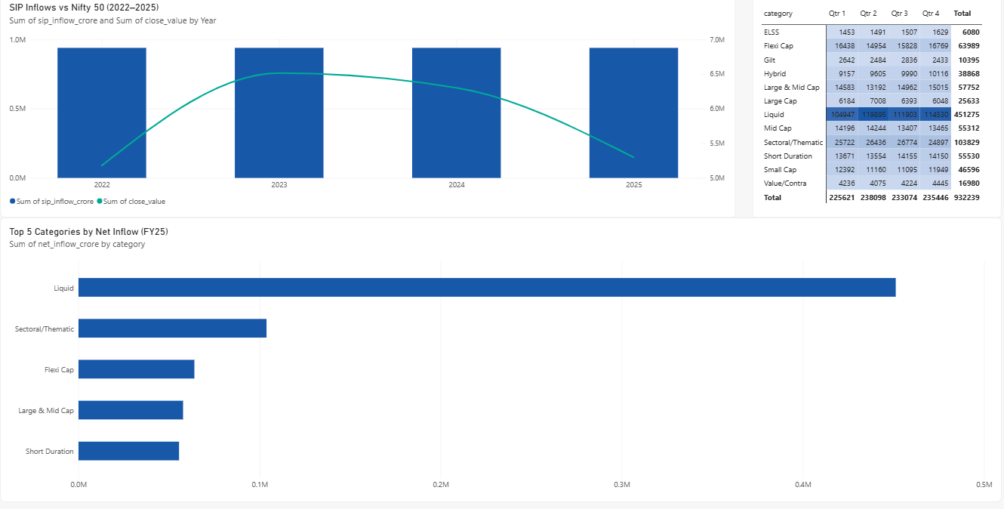
Figure 4: Page4_SIPMarketTrends.png

Limitations
Several limitations should be considered when interpreting this analysis:
Data Nature: The dataset used for this project, while structurally realistic and AMFI-consistent, is synthetic. Absolute figures (returns, AUM, alpha/beta values) should be treated as illustrative of methodology rather than as live market intelligence.

Low Benchmark Correlation: As noted in Section 5, R-squared values between fund returns and the Nifty 100 benchmark were unusually low across nearly all 40 schemes, including large-cap equity funds that would typically show strong benchmark tracking. This suggests either a data generation characteristic of the synthetic dataset or a data alignment issue that would benefit from further investigation before drawing real-world conclusions from alpha/beta figures.

Static Risk-Free Rate: The Sharpe and Sortino Ratio calculations used a fixed 6.5% annual risk-free rate (RBI repo rate proxy) for the entire analysis period. In reality, the repo rate fluctuated during 2022–2026, and a time-varying risk-free rate would produce more precise risk-adjusted metrics.

Survivorship and Scheme Coverage: The 40-scheme universe, while diverse across categories, represents a small subset of the 1,500+ schemes in the actual Indian mutual fund industry (per the AUM-by-fund-house data). Findings should not be generalized to the full industry.

Category Imbalance: The universe skews heavily toward equity (85%) versus debt (15%) funds, which may bias aggregate findings toward equity-market dynamics.

Recommendations
Based on the findings of this analysis, the following recommendations are proposed:

1. Validate Benchmark Data Alignment: Before using the alpha/beta figures for any investment decision-making, investigate the low R-squared values found across the fund universe — check for date misalignment, incorrect benchmark mapping per fund, or data generation artifacts in the source NAV/benchmark series.

2. Incorporate Time-Varying Risk-Free Rate: Future iterations of this analysis should pull historical RBI repo rate data month-by-month rather than using a single static rate, improving the precision of Sharpe and Sortino calculations.

3. Expand the Fund Universe: Extending analysis to a larger, more representative sample of schemes (or the full industry dataset) would improve the generalizability of category-level and demographic findings.

4. Automate Data Refresh: Given the live NAV fetch capability already built in Day 1 of this project (via the mfapi.in API), a scheduled refresh pipeline could keep the SQLite database and Power BI dashboard current without manual re-import.

5. Add Debt-Fund-Specific Benchmarking: Since 6 of the 40 schemes are Debt category funds, future work should benchmark them against CRISIL Gilt or CRISIL Liquid indices (already present in the dataset) rather than Nifty 100, for a more meaningful alpha/beta comparison.

6. Publish and Share the Dashboard: Publishing the Power BI dashboard to Power BI Service (free tier) would allow stakeholders to access live, interactive views without needing Power BI Desktop installed locally.

Appendix A: Methodology & Formulas

Daily Return: daily_return = (NAV_t / NAV_t-1) − 1

CAGR: CAGR = (NAV_end / NAV_start)^(1/n) − 1, where n is the holding period in years, calculated using the actual calendar-day span between the start and end dates.

Sharpe Ratio: Sharpe = (Rp − Rf) / σ(Rp) × √252, where Rp is the mean daily return, Rf is the daily risk-free rate (6.5% annual, RBI repo rate proxy), σ(Rp) is the standard deviation of daily returns, and √252 annualizes the ratio based on trading days per year.

Sortino Ratio: Same formula as Sharpe, but the denominator uses only the standard deviation of negative-return days (downside deviation), penalizing only harmful volatility rather than all volatility.

Alpha and Beta: Estimated via Ordinary Least Squares (OLS) linear regression of each fund's daily returns against the Nifty 100 benchmark's daily returns, using scipy.stats.linregress. Beta is the regression slope (sensitivity to benchmark movement); Alpha is the regression intercept, annualized by multiplying by 252 (representing return unexplained by benchmark movement).

Maximum Drawdown: For each point in time, drawdown = (NAV_t / running_maximum_NAV) − 1. Maximum drawdown is the most negative value of this series across the fund's full history, with peak and trough dates identified as the last all-time-high before, and the lowest point during, the decline.

Fund Scorecard: A composite 0–100 score computed as: 30% × percentile_rank(3yr CAGR) + 25% × percentile_rank(Sharpe Ratio) + 20% × percentile_rank(Alpha) + 15% × percentile_rank(inverse Expense Ratio) + 10% × percentile_rank(inverse Max Drawdown). Percentile ranks are calculated across all 40 schemes, with expense ratio and max drawdown inverted so that lower cost and shallower drawdown score higher.

Tracking Error: Calculated as the annualized standard deviation of the daily difference between fund returns and benchmark returns: tracking_error = σ(Rfund − Rbenchmark) × √252.

Appendix B: Complete Fund Scorecard (All 40 Schemes)

 | Overall  Rank | Category | Fund Score | CAGR 3yr | Sharpe | Alpha | Expense  Ratio | Max Draw down
UTI Mid Cap Fund - Regular - Growth | 1 | Equity | 88.1875 | -0.00767 | -0.20583 | 0.028969 | 1.51 | -0.28001
HDFC Top 100 Fund - Regular Plan - Growth | 2 | Equity | 88.125 | 0.012924 | -0.20152 | 0.037476 | 1.55 | -0.24734
Axis Small Cap Fund - Regular - Growth | 3 | Equity | 85.25 | -0.11703 | -0.07597 | 0.048016 | 1.38 | -0.51678
ABSL Small Cap Fund - Regular - Growth | 4 | Equity | 80.4375 | -0.04151 | 0.162661 | 0.108971 | 1.53 | -0.35447
Axis Bluechip Fund - Regular - Growth | 5 | Equity | 79.9375 | 0.005258 | 0.030785 | 0.068995 | 1.64 | -0.14402
SBI Small Cap Fund - Direct Plan - Growth | 6 | Equity | 78.5625 | -0.01337 | -0.05719 | 0.048824 | 0.72 | -0.52574
Kotak Emerging Equity Fund - Regular - Growth | 7 | Equity | 74.875 | 0.077542 | 0.076 | 0.078044 | 1.56 | -0.24004
HDFC Short Term Debt Fund - Regular - Growth | 8 | Debt | 70.625 | 0.039155 | -0.56709 | 0.042818 | 0.56 | -0.04308
ABSL Liquid Fund - Regular - Growth | 9 | Debt | 69.625 | 0.063143 | -0.81557 | 0.060861 | 0.79 | -0.00162
SBI Magnum Gilt Fund - Regular Plan - Growth | 10 | Debt | 68.75 | 0.05839 | -0.22658 | 0.056209 | 0.77 | -0.04329
Nippon India Gilt Securities Fund - Regular - Growth | 11 | Debt | 67.875 | 0.040613 | -0.35663 | 0.050748 | 0.55 | -0.08316
Nippon India Small Cap Fund - Regular - Growth | 12 | Equity | 64.1875 | 0.08006 | 0.448434 | 0.175007 | 1.53 | -0.23345
Kotak Bluechip Fund - Regular - Growth | 13 | Equity | 63.125 | 0.17263 | 0.494273 | 0.130429 | 1.59 | -0.17574
Kotak Liquid Fund - Regular - Growth | 14 | Debt | 61.375 | 0.066944 | -0.08875 | 0.064557 | 0.6 | -0.00116
HDFC Mid-Cap Opportunities Fund - Direct - Growth | 15 | Equity | 60.375 | 0.112425 | 0.300612 | 0.119891 | 0.78 | -0.21117
DSP Top 100 Equity Fund - Regular - Growth | 16 | Equity | 58.8125 | 0.180397 | 0.464037 | 0.131732 | 1.54 | -0.14845
UTI Flexi Cap Fund - Regular - Growth | 17 | Equity | 56.3125 | 0.255497 | 0.619518 | 0.162113 | 1.64 | -0.2154
Axis Bluechip Fund - Direct - Growth | 18 | Equity | 54.875 | 0.208116 | 0.129614 | 0.082328 | 0.75 | -0.21751
ICICI Pru Liquid Fund - Regular - Growth | 19 | Debt | 54.5 | 0.073925 | 0.495723 | 0.067462 | 0.74 | -0.00098
ICICI Pru Value Discovery Fund - Regular - Growth | 20 | Equity | 51.375 | 0.184174 | 0.648879 | 0.162539 | 1.41 | -0.19826
Mirae Asset Emerging Bluechip Fund - Regular - Growth | 21 | Equity | 49.0625 | 0.147444 | 0.926287 | 0.20873 | 1.52 | -0.15273
ICICI Pru Bluechip Fund - Regular - Growth | 22 | Equity | 48.875 | 0.13975 | 0.797973 | 0.177033 | 1.42 | -0.13898
UTI Nifty 50 Index Fund - Regular - Growth | 23 | Equity | 47.5 | 0.196624 | 0.817099 | 0.170488 | 1.57 | -0.1086
Nippon India Large Cap Fund - Direct - Growth | 24 | Equity | 43.9375 | 0.210847 | 0.645207 | 0.156438 | 0.72 | -0.1863
Nippon India ETF Nifty 50 BeES | 25 | Equity | 43.5 | 0.200032 | 0.664857 | 0.151364 | 0.89 | -0.11651
HDFC Top 100 Fund - Direct Plan - Growth | 26 | Equity | 43.25 | 0.184299 | 0.77579 | 0.177298 | 0.92 | -0.152
SBI Bluechip Fund - Direct Plan - Growth | 27 | Equity | 36.5 | 0.162634 | 0.953279 | 0.198686 | 0.66 | -0.11803
Nippon India Large Cap Fund - Regular - Growth | 28 | Equity | 35.9375 | 0.226466 | 1.081659 | 0.218294 | 1.51 | -0.17414
DSP Small Cap Fund - Regular - Growth | 29 | Equity | 35.8125 | 0.269935 | 0.949796 | 0.300579 | 1.52 | -0.31172
DSP Midcap Fund - Regular - Growth | 30 | Equity | 35.75 | 0.268631 | 1.132122 | 0.265986 | 1.61 | -0.17248
SBI Small Cap Fund - Regular Plan - Growth | 31 | Equity | 35.125 | 0.266631 | 0.945308 | 0.30337 | 1.43 | -0.28706
ABSL Frontline Equity Fund - Regular - Growth | 32 | Equity | 34.3125 | 0.289602 | 1.027213 | 0.213998 | 1.6 | -0.11292
Mirae Asset Tax Saver Fund - Regular - Growth | 33 | Equity | 28.8125 | 0.291714 | 1.23493 | 0.282704 | 1.6 | -0.16397
SBI Bluechip Fund - Regular Plan - Growth | 34 | Equity | 27.6875 | 0.304486 | 1.208267 | 0.23201 | 1.54 | -0.15012
Axis Midcap Fund - Regular - Growth | 35 | Equity | 25.5 | 0.351025 | 0.998231 | 0.260767 | 1.38 | -0.20961
ICICI Pru Bluechip Fund - Direct - Growth | 36 | Equity | 22.5 | 0.324789 | 1.026524 | 0.211948 | 0.8 | -0.12588
HDFC Mid-Cap Opportunities Fund - Regular - Growth | 37 | Equity | 21.75 | 0.32434 | 1.093699 | 0.271954 | 1.38 | -0.16217
Kotak Flexicap Fund - Regular - Growth | 38 | Equity | 20.5 | 0.295751 | 1.306744 | 0.273305 | 1.45 | -0.12974
ICICI Pru Midcap Fund - Regular - Growth | 39 | Equity | 20.25 | 0.317692 | 1.180101 | 0.292636 | 1.36 | -0.18189
Mirae Asset Large Cap Fund - Regular - Growth | 40 | Equity | 16.25 | 0.33992 | 1.448291 | 0.269838 | 1.46 | -0.11266

