**TAPCHAT : User-friendly App for Visually Impaired**

**COLLEGE :**UNIVERSITY OF KERALA, KARYAVATTOM CAMPUS

**BRANCH :**DEPARTMENT OF COMPUTATIONAL BIOLOGY AND BIO- INFORMATICS

**GUIDE :** Dr. BIJI C.L

**STUDENTS :** Ms. AMRUTHA P

Mr. VINOD M.P

Mr. AKHIL VASIM

Mr. AJAY PRADEEP

Ms. ATHIRA H

# Keywords:

Speech to Text, Text to Speech, Social media App, Speech Recognition

# Introduction:

Current social media apps primarily use text as a medium to communicate with others. There also exist other methods such as emojis and audio sharing. However, audio can have more potential among the differently-abled person. Visually impaired people who depend more on audio will find it helpful. We aim to increase audio usage in all the tasks done by the ordinary person so that the visually impaired can also use them. Currently, We planned this app in HTML. Android versions can also be made. Touch features are globally used rather than a specific point on the screen. Along with that, the text feature is also included for typing. By doing this, we are hoping for the best user-friendly app for visually impaired people.

# Objectives :

Specific point touch functions can be globally assigned so that the visually impaired can easily use the app without worrying about mistakes. Because everywhere, the command will work the same.

1. Create an app that mocks the currently famous chatting app with global control system
2. Implement audio response for every step performed in the app.

# Methodology :

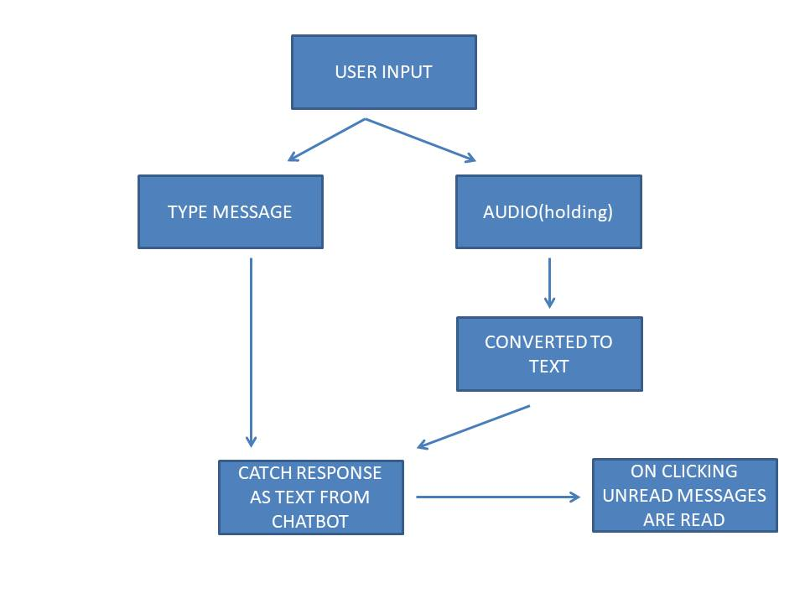

**Fig.1:Working Flowchart.**

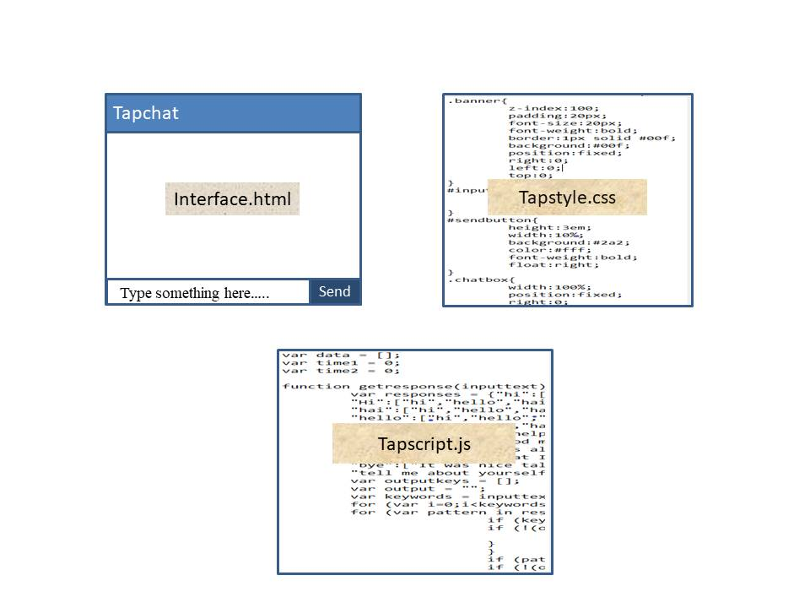

**Fig.2: Source Files**

The TAPCHAT have been framed with html for the layout and java script for logical processing. It is developed especially for visually impaired people. So it read unread message when clicking on the screen. A PC with microphone and speaker access is all needed for the working of the TAPCHAT. This application can also be implemented as android versions.

**Hardware Requirements:**

* PC with Microphone and Speakers

**Software Requirements:**

* Latest Internet browser
* HTML
* Javascript
* CSS

# Results and Conclusion :

1. The text messages are converted to audio messages and text can be generated using voice recognition.

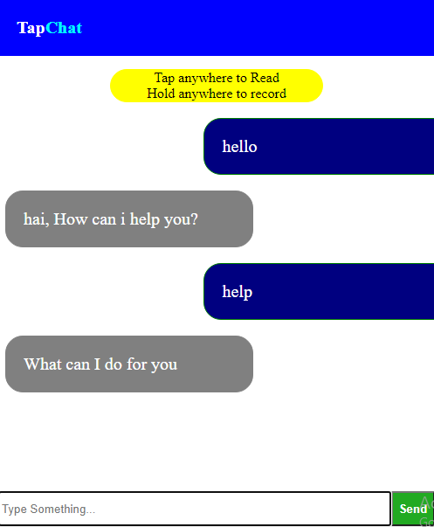

# Scope Or Future Work :

We have more ideas like implementing, scroll up to create beep sound in which number of beeps can be used by visually impaired to count how much message need to be read from the top.

# Applications of The Project:

1. Acts as an user-friendly medium for visually impaired people.
2. It can be implemented as android application.
3. Can be developed and modified further for making it available in other people also.