Secure boot, authentic boot & runtime integrity — TDA4VM ADAS ECU
Scope and terminology note: this document covers three related but distinct controls — Secure Boot (verify-and-enforce), Authentic/Measured Boot (measure-and-log), and Runtime Integrity Monitoring (continuous re-checking after boot, referred to here as "RTIC/RTMD"). "RTMD" is not a term verifiable against TI's public documentation the way DMSC/TIFS/SA2UL were — it is treated here as the industry-standard Runtime Integrity Checking (RTIC) concept, built from TDA4VM's known primitives (SA2UL hashing, NvM storage), not as a confirmed named TI silicon feature. Please correct the term if your course defines it differently.

0. Conceptual primer: three different controls, three different jobs
Before the formal cybersecurity engineering flow, it helps to be clear on what each control actually does, since they're easy to conflate:
- Secure Boot verifies each boot stage's signature/hash and halts or falls back immediately if verification fails. This is what TDA4VM actually implements (RBL → TIFS → SBL → application).
- Authentic (Measured) Boot verifies each stage too, but instead of halting on failure, it measures and records the result for a later verifier (local policy or remote attestation) to judge — trading immediate enforcement for flexibility.
- Runtime Integrity Monitoring (RTIC) is not a boot-time control at all — it runs after boot has already completed, periodically re-checking that code/critical data hasn't been tampered with while the system was running. Neither of the other two controls can see this class of tampering, because they only run once, at boot.
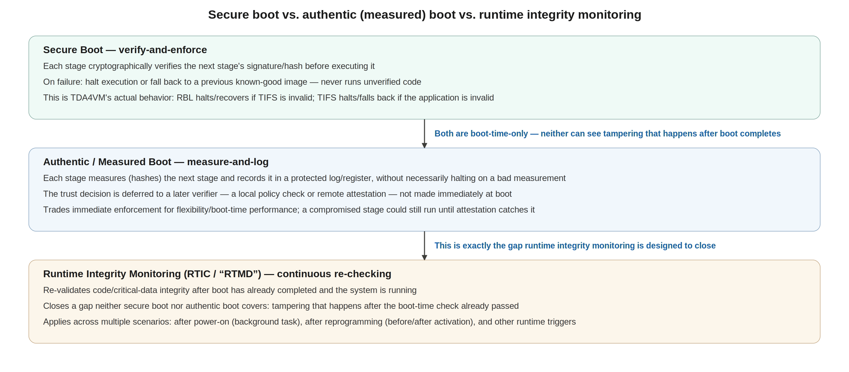
Figure 0 — Secure boot vs. authentic boot vs. runtime integrity monitoring

1. Cybersecurity engineering flow
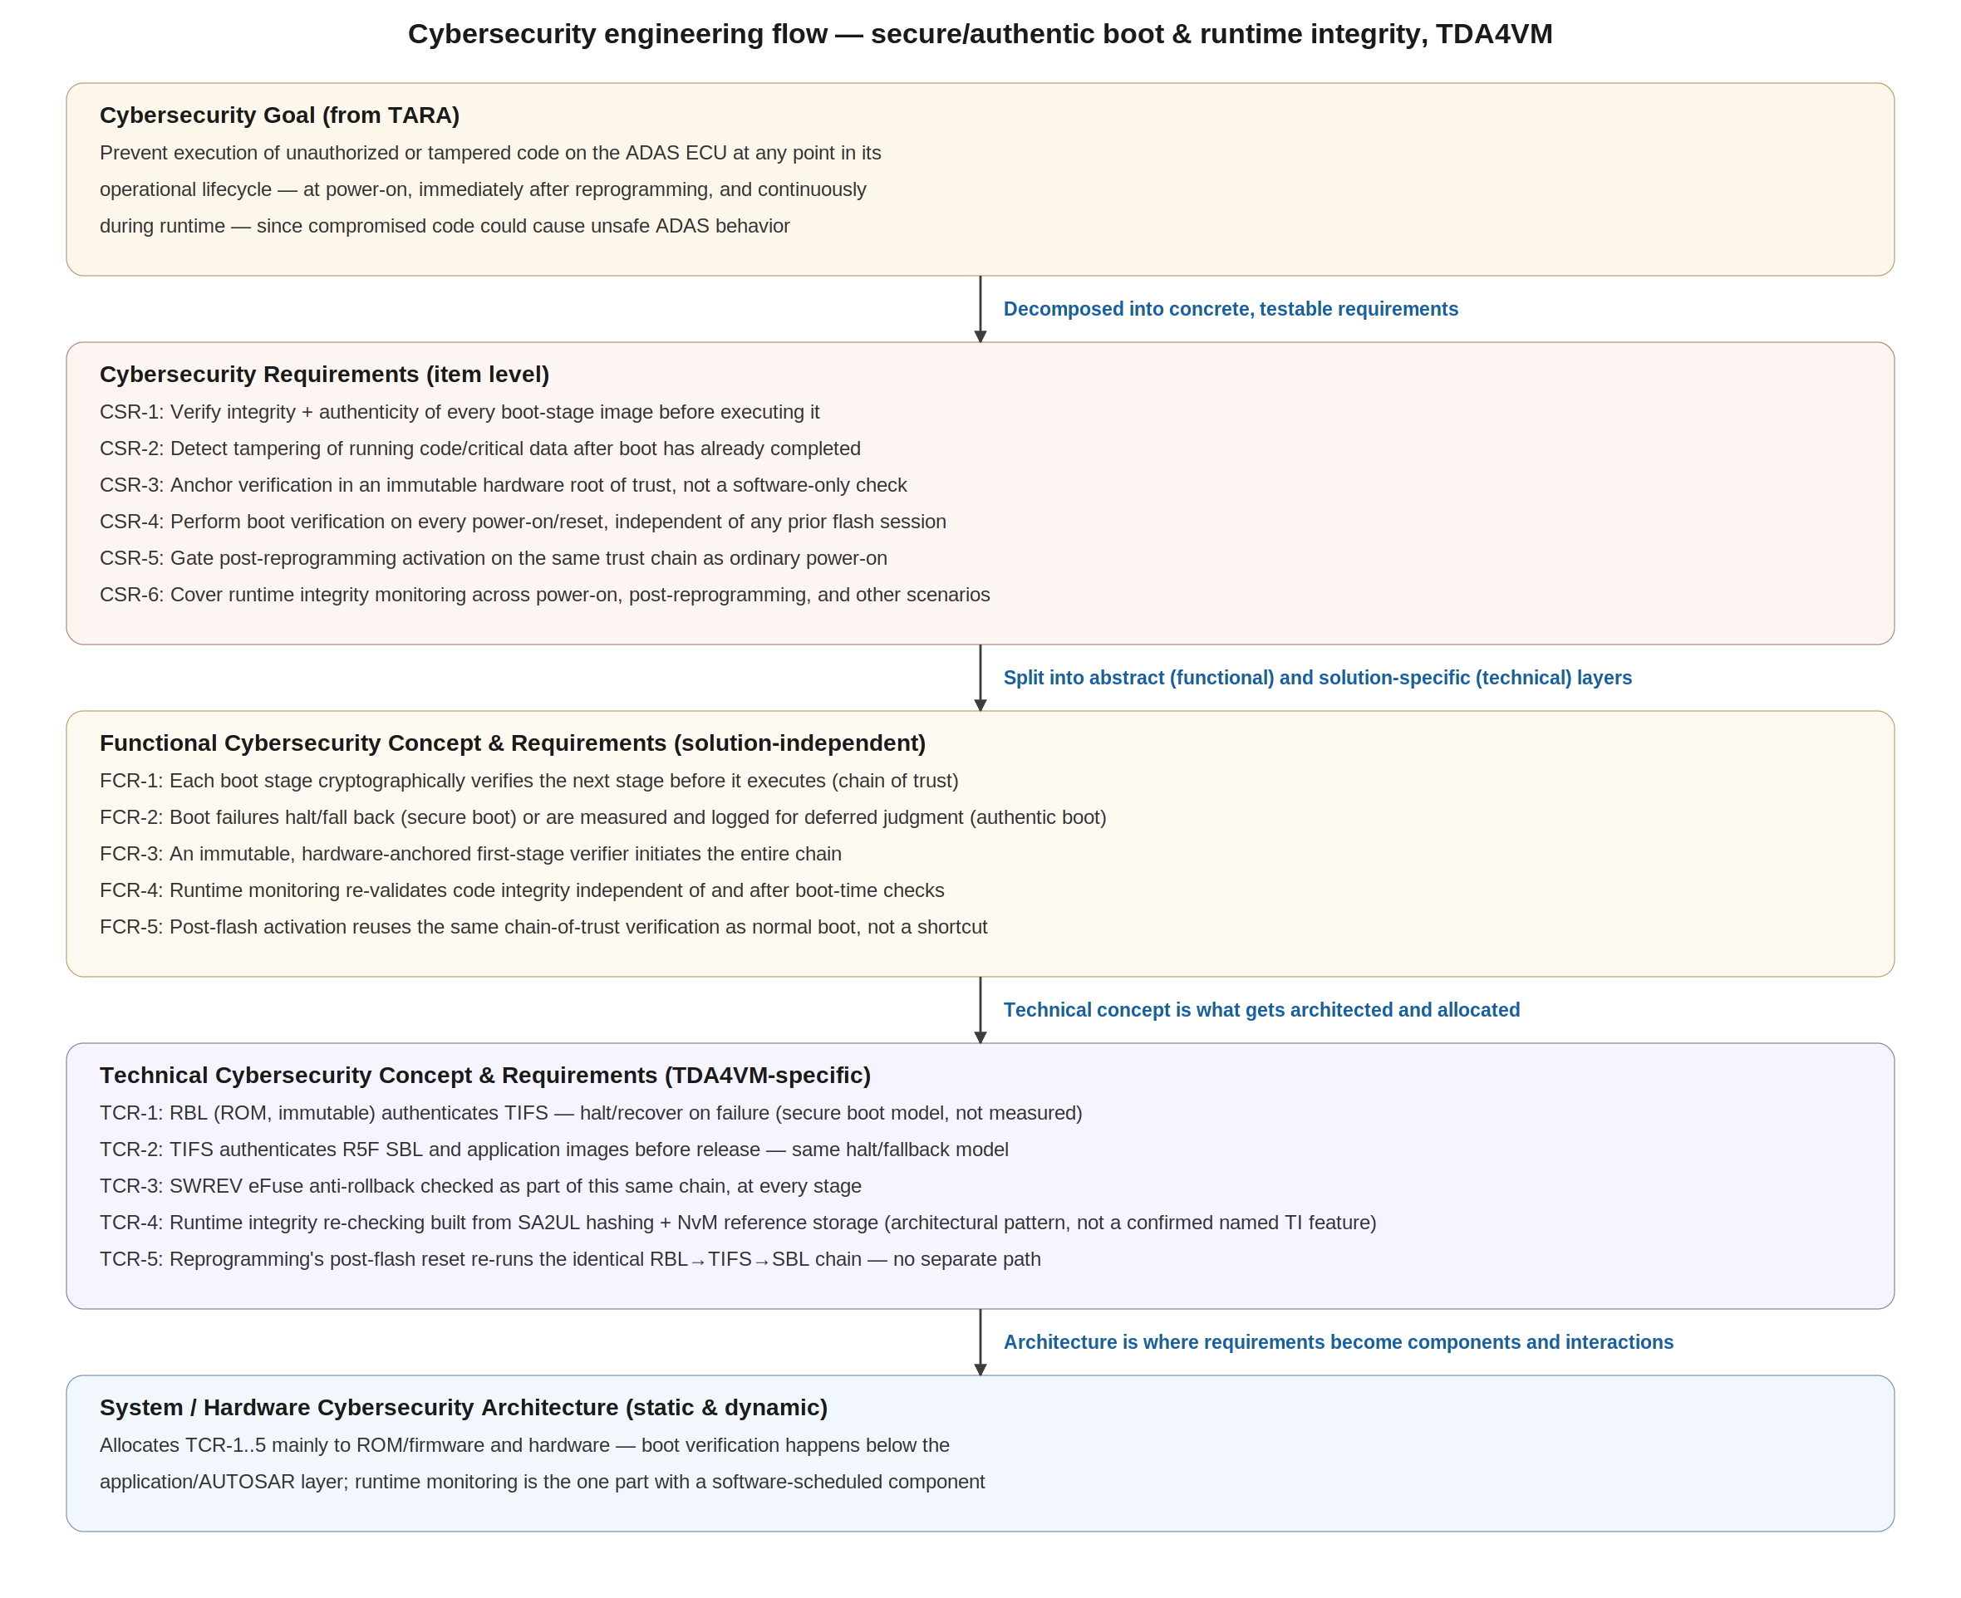
Figure 1 — Cybersecurity engineering flow for secure/authentic boot and runtime integrity

2. Cybersecurity Goal
Prevent execution of unauthorized or tampered code on the ADAS ECU at any point in its operational lifecycle — at power-on, immediately after reprogramming, and continuously during runtime — since compromised perception/planning code could cause unsafe ADAS behavior. This goal spans a wider time horizon than secure flashing alone: flashing protects the moment an image is installed, this goal protects every moment the ECU is powered.

3. Cybersecurity Requirements (item level)
- CSR-1: Verify integrity and authenticity of every boot-stage image before executing it.
- CSR-2: Detect tampering of running code/critical data after boot has already completed.
- CSR-3: Anchor verification in an immutable hardware root of trust, not a software-only check.
- CSR-4: Perform boot verification on every power-on/reset, independent of any prior flashing session.
- CSR-5: Gate post-reprogramming activation on the same trust chain used for ordinary power-on.
- CSR-6: Cover runtime integrity monitoring across power-on, post-reprogramming, and other operational scenarios.

4. Cybersecurity Concept

4.1 Functional Cybersecurity Concept & Requirements
- FCR-1: Each boot stage cryptographically verifies the next stage before it executes (chain of trust).
- FCR-2: Boot failures halt/fall back (secure boot) or are measured and logged for deferred judgment (authentic boot) — the strategy is a deliberate choice, not interchangeable defaults.
- FCR-3: An immutable, hardware-anchored first-stage verifier initiates the entire chain.
- FCR-4: Runtime monitoring re-validates code integrity independent of and after boot-time checks.
- FCR-5: Post-flash activation reuses the same chain-of-trust verification as normal boot, not a shortcut.

4.2 Technical Cybersecurity Concept & Requirements (TDA4VM-specific)
Functional req. | Technical realization on TDA4VM
FCR-1 / FCR-3 | RBL (ROM, immutable) is the first code executed at power-on; it authenticates TIFS via X.509 signature (SHA-256 + RSA-4K/ECC) before loading it. TIFS then authenticates the R5F SBL, and the SBL/TIFS chain authenticates application images before releasing R5F/A72.
FCR-2 | TDA4VM's documented behavior is secure boot proper (halt/fallback on failure) at every stage — not measured/authentic boot. Authentic-boot-style deferred attestation is presented here as an architectural option (e.g., writing stage hashes to a secure log for later remote attestation), not a feature confirmed in TI's public documentation.
FCR-4 | Built from available primitives: SA2UL SHA-256 hashing of a designated code/data region, compared against a reference value in NvM established at the last verified boot. This is the RTIC/"RTMD" pattern — an architecture applied to TDA4VM's primitives, not a named, confirmed TI silicon feature.
FCR-5 | The ECU reset that ends a flashing session (Section covered separately in the secure flashing document) triggers the identical RBL→TIFS→SBL chain — reprogramming does not get a separate, weaker verification path.

5. System Cybersecurity Architecture
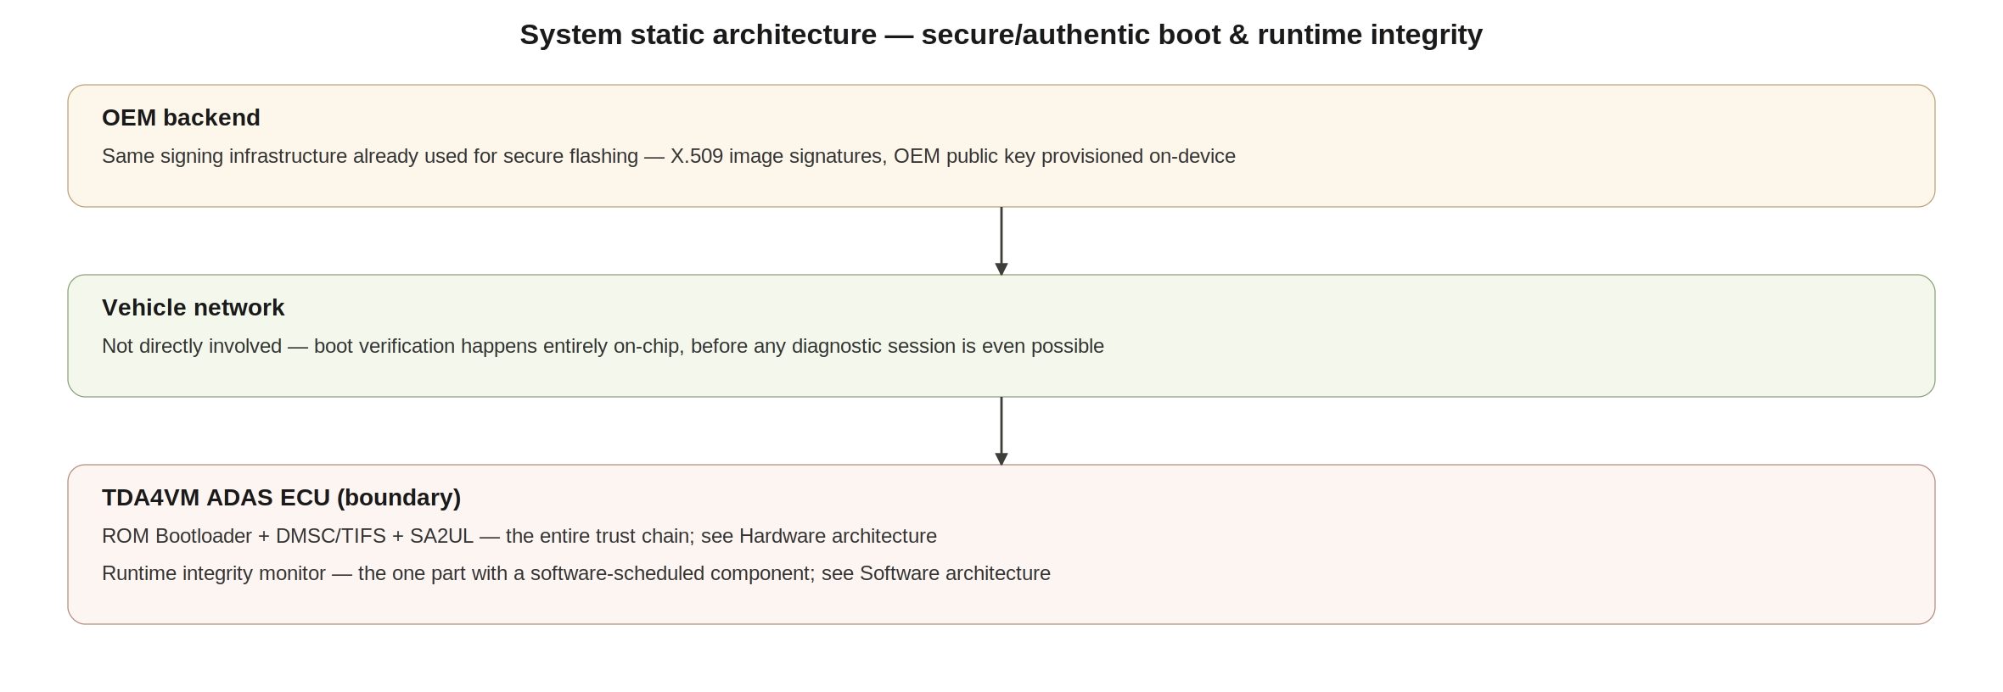
Figure 2 — System static architecture
This topic is almost entirely on-chip: unlike secure flashing or diagnostics, no tester or vehicle-network interaction is involved in boot verification itself — it completes before any diagnostic session is even possible. The OEM backend's role is limited to having already signed the images (the same signing infrastructure covered in the secure flashing document); there is no separate system-level dynamic flow to diagram here beyond that reuse.

6. SW Requirements & HW Requirements (allocated)

6.1 Software requirements
- A runtime monitor task shall be scheduled (periodically and/or on wake-from-low-power) to re-check the integrity of designated code/critical-data regions.
- The monitor shall not perform its own cryptographic operations directly — hashing shall be delegated to SA2UL, consistent with the delegation pattern used for flashing and diagnostics.
- The response to a detected integrity violation shall be a configured policy decision (safe degradation vs. forced reset), coordinated with the safety concept — not a default hard-coded action.

6.2 Hardware requirements
- The ROM Bootloader shall authenticate TIFS via X.509 signature on every power-on cycle, with no bypass path on HS-SE devices.
- TIFS shall authenticate each subsequent boot stage (SBL, application images) before releasing the corresponding core, and shall check the SWREV anti-rollback counter at each stage.
- SA2UL shall support both boot-time signature verification and lightweight runtime hash computation using the same hardware engine.
- No reset source (power-on, watchdog, software-triggered) shall bypass the boot verification chain; only a preserved-context low-power wake may not trigger a full re-verification, and this must be explicitly confirmed per low-power mode.

7. Software Architecture
As with the JTAG/debug topic, there is limited application-software architecture for secure/authentic boot itself — that verification happens in ROM/TIFS, below the AUTOSAR layer. The one genuine software-architecture component this topic introduces is the runtime integrity monitor, covered below.
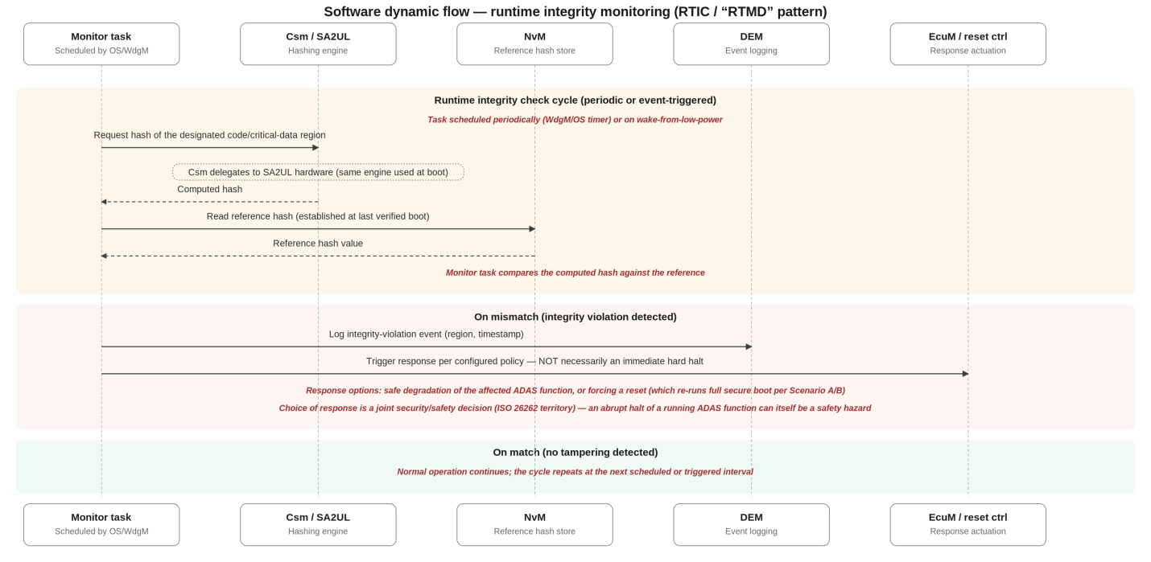
Figure 3 — Software dynamic flow: runtime integrity monitoring cycle
Note the asymmetry deliberately built into this flow: the monitor performs a cheap hash comparison against an already-established reference, not a full signature re-verification. That's not a shortcut — it's correct given what's actually needed here (see Section 8.2). It's also why the response to a violation is a policy decision rather than an automatic hard halt: unlike a boot-time failure (where nothing is running yet, so halting is safe), a runtime violation means an ADAS function is already active, and abruptly stopping it can itself create a safety hazard. This is a genuine security/safety trade-off, not a purely security-driven choice.

8. Hardware Architecture

8.1 Hardware static architecture
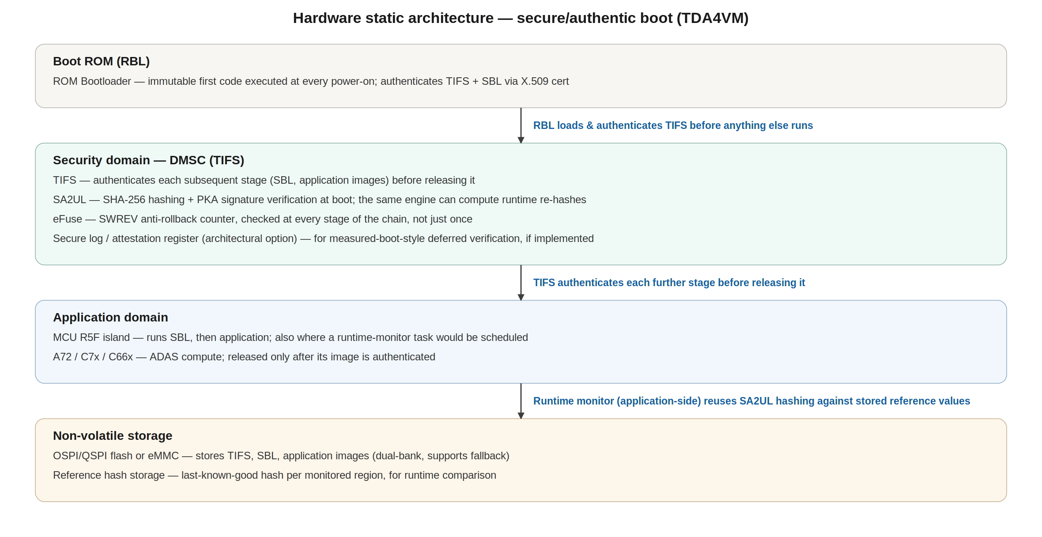
Figure 4 — Hardware static architecture

8.2 Hardware dynamic architecture: three scenarios
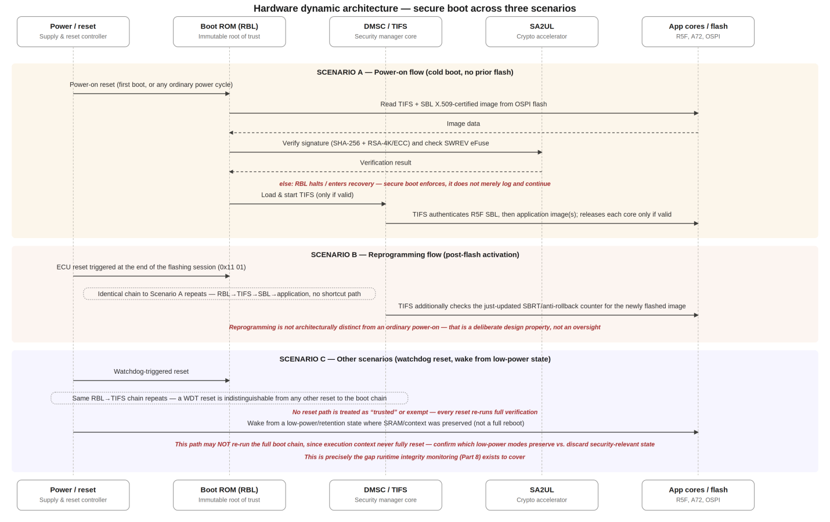
Figure 5 — Hardware dynamic architecture across power-on, reprogramming, and other scenarios
Scenario A (power-on) and Scenario B (reprogramming) are architecturally identical — the second is not a special case of the first, it IS the first, triggered by a different event. This is deliberate: giving reprogramming a distinct, possibly weaker verification path would be a real vulnerability, since it would mean the one moment attackers most want to compromise (right after a flash) is checked less rigorously than every other boot.
Scenario C is where this document earns its keep beyond restating the flashing document's boot chain: a watchdog reset behaves identically to any other reset (full re-verification, no exceptions) — but a wake from a low-power/retention state, where execution context was preserved rather than fully reset, may not re-run the boot chain at all. That gap is not a flaw to be silently accepted or a reason to distrust the architecture — it's the specific, concrete reason Section 7's runtime integrity monitoring exists as a separate control rather than being redundant with secure boot.

