GRAPHICAL PASSWORD BASED TO AVOID SHOULDER SURFING
A

PROJECT REPORT

on

SWE4099-Co-op/Capstone Project

Submitted in partial fulfilment for the award of the degree of
M-Tech
in
Software Engineering
by
Name of the Student | Registration Number:
S. Vinod Kumar Reddy | 16MIS0336

Under the guidance of

Prof. Gundala Swathi



School of Information Technology and Engineering Department of Software and Systems Engineering
March 2021

School of Information Technology and Engineering Department of Software and Systems Engineering

DECLARATION BY THE CANDIDATE

I hereby declare that theSWE4099-Co-op/Capstone Project report entitled “GRAPHICAL PASSWORD BASED TO AVOID SHOULDER SURFING” submitted by me to VIT, Vellore, in partial fulfillment of the requirement for the award of the degree of M-Tech (Software Engineering) is a record of bonafide carried out by me under the guidance of Prof.Gundala Swathi. I further declare that the work reported in this project has not been submitted and will not be submitted, either in part or in full, for the award of any other degree in this institute or any other institute or university.

Place: Vellore

Date: 06/08/2021

S. Vinod Kumar Reddy(16MIS0336)

Signature of the Candidate

School of Information Technology and Engineering Department of Software and Systems Engineering

BONAFIDE CERTIFICATE

This is to certify that the SWE4099-Co-op/Capstone Project report entitled “GRAPHICAL PASSWORD BASED TO AVOID SHOULDER SURFING” by S. Vinod Kumar Reddy(16MIS0336) to VIT,Vellore, in partial fulfillment of the requirement for the award of the degree of M-Tech (Software Engineering) is a record of bonafide work carried out by him /her under my guidance. The project fulfills the requirements as per the regulations of this Institute and in my opinion meets the necessary standards for submission. The contents of this report have not been submitted and will not be submitted either in part or in full, for the award of any other degree or diploma in this institute or any other institute or university.

Signature of Internal Guide

ABSTRACT

Since conventional password schemes are vulnerable to shoulder surfing, many shoulder surfing resistant graphical password schemes have been proposed. As most users are more familiar with textual passwords than pure graphical passwords, textbased graphical password schemes have been proposed. None of existing text-based shoulder surfing resistant graphical password schemes is both secure and efficient enough. we propose an improved text-based shoulder surfing resistant graphical password scheme by using colours. In the proposed scheme, the user can easily and efficiently login system. Next, we analyze the security and usability of the proposed scheme, and show the resistance of the proposed scheme to shoulder surfing and accidental login. To Overcome the Problem of Existing Graphical Password Scheme, Textual Password Scheme and text based shoulder surfing resistant graphical password Scheme, the Improved Text and Colour Based Graphical Password Scheme to reduce Shoulder Surfing Attack is Proposed. Using this Scheme user can efficiently login the system. The proposed scheme is used to reduce the Shoulder surfing attack and it will improve the security of existing Applications. By proposing an efficient authentication scheme for preventing shoulder surfing attacks (EASPSS), a numeric keypad based authentication method that operates on devices. EASPSS uses the technique of hybrid images to blend two keypads. The user who is close to the device is seeing one keypad to enter the numeric password, while the attacker who is looking at the device from a bigger distance is seeing the other keypad. The user’s keypad is shuffled in every authentication attempt since the attacker may memorize the spatial arrangement of the pressed digits with otp for the secured validation for the user.

LITERATURE SURVEY

Leon Bošnjak[1] considering confirmation strategies' strength against shoulder riding assaults has become a need while assessing novel literary and graphical plans. Analysts rush to announce their new strategy safe against these assaults, while giving little consideration to how the acquired outcomes were estimated and whether they are equivalent to those of different techniques. In this work, we feature these issues and build up an answer: an outfit of weakness measurements evaluating strategies' helplessness to bear riding assaults. We accept our methodology gives knowledge into how shoulder riding tests could be improved later on.

Leon Bošnjak[2] Shoulder surfing is an assault vector broadly perceived as a genuine danger - enough to warrant analysts committing an extensive exertion toward planning novel verification techniques to be shoulder riding safe. Regardless of a huge number of proposed arrangements throughout the long term, few have utilized exact assessments and examinations between various techniques, and our comprehension of the shoulder riding wonder stays restricted. Excepting the difficulties in exploratory plan, the purpose behind that can be principally credited to the absence of target and equivalent weakness measures. In this paper, we build up a gathering of weakness measurements, a first undertaking toward a thorough evaluation of a given technique's helplessness to observational assaults. In the biggest on location shoulder riding test (n = 274) until this point in time, we confirm the model on four adroitly unique validation techniques in two perception situations. On the case of a novel half breed confirmation strategy dependent on affiliations, we 4 investigate the impact of info type on the enemy's viability. We give first observational proof that graphical passwords are simpler to watch; in any case, that doesn't really imply that the watched data will permit the assailant to figure the casualty's secret word simpler. An inside and out examination of individual measurements inside the bunches offers knowledge into numerous extra parts of the shoulder riding assault not investigated previously. Our relative system makes a progression in assessment of shoulder surfing and facilitates our comprehension of observational assaults. The outcomes have significant ramifications for future shoulder riding contemplates and the field of Password Security all in all.

Peng Foong Ho,1 Yvonne Hwei-Syn Kam,2 Mee Chin Wee,1 Yu Nam Chong,1 and Lip Yee Por [3] In this paper, a new search metrics picture-based password authentication method that is resistant to shoulder-surfing attack was proposed. The proposed method uses a concept of concealing password information as much as possible from prying eyes. On top of concealing the password images (which gives the proposed method its shoulder-surfing resistant properties) and the amount of password images, the proposed method also conceals whether the user input is a password picture or a distracter picture. A simulation was conducted to find out the final “target” pictures that are also password pictures and the distribution of these final “target” pictures in a 5 × 5 grid. The result of the simulation shows that the final “target” picture selected using the proposed algorithm is random and it does not bias towards the selection of a password picture to become the final “target” picture. Moreover, the final “target” pictures generated by the proposed algorithm are distributed across all the grid locations. This means that the proposed method is able to resist the frequency of occurrence analysis and location detection analysis attacks. A user study was conducted. The result shows that the proposed method is able to resist shoulder-surfing attack.

Mrs.Aakansha S. Gokhalea, Prof. Vijaya S.Waghmareb [4] these days PC just as data security is the most critical test. Approved clients should get to the framework or on the other hand data. Approval can't happen without verification. For this confirmation different strategies are accessible. Among them the most well known and simple is the secret phrase method. Secret word guarantees that PC or data can be gotten to by the individuals who have been allowed option to view or access them. Customary secret word method is a literary secret key which is likewise called alphanumeric secret key. Yet, these printed passwords are anything but difficult to break through different kinds of assault. So to defeat these weaknesses, a graphical secret key strategy is presented. As name proposes in this strategy (pictures) are utilized as a secret key rather than text. Likewise mental examination says that human can without much of a stretch recollect pictures than text. So as indicated by this reality, graphical passwords are anything but difficult to recall and hard to figure. But since of realistic nature, 5 essentially all the graphical secret word methods are defenceless against shoulder riding assault. So here, another graphical secret phrase verification strategy is proposed which is impervious to bear surfing and furthermore different kinds of potential assaults somewhat. It is a mix of acknowledgment and review based methodology. It very well may be helpful for brilliant held gadgets like advanced cells, PDA, iPod, iPhone and so forth

Jiang P, Wen Q Y, Li W M, Jin Z P, Zhang H [5] in this paper, another plan that utilizes digraph replacement rules to disguise the system or action needed to determine secret key pictures is proposed. In the proposed strategy, a client is just needed to tap on one of the pass-picture rather than both pass-pictures appeared in each challenge set for three successive sets. While this movement is sufficiently basic to lessen login time, the pictures clicked have all the earmarks of being irregular and must be gotten with complete information on the enrolled secret key alongside the action rules. Along these lines, it gets inconceivable for shoulder-riding aggressors to get the data about which secret key pictures and pass-pictures are utilized by the client. In spite of the fact that the aggressors may think about the digraph replacement rules utilized in the proposed strategy, the situation data utilized in each challenge set remains. Client study results uncover a normal login cycle of not exactly a large portion of a moment. Moreover, the proposed strategy is impervious to bear riding assaults.

SYSTEM REQUIREMENTS

The following are the system requirements for this project:
1. Software requirements
2. Hardware requirements

SOFTWARE REQUIREMENTS:
The software requirements document is the specification of the system. It should include both a definition and a specification of requirements. It is a set of what the system should do rather than how it should do it. The software requirements provide a basis for creating the software requirements specification. It is useful in estimating cost, planning team activities, performing tasks and tracking the teams and tracking the team’s progress throughout the development activity.

Operating System: Windows
Technology: Java and J2EE
Web Technologies: Html, JavaScript, CSS
IDE : My Eclipse
Database : My SQL
Java Version : J2SDK1.5

HARDWARE REQUIREMENTS :
The hardware requirements may serve as the basis for a contract for the implementation of the system and should therefore be a complete and consistent specification of the whole system. They are used by software engineers as the starting point for the system design. It shows what the system does and not how it should be implemented.

Hardware - Pentium
Speed - 1.1 GHz
RAM - 1GB
Hard Disk - 20 GB

DETAILED DESIGN:

1. System Architecture:
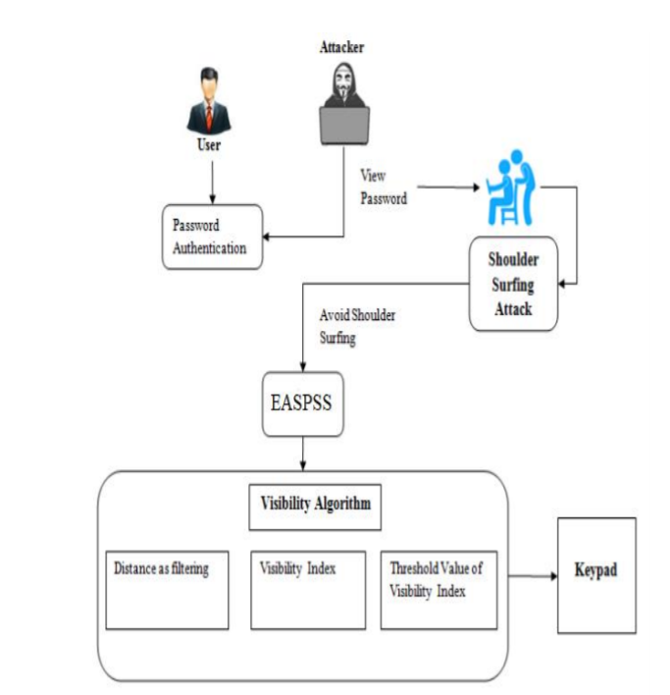

UML Diagrams

1. Class Diagram:
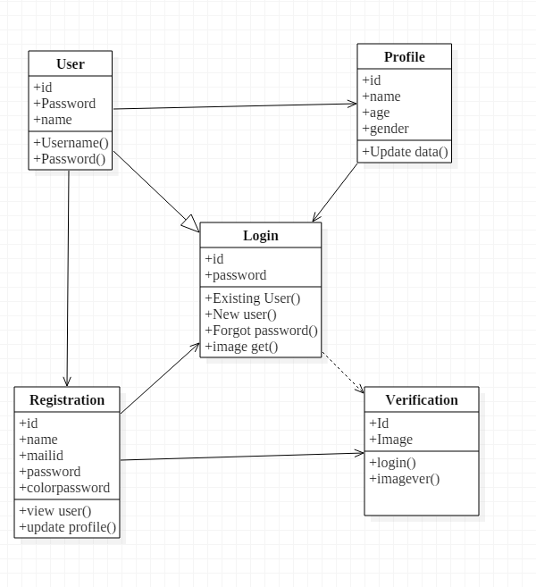

2. USE CASE DIAGRAM:
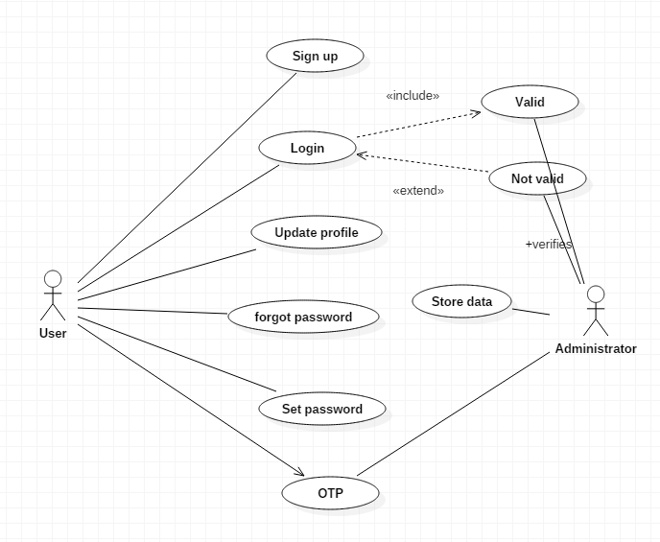

3. SEQUENTIAL DIAGRAM:
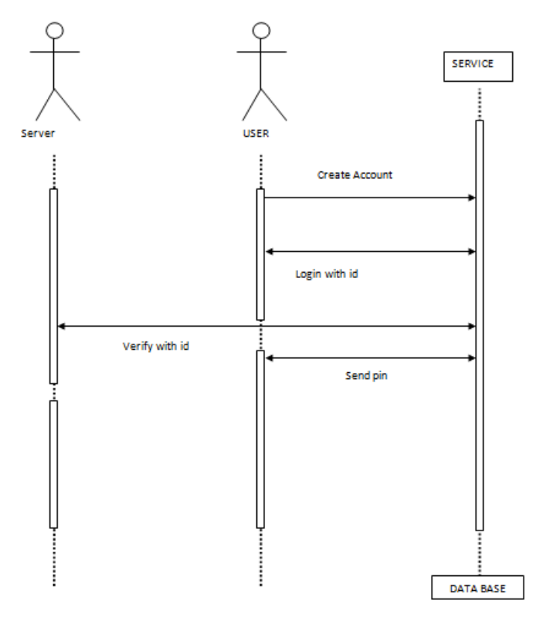
4. ACTIVITY DIAGRAM:
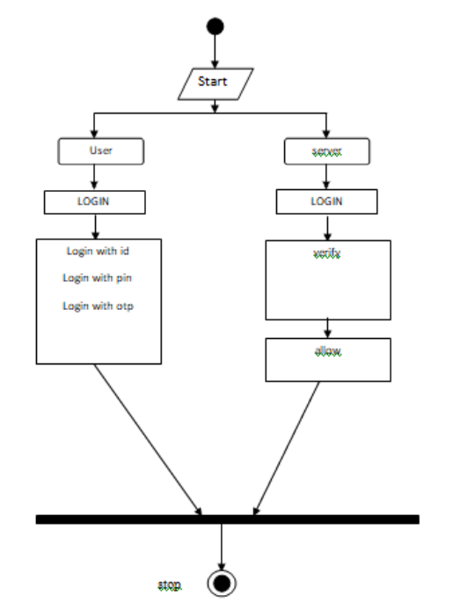

Module Description

LIST OF MODULES
This Scheme consists of five modules
• Holder account application Module
• OTP Generation Module
• Virtual keyboard Module
• Login
• Registration

Holder account application Module: In this module the holder is going to create an account with some system mandatory field, these fields are used in further upcoming process. This module is like a privilege form to get an action in application service.

OTP Generation Module: One Time Password is generated by using Random Generation Algorithm which is sent to account holder’s mail when the card is going to be swiped. This will enhance the additional security level in ATM transaction.

Virtual keyboard Module: We create the alternate solution for security in ATM PIN ENTRY Method by generation of virtual keyboard. In this key board we implement random keys using Shuffling algorithm at the transaction of every time.

Login Module: This module consists of user name and password which enables the user to open their account. If user name and password doesn’t match it shows as invalid login details.

Registration Module: user is going to create an account with some system mandatory field; these fields are used in further upcoming process. This module is like a privilege form to get an action in application service.

DATA FLOW DIAGRAMS
1. USER LOGIN:

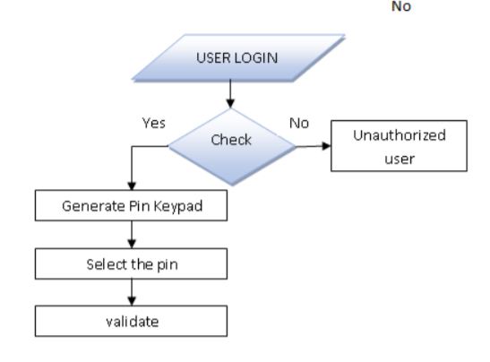
2. WEB SERVER:
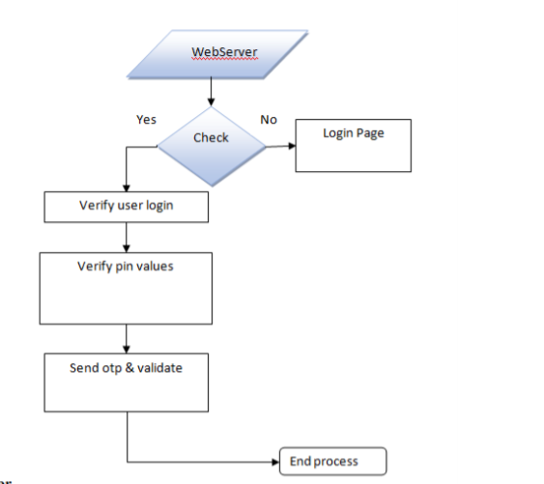

3. DEPLOYMENT DIAGRAM:
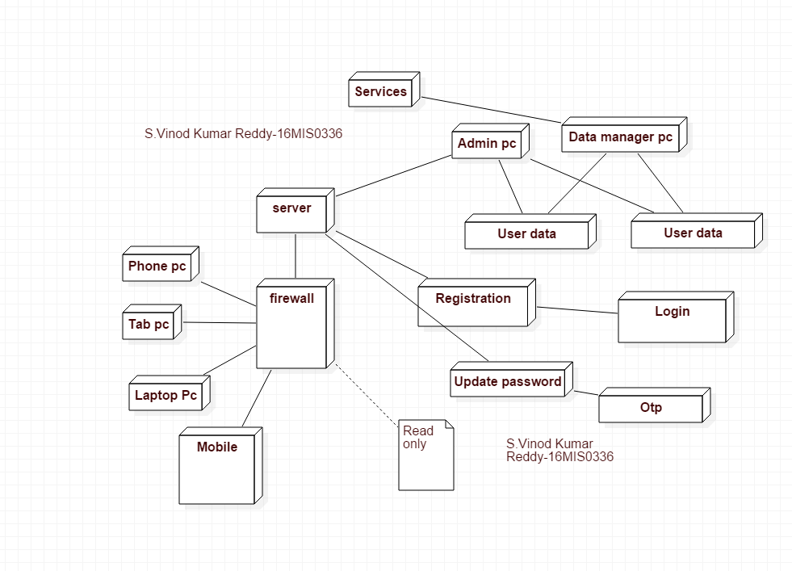

References:
[1] Bošnjak, Leon & Brumen, Boštjan. (2018). Improving the Evaluation of Shoulder Surfing Attacks. 1-2. 10.1145/3227609.3227687.

[2] Bošnjak, Leon & Brumen, Bostjan. (2019). Shoulder Surfing: From An Experimental Study to a Comparative Framework.

[3] http://dx.doi.org/10.1155/2014/838623

[4] http://creativecommons.org/licenses/by-nc-nd/4.0/

[5] Jiang P, Wen Q Y, Li W M, Jin Z P, Zhang H. An anonymous and efficient remote biometrics user authentication scheme in a multi server environment. Frontiers of Computer Science, 2015, 9(1): 142–156

[6] iswas Gurung, P. W. C. Prasad, Abeer Alsadoon, Amr Elchouemi, "Enhanced Virtual Password Authentication Scheme Resistant to Shoulder Surfing", Soft Computing and Machine Intelligence (ISCMI) 2015 Second International Conference on, pp. 134-139, 2015

***THANK YOU***

