**Sales Return System**

The application works on selection of following 3 major fields that is - 1. Select Depot Name + Code

1. Select Dealer Name + Code
2. Reason of Return.

**Masters created / required as per the flow:**

1. Admin Master
2. Approval Matrix
3. Sales Return Reason (defined at Admin label)
4. Sales Return Reason (master for sub-reasons pre - defined against the Reasons for Depot)
5. Employee Master (to manage the employee as per the flow again specific Depot Name).

**Steps / Flow Process for Sales Return System:**

*Step 1* - First of all fill up the Masters detail for defining the Depot, Dealer, Employee, and Admin from login through 0 in lfg.

*Step 2* - The request form needs to be filled up to process the return request of the sold product.

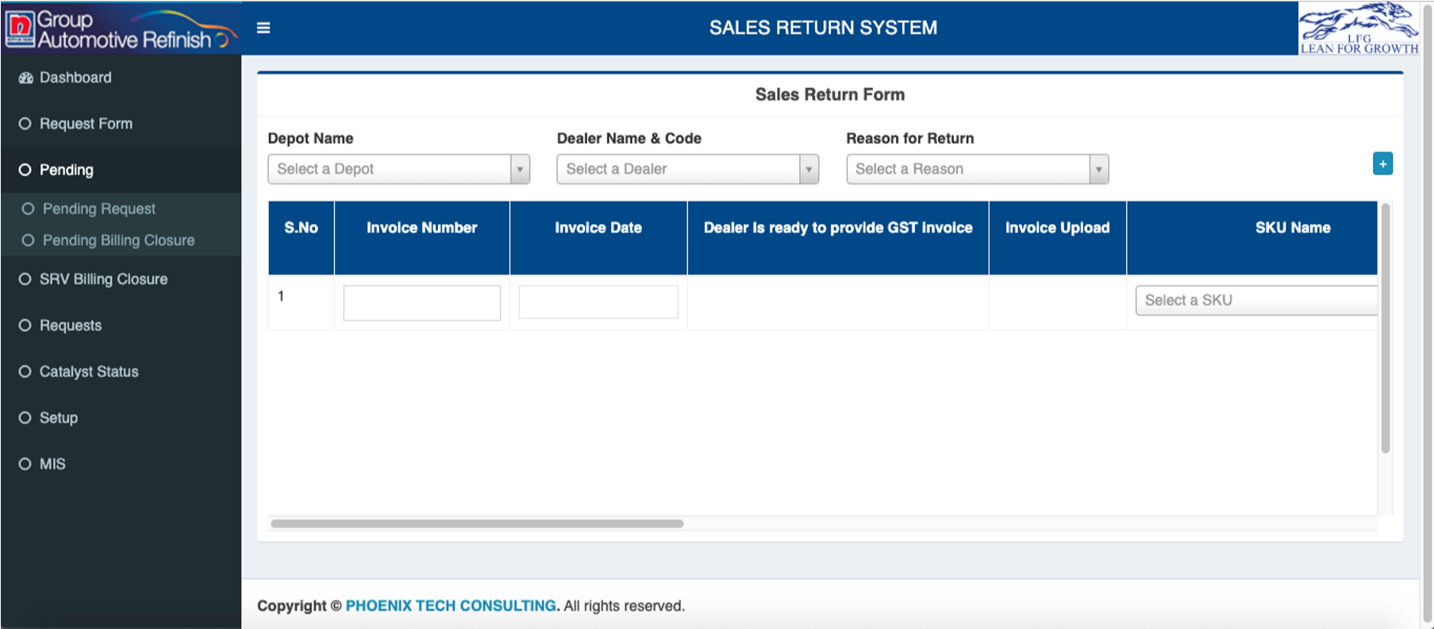

**Flow of Create Request:**

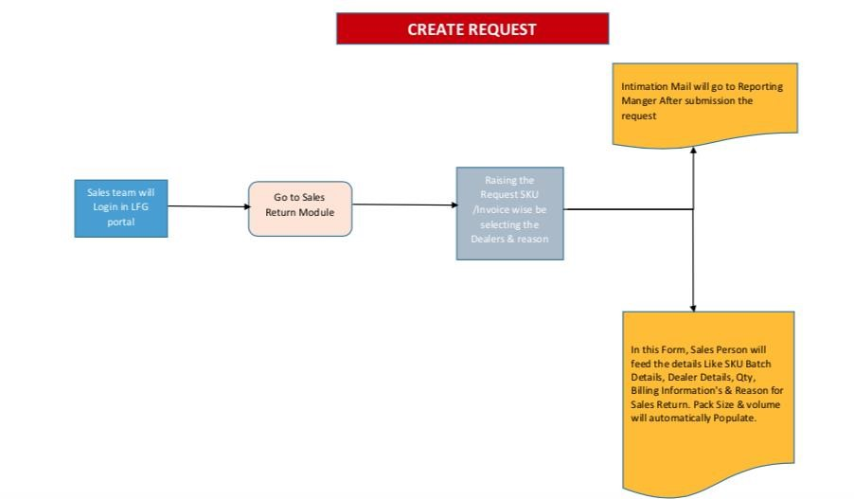

**Explanation of the Create Request Flow:**

The user will login from LFG and then it access the Sales Return Application under AMS.

After accessing user need to access the Sales return request form. The user will fill up all the required fields and the process work on basis of **Invoice ->** **SKUName** -> **SKU Code** -> **Batch No.**

Special points::

1. The Customer Complain no will come only for Quality Reason.
2. If user doesn’t select yes or no for - Dealer is ready to provide GSt then blank must be displayed.
3. Invoice Upload - file size must be defined and limit also.
4. Shelf life - must be calculated as per the logic of Current date - Manufacturing Date and converted into counts.
5. SRV quantity - SRV Quantity cannot be more than Invoice Quantity.
6. Volume = SRV Quantity * Pack size

**APPLICATION FLOW**

**Prerequisites** - All the flow works once the specific masters updated and the values assigned in approval matrix.

**Flow for Quality Reason:** 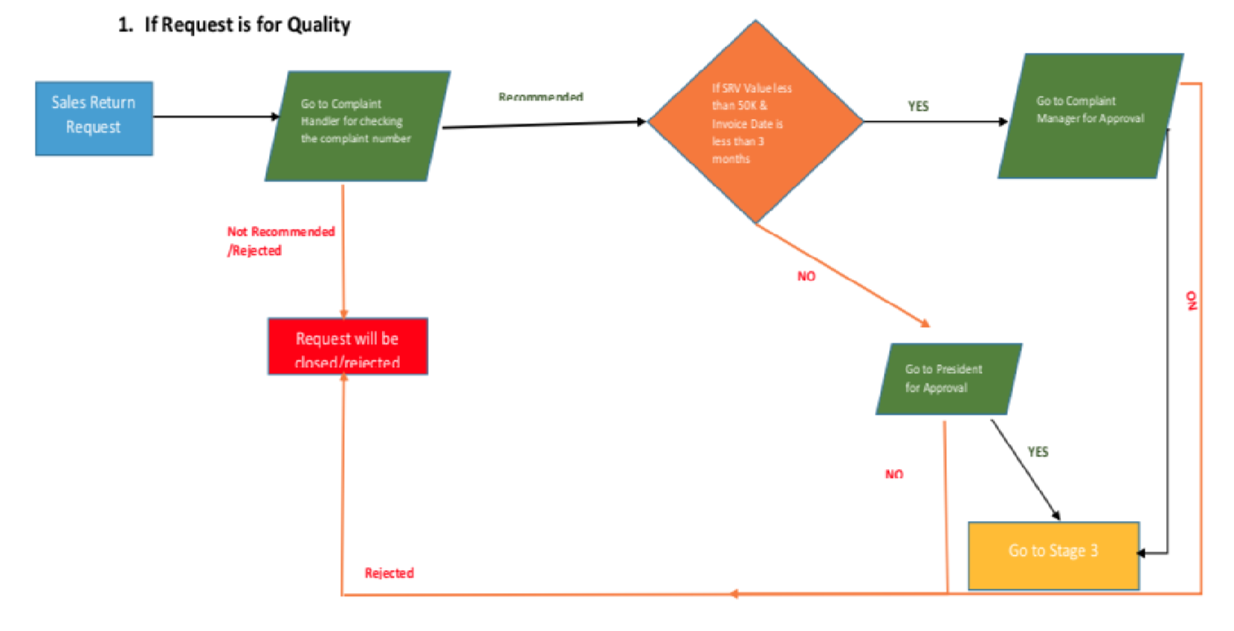

**Flow for Logistics Reason:**

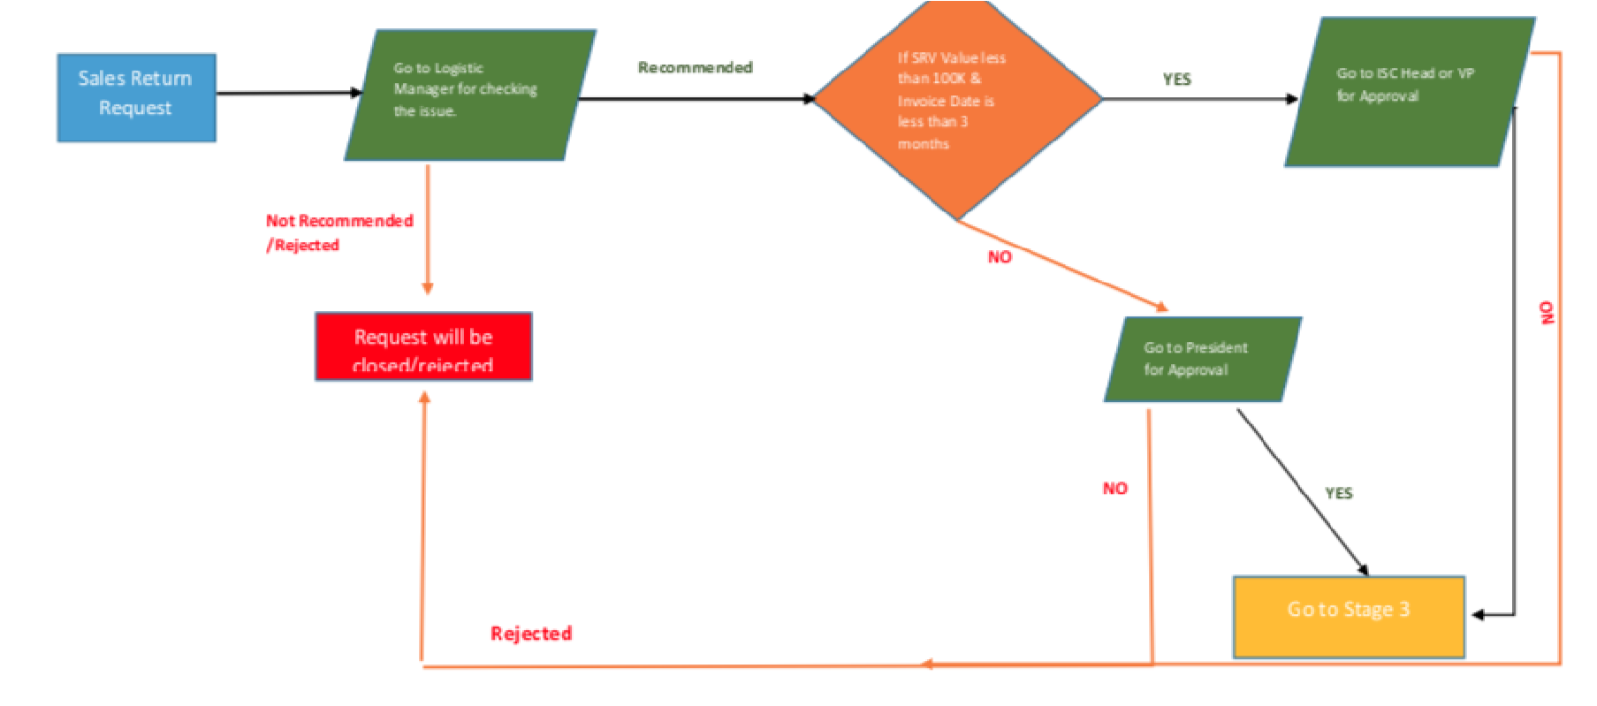

**Flow for Commercial:**

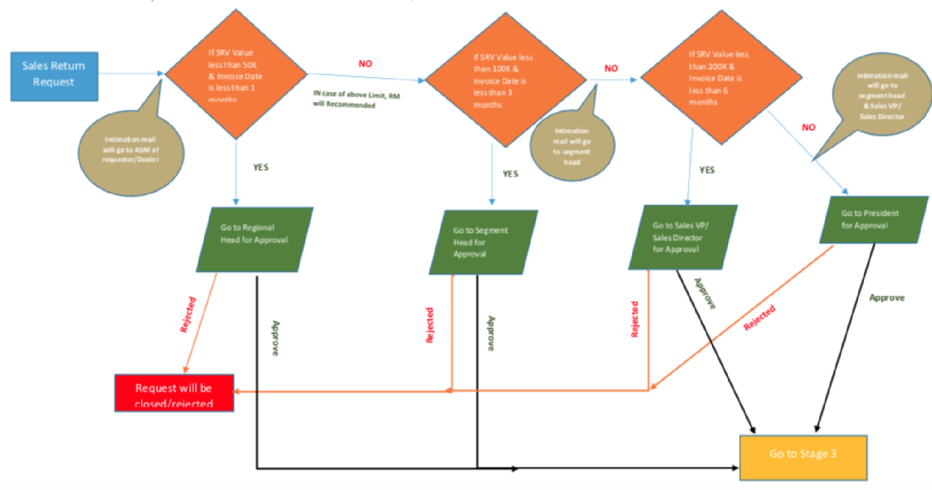

**Flow for SRV Billing Closure:**

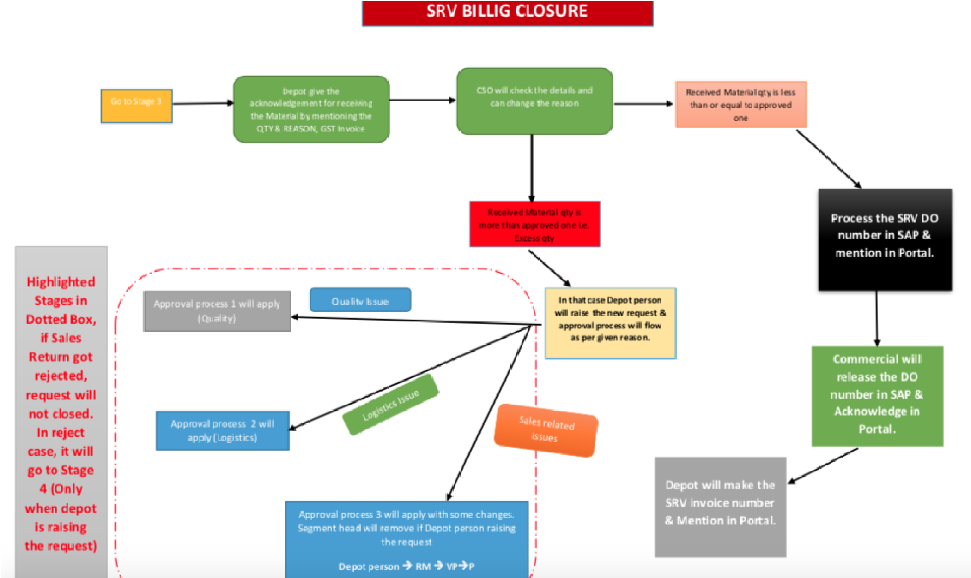

|  |  |  |  |  |
| --- | --- | --- | --- | --- |
| **Status_Id** | **Status** |  | **Role_Id** | **RoleName** |
| 1 | Submitted |  | 1 | User |
| 2 | Pending Complaint Handler |  | 2 | Complaint Handler |
| 3 | Pending Complaint Manager |  | 3 | Complaint Manager |
| 4 | Pending Logistic Manager |  | 4 | Logistic Manager |
| 5 | Pending Logistic Head |  | 5 | Logistic Head |
| 6 | Pending Regional Head |  | 6 | President |
| 7 | Pending Segment Head |  | 7 | Regional Head |
| 8 | Pending Sales Director |  | 8 | Segment Head |
| 9 | Pending President |  | 9 | Sales Director |
| 10 | Recommended Complaint Handler |  | 10 | Depot Manager |
| 11 | Recommended Logistic Manager |  | 11 | CSO |
| 12 | Recommended Complaint Manager |  | 12 | Commercial |
| 13 | Recommended Logistic Head |  |  |  |
| 14 | Recommended Regional Head |  |  |  |
| 15 | Rejected |  |  |  |
| 16 | Approved |  |  |  |
| 17 | Pending User |  |  |  |
| 18 | Reconsidered Complaint Handler |  |  |  |
| 19 | Reconsidered Logistic Manager |  |  |  |
| 20 | Reconsidered Complaint Manager |  |  |  |
| 21 | Reconsidered Logistic Head |  |  |  |
| 22 | Reconsidered Regional Head |  |  |  |
| 23 | Reconsidered President |  |  |  |
| 24 | Reconsidered Regional Head |  |  |  |
| 25 | Reconsidered Segment Head |  |  |  |
| 26 | Reconsidered Sales Director |  |  |  |
| 10017 | Saved As Draft |  |  |  |
| 10018 | Close |  |  |  |
| 10019 | Pending Depot |  |  |  |
| 10020 | Pending CSO |  |  |  |
| 10021 | Pending Commercial |  |  |  |
| 10022 | Acknowledge by Depot |  |  |  |
| 10023 | Approve By CSO |  |  |  |
| 10024 | Approve By Commercial |  |  |  |
| 10025 | Approve By Depot |  |  |  |