SLX Internet Domain Guidelines
Scope: Validation of Internet Domain, Parent Organization, extraction of Organization Name from Sourcing
Input File Format
- Internet Domains with Organization Name and Parent Organization Name.
Processing method:
- Search the item as per below criteria

- For some of the given Parent Organization, Parent Internet Domain is given but we need to identify it and capture Parent Organization Output as None.
Ex: Internet Domain: adcomsolutions.com Organization Name: ADCOM SOLUTIONS
Parent Organization Name: None

- For some of the given Parent Organization, Parent Internet Domain is not given, for such cases we need to capture Parent Internet Domain from google and Parent Organization Output as None.
Ex: Internet Domain: ace-cranes.com Organization Name: ACE CONSTRUCTION
Parent Organization Name: None

- Search the given Parent Organization subsidiaries in Google, update the new Internet Domain which is not available in the given data.
Ex: New Internet Domain: sollersford.ru, Organization Name: FORD SOLLERS, Parent Organization Name: FORD MOTOR COMPANY

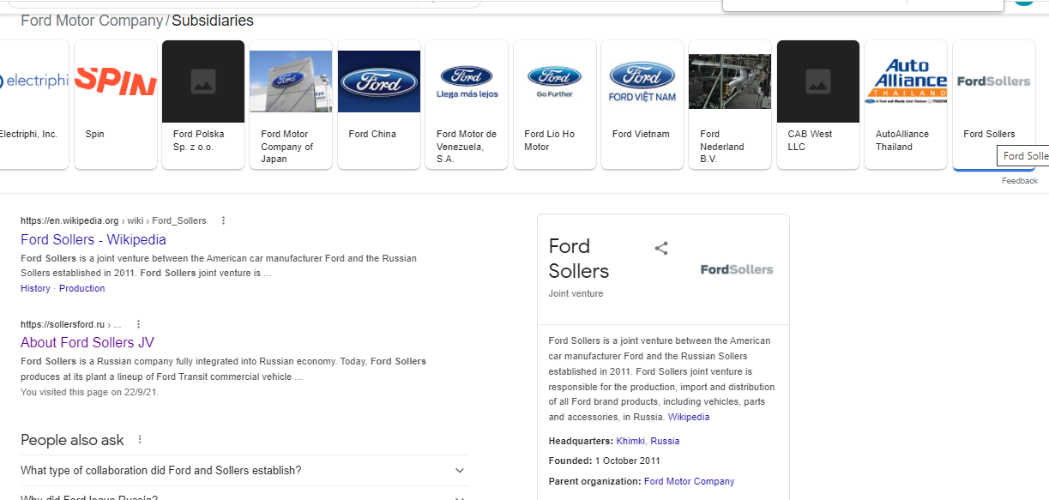

- Search the given Parent Organization subsidiaries in Google, create new line only if we get Internet Domain for the obtained subsidiary
Example:1

- Internet Domain: ghco.com
Organization Name: GRAHAM HOLDINGS COMPANY
Parent Name: None

Here just we need to validate the Organization name and Parent Organization Name

Example:2

- Internet Domain: marketswitch.com
Organization Name: EXPERIAN PLC
Parent Organization: None.

In this given Internet Domain is redirecting to the Parent Domain (i.e experian.com), we need to update Organization Name as EXPERIAN PLC and Parent Organization Name as None

Example: 3

- Internet Domain: aahvs.duke.edu
Organization Name: DUKE UNIVERSITY
Parent Organization: DUKE UNIVERSITY
Whenever the Parent Organization is Universities/Government Organizations, We must update Organization Name same as Parent Organization Name (No need to update Departments which comes under the given Parent)

Example: 4

- Internet Domain: wceend.nl
Organization Name: SC JOHNSON AND SON INC
Parent Organization: SC JOHNSON

Whenever we get brand on searching the given Internet Domain, if the copyright is available in the webpage, then we capture Organization Name as copyright

Example: 5

- Internet Domain: clydes.com
Organization Name: CLYDES
Parent Organization: GRAHAM HOLDINGS COMPANY

Whenever we get brand on searching the given Internet Domain, if the copyright is not available in the webpage, then we capture Organization Name as it is.
Example: 6

- Internet Domain: 2130third.ucsf.edu
- Organization Name: UNIVERSITY OF CALIFORNIA SAN FRANCISCO
Parent Organization: UNIVERSITY OF CALIFORNIA

For the "Website Not Opening case" with respect to Universities, If we can able to identify the Organization Name from the given Internet Domain, then we can update the Organization Names. Earlier we updated both parent and organization name as same

Example: 7
Non-.edu domains will not be used for the academic institutions itself but may be used for related/affiliated organizations
Example: bsc.coop is Berkeley Student Cooperative, a charitable organization that is independent from the University of California system

- Whenever we find New Internet Domain which is not available in the given data, we need to capture that domain in the new line with the comment” New Internet Domain Added”

- When the given Internet domain is not valid/does not open, we will capture Parent Organization Name itself in the Organization Name, and should comment “Website is not opening”

General Rules

- Avoid unnecessary punctuations in the Organization Name (i.e the period (.) at the end of “The Bahrain Horse Racing Affairs Directorate.”).

- Organization Names in ALL CAPITAL LETTERS

- Don't Update Parent Organization Name unless we have strong evidence

- Internet Domains should not include any slashes (/) or protocols (i.e. http)

- Do not include regional/language-specific subsites (i.e. microsoft.com/fr-fr)

- Do include regional/language-specific domain/subdomains (i.e. microsoft.fr, ca-en.alliedelec.com)

- If a subdomain redirects to the primary domain (i.e. microsoft.fr -> microsoft.com) or the subdomain the a language-specific site for the same main company (i.e. ca-en.alliedelec.com), include a row for the internet domain but use the primary company name as the Organization Name and "None" as the Parent Organization Name.

- Omit/ignore holding companies and companies with very complex structures as these can take a while to figure out the specifics.

