Standardization of
Material Descriptions
Production Guidelines

Basic Rules
The follow rules are to be applied
- Always ask yourself “WHAT DO I HAVE IN MY HAND” – what is the Noun?
- Respect the format proposed for every value you want to add.
- Respect the value standardization.
- Space Allowed. Any multi-spacing within the value range is replaced with a single space.
- Correct all spelling mistakes.
- No punctuation and accent.
- Only some special characters are allowed. See p.10 of this document.
- No plural in the Noun.
- No abbreviation in the Noun.
- No Size Conversions are to be done EG 1-1/2in to 38.1mm or visa versa.
- All imperial sizes to be fractionalised – not decimals. I.e. 1-1/2 not 1.5 inches. Note the format that fractions are capture. (https://www.metric-conversions.org is a great site to use.)
- Use existing abbreviations/acronyms only. See pg.12-23of this document.
- No base unit of measure (BUOM) in the short description.
- All data is to be in upper case.
- Additional Features – Must have direct value add to class.
- Please see below Rules for short description regarding OEM and Non-OEM items.
- Reducing sizes must be captured largest to smallest. I.e. 30 x 25mm
- Don’t fabricate / guess, only add what can be substantiated via source documents and / or internet and catalogues.
- Kits and Sets are always capture with the work Kit or Set First, then followed by the Type. E.g. Kit Valve Repair, Set Socket Wrench. These will be defined by the Taxonomy.
- Positions are always captured first and then followed by the side E.g. Left Rear = Rear Left
- REBUILD Items, These items are to be created using the material type “ZCAP”. The word “Rebuild” will be part of the description.
- Difference between Wire, Cable, Cord (electrical):
Wire - has a single Core, Generally Bulk
Cable - has multiple Cores with a common insulation, Generally Bulk
Cord - has a termination on one or both ends.
- Difference between Screw and Bolt:
Screw - cuts its own thread.
Bolt – matches a thread into which it is secured.
- Difference between Lamp, Light, Globe
Lamp –Something that emits light in various colours.
Light –A complete unit that has the lamp as well as the fittings.
Globe –A spherical dome shape that surrounds a lamp or light.
- Difference between Set vs Kit
Set – A collection of the SAME items with different sizes. I.e. O-Rings, Screws, etc.
Kit–A collection of different items supplied together. Kit Valve Repair may have seals, bearing, seat, etc.

SPECIAL CHARACTERS
Within the descriptions being compiled via the taxonomy in the MDG, there are specific rules defined to ensure data consistency. Although the MDG will apply these automatically when compiling the various descriptions, these rules need to be applied when entering the values in the MDG.

SPECIAL CHARACTERS | RULES FOR SPECIAL CHARACTERS
. | Full stops will be used to break decimals. No spaces are allowed on either side of a full stop. No full stop are to be at the end of description.
/ | A Forward (front) slash will only be used in Part numbers; Drawing numbers; Reference numbers or Fractions. No spaces are allowed on either side of a Front Slash.  It is also used to separate values within a property (Used instead of the word “or”). I.e. 110 or 220 VAC = 110/220 VAC
- | A hyphen (dash) is allowed in the use of Part Numbers, Drawing numbers; Reference numbers or where grammatically necessary in descriptions.  It is also used to indicate a Negative (minus) value.  It is further used to indicate a range of values. (Used instead of the word “to”).I.e 110 to 220VAC = 110-220VAC  No spacing allowed on either side.
x | An alone standing X is only allowed to denote "times" in sizes and will be in UPPER case. I.e. 20 X 50 X 10mm.  If an X is part of the keyword or brand it MUST be UPPERCASE.
& | Ampersand may be used to replace the word AND to save space
% | Percentage may NOTbe used to describe proportion. The abbreviation "PCT" is to be used instead.
+ | A Plus is allowed and us typically used in Tolerance.
+/- | A Plus Minus is allowed and is typically used in Tolerance. Do not use “±”.  Note that ASCII code characters are not to be used.
≥ | The "Greater than or Equal to" symbol is to be captured as ">="  Note that ASCII code characters are not to be used.
≤ | The "Less than or Equal to" symbol is to be captured as "<="  Note that ASCII code characters are not to be used.
° | The Degree sign is to be captured as DEG  Note that ASCII code characters are not to be used.
“ | This is commonly used in industry to denote INCHES. This is not to be used. The INCH abbreviation “IN” is to be used instead.
‘ | This is commonly used in industry to denote FEET/FOOT. This is not to be used. The FEET/FOOT abbreviation “FT” is to be used instead.
* | This symbol is often used to separate different dimensions / values in industry. This symbol is NOT to be used. The “X” is to be used.  Eg. 150*100 is to be captured as 150 X 100.
Ø | This is very often used to denote “Diameter” or “Bore” and is not to be used. Use the prefix “DIA” instead.  Note that ASCII code characters are not to be used.
MM² / MM³ | The miniature “²” or “³” are not to be used. MM2 or MM3 is the correct manner of capturing these values.  Note that ASCII code characters are not to be used.
(3) DIA 10 MM HOLES | When there is more than a single quantity of a given value, the quantity is to be in brackets followed by the value.  I.e. (3) DIA 10 MM HOLES means that there are 3 holes and the holes are 10 MM in diameter.

TOLERANCES
When Capturing Tolerances the following format is to be used.
Plus: the “+” shall be used, e.g. +0.001
Minus: the “-” shall be used, e.g. -0.0001
Plus/minus: “+/-“ shall be used, e.g.+/-0.0001

SERIES OF NO’S
Apply the following rules for where values are capture in series. This is normally used for Bits, Sockets, Kits, etc.
Single | 1,3,9,15,18
Range | 1-3  -10 TO 15
Single and Range combination | 1,3,7-9,15,18,20-25

RANGES
Please apply the following rules when capturing ranges in value fields.
Note that when a range is from a negative to a positive then the word ”to” is used.
Negative to Positive | -150 TO 120
Positive to Positive | 120-150
Minimum to Maximum | 120-150

COLOR
When capturing colour(s) of items it is normally done alphabetically. E.g. Blue, Green Dark, Green Light, Yellow.
Colors are always captured with the Color name first followed by the shade. E.g. Green Dark

NOTE: This rule is NOT APPLIED to items where the color code defines ratings. E.g. Resistors, Pipes, Gaskets etc.Thesecolors sequencesmust not be changed and must be captured as per the Manufacturer specifications.

DIMENSIONS, SIZES
Prefixes are added to Descriptions. E.g. ID 25XOD 35 MMXLG 6 M
Standard Abbreviations
ABBREVIATION - EN | ABBREVIATION - ES | ABBREVIATION - FR | DESCRIPTION
DIA | DIA | DIA | DIAMETER
DP | PROF | PROF | DEPTH
HT | LAT | HT | HEIGHT
ID | DIA INT | DIA | INSIDE DIAMETER
OD | DIE EXT | DE | OUTSIDE DIAMETER
LG | LRG | LG | LENGTH
THK | ESP | EP | THICKNESS
SQ | CUAD | CAR | SQUARE
WD | LRG | LRG | WIDTH

Format examples: Note the sequence in which these dimensions have been captured.
DIMENSION / SIZE FORMAT | EXAMPLE
DIA X HT X DP | DIA 25 X HT 15 X DP 50 MM
DIA X LG | DIA 1/2 X LG 10 IN
DIA X LG X THK | DIA 50 X LG 200 X THK10 MM
DIA X THK | DIA 10 X THK 1/2 IN
ID X OD | ID 3 X OD 4-3/4 IN
ID X OD X LG | ID 12-1/2 X OD 15 X LG 24 IN
ID X OD X LG X THK | ID 10 X OD 20 X LG 150 X THK 1.5 MM
ID X OD X THK | ID 3/4 X OD 1-1/8 X THK 1/4 IN
SQ X DP | SQ 50 X DP 200 MM
SQ X DP X THK | SQ 50 X DP 25 X THK 2 MM
SQ X LG | SQ 12 X LG 20 IN
SQ X HT | SQ 3/4 X HT 4-5/16 IN
SQ X THK | SQ 65 X THK 45 MM
WD X LG | WD 1-1/2 X LG 2-3/4 M
WD X LG X DP | WD 250 X LG 800 X DP 50 MM
WD X LG X HT | WD 3-1/2 X LG 12 X HT 2 IN
WD X LG X THK | WD 35 X LG 1200 X THK 4 MM

UNIT OF MEASURES/NOTES
(These are NOT BUOM, but rather value UOM's)
- Container Type

ABBREVIATION | DESCRIPTION
BG |  | Bag
BT |  | Bottle
BX |  | Box
CS |  | Case
CT |  | Carton
DR |  | Drum
DZ |  | Dozen
EA |  | Each
GR |  | Gross
JR |  | Jar
PD |  | Pad
PK |  | Pack
PL |  | Pallet
PR |  | Pair
TB |  | Tube

Digital
ABBREVIATION | DESCRIPTION
GB | Gigabyte
KB | Kilobyte
MB | Megabyte
TB | Terabyte

- Electrical Units/Ratings
When capturing electrical values the general order is as follows. (This is used when there is no Value field to be able to capture values per characteristic).

If you have 2 different values for the same type of Voltage/Amp etc. always capture the Lowest First
Eg.: 120/240VAC

Volts, Amps, Phase, Watts, VA Rating, followed by the rest (Horsepower, Ohm, etc.), Hertz is always last.
I.e: 120/240VAC, 5A, 2PH, 50W, 3KV, 3HP, 5 OHM, 50/60HZ

There are, however items where the Electrical rating, should be split into separate Properties, as below:
- CURRENT = Ampere (A)
- POTENTIAL = Voltage (V)
- POWER = Wattage (W)

ABBREVIATION | DESCRIPTION
A | Ampere
AH | Ampere hour
AS | Ampere second
AC/DC | Alternating current/direct current
C | Coulomb
F | Farad
H | Henry
KA | Kilo Ampere
KV | Kilovolt
KVA | Kilo volt ampere
KW | Kilowatt
KWH | Kilowatt-hour
OHM | Ohm
VA | Volt-ampere
W | Watt
KW | Kilo Watt

- Voltage units
ABBREVIATION | DESCRIPTION
V | Volt
VAC | Volt Alternative Current
VDC | Volt Direct Current

- Frequency
ABBREVIATION | DESCRIPTION
GHZ | Gigahertz
HZ | Hertz
KHZ | Kilohertz
MHZ | Megahertz
- Length
ABBREVIATION | DESCRIPTION
CM | Centimetre (Only to be used for Clothing related dimensions)
FT | Feet
IN | Inch
KM | Kilometre
LG | Length
M | Meter
MI | Mile
MM | Millimetre
RL | Roll
YD | Yard
UM | Micron
Note:
Less than 1000 MM = MM
Greater than 1000 MM = M
Greater than 1000 M = KM

- Nominal Pipe Sizes
ABBREVIATION | DESCRIPTION
SCH | Schedule
NPS | Nominal Pipe Size

- Power Unit
ABBREVIATION | DESCRIPTION
HP | Horsepower
W | Watt

- Pressure Ratings
DO NOT Convert PSIG, PSID or PSIA Ratings.
DO NOT Convert PSI to LB for Pressure Gauges, Switches and Transmitters.
DO NOT Convert PSI to PSIG

ABBREVIATION | DESCRIPTION
BAR | Bar
HPA | Hecto Pascal
KPA | Kilo Pascal
MPA | Mega Pascal
MBAR | Millibar
PA | Pascal
PSI | Pounds per Square Inch
PSID | Pounds per Square Inch Differential
PSIG | Pounds per Square Gauge

- Shape
ABBREVIATION | DESCRIPTION
RND | Round
SQ | Square
TRIA | Triangle
RECT | Rectangle
HEX | Hexagon/Hexagonal
OCT | Octagon
HEP | Heptagon

- Speed
ABBREVIATION | DESCRIPTION
CPM | Counts per minute
CW | Continuous wave
FT/MIN | Foot per minute
FT/SEC | Foot per second
KM/H | Kilometre per hour
MPH | Mile per hour
M/S | Meter per second
RPM | Revolutions per minute
RPS | Revolutions per second

- Time
ABBREVIATION | DESCRIPTION
D | Day
HR | Hour
MIN | Minutes
MS | Millisecond
S | Second
YR | Year
MNTH | Month

- Temperature Unit
ABBREVIATION | DESCRIPTION
DEG C | Degree Celsius
DEG F | Degree Fahrenheit
K | Kelvin

- Volume
ABBREVIATION | DESCRIPTION
CL | Centilitre
DL | Decilitre
DM3 | Cubic decimetre
DR | Drum
FL OZ | Fluid ounce
FT3 | Cubic foot
GAL | Gallon
L | Litre
M3 | Cubic meter
ML | Millilitre
MM3 | Cubic millimetre

- Weight
ABBREVIATION | DESCRIPTION
CG | Centigram
DG | Decigram
G | Gram
HG | Hectogram
KG | Kilogram
LBS | Pound
OZ | Ounce
T | Metric ton (UK)
TON | Short ton (US)
TES | Tesla
MG | Milligram
ST | Stone

THREAD ABBREVIATION and NOTES
Note: If there is a sequence to capture for the thread information Capture it in a string format.
Capture as Thread Direction, Series, Class, Thread Size, Thread type.

Imperial Example
A typical example and breakdown of how thread data may be found is: 1/4-20UNC-2A,
- LH = if Left Hand (No symbol required for right hand thread).
- UNC = Thread series (Unified Coarse thread).
- 2A = Thread class symbol (A = External Tread and B = Internal Thread)
- 20 = Number of Threads Per Inch (TPI).
- 1/4 = Nominal Size.
Short Description. ex. LH,UNC,2A,20,1/4 IN
Long Description ex. LH,UNC,Cl 2A,20 TPI,1/4 IN

Metric Example
A typical example and breakdown of how thread data may be found is: M10, 1.25mm BSF, 2g
- LH = if Left Hand (No symbol required for right hand thread).
- BSF = Thread Type (British Standard Fine)
- 1.25mm = Thread Pitch
- 2g = Thread Class (Capital Letter = Internal, Small Letter = External Thread)
- M10 = Nominal size
Short Description. ex. LH,BSF,2G,1.25 MM,M10
Long Description ex. LH,BSF,CL2G,PITCH 1.25 MM,M10
Thread Class Imperial:
A = External
B = Internal

Thread Class metric:
G/H = Internal
E/F = External

Thread Direction:
RH = Right Hand (this is normally not captured as this is normally the default direction)
LH = Left Hand

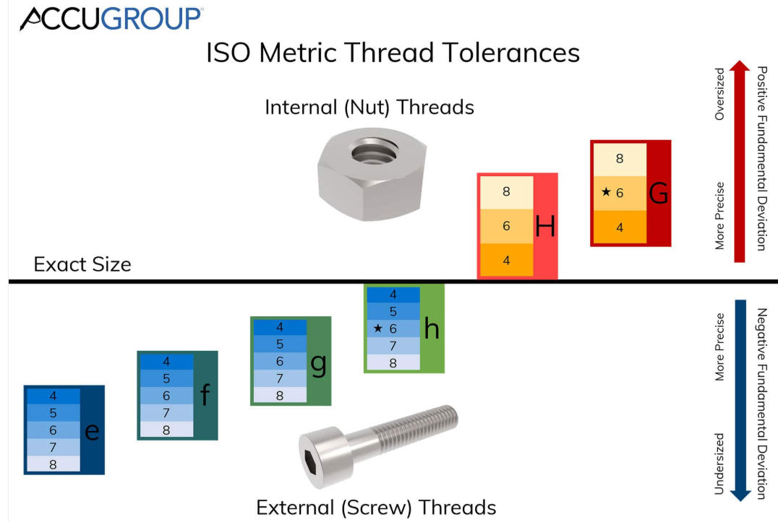

THREAD SERIES LIST
ABBRREVISION | DESCRIPTIONS
BSF | British Standard Fine
BSP | British Standard Pipe
BSPF | British Standard Pipe Fitting
BSPP | British Standard Pipe Parallel
BSPT | British Standard Pipe Taper
BSW | British Standard Whitworth
FBSP | Female British Standard Pipe
FNPT | Female National Pipe Taper
FPT | Female Pipe Taper
MPT | Male Pipe Taper
NPS | National Pipe Straight
NPT | National Pipe Taper
NST | National Standard Thread
UNC | Unified National Coarse
UNEF | Unified National Extra Fine
UNF | Unified National Fine
UNR | Unified National Round (Round Root)
UNS | Unified National Special

MATERIAL ABBREVIATION

ABBREVIATION | DESCRIPTION
AG |  | Silver
AL |  | Aluminum
ALALOY |  | Aluminium Alloy
APL |  | AluminiumPolyethylene Laminate
AS |  | Alloy steel
SAN |  | Styrene-Acrylonitrile (plastic)
ASB |  | Asbestos
AU |  | Gold
BMS |  | Bright mild steel
BRS |  | Brass
BRS CR PLTD |  | Brass Chrome Plated
BRS FRGD |  | Brass Forged
BRS NIPLTD |  | Brass Nickel Plated
BRS PLTD |  | Brass Plated
BRS SNPLTD |  | Brass Tin Plated
BRZ |  | Bronze
C |  | Carbon
CA |  | Cellulose Acetate
CANV |  | Canvas
CD |  | Cadmium
CHN STL |  | Chain Steel
CI |  | Cast iron
CI HRD NI |  | Cast Iron Hard Nickel
CEMNT |  | Cement
COMPD |  | Compound
CNCRT |  | Concrete
CPE |  | Chlorinated Polyethylene
CPVC |  | Chlorinated Polyvinyl chloride
CR |  | Chrome/chromium
CRMO |  | Moly chrome/chrome moly
CRSTL |  | Chrome steel
CS |  | Carbon steel
CS CAD |  | Carbon Steel Cadmium
CS CADPLTD |  | Carbon Steel Cadmium Plated
CS CTD |  | Carbon Steel Coated
CS CUPLTD |  | Carbon Steel Copper Plated
CS GALV |  | Carbon Steel Galvanized
CS PLTD |  | Carbon Steel Plated
CS RUBRLND |  | Carbon Steel Rubber Lined
CS GALV |  | Carbon Steel, Galvanized
CS PP LND |  | Carbon Steel Polypropylene Lined
CS ZNCTD |  | Carbon Steel Zinc Coated
CS ZNPLTD |  | Carbon Steel Zinc Plated
SS CST |  | Cast Stainless steel
CU |  | Copper
CU ALOY |  | Copper Alloy
CUALOYCST |  | Copper Alloy Cast
CU NI ALOY |  | Copper Nickel Alloy
CU NIPLTD |  | Copper Nickel Plated
CUSNPLTD |  | Copper Tin Plated
CVS |  | Chrome Vanadium Steel
DI |  | Ductile iron
EPTFE |  | Expanded Polytetrafluoroethylene
EP |  | Ethylene Propylene
EPDM |  | Ethylene Propylene Diene Monomer
EPM |  | Ethylene PropyleneMonomer
EPR |  | Ethylene Propylene Rubber
ETFE |  | Ethylene-tetrafluoroethylene
EVA |  | Ethylene Vinyl Acetate
FBR |  | Fibre
FBRGLS |  | Fiberglass
FE |  | Iron
FE GALV |  | Iron Galvanized
FE NIPLTD |  | Iron Nickel Plated
FE OXID |  | Iron Oxide
FEP |  | Fluorinated Ethylene Propylene
FLPE |  | Fluorinated Polyethylene
GALV |  | Galvanized
GALVCTD |  | Galvanized Coated
GE |  | Germanium
GI |  | Galvanised iron
GLS SFTY |  | Glass Safety
GMS |  | Galvanised Mild Steel
GRP |  | Glass Reinforced Plastic
GS |  | Galvanised steel
HCS |  | High Carbon Steel
HDPE |  | High Density Polyethylene
HDPP |  | High Density Polypropylene
HDPU |  | High Density Polyurethane
HG |  | Mercury
HNBR |  | Hydrogenated Acrolyontrile Butadiene Rubber
HRS |  | Hot Rolled Steel
HS |  | Hassium
HSS |  | High Speed Steel
HTS |  | High Tensile Steel
LCP |  | Liquid Crystal Polymer
LDPE |  | Low Density Polyethylene
LTHR |  | Leather
LTS |  | Low Tensile Steel
MDPE |  | Medium Density Polyethylene
MG |  | Magnesium
MGO |  | Magnesium Oxide
MI |  | Malleable Iron
MN |  | Manganese
MO |  | Molybdenum
MPTFE |  | MultifullPolytetrafluoroethylene
MS |  | Mild Steel
MS EPXYCTD |  | Mild Steel Epoxy Coated
MS GALV |  | Mild Steel Galvanized
NBR |  | Nitrile Butadiene Rubber
NI |  | Nickle
NIHRD |  | Nickel Hard
NIPLTD |  | Nickel Plated
NIPLTD CU |  | Nickel Plated Copper
NI STL |  | Nickel Steel
NPR |  | Neoprene
NYL |  | Nylon
P |  | Phosphorus
PA |  | Polyamide
PAN |  | Polyacrylonitrile
PB |  | Lead
PC |  | Polycarbonate
PE |  | Polyethylene
PET |  | Polyethylene Terephthalate
PEVA |  | Polyethylene Vinyl Acetate
PI |  | Polyimide
PLSTC |  | Plastic
PLSTC FBR |  | Plastic Fibre
PLSTC HRD |  | Plastic Hard
PLTD BRS |  | Plated Brass
PLSTC FE |  | Plated Iron
PLSTC STL |  | Plated Steel
PLYMR |  | Polymers
PLYF |  | Polyolefin
PP |  | Polypropylene
PPO |  | Polypropylene Oxide
PPS |  | Polypropylene Sulphide
PT |  | Platinum
PTFE |  | Polytetrafluoroethylene
PU |  | Polyurethane
PVA |  | Polyvinyl Acetate
PVAL |  | Polyvinyl Alcohol
PVB |  | Polyvinyl Butral
PVC |  | Polyvinyl Chloride
PVCA |  | Polyvinyl chloride acetate
PVDC |  | Polyvinyl Dene chloride
PVDF |  | Polyvinyl Dene Fluoride/Difluoride
PVF |  | Polyvinyl Fluoride
PVFM |  | Polyvinyl Formal
PVS |  | Polyvinyl Siloxane
RH |  | Rhodium
RPTFE |  | Reinforce Polytetrafluoroethylene
SBR |  | Styrene Butadiene Rubber
SGI |  | Spheroidal Graphite Iron
SHT MTL |  | Sheet Metal
SHT STL |  | Sheet Steel
SI |  | Silicone/Silicon
SIC |  | Silicon Carbide
SN |  | Tin
SS |  | Stainless Steel
STL |  | Steel
TI |  | Titanium
TPE |  | Tetrafluroethylene
TPE |  | Thermoplastic Elastomer
UPES |  | Unsaturated Polyester
UPVC |  | Un-practiced polyvinyl chloride
V |  | Vanadium
WC |  | Tungsten Carbide
WI |  | Wrought Iron
WL |  | Wool
WS |  | Wrought Steel
ZN |  | Zinc
ZR |  | Zirconium

GENERAL ABBREVIATION

ABBREVIATION | DESCRIPTION
AWS | American Welding Association
AWG | American Wire Gauge
BC | Bayonet Cap (lamp)
BTU | British thermal unit
CD | Cadela (luminous Intensity)
CAL | Calorie
CARAT | Carat
CA | Centiare
Cl | Class
CES | Candelabra Edison Screw (lamp)
C/W | Come With
C | Core (cable)
CSK | Countersunk
DB | Decibel
DEG | Degree / °
DN | Dimension Nominal
DP | Double Pole
DPDT | Double Pole , Double Throw
DPST | Double Pole , Single Throw
DWG | Drawing
DUPL | Duplicate
ELECMAG | Electromagnetic
ES | Edison Screw (lamp)
F | Farad
FF | Flat Face
FL OZ | Fluid ounce
FT LBS | FootPound
FR | Front
HD | Head
HRS | Hours
HYDR | Hydraulic
G | Gauss
GR | Grade (material)
GES | Giant Edison Screw (lamp)
HEX | Hexagon/Hexagonal
HPS | High Pressure Sodium
IMP | Impulse
J | Joule
KJ | Kilojoule
LH | Left Hand
LBS | Pound
LM | Lumen
LES | Lilliput Edison Screw (lamp)
LDR | Light Dependent (Resistor)
LUX | Lux
M | Male
MNFR | Manufacturer
MAX | Maximum
MFD | Microfarad
MBC | Miniature Bayonet Cap
MES | Miniature Edison Screw (lamp)
MW HR | Megawatt hour
UM | Micron / μm
MIN | Minimum
MISC | Miscellaneous
N | Newton (force)
NB | Nominal Bore
N/M2 | Newton per meter squared
N/S | Newtons per second (rate of force development)
NC | Normally Closed
NO | Normally Open
OEM | Original Equipment Manufacturer
PPM | Part per million
PCT | Percent
PERM | Permanent
PCS | Piece
PLTD | Plated
P | Pole
PH | Phase
PM | Post Meridiem
PDR | Potential Duplicate Report
PSIA | Pounds per square inch absolute
PRES | Pressure
RAD | Radian
REAR | Rear
RF | Raised Face
RH | Right Hand
SBC | Small Bayonet Cap (lamp)
SCKT | Socket
SES | Small Edison Screw (lamp)
SFTWR | Software
SSR | Solid State (Relay)
SUPL | Supplier
TEMP | Temperature
THD | Thread/Threaded
VSD | Variable Speed Drive
WH | Watt-hour
YEL | Yellow

Examples per material (item) types
This section is to supply information for a particular material master type. Please note that not all material types are in examples below.

Material is to be captured as Material and Material Grade E.g. Stainless Steel 316L, further the Material Specification must be captured where available E.g ASTM A193 B8 CL1

Metric to Imperial Conversion
All imperial sizes are to be fractionalized.
E.g. 1.5 IN = 1-1/2 IN
Here is a good website to use to do conversions –
https://www.metric-conversions.org/length/inches-to-millimeters.htm
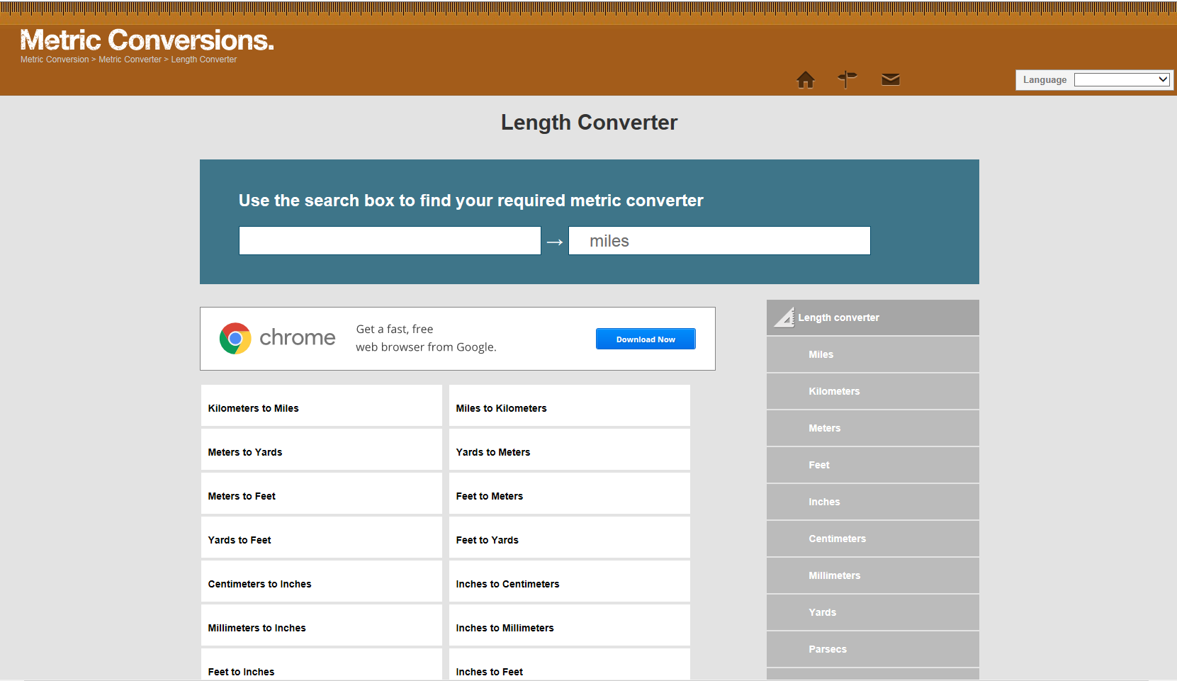
Select “Inches to “Millimetre’s”

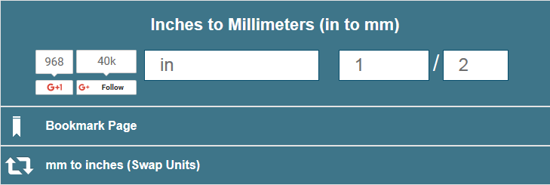
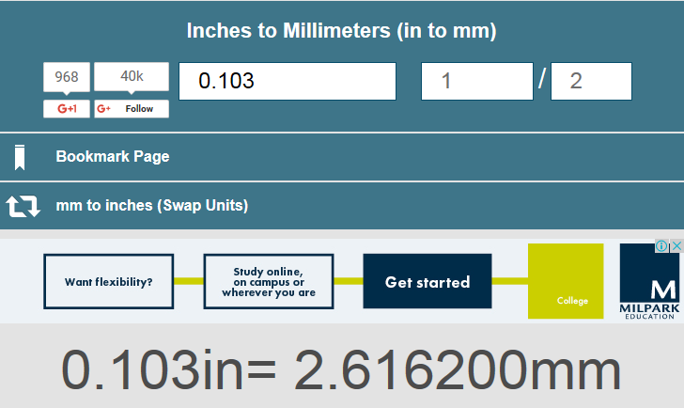
Imperial size converted to metric in millimetres.
Enter imperial decimal size.
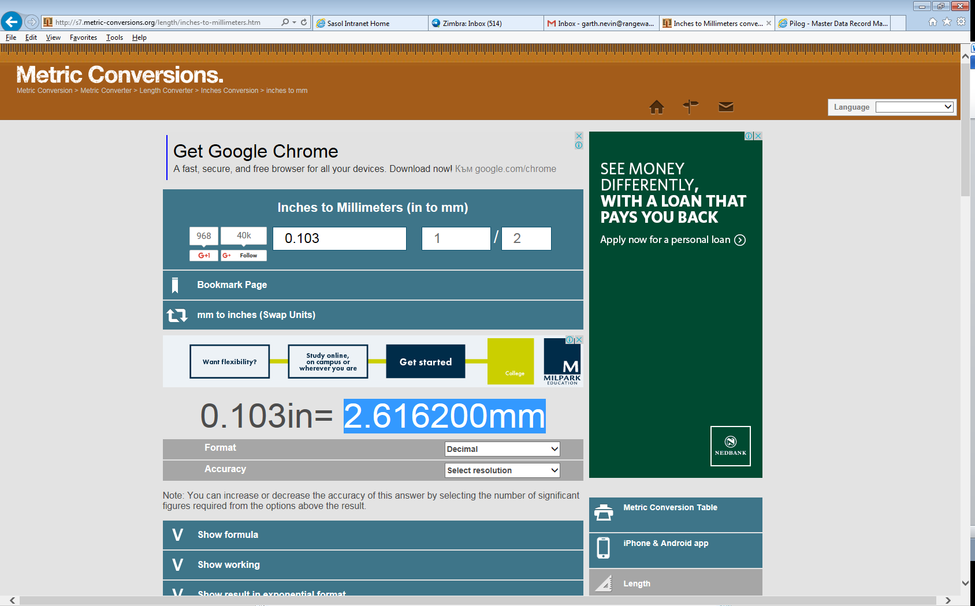
Highlight and copy.
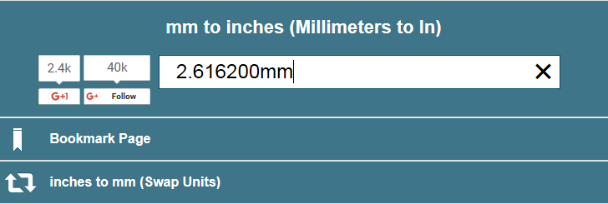
Paste copied millimetre’s value
Click on “Swap Units”
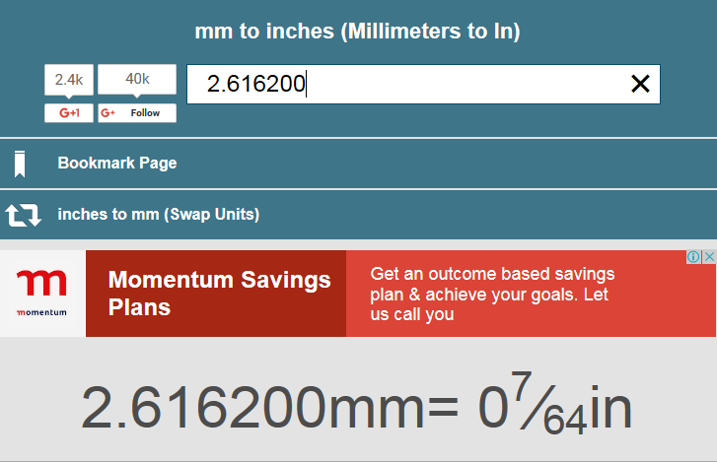
Remove “mm” at the end of number
Imperial fraction is given and to be used.

